Configure 16-bit Application Support in Windows 10
16 Bit support will require enabling the NTVDM feature. To do so, press Windows key + R then type: optionalfeatures.exe then hit Enter. Expand Legacy Components then check off NTVDM and click OK.
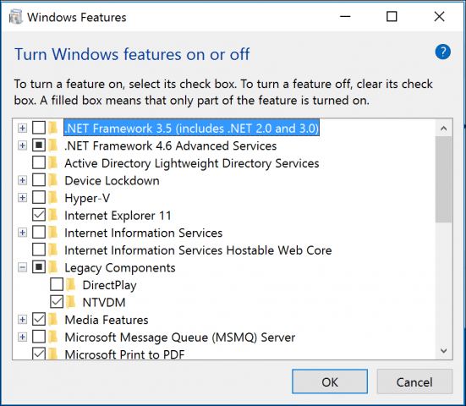<img class="size-medium The next step is to install the feature through the Command Prompt. Press Windows key + X then click Command Prompt (Admin.) At the command prompt, type the following command:

FONDUE.exe /enable-feature:NTVDM
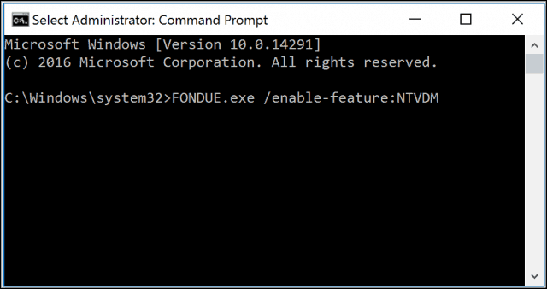<img The The add feature wizard for NTVDM will launch. Click Install this feature to complete the installation. Then restart your computer if required.
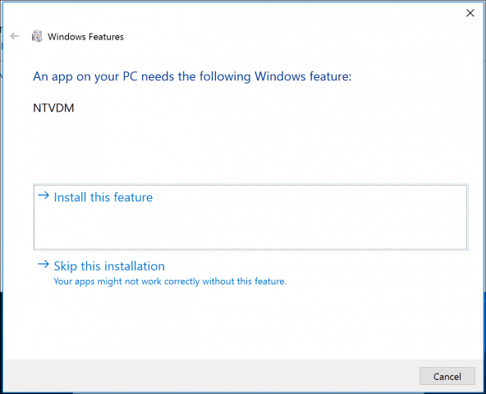

Now 16-bit application support is enabled. You can proceed to install your application as normal.
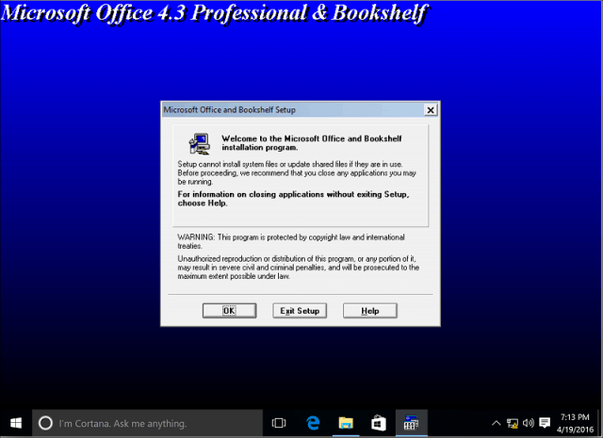<img Some Some applications might require additional permissions. Review our compatibility article for more information about adjusting those settings.
We’re curious about what types of 16-bit applications you still are running. Leave a comment below and let us know. Also, if you’re experiencing any problems with it, head to our new and improved Windows 10 Forums for additional support.

