1. NEW PLAY LIST 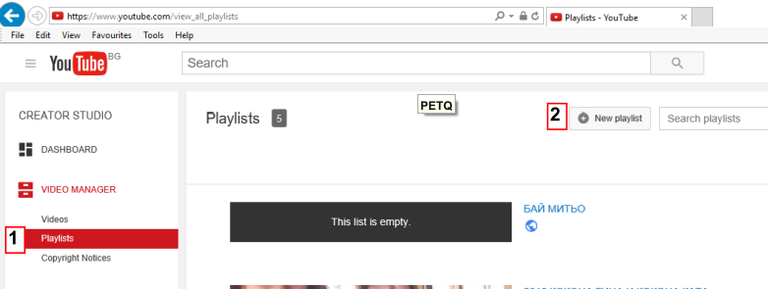
2. EDITOR
3. YouTube Video Converter and Download
4. ДЕТСКИ ПЕСНИ
5. https://www.youtube.com/watch?v=FrsM9WggCdo&list=PLhydd

6.

1. Download Subtitles from Youtube – As.SRT
2. Download Subtitles from Youtube - As .TXT
3.

