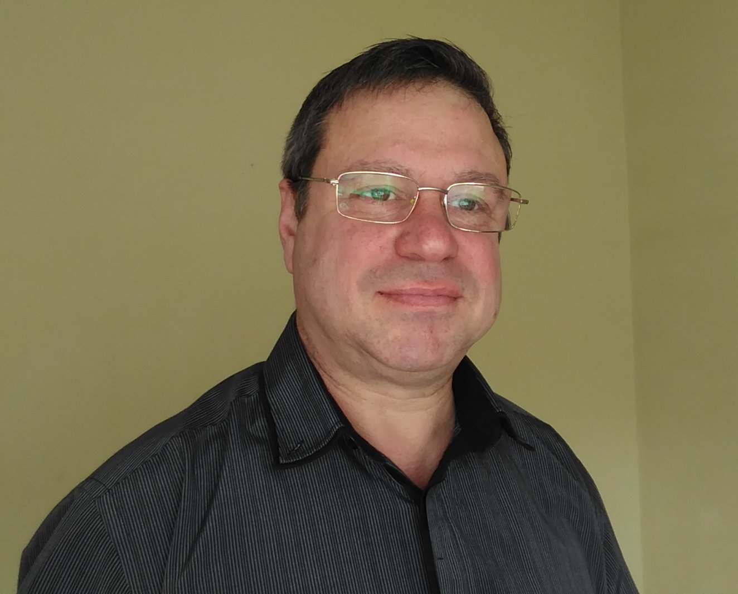

Personal Details  First name(s) / Surname(s)  Phone  E-mail  Nationality  I live in  Birth date  Gender  Education and training  Name and type of organisation providing education and training  Location  Level  Dates  Title of qualification awarded  Work Experience  Dates  Name of Company  Company affiliation  Location  Type of business or sector  Personal skills and competences  Database developer  Manufactured and sold custom software  Software developer and accounting services | Stefan Ivanov Mirchev  +359889998611  si.mirchev@gmail.com  Bulgaria  Burgas/Bulgaria  26.02.1961  Male  University of Economics  Varna  Master's degree  September 1983 - June 1988  Economics of Industry  February 1990 - to this day  Kosi’61. Ltd  Proprietor  Bulgaria  Information technologies, computer equipment, computer networks and communications, operating systems, accounting оffice.  I started with Clipper Summer ’87 Compiler, next software  used: CA-clipper 5.3 Visual Foxpro 9.0, HTML CSS, HTML JavaScript, PHP, MySQL, phpMyAdmin, Ruby, GitHub, Python, Favorite operating system – Linux.  Accounting, Labor and wages, Warehouse-shop, Interest rate, Hotel accommodation.  Private companies.

