LIBREOFFICE
WRITER

SIDEBAR SETTINGS -> styles F11

Alt + Mnemonic
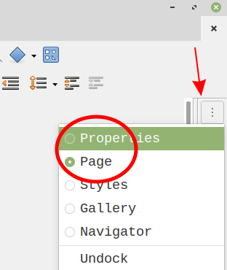
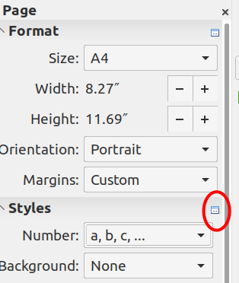

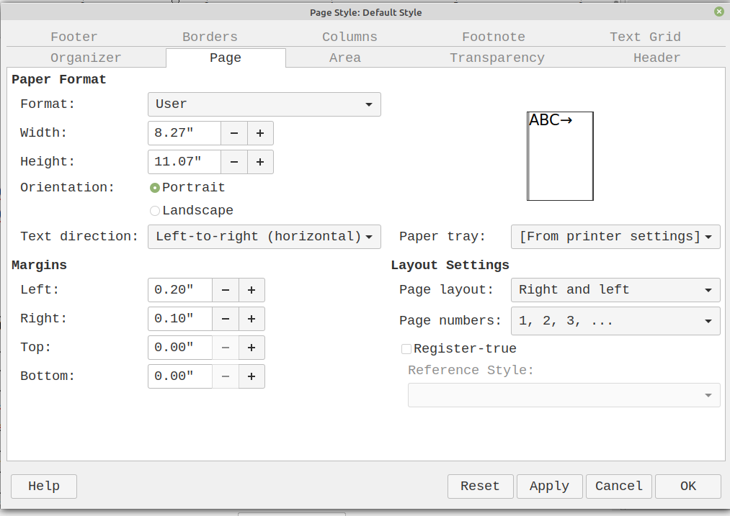

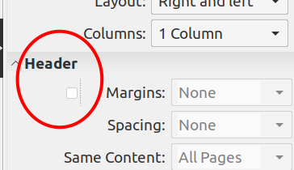

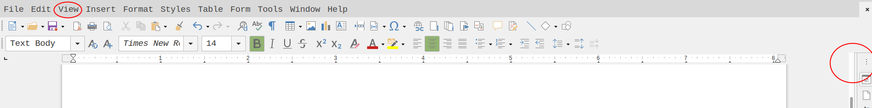

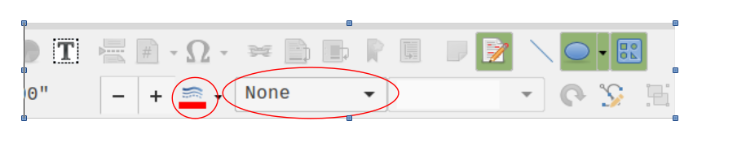

TABLE DRAW

In tabel cell mouse right botton -> Split cells

CALC

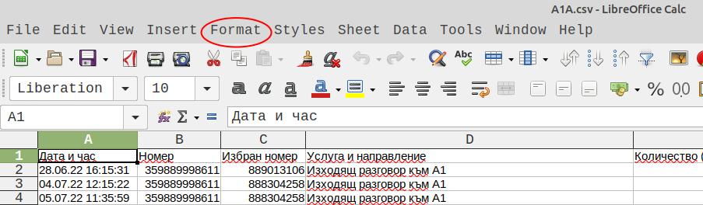

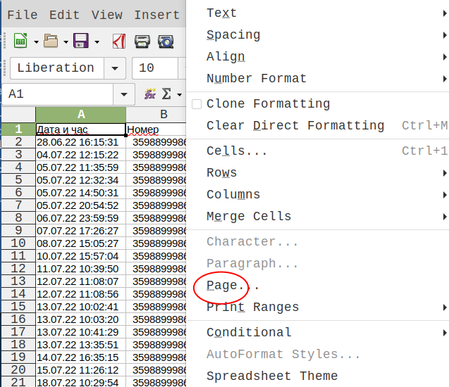

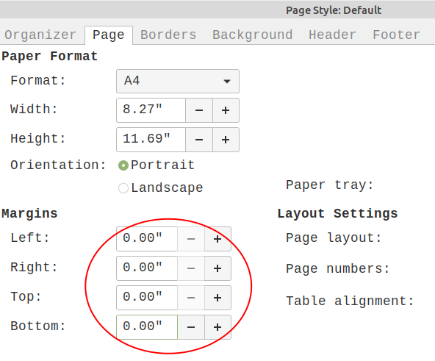

Change numeric separtaor comma with dot :-> Tools -> Options -> Language sttings
->languages ->

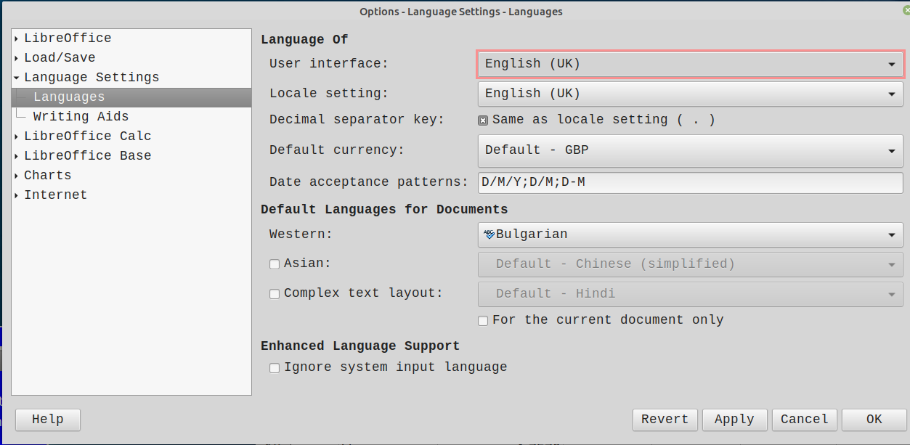

Paste unformatted text default option

1. Tools -> Customise ->

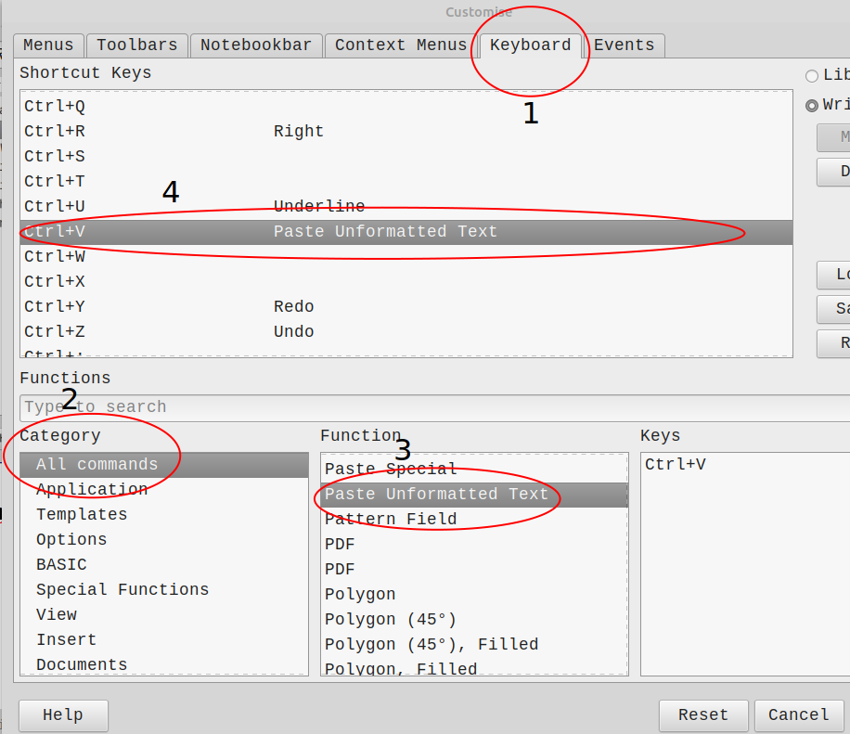

How do you edit the right mouse button menus?

1. Tools -> Context mouse ->
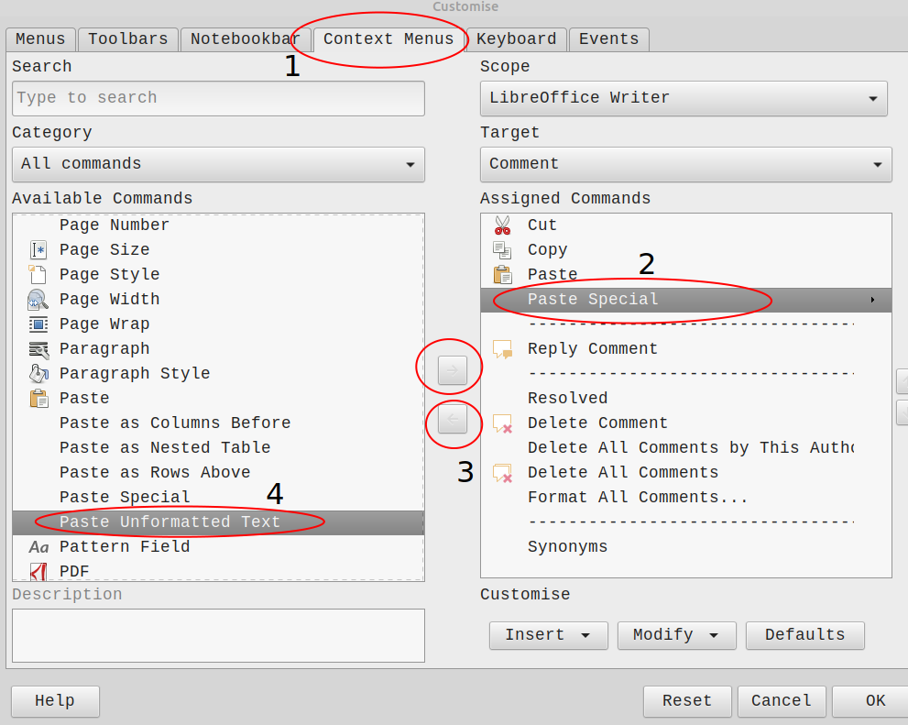

Prevent "delete content" prompt when backspacing?

1. Tools ▸ Customize ▸ Keyboard tab.
2.Shorcut Keys go to Backspace.
3. Click Modify button
4. Sve

Prevent "import options" prompt when paste or Ctrl=v ?
stop the dialog to select a language for content copied&pasted from a browser in Calc from popping up?
Duble click left buttom mouse on cel

IMPRES PPT PPX

Slide Transition -> Slide -> Slide Transiti

EMOTICONS

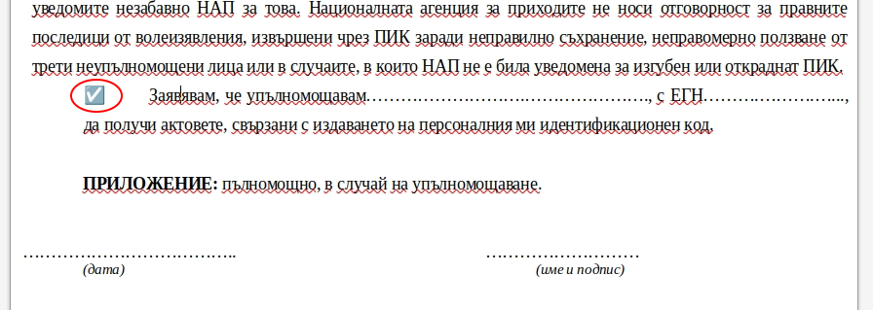

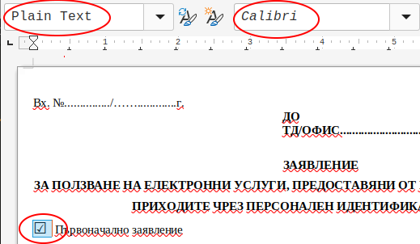

HYPERLINK

1. Go text -> IMPRES PPT PPX
2. Mark text -> IMPRES PPT PPXwith mouse -> Copy
3. Insert -> Bookmark ->

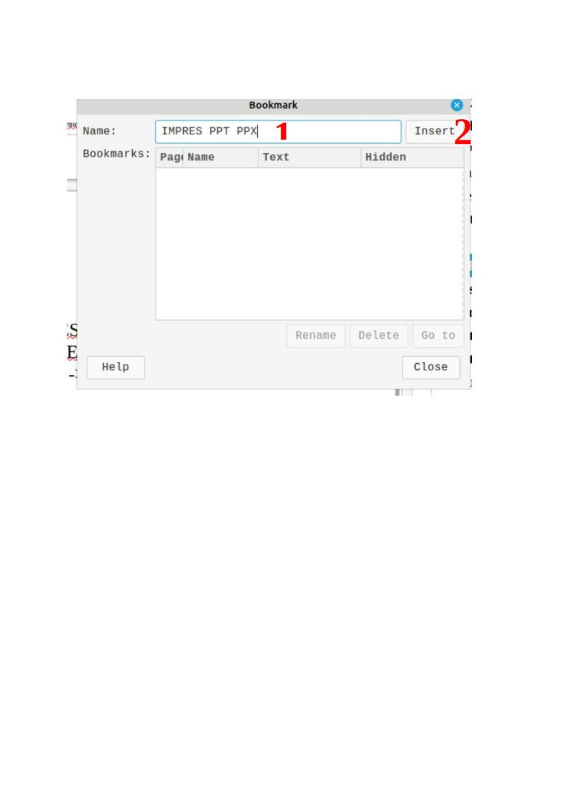

. ABCD -> Mark ABCD with mouse -> Insert -> Hyperlink ->

1

TRANSPERANT

Select the background box  Set Fill to None (F11, Area, Fill, None)  - 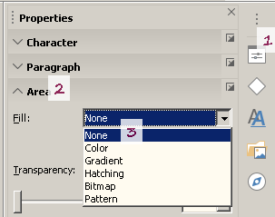 | it is a bitmap:  Select the image  Choose menu Tools - Color Replacer  Select the Pipette icon (image of a painter palette), and click on the white background  Select a Tolerance value (you can play with this value)  Click on Replace button  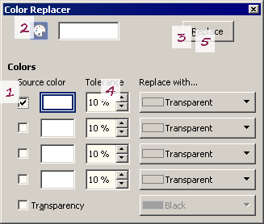

SELECT

Format- Image - Crop

SAVE SELECT /PART OF IMAGE/
Format-> Image -> Crop->Save-> Right button mouse->
-> Save ->
" The image has been modified. By default the original image will be saved. Do you want to save the modified version instead?"
-> Yes

