MASTER PDF – MENUAL

1. Select text
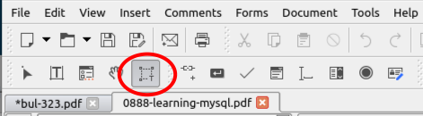

2. Edit text object Alt+2
3. Inset text Ctrl+t
4. Hand tol Alt+4

Transparency Stamp

1. EDIT ONLY .PNG FILE WITH PINTA !!!!

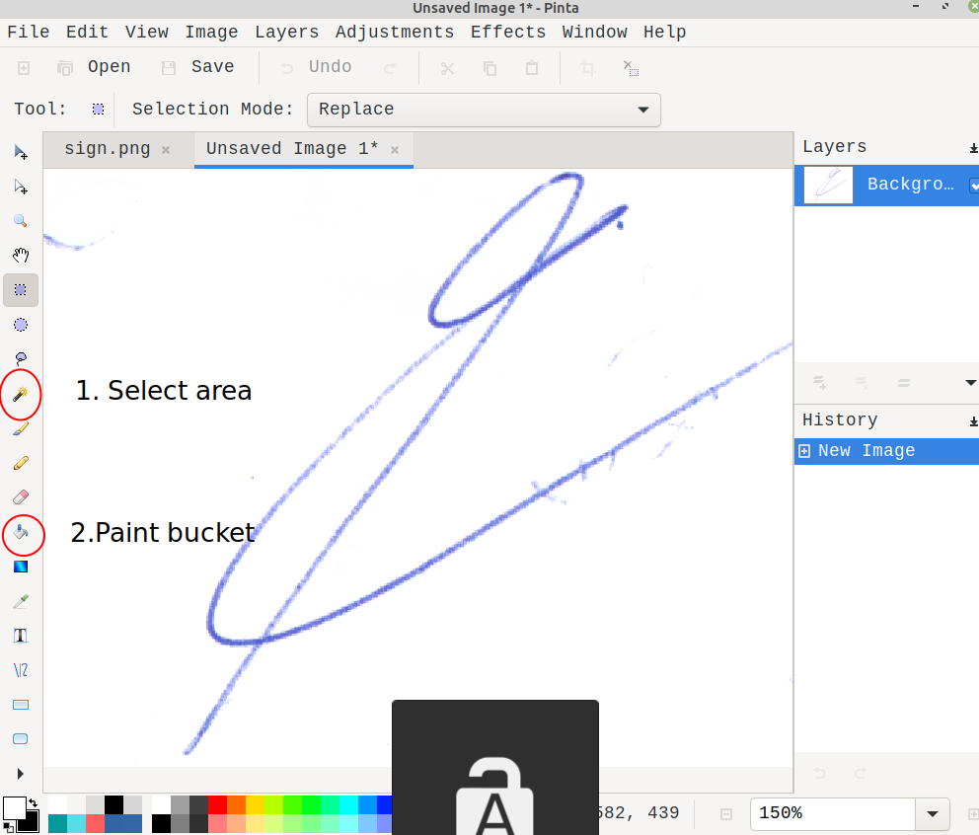

3. Install /IDISK/PDF-Xchange/PDFXVwer.exe in WIN 10 32
4. Open /disc/COMP/Z_PECH/CHEF/PECH-PODP.pdf

