MYSQL – MENUAL
MySQL MANULA
W3Schools.bg

PISHEM SAMO mysqli nikoga samo mysql

8.
1. PHP PDO Prepared Statements Tutorial
2. Nauchi me Mysql
7. Обобщение
1. folder /gataka;
a) v file zaiav_get.html v reda <form method="GET" action="obrab.php?page=1&name=gogo"
-> ?page=1&name=gogo" ne se chetat ot obrab.php
b) v zaiav_post.html vsichko varvi
6. SQL injections https://php.w3schools.bg/mysql-database/%D1%81%D0%B2%D1%8A%D1%80%D0%B7%D0%B2%D0%B0%D0%BD%D0%B5-%D1%81-mysql/

$con=mysqli_connect('127.0.0.1','kosy','089754','invoice');  mysqli_set_charset($con,"utf8");  $id=(float)$_GET['id'];  echo '<pre>'; echo $id ; echo '<pre>';  # $pass=mysqli_escape_string($con,$_GET['password']);  if ($con == TRUE):  echo 'Connected successfully';  else:  echo 'Connection failed: ';  endif; | Ako potrebitelq prati id=6 s comandata  localhost/?id=6  pro`itaneto go pravi s comandata →  $id=(float)$_GET['id'];
$con=mysqli_connect('127.0.0.1','kosy','089754','invoice');  mysqli_set_charset($con,"utf8");  $pass=mysqli_escape_string($con,$_GET['password']);  if ($con == TRUE):  echo 'Connected successfully';  else:  echo 'Connection failed: ';  endif;  # $sql='SELECT * FROM invoice WHERE `password`="'.$_GET['password'].'"';  $sql='SELECT * FROM invoice WHERE `password`="'.$pass.'"';  echo '<pre>' ; echo $sql;  $result=mysqli_query($con, $sql);  echo '<pre>';  # print_r(mysqli_fetch_assoc($result));  while ($row=mysqli_fetch_assoc($result)){  echo '<br>'.$row['user_id'].'__'.$row['user_name'].'__'.$row['password'] ;  } | Funkciata mysqli_escape_string()  kriptira stoinostta I weche ne moge da se prochete bazata danni poqwqwa se simvola  koito pokazwa che dannite sa kriptiranu  / kazwa na mysql razbiraj kato simvol a ne kato specialni simwoli
$con=mysqli_connect('127.0.0.1','kosy','089754','invoice');  mysqli_set_charset($con,"utf8");  if ($con == TRUE):  echo 'Connected successfully';  else:  echo 'Connection failed: ';  endif;  $sql='SELECT * FROM invoice WHERE `password`="'.$_GET['password'].'"';  echo '<pre>' ; echo $sql;  $result=mysqli_query($con, $sql);  echo '<pre>';  # print_r(mysqli_fetch_assoc($result));  while ($row=mysqli_fetch_assoc($result)){  echo '<br>'.$row['user_id'].'__'.$row['user_name'].'__'.$row['password'] ;  } | Tozi pasag chete cqlata informaciq v  invoice no smo sas komanda v  firefox :  ttp://localhost/?user_name=gogo&password=%22%20or%201=1;%23  ili haker:  http://localhost/?user_name=gogo&password=%22%20or%201=1;%23
$con=mysqli_connect('127.0.0.1','kosy','089754','invoice');  mysqli_set_charset($con,"utf8");  if ($con == TRUE):  echo 'Connected successfully';  else:  echo 'Connection failed: ';  endif;  $sql='SELECT * FROM invoice WHERE `user_name`="'.$_GET['user_name'].'"  AND `password`="'.$_GET['password'].'"';  echo '<pre>' ; echo $sql;  $result=mysqli_query($con, $sql);  echo '<pre>';  print_r(mysqli_fetch_assoc($result));  -------------------------------------------------------------  http://localhost/?user_name=gogo&password=123456  -------------------------------------------------------------  http://localhost/?user_name=gogo&password=%22%20or%201=1;%23  -------------------------------------------------------------  http://localhost/?user_name=gogo&password=%22%20or%201=1;%23; drop datebase; | Zayavka s user_name=gogo I  password=123456  se vzema red ot invoice s s tezi usloviq  IZTRIE BAZATA S DANNI !!!!

5. Last insert ID

$con=mysqli_connect('127.0.0.1','kosy','089754','invoice');
mysqli_set_charset($con,"utf8");

# $result=mysqli_query($con, 'INSERT INTO invoice (user_name1, password) VALUES ("misho","cccccc")');
$result=mysqli_query($con,'UPDATE invoice SET `password` = "ffffffff" WHERE user_id=18') ;

echo '<pre>'; var_dump($result); echo '<pre>';

if ($result == TRUE):
echo 'Connected successfully';
else:
echo 'Connection failed: ';
endif;

echo '<pre>'; echo mysqli_affected_rows($con)

$con=mysqli_connect('127.0.0.1','kosy','089754','invoice');  mysqli_set_charset($con,"utf8");  $result=mysqli_query($con, 'INSERT INTO invoice (user_name, password) VALUES ("misho","cccccc")');  echo '<pre>';  var_dump($result);  if ($result == TRUE):  echo 'Connected successfully';  else:  echo 'Connection failed: ';  endif;  echo mysqli_insert_id($con) | var_dump($result); vrashta  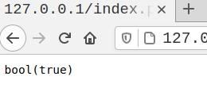  vrashta posledniq ID dori I iztriem zapis  prodylvawata da narastwat

4. Заявка SELECT

2. Connection 3. Database encoding

$con=mysqli_connect('127.0.0.1','kosy','089754','invoice');  if ($con == TRUE):  echo 'Connected successfully';  else:  echo 'Connection failed: ';  endif;  mysqli_set_charset($con,"utf8");  $result=mysqli_query($con,'SELECT user_id, user_name, password FROM invoice');  # $result=mysqli_query($con,'SELECT * FROM invoice');  # var_dump($result);  # echo '<pre>'; echo mysqli_num_rows ($result); ; echo '</pre>';  # echo mysqli_fetch_assoc($result);  echo '<pre>';  print_r (mysqli_fetch_assoc($result));  echo '<pre>';  while ($row=mysqli_fetch_assoc($result)){  echo '<br>'.$row['user_id'].'__'.$row['user_name'].'__'.$row['password'] ;  } | Moge i if ($con): ili if (!$con): zashtoto php wsichko swevda do  true I false 1 ili 0  //vzimame samo dve koloni  dava greshka che pechatame masiv s echo  pechata pyrwiq red v masiv I taka q prawi razbiraema za php  while chete redowete I dokato ima priema true  ako nqma false, A ne kakto e pri men proverka za kraj na  fajla eof()

1. Въведение

Otvori -> NE localahost v browser a 127.0.0.1

!!! IZTRIVANE NA TABLICA:
Sekciq Structure -> check box tablicite koito iskam -> sekcia With selected

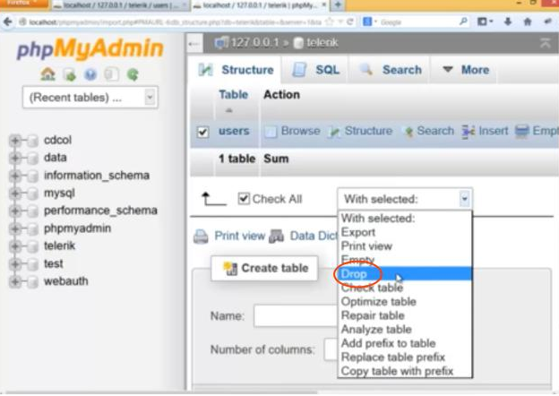

Delete group invoce

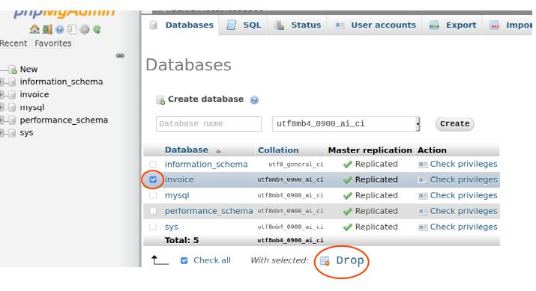

CREATE TABLE `invoice`.`invoice` ( `user_id` INT NOT NULL , `user_name` VARCHAR(50) NOT NULL , `password` VARCHAR(50) NOT NULL , `date_registred` DATE NOT NULL ) ENGINE = InnoDB CHARSET=utf16 COLLATE utf16_general_ci;
Type -> varchar = character
Collation -> utf-8 general ci
4-ri osnovni komandi SELECT - INSERT - UPDATE – DELETE
SELECT * FROM "table_name"; -> WSI`KI KOLONI
DELETE FROM invoice WHERE user_name = 'stefan';
INSERT INTO `invoice` (`user_id`, `user_name`, `password`, `date_registred`) VALUES ('1', 'petko', 'qwerty', '2021-06-23 12:04:49');

Redacia na strukturana na tablicata -> Change
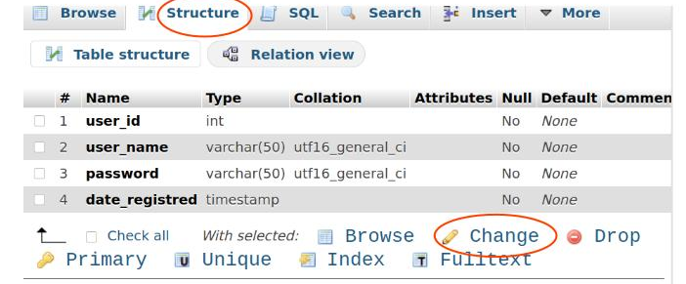

WAGNI NASTROIKI NA TABLICITE:
1. Chesto polzuwani nastroiki:

A_I -> auto increment - автоматично увеличаване

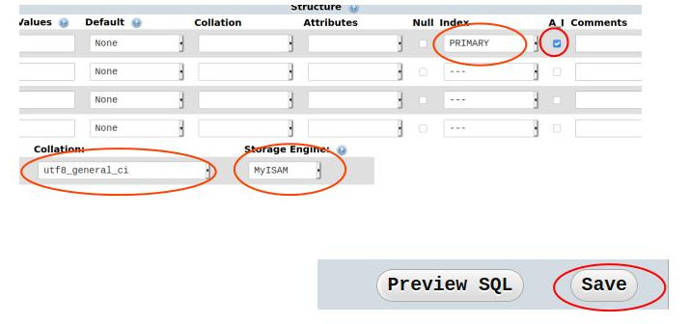

-----------------------------------

MySQL e star variant raboti se MySQli -> https://www.php.net/manual/en/book.mysqli.php
-> MySQL Improved Extension
- netstat -tlnp – pokazawa porta na phpMySQL nobhodim da se vavede v dolnata komanda

