Rambler GPX Editor - map

I. INSTALL ANDROID
!!!!! Tablet never from X-plore only from File Manage !!!!!
!!!! Desable android app automatic update !!!!!!!
Play store → Right user icon → Settings →
- M301t – Auto-update apps
- LENOVO → Network peferences – Auto-update apps

1. From :
- first → /IDISK/ANDROID/Firefox_org.mozilla.firefox.apk
- second https://drive.google.com/drive/my-drive download
→ IDISK/ANDROID/03-BROWSER/Firefox/Firefox_org.mozilla.firefox.apk
3. Download ANDROID/README.DOC with ThinkFreeViewer ->
Copy/paste something:
- double touch with finger over → Share → Gmail -> then Copy
2. General -Set a Homepage → Custom → www.google.com
3. Login in Browser Firefox → si.mirchev@gmail.com di*0
4. BOOKMARKS →
Copy/Paste -> in Browser Firefox
- TV
file:///storage/emulated/0/HLP/FAVORIT/Bookmarks.html

- ME301T AND LENOVO

file:///sdcard/HLP/FAVORIT/Bookmarks.html

5. Check → /HLP/FAVORIT/Bookmarks.html
6. X-plore → install this have icon – no android
6. Remov → Brouser ,
7. Install all 03.Bulgarian keyboard → Tablet System → Language & input →
Default → Hacker’s Keyboard
Hacker’s Keyboard System → Input Languages → български en_GB
7. Name Folders → 01-EXPLORER 02-SOCIAL 03-BROWSER
04-DICTIONARY 05-MULTIMEDIA 06-GOOGLE 07-TOOLS
8. Folder and files ANDROID: ls */*

01-EXPLORER/DOWNLOAD:

01-EXPLORER/Easy Scanner:
Easy Scanner_com.easy4u.scannerpro.apk

01-EXPLORER/Ebook:
app.angeldroid.openbook.apk

01-EXPLORER/File Explorer:
File-Explorer-for-Android_v1.0pakage.apk

01-EXPLORER/PRINTER:
D:IDISKANDROID01-EXPLORERPRINTERPrint For Everyone_com.able.vipul.printforeveryone.apk

01-EXPLORER/Spell Checker Edito:
Spell Checker Editor.apk

01-EXPLORER/WPS:
wps.zip

01-EXPLORER/X-PLORE:
X-plore-3.95.00.apk
X-plore-Pro_4.10.01-Android-1.com.apk
X-plore settings.zip
X-plore v4.14.20_Andropark.info.apk

02-SOCIAL/AnyDesk:
anydesk-6-3-2.apk

02-SOCIAL/Marine Nevigation Lite:
i-Boating
Marine Navigation Lite

02-SOCIAL/Messenger Litle:
Messenger Lite_com.facebook.mlite.apk

02-SOCIAL/Reminder:
Hourly Reminder_v3.3.10.apk

02-SOCIAL/Speech BG:
speechlab.rar

02-SOCIAL/Sync:
com.sync.mobileapp.apk

02-SOCIAL/Text to speech:
hesoft.T2S_60.apk

02-SOCIAL/Viber:
viber-10-2-1-6.apk

03-BROWSER/ANTIVIR-CLEANER:
D:IDISKANDROID03-BROWSERANTIVIR-CLEANERBitdefender Security_3.3091.1340.apk
Security Center_com.rocket.tools.clean.antivirus.master.apk

03-BROWSER/Bar & QR:
Bar & QR Code Reader_1.1.apk

03-BROWSER/BlockSite:
BlockSiteBlockSite_co.blocksite.apk

03-BROWSER/Chrome:

03-BROWSER/Cozy-Magnifier:
cozy-magnifier-and-microscope3-0-3.apk

03-BROWSER/File Transfer:
File TransferFile Transfer_com.filetransfer.copydata.cloneit.apk

03-BROWSER/Firefox:
D:IDISKANDROID03-BROWSERFirefoxFirefox_org.mozilla.firefox.apk

03-BROWSER/FORECA:
FORECA.bmp

03-BROWSER/HTML:
anWriter-Pro-v1.6.1.apk

03-BROWSER/Mobile Assistant:
Mobile Assistant_com.lenovo.magicplus.apk

03-BROWSER/New Calendar:
new-calendar-1-0-70.apk

03-BROWSER/Thermometer:
com.appsxi.thermoml_2015-01-11.apk
Thermometer_com.pizzaentertainment.thermometer.apk

03-BROWSER/W3School:
W3School_com.ananomatic.w3school.apk

03-BROWSER/Weather:
WeatherLocal weather_v2.3.1.apk
WeatherWeather Weawow_v4.0.0.apk

04-DICTIONARY/Bulgarian keyboard:
bulgarian-keyboard-2-1-0-8.apk
Bulgarian Language Pack_app.typo.photokeyboard.bulgarian.apk
Hacker's Keyboard_org.pocketworkstation.pckeyboard.apk
Photo Keyboard_app.typo.photokeyboard.apk

04-DICTIONARY/Calculator:

04-DICTIONARY/Clock:
Clock_1.0.1_apk-dl.com.apk

04-DICTIONARY/English Bulgarian:
ProDict BG-EN_com.prodict.bgenf.apk

04-DICTIONARY/GAMES:
18 Backgammon_com.tavla5.apk
bridge_baron.apk
uk.co.aifactory.backgammonfree.apk

04-DICTIONARY/Offline Translator:
Offline Translator v2.97 [Patched].apk

04-DICTIONARY/Wallpapers:
Aqua
Clock

05-MULTIMEDIA/Camera:

05-MULTIMEDIA/FM Radio:

05-MULTIMEDIA/Gallery:

05-MULTIMEDIA/HD Video Player:
HD Video Player_dflip.xx.highquality.videoplayer.apk

05-MULTIMEDIA/Music Folder:
de_zorillasoft_musicfolderplayer_donate-251.apk

05-MULTIMEDIA/New:
LENOVO
ME301T

05-MULTIMEDIA/Sound Reccord:
D:IDISKANDROID05-MULTIMEDIASound RecorderCube ACR_com.catalinagroup.callrecorder.apk
Sound Recorder_com.android.soundrecorder.apk

06-GOOGLE/Bike:
07.BikeB.iCycle_com.b_icycle.android.apk

06-GOOGLE/Body:
Body3D_Bones_and_Organs-3.1.0.apk

06-GOOGLE/FlashLight:

06-GOOGLE/Gmail:

06-GOOGLE/Google Settings Speech:
Google_com.google.android.googlequicksearchbox.apk

06-GOOGLE/IGO:
COUNTRY
IGO-PAL.zip
Primo.exe
README.txt
Routes
ui_android.zip

06-GOOGLE/Maps:

06-GOOGLE/Play Store:
Google Play Store_com.android.vending.apk

06-GOOGLE/Radarbot Pro:
D:IDISKANDROID02-SOCIAL09.Radarbot ProRadarbot Pro_com.vialsoft.radarbot.apk

06-GOOGLE/Torrent:
µTorrent_com.utorrent.client.apk

07-TOOLS/Apk Extractor:
Apk Extractor_com.ext.ui.apk

07-TOOLS/Compass:
ME301T

07-TOOLS/FTP:
WiFi_Pro_FTP_Server.ver.1.9.5.build.74.apk

07-TOOLS/Shortcuts:
com.jy.iconchanger.ad.apk
foreca.bmp
HTTP Shortcuts_ch.rmy.android.http_shortcuts.apk
shortcuts.json

07-TOOLS/Time Calibrator Apk v1.41:
com.xonix.timecalibrator.apk

07-TOOLS/Uninstaller:
com.rootuninstaller.pro_8.3_paid-www.apkhere.com.apk
Smarto Fast Uninstaller_com.smartomedia.fastuninstaller.apk

07-TOOLS/WiFi:
Home WiFi Alert_info.lamatricexiste.networksearch.apk

09-REPAIR/Adobe Flash Player:
install_flash_player_ics.apk

09-REPAIR/Advanced Tools:
Alarm and pill reminder_br.com.caiocrol.alarmandpillreminder.apk

09-REPAIR/GIF:
com.robin.huangwei.gifviewerfree_3.3.1.2_[www.apk-dl.com].apk

09-REPAIR/Image Editor:
com.pcvirt.ImageEditor.apk

09-REPAIR/ImageReader:
ABBYY FineReader.txt
com.nullproduct.imagereader.apk

09-REPAIR/Print Screen:
Print Screen .apk
README.doc

09-REPAIR/Reboot Manager:
com.jc.rebootmanager.apk

09-REPAIR/ROOT:
KingoRoot.apk

LENOVO/10.YouTube:

LENOVO/11.Voice Se:

LENOVO/13. Google:

LENOVO/1.Lenovo Companion:

LENOVO/2. Assistant:

LENOVO/2.SINCit:

LENOVO/3.Securitay:

LENOVO/3.Theme:

LENOVO/4.Securitay:

LENOVO/4.Theme:

LENOVO/5.Dolbi:

LENOVO/6.Videos:

LENOVO/7.Music:

LENOVO/8.Drive:

LENOVO/8.Email:

LENOVO/9.Data monitor:
Apk Extractor_com.ext.ui.apk

LENOVO/9.SINCit:

II. TELEPHON

!!!!!! NIKOGA Email !!!! wkarwa parola w telefona!!!!!!!!!

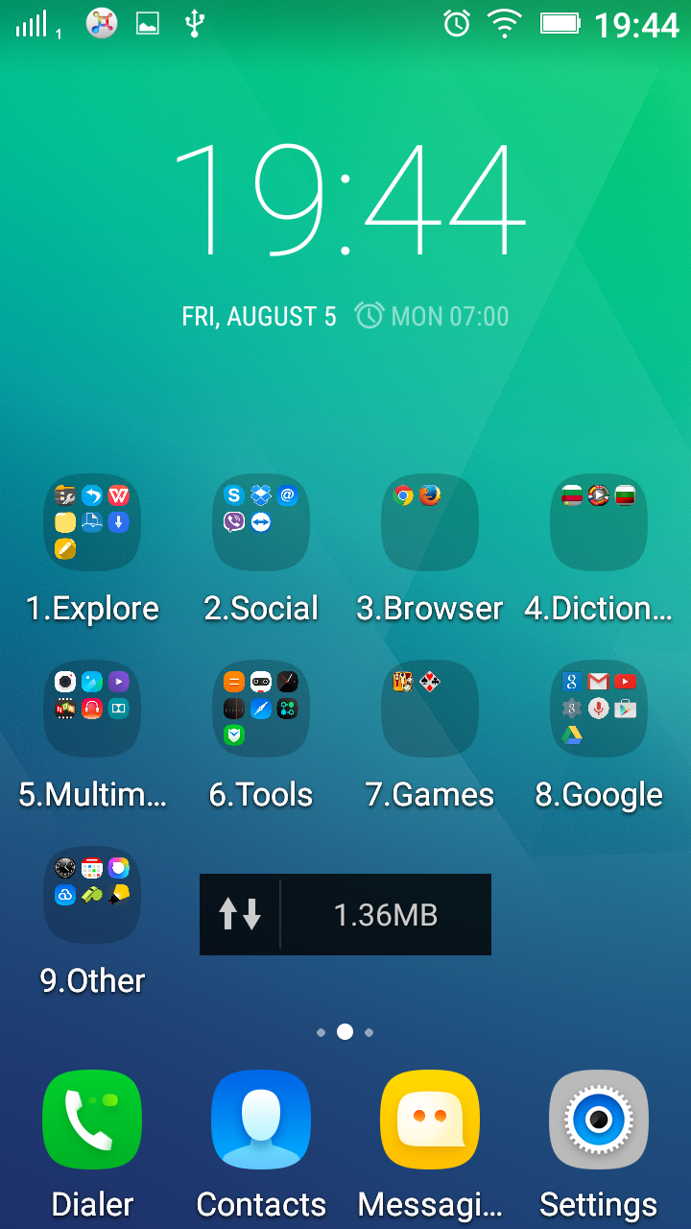 | REMOVE  - Email  - Drive

