PHP – MENUAL

https://php.w3schools.bg/
https://www.php.net/

https://tutorials.bg/kursove

x

Index of - samo aok niama index.php

50. PHP: Обобщение
<pre> dlei redove pri -> masiv print_r()
<br> -> echo

49. PHP: Практически задачи - част 3
x
-index.php
<?php
$raw_data=file('data.csv');
$data=[];
foreach($raw_data as $v){
$a0=explode(',',$v);

$data[]=[
'date'=>$a0[0],
'zone'=>$a0[1],
'user'=>$a0[2],
'product'=>$a0[3],
'q'=>$a0[4],
'price'=>$a0[5],
'total'=>$a0[6]
];
}

require "table.php";
?>

-table.php
<html>
<head>
<title>Bxog</title>
<meta charset="UTF-8" />
</head>

<body>
<table border="1">
<tr>
<td>Дата</td>
<td>Зона</td>
<td>Kлиент</td>
<td>Продукт</td>
<td>Количество</td>
<td>Цена</td>
<td>Тотал</td>
</tr>
<?php
foreach($data as $v){
echo '<tr>
<td>'.$v['date'].'</td>
<td>'.$v['zone'].'</td>
<td>'.$v['user'] .'</td>
<td>'.$v['product'].'</td>
<td>'.$v['q'] .'</td>
<td>'.$v['price'] .' </td>
<td>'.$v['total'] .'</td>
</tr>'; }
?>
</table>
<body>
<html>

Tova e losha praktika da se smeswat php i html codove!
Vizualizaciata na php obrabotkata e redno da e v otdelene fail
pokazano w gorniq primer
<?php
$raw_data=file('data.csv');
$data=[];
foreach($raw_data as $v){
$a0=explode(',',$v);

# 1 pp($a0);
# 2 $date=$a0;

$data[]=[
'date'=>$a0[0],
'zone'=>$a0[1],
'user'=>$a0[2],
'product'=>$a0[3],
'q'=>$a0[4],
'price'=>$a0[5],
'total'=>$a0[6]
];
}

?>

<html>
<head>
<title>Bxog</title>
<meta charset="UTF-8" />
</head>

<body>
<table border="1">
<tr>
<td>Дата</td>
<td>Зона</td>
<td>Kлиент</td>
<td>Продукт</td>
<td>Количество</td>
<td>Цена</td>
<td>Тотал</td>
</tr>
<?php
foreach($data as $v){
echo '<tr>
<td>'.$v['date'].'</td>
<td>'.$v['zone'].'</td>
<td>'.$v['user'] .'</td>
<td>'.$v['product'].'</td>
<td>'.$v['q'] .'</td>
<td>'.$v['price'] .' </td>
<td>'.$v['total'] .'</td>
</tr>';
}
?>

</table>
<body>
<html>
48. PHP: Практически задачи - част 2
!!! ЧЕТЕНЕ НА ТХТ ФАЪЛОВЕ !!
x

<?php  $raw_data=file('data.csv');  $data=[];  foreach($raw_data as $v){  $a0=explode(',',$v);  # 1 pp($a0);  # 2 $date=$a0;  $data[]=[  '111' => $v,  'date'=>$a0[0],  'zone'=>$a0[1],  'user'=>$a0[2],  'product'=>$a0[3],  'q'=>$a0[4],  'price'=>$a0[5],  'total'=>$a0[6]  ];  # break;  }  pp($data[4]['date']);  pp($data[5]['total']);  pp($data);  function pp ($ar){  echo '<pre>'; print_r($ar) ; echo '</pre>';  }  ?> | Chete data.csv kato razbira razdelitelnata zapetaq  Chete red po red promenlivata $raw_data  prewrashat reda w masiv  pechat na reda vav vid masiv  v prom $data se sahrnqvat vsichki redowe  pod formta ma masivi  tozi primer pokazva smyana na index id  $a0[0] - e indeksa  !!! Tozi prime pokazva kak shte poluchim  wska danna ot fajla.!!!!  pechat  Funcia za pchat na ekran

explode() text kam masiv
$raw_data=file('data.csv');
echo $raw_data[0];
$a0=explode(',',$raw_data[0]);
echo '<pre>'; print_r($a0) ; echo '</p

$raw_data=file('data.csv');
echo '<pre>'; print_r($raw_data[2]) ; echo '</pre>';
echo '<pre>'; print_r($raw_data) ; echo '</pre>';
file( data.csv) mu razbira razdelitelq i go prewryshta v masiv
file_get_contents(data.csv) -> edin cyal string
47. PHP: Практически задачи - част 1
x NO
46. PHP: Сесии - част
1- vi red v php faila -> <?php 2-ri red -> session_start()
examples:
# 1
# $options = ['cookie_httponly' => true, 'cookie_lifetime' => 86400 ];
# session_start($options);

# 2
# setcookie('ivan', "John", time() + (86400 * 30));
setcookie('chefo', "John");

#3
session_start([
'cookie_httponly' => true,
'cookie_lifetime' => 86400,
'name'=>'chefo',]);

$cookie_value = "John Doe";
$_SESSION['count']+=1;
echo $_SESSION['count'] ;

# session_destroy()
gornite nastroiki mogat da se naprawyat i prez -> /etc/php/7.2/apache2/php.ini

45. PHP: Сесии - част 1 - бисквитки
x mehanizam s koit ni dava razbirame che veche imame zayavka ot tzi potrebitel
tay kkaoto wsyaka potrebitelska zayavka e smostoqteln /stateless/ s koncepciqta
za sisiyata markirame – davame nishan che ot tozi baruser weche imame zqwka
i sledwashti q pyt kogato poluchim zayavka ot tozi brawser taka da se kave da razberem
che tozi potrebitel veche vlzal vav saita
a) sazdava biskvitka -> s file i1.php
session_start();
$_SESSION=['user'=>'ivan','age'=>'39'];
echo '<pre>'; echo '-----------------------'; echo '</pre>';
echo '<pre>'; print_r($_SESSION); echo '</pre>';
$_SESSION['user']='Stefan';
$_SESSION['age']='99';
echo '<pre>'; echo '-----------------------'; echo '</pre>';
echo '<pre>'; print_r($_SESSION); echo '</pre>';
echo '<pre>'; echo $_SESSION['age'] ; echo '</pre>';
# session_destroy() -> NE TRYABVA DA E VKLUCHENO
Sled start na biskvitka se vigda v F12

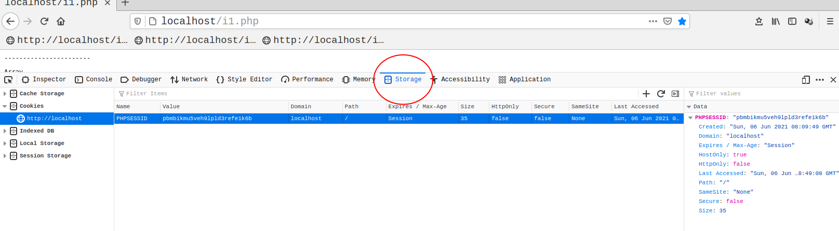

b) proverka sadarganie za biskvitka -> i2.php
# session_destroy() -> NE TRYABVA DA E VKLUCHENO
- proverka za elemnt da li go ima
session_start();
if ($_SESSION['user']=='Stefan') {
echo '<pre>'; echo $_SESSION['age'].' true' ; echo '</pre>';
}
- proverka za elemnt da li go ima
session_start();
if ($_SESSION['user']=='Stefan') {
echo '<pre>'; echo $_SESSION['age'].' true' ; echo '</pre>';
}
- # session_start(); -> bez otvorena sesiq
if ($_SESSION['user']=='Stefan') {
echo '<pre>'; echo $_SESSION['age'].' true' ; echo '</pre>';
}

44. PHP: $_SERVER - глобална променлива
x dawa parametrite na wev servera vig file -. login.php
toi se startira i ot failovete -> login_get.html login_post.html

$url = 'www.mysite.com/category/subcategory?myqueryhash';  echo parse_url($url, PHP_URL_QUERY); # output "myqueryhash"  $queries = array();  parse_str($_SERVER['QUERY_STRING'], $queries);  echo '<pre>'; print_r($_SERVER); echo '<pre>'; | Primer za chetene na zayavki  komandata dawa palna kartina na url wrazkata

42 -43. PHP: Метод get – post-заявка от потребителя
x
a) v fail /home/inter/work/php/login_get.html login_post.html
redata -> <form method="GET" action="login.php ? page=1 & name=gogo">
- zadva izpylnenieto na faila -> login.php ot domeina /localhost/
- method="GET" -> metod na zayavkata
- ? -> nachalo na zadawane na opcii na html protokola
- & -> razdelq dve opcii
Tova se naricha Key-Value Pair ili query parameters ili get zayavka
b) s GET zayavka sled kato izvikame s komandata -> localhost/login_get.html
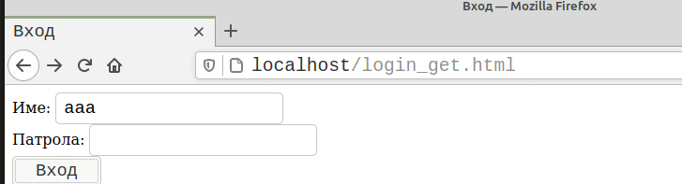

v broesera se shte se vidi i име и паролата:
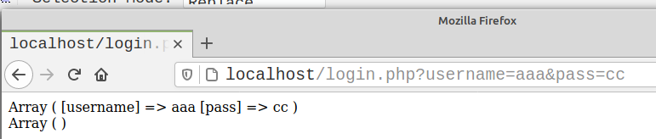

c) s POST zayavka sled kato izvikame s komandata -> localhost/login_post.html
v broesera nyama da se shte se vidi i име и паролата:
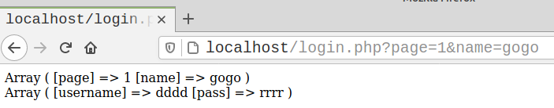

!!! WSICHKO BEZ IZKL. KOETO IDWA PREZ hhtp PROTOKOLA E STRING!!!
!!! NIKOGA NE PROMENQITE STOJNOSTI NA PARAMETRO V $_GET!!!
READ HTML PROTOKOL
a) paste -> localhost/forum/posts.php?id=1238&per_page=10&page=5
b) F12
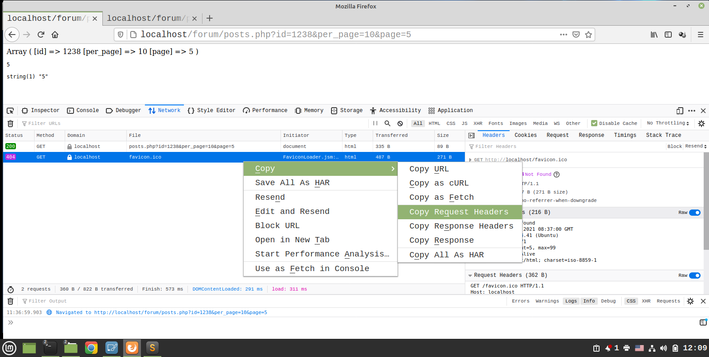

ili
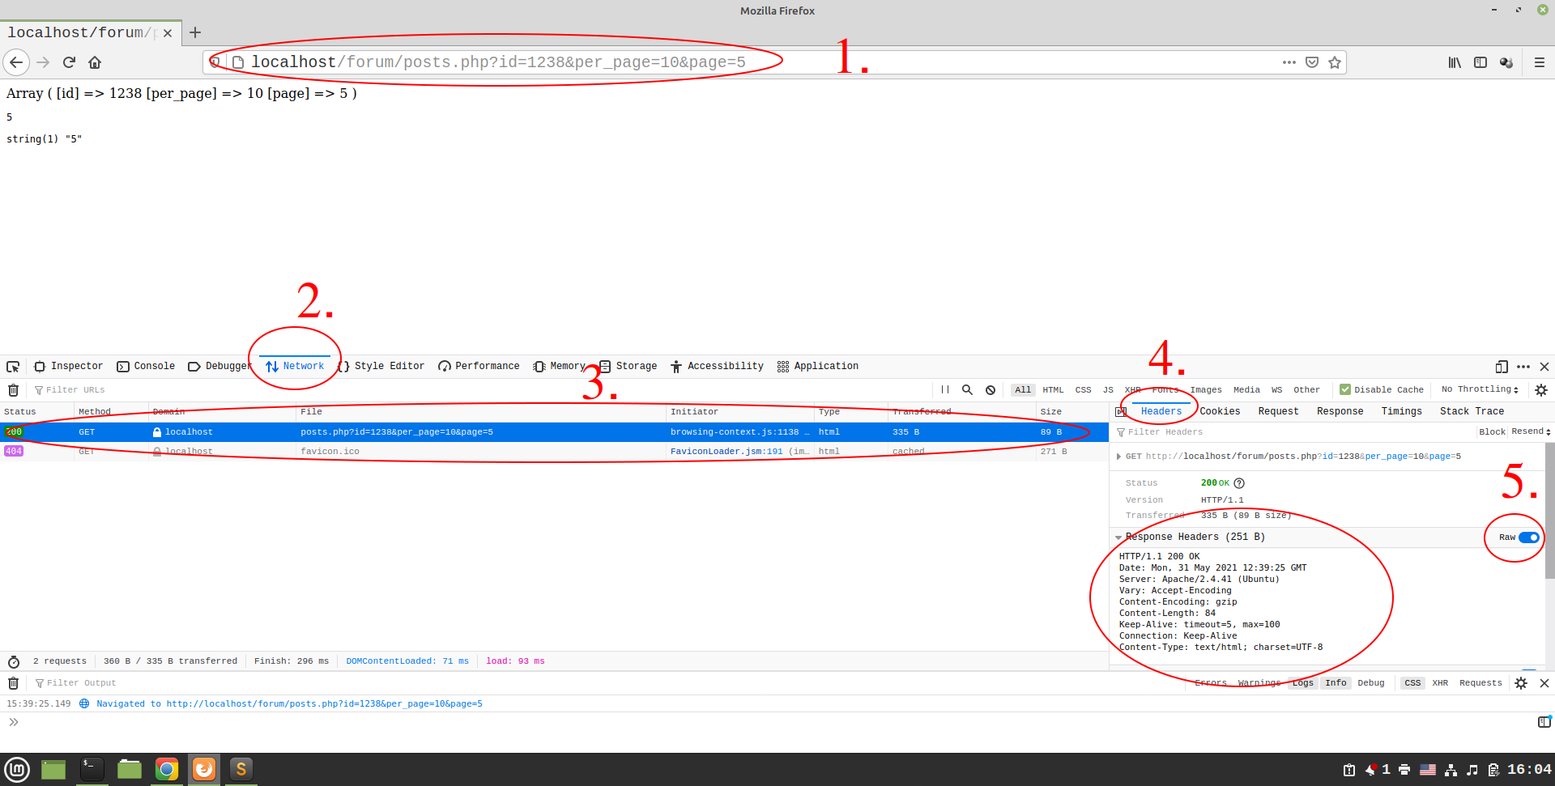

41. PHP: Работа с дати и часове - част 2
x
$date='2017-03-04 13:12:51';
echo strtotime($date); echo '<br>';
$result=date_create_from_format('Y-m-d H:i:s',$date);
echo date_format($result,'U'); echo '<br>';
echo date_format($result,'Y-m-d H:i:s');
40. PHP: Работа с дати и часове - част 1
date_default_timezone_set('Europe/Sofia');
echo date_default_timezone_get().'<br>';
echo date('d-m-Y H:i:s').'<br>';;
39. PHP: include / require – разделяне на php кода във файлове.
// in file index.php
1. Pri greshka ne spira izpalnenieto na programta
include 'functions.php'; echo circleArea(5);
2. Pri greshka spira izpal. Na programata
require 'functions.php'; echo circleArea(5);
// in file functions.php
function circleArea($radius){return pi()*pow($radius,2);}
3. spira powtorno startirana ako se poluch zaciklqne
include_once 'functions.php'; echo circleArea(5);
4. require_once 'functions.php'; echo circleArea(5);
38. PHP: Работа с файлове - част 4 – назначаване на път
x
/var/www/html e ravno na
DIRECTORY_SEPARATOR.'var'.DIRECTORY_SEPARATOR.'www'.DIRECTORY_SEPARATOR.'html' -> tova se rawi zashto na windows rzadelitela na dir e \ ana wsichki ostanal e /
za papaka -> sudo chmod -R 777 /data -> shte svali zashtitata na na papka
37. PHP: Работа с файлове - част 3
x
$data=file('data.txt'); $total=0;
foreach($data as $v){
echo '<pre>'; echo ($v); echo '</pre>'; $total+=$v;
echo '<pre>'; echo ($total); echo '</pre>';}

$data=file('data.txt');
$total=array_sum($data) ; echo round($total/count($data),2);

echo '<pre>';echo count($data); echo '</pre>';
$sum=$data[0]; echo '<pre>'; echo $sum; echo '</pre>'; $i=0;
while($i<count($data)){ $i++; echo $i.'<br>';
if($i==count($data)){echo round($sum/count($data),2).'<br>';
echo '<pre>'; echo 'Srdna preteglena'; echo '<pre>'; }
else{ $sum=$sum+$data[$i]; echo '<pre>'; echo $sum; echo '</pre>';}
}
36. PHP: Работа с файлове - част 2 – четене на файл
$data=file('/var/www/html/data.txt');
echo '<pre>';print_r($data); echo '</pre>';

$data=file_get_contents('/var/www/html/data.txt');
echo '<pre>'; print_r($data); echo '</pre>';

$data=file('/var/www/html/data.txt');
echo '<pre>'; echo $data; echo '</pre>';

$data=file_get_contents('/var/www/html/data.txt');
echo '<pre>'; echo $data; echo '</pre>';
35. PHP: Работа с файлове - част 1 – запис във файл
x
!!!PHP PO PODRAZBIRANE RZABIRA DIR NA IZPYLNQWANIQ FAIL,!!!
patya w dolnite funkcii ne e neobhodim
s prom. $data1=file('data1.txt'); ne move da se zameni v dolnite funkcii
$data1=file('data1.txt');
if(!file_exists('data1.txt')){
file_put_contents('data1.txt', "Hello\n",FILE_APPEND);}

34. PHP: Функции - част 6
x
zadavane na tipa na prom int float
$a=2; $b=aaaa($a); echo $b.'<br>';
function aaaa(float $r,$pi=3.14){
$b=$pi*pow($r,2); return $b; }
33. PHP: Функции - част 5
x
!!!!!!!DRUG NACHIN ZA VKARWANE NA ST. NAPROMV
FUNC E S SIMVOLA &!!!!!!!
- bez sim & - predavane po stoinost
$r=1; test($r); echo $r.'<br>';
function test($r){echo $r.'<br>'; $r++; echo $r.'<br>'; }
- sas sim. & - predawane po referenciya
$r=1;
test($r); echo $r.'<br>';
function test(&$r){echo $r.'<br>'; $r++; echo $r.'<br>'; }

32. PHP: Функции - част 4
!!!global -> iziskwa difinirane na promenlivata vav funkciara predi
izwikwaneto na funkciata – nokoga da se polzuwa tozi kod
promenlivite vav funkciyata sa samo za samata func i ne se zapaz
vat stoinostis za druga funkciya!!!
$r=1; test(); function test(){global $r; echo $r; }
31. PHP: Функции - част 3
priswoqwane v romenliva rezultat na funkciqat
!!! return spira rabota na funkciyata!!!
$a=2; $b=1; aaaa($a,$b); $bbb=aaaa($a,$b); echo $bbb.'<br>';

function aaaa($r,$b){$ccc= 10*pow(($r+$b),2).'<br>'; return $ccc; }
30. PHP: Функции - част 2
x
!!! prom $a i $b izvan funk nyamat nishto obsto s sashtite
prom v func. Pri swoqwanet na stojnosts za celite na func.
stava s aaaa($a,$b);!!!
$a=3; $b=1; aaaa($a,$b);
function aaaa($r,$b){ echo 10*pow(($r+$b),2).'<br>'; }
29. PHP: Функции - част 1
x nyama
28. PHP: Цикли - част 3

system('clear'); sleep (1);
$users=['ivan','petko','maria','gogo','jon','koko'];
for($i=0;$i<count($users);$i++){echo $users[$i].'<br>';}

!!!obhovdane na masiwi – nai-dobriq nachin!!!
$users=['ivan','petko','maria','gogo','jon','koko'];
foreach($users as $v){echo $v.'<br>';}

$users=[0=>'ivan',5=>'petko','user'=>'maria','aaa'=>'gogo','jon','koko'];
foreach($users as $k=>$v){echo 'Key:' .$k. ' '.$v.'<br>'; }

$users=[
['user'=>'user1', 'email'=>'user1@mail,com'],
['user'=>'user2', 'email'=>'user2@mail,com'],
['user'=>'user3', 'email'=>'user3@mail,com'],
['user'=>'user4', 'email'=>'user4@mail,com'], ];

foreach($users as $k=>$v){echo 'Key:' .$k. ' '.$v['user'].'<br>';
echo 'Key:' .$k. ' '.$v['email'].'<br>'; }
27. PHP: Цикли - част 2 while() ; do{}while()

$i=0; do{echo $i. '<br>' ; $i++; }while($i<10);
chetene na fail - broi redowete v data.txt
while($i<count($data)){$i++; echo $i. '<br>'; echo '<pre>'; echo 'aaa'; echo '<pre>';
if($i==count($data)){echo '<pre>'; echo 'bbb'; echo '<pre>';}}

$i=0; while($i<10){$i++; echo '<pre>'; echo '<pre>'; echo $i.'<br>'; }

26. PHP: Цикли - част 1 – for() ,
for($i=10;0<$i;$i-=3){echo $i.'<br>'; if ($i==4){break;}}

for($i=0;$i<10;$i++){echo '<pre>'; echo 'aaaaa'; echo '<pre>'; echo $i.'<br>';}

25. PHP: Какво е php.ini

sudo apt-get install apache2 php7.4 libapache2-mod-php7.4 mysql-server php-mysql phpmyadmin php-mbstring
!!! cp ~/work/library/php/php.ini /etc/php/7.4/apache2/php.ini !!!
check 7.2 folder
cp ~/work'linux/hlp/init.el ~/.emacs.d
xed /etc/php/7.4/apache2/php.ini
- display_errors = Off -> make ON
- post_max_size = 8M -> zayavka kam servera do 8M – nqma ogranichenie
- file_uploads = On -> Off nikoj ne move da kachva fajlowe prez php
- upload_max_filesize = 2M -> max razmer na faila koito move da se kachva
- max_file_uploads = 20 – br. Na failovete za edna zayavka.
!!! sled promenite restart na apache2 -> sudo apache2ctl restart
- errors
a) Parse – fatalna greshka spira izpanenieto ;
b) worning – ne spira ama mai se dopuska seriozna greshka
c) notes – mogat da ne im se obrashta vnimanie
d) deprecated v po-nowa versiq na php nqkoya funkciq /komanda ne se poddarva
24. PHP: Масиви - част 3
- проверка за елемнет в масив
if (array_key_exist('username',$a0)){echo 'YES'}
$a0=[
['username'=>'Иван', 'age'=>18,'mail'=>'aaa@bbb.com'],
['username'=>'Стефан','age'=>'60','mail'=>'ccc@ddd.com'],
];
echo '<pre>'; print_r($a0); echo </pre>';

$b0=[3,4,5,'idx'=>[45,'a','ok']] ;
$a0=['username'=>'ivan','index'=>$b0];

pri mnogomernite arhivi trqbva da se zadae pytya -> $a0['index']['idx']=65;
echo '<pre>'; primant_r($a0); echo '</pre>';

$b0=[9,8,7] ; $a0=[ 2,'friends'=>5,8,$b0];
echo '<pre>'; print_r($a0); echo '</pre>';
!!! print_r() - e print. Na masivi, a echo -> stringove !!!
!!! t.e. masiva -> print_r($a0) NO element -> echo $a0['friends']
23. PHP: Масиви - част 2 - $a0[0] - e indeksa

$a[10]="gogo" -> v skobi se postavya indeks/kluch cifrow ili simmvolen stil
$a=[ 2,'friends'=>5,8,-1,'ivan']; -> zadavane na index
$a['username']='ivan';
unset($a['username']) -> premhvane na elemnt
22. PHP: Масиви - част 1 - $a0[0] - e indeksa
$a=[ 2,5,8,-1,'ivan',true]; var_dump($a) ; $a[]="gogo" ;
echo '<pre>'; print_r($a); echo '</pre>';echo $a[2];
var_dump($a[4]) ;
21. PHP: Операции със стрингове

echo str_repeat("_", 20).chr(232);echo '<pre>';
print_r($arr0[0]['username'].' '.$arr0[1]['age']);
echo '<pre>'; echo '222222222222222'; echo '<pre>';

$a0="Hello from php world"; $b0='php' ; echo strpos($a0, $b0);
$a0="Hello from php world"; $b0='Php' ; echo strIpos($a0, $b0);
strIpos – ne prawi razlika gp+olemi malki bukwi
strrIpos tarsene otzad napred
$a="Hello from php world"; echo $a echo str_replace('php', 'java', '$a');
$a0="Hello from php world"; $b0='php' ; echo str_replace('php', 'java', $a0);
20. PHP: Документация - www.php.net
19. PHP: Условни оператори - част 3 if()
$a=18;
if ($a==20){echo "OK";}
elseif($a==19){echo '$a==19';}
else{echo "NOT OK";}
18. PHP: Условни оператори - част 2

$age=20; if($age==20){echo "User is 20 year";}
echo '<br>'; $a=20; $b=30; if($a==20 and && $b==30){echo "AND";}
echo '<br>'; $a=20; $b=30; if($a==20 or || $b==30){echo "OR";}
17. PHP: Условни оператори - част 1
Edno „=“ -> stoinosta ot dqsno se prisvoqwa v lqwo ; Dve „==“ - proverka za rawenstvo
$age=20; if($age==20){echo "User is 20 year";}

echo '<br>After';
2 izraz e proverka dali $age promenliva e „0“ ilo razlichno ot „0“, ako e 0 t.e. e falsh i nyama
da se izpalni uslovieto t.e. echo "User is 20 year"; nqma da se izpishe,
!!!V PHP PRAZEN STRIN „ “ i 0 sa FALSH ; NULL ne inicializiran!!!
Tri ravenstva – rawnqwanite promnlivi ryabva da sa ot edin i sasht tip i s ravni stoinosti.
$age=20;
if($age){echo "User is 20 year";} ; echo '<br>After';
if($age===null){echo "User is 20 year";}
!!! ne ravno!!!
if($age!=null){echo "User is 20 year";}

16. PHP: Конкатенация !!! . tochka sabira sbor na stringove
!!! /“ - kavichki se priemat akato simvol ne kato ogranichitel !!!
sabirane na stringove
$a="ivan"; $b="Stefan"; echo $a,$b ; echo $a.$b ;
var_dump($a); ec
15. $a="ivan"; echo strlen($a) ; echo mb_strlen($a);
$a="ivan\" "; echo $a ; $a="ivan\n "; echo $a ;
13. Type casting – mehanizam za prehwytlyane ot edin tip w dryg
$a="1980"; $b=(int)$a; $b=(float)$a ;$b=(bool)$a;
$b=(string)$a; echo gettype($b); var_dump
15. PHP: Стрингове
14. PHP: Expressions
13. PHP: Type casting
12. PHP: Коментари
sami v reda - // mqkolko reda /* .. */
11. PHP: Типове данни
10. PHP: Математически операции
9. PHP: Променливи
8. PHP: Web Server
run PHP in format – menu 5
„
Index of /
[] Name Last modified Size Description
[] 0index.php 2022-08-22 14:21 30
[] data.csv 2021-06-18 17:04 1.2K
[] table.php 2022-01-13 13:44 719
Apache/2.4.41 (Ubuntu) Server at localhost Port 80
„

aaaizpylnenie php web server !!! VAGNA KONCEPCIYA!!!!
- v termina se otiwa v rabotnta dir -> cd ~/work/php
- v terminal s comandata -> php -S localhost:8080
kato se poyavyava saobshtenie „[Mon May 17 19:26:28 2021] PHP 7.4.3 Development Server (http://localhost:8080) started“ – koeto oznachava che vsichko e normalno.
- sled tova v brawsera primerno google chrome napisvame -> localhost:8080
vryshta sabshtenie -> Not Found zastoto v rabotnta dir /~/work/php/localhost ne
namira fail -> index.php kogoto avtomaticno da izpylni. Ako se paste index.php
v abotnta dir /~/work/php/localhost i v brawse starrtira otnovo localhost:8080
faila se izpalnyava.
- ako iskame da izpylnim fail s proizvolno naimenowanie naprimer aaa.php
komandata e -> localhost:8080/aaa.php v brawsera /ne na terminala/ i
rezyltata se vigda v brausera -> a kakwo stava na terminala?
- na terminala se izpisva istoriata na rabota na localhosta :
„[Mon May 17 19:49:07 2021] 127.0.0.1:34080 Closing
[Mon May 17 19:49:07 2021] 127.0.0.1:34090 Accepted
[Mon May 17 19:49:07 2021] 127.0.0.1:34086 [200]: GET /aaa.php
[Mon May 17 19:49:07 2021] 127.0.0.1:34086 Closing“
- VSICHKO RABOTI PERFEKTNO!!!!!
-!!!VAGNO!!!
- php -S -> oznachava che shte startita Web server
- localhost:8080 -> oznachava adresa/domeina na koyto tozi Web server
tryabva da raboti
- porta 8080 move da se promeni s -> php -S localhost:7954
i ph. Faylovete se izpylnqwat kakto pri port 8080
- wseki domein e asociiran s konkretna direktoriya /root/, sgashnta
e -> cd ~/work/php , ako iskame da smenime root dir towa stawa
s komandata -> php -S localhost:7954 /ili 8080/ -t /home/inter/work/a_my
tocnata comanda -> php -S localhost:7954 -t /home/inter/work/a_my - v terminal,
sled tova na komndta localhost:7954 – v brawser otnovo dawa „Not Fond“,
no na komandata ->localhost:7954/bbb.php – vednaga se izpalnqwat zashto
sa widimi za servera
- ako premestim bbb.php v dir noi to s localhost:7954/bbb.php nqma da se
izpylni, no s comand -> http://localhost:7954/noi/bbb.php veche e ok.
- ideqta na URL e da kage na web server koi php file trqbva da bade izpalnen
ZAKLUCHENIE :
a) prez terminala nznachavame otivame s cd v koya da e papka i ya
naznachavame za root s php -S localhost:8080
b) bez cd root naznachavame php -S localhost:8080/ -t /home/inter/work/a_my
c) Ot browse se startirat php failove v root folder s -> localhost:8080/bbb.php ili
s -> localhost:7954/noi/bbb.php ako e v pod dir
d) Wsichko do tuka e pri rabora s vgradeniq server no Pri rabota se polzuwa apache
kato napisha samo -> localhost -> shte se startira faila index.html v dir /var/www/html, a
za da se index.php -> chmod a+r /var/www/html/index.php !!!
7. PHP: Синтаксис - част 2
6. PHP: Синтаксис - част 1
5. PHP: Защо Web server
4. PHP: Първи стъпки
<php
echo/print "Hello World!\n"; \n – now red
?>
3. PHP: Инсталация под Windows
2. PHP: Инсталация под Linux
1. Въведение в PHP

I. PHP → install → ne instalirai -a zastoto tastoto php.7.0
sudo apt-get install apache2 libapache2-mod-php mysql-server php-mysql phpmyadmin php-mbstring
za php znakat izwan terminala ne znam dali raboti taka che napishi primrno
w brawsera celia pat

