[Emacs](http://www.gnu.org/software/emacs/) с [Ruby mode](http://www.emacswiki.org/emacs/RubyMode) и [Rsense](http://rsense.github.io/)

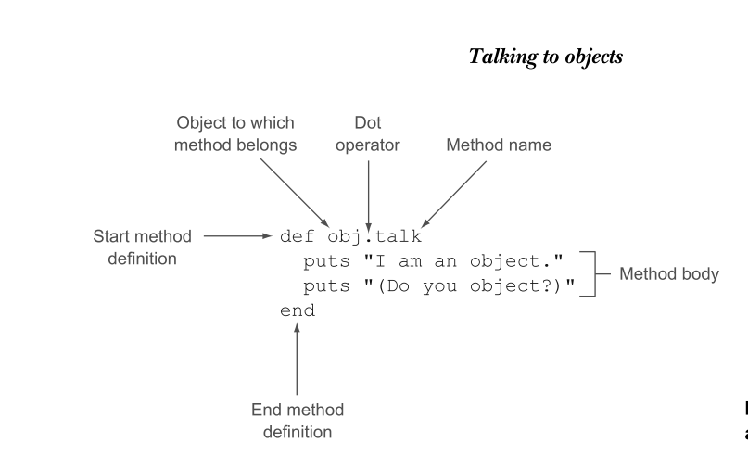

Variables:

– Local

– Instance

– Class

– Global

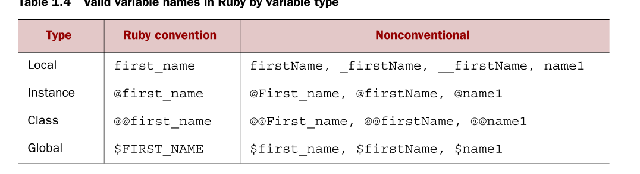

Constants -> Constants begin with an uppercase letter.

Keywords -> class ; if

Method names

Boolean /*булева*/ -> true or false.

Method converts an object:

- to_s (to string)

- to_sym (to sym-bol)

- to_a (to array)

- to_i (to integer) цяло число

- to_f (to float)

Comparisons and the Comparable module

== != > < >= and <=

+ - * / x – не е умножение а превръщане шестнадесетично цяло число  
изрази:

