CONTENT

Boot menu - F9 Bios Setup - F10

1. Install Linux

M1 SSD SAMSUNG chef pass 2 170003 4001 820055

M2 SSD KINGSTON kosy pass 1 **150002 4001 360108**

!!! PRI PROBLEM S USB NA VIRTUALBOX TRQBWA DA SEVIDI TOVA

SOFTUWRA SI TOCHEN NE E PROBLEM AKO NE SE WIGDAT FLASHKTE

SMENQJ FLASKIUTE DOKATO SE VIDYAT!!!!

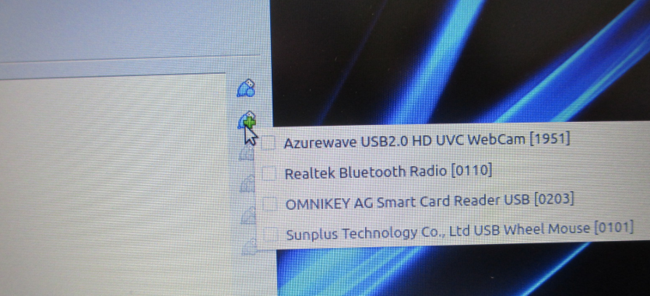

Samo preinstalacia na OS ot 14 tochka

A. 1-15 With Create a partition.

1. Include instal usb restart laptop press ESC

2. Uefi SanDisk Cruzer - second position

3. Menu-> Disks-> With red мinus delete partition to -> 512GB

4. ⚙️ Additional partition options ->+/down/ -> Next -> Erase

-> For use with Windows (NTFS)

5. Linux Mint 20.1 Cinnamon 64 bit

6. English English

7. install multimedia codecs

8. Something else /4th/

9. New partition table

10. Free space 512110

11. 150002 mountain point -> /

12. + 4001 -> swap area

13. +360108- mountain point ->suap area

14. Disks -> click on 360108 --> Format ->For use with Windows (NTFS)

B. Just a reinstall OS

16. Erase linux mint 20.1 Ulyssa and reinstall - First

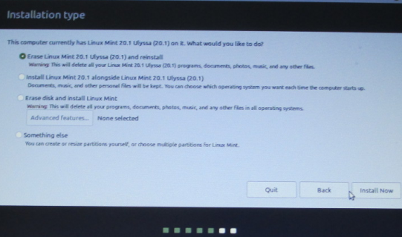

!!!!! CHECK BOX CHECK BOX CHECK BOX CHECK BOX !!!!!!!

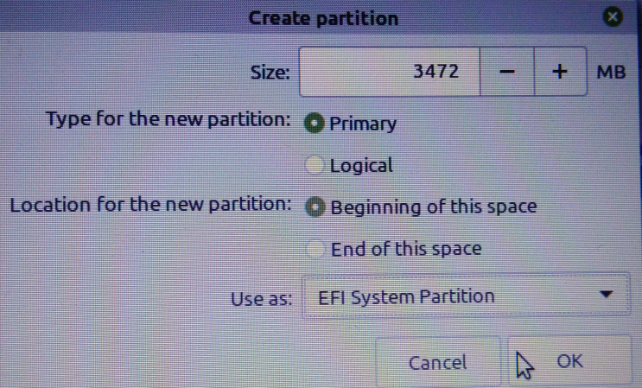

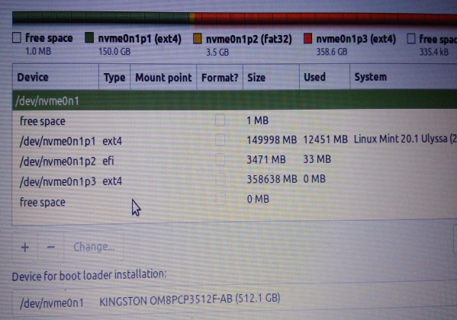

II. Setup VBOX

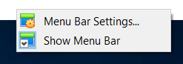

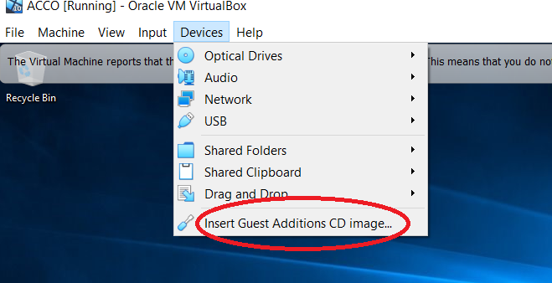

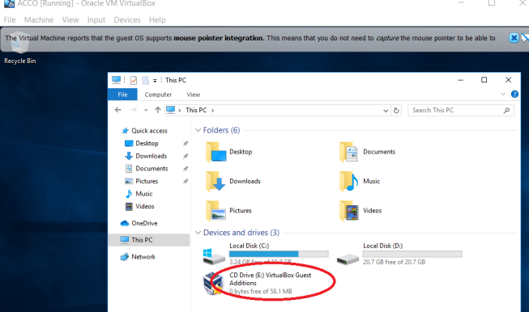

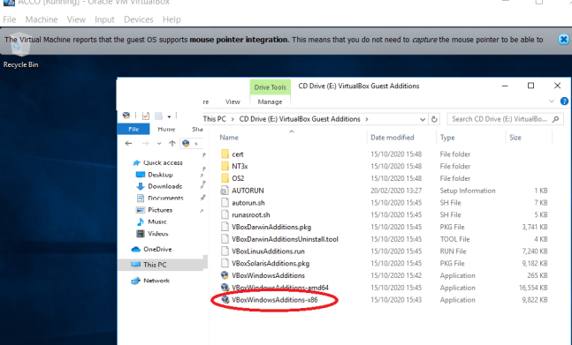

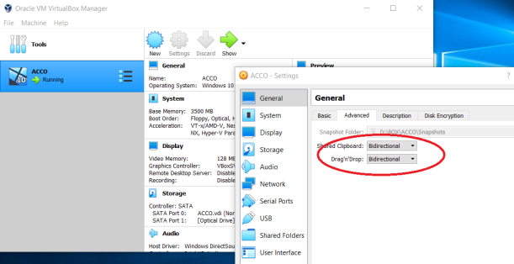

Install -> Oracle\_VM\_VirtualBox\_Extension\_Pack-6.1.16.vbox-extpack

III. Inastall Phone control

sudo apt-get install scrcpy

sudo apt install adb

This maybe not need

!!! AFTER REBOOT PHONE INCLUDE

|  |  |
| --- | --- |
| 1. USB CABELIBOX - FIRST TIME  CHECK BOKS, THEN REMOVE KABEL |  |

|  |  |
| --- | --- |
| 2. FOR INTER |  |

adb connect 192.168.0.204:5555

adb connect 192.168.0.204:5555 adb devices scrcpy

if not work - ~/work/linux/sh/phone\_restart.sh

\*57 – Trace Call: Traces the number of the last incoming call received. Useful when the call warrants legal action.

* \*60 – Call Block: Prevents calls from select phone numbers and gives callers a recording that says you’re not accepting calls.
* \*67 – Caller ID Block: Hides your phone number on Caller ID systems.
* \*69 – Call Return: Redials the last number that called you.
* EXAMPLE: if you wanted to block your phone number when calling 555-555-5555, you'd need to dial \*67-555-555-5555.
* \*70 – Call Waiting: Places your call on hold so you can answer another.
* \*72 – Call Forwarding: Forward your call to another phone number.
* \*77 – Anonymous Call Rejection: Blocks calls from private callers.
* \*80 – Disable Call Block (\*60)
* \*82 – Disable Caller ID Block (\*67)
* \*87 – Disable Anonymous Call Rejection (\*77)

+91

Call

adb shell am start -a android.intent.action.CALL -d tel:+359889998611

adb shell am start -a android.intent.action.CALL -d tel:+919999999999

adb shell am start -a android.intent.action.CALL -d tel:+447405765402

adb shell service call phone 1 s16 "" s16 "#####"

adb shell service call phone 1 s16 "" s16 "+447405765402"

adb shell service call audio 7 i32 3 i32 0 i32 1

# Change the volume by the service-call

# - audio 7 : interface IAudioService

# - i32 3 : Speaker (1: Phone 3: Speaker 4: alarm 6: Bluetooth)

# - i32 0 : UI print Off (1 : UI print On)

# - i32 1 : Volume Level (0 ~ 15)

adb shell service call audio 3 i32 3 i32 0 i32

adb shell input keyevent [KEYCODE\_UNKNOWN](https://developer.android.com/reference/android/view/KeyEvent" \l "KEYCODE_UNKNOWN)

SMS

adb shell am start -a android.intent.action.SENDTO -d sms: 81XXXXXX33 --es sms\_body "SMS BODY GOES HERE" --ez exit\_on\_sent true

adb shell am start -a android.intent.action.SENDTO -d sms:+359898690758 --es sms\_body "Митаче\_сложи\_колкото\_можеш\_лед\_във\_фризеар" --ez exit\_on\_sent true

adb shell input keyevent KEYCODE\_UNKNOWN

adb shell input keyevent 3 home

adb shell input keyevent 4 back

adb shell input keyevent 5 call

adb shell input keyevent 5 pick up a call / answere

adb shell input keyevent 6 adb shell input keyevent KEYCODE\_ENDCALL

adb shell input keyevent 22

adb shell input keyevent 24 volume\_up

adb shell input keyevent 25 volume\_down

adb shell input keyevent 66

adb shell input keyevent 164 toggle MUTE the speaker

adb shell input keyevent 91 toggle MUTE the microphone

adb shell setprop persist.sys.tel.autoanswer.ms 2000 - auto answer the incoming call in 2 seconds

adb shell setprop persist.sys.tel.autoanswer.ms 0 - To turn off auto answer

adb shell input keyevent 207 Contacts

Android 5 and older (here android 4):

adb shell service call isms 5 s16 "com.android.mms" s16 "+01234567890" s16 "+01SMSCNUMBER" s16 "Hello world !" i32 0 i32 0

Android 5 and later (here android 9:

adb shell service call isms 7 i32 0 s16 "com.android.mms.service" s16 "+1234567890" s16 "null" s16 "Hey\ you\ !" s16 "null" s16 "null"

adb shell service call isms 7 i32 0 s16 "com.android.mms.service" s16 "+1234567890" s16 "null" s16 "Hey\ you\ !" s16 "null" s16 "null"

adb shell service call isms 5 s16 "com.android.mms" s16 "+01234567890" s16 "+01000000000" s16 "Hello world !" i32 0 i32 0

**REPAIR Phone control**

sudo apt-get install libmtp-common mtp-tools libmtp-dev libmtp-runtime libmtp9

https://stackoverflow.com/questions/33462720/adb-unable-to-connect-to-192-168-1-105555

Make sure you are not connected to a VPN. I was able to connect to adb as soon as I disconnected from the VPN. For a sure way to connect do this:

1. Unplug USB
2. Restart Android device
3. Shutdown Android Studio or any other IDE using ADB
4. adb kill-server
5. Plug back in USB after restart
6. adb devices This automatically starts the server. You sould see the device plugged in via USB
7. adb shell ip addr - show wlan0 to get your devices IP address
8. adb tcpip 5555 - Set the port to 5555 that you want to connect through
9. adb connect 192.168.0.6:5555 - Replace IP address with one from step 6.
10. Disconnect the USB

**!!! ON TERMINA IF OK**

disconnected everything

\* daemon not running; starting now at tcp:5037

\* daemon started successfully

error: no devices/emulators found

connected to 192.168.0.204:5555

unable to connect to 192.168.0.205:5555: Connection refused

List of devices attached

192.168.0.204:5555 device

INFO: scrcpy 1.12.1 <https://github.com/Genymobile/scrcpy>

/usr/share/scrcpy/scrcpy-server: 1 fil...shed. 0.1 MB/s (24773 bytes in 0.228s)

error: more than one device and emulator

ERROR: "adb reverse" returned with value 1

WARN: 'adb reverse' failed, fallback to 'adb forward'

INFO: Initial texture: 720x1280

**!!! ON TERMINA IF OK**

To connect your phone to adb you can use the given steps... To download ADB manually go to given link... <https://developer.android.com/studio/releases/platform-tools.html>

1. Unplug USB

2. Restart Android device

3. Shutdown Android Studio or any other IDE using ADB

4. adb kill-server

5. Plug back in USB after the restart

6. adb devices This automatically starts the server. You sould see the device plugged in via USB

7. adb shell ip addr show wlan0 to get your devices IP address

8. adb tcpip 5555 Set the port to 5555 that you want to connect through

9. adb connect 192.168.0.6:5555 Replace IP address with one from step 6.

10. Disconnect the USB

IV. Option – Install → com.sand.airdroid\_v4.1.5.0-30214\_Android-4.0.apk

AirDroid [si.mirchev@gmail.com](mailto:si.mirchev@gmail.com) di0 → Izlishno

inastall on phone AirDroid → com.sand.airdroid\_v4.1.5.0-30214\_Android-4.0.apk

in browser → http://1**92.168.0.205**:8888 -inter

http://web.airdroid.com/

**!!!!!NEVER ON TELEPHONE!!!!!**

IV. Install linux to flash from .iso file ->see ~/work/library/linux/iso.sh

1. CREATA .iso FILE !!! NOT WINDOWS FILES CRATE .ISO FILE!!!

mkisofs -o ~/work/iso/$fname0.iso ~/work/dvd

mkisofs -o ~/work/iso/$fname0.iso ~/work/dvd

2. CREATR nemo -> Dvices -> CDROM, remove CDROM AND CONTANINT ext

unmont CDROM

sudo mount -o loop ~/work/iso/'$fname0.iso '~/work/ext

3. EXTRACT .ISO FILE TO FLASH

file-roller --extract-to=/media/kosy/USB-2G ~/work/iso/Office2007.iso

4. MAKE LINUX INSTALL FLASH !!! NOT ON 2 GB FLASH !!!

# PROGRAMMA /home/kosy/IDISK/LINUX/32-64/64/balenaEtcher-1.7.0-x64.AppImage

# NOT INSTALL ONLY RUN !!!

VI. Install Windows 11 STOP / UNCHECK M2 IN BIOS HP

1. HP -> Setup -> Security -> Utilies ✅ Save/Restore GTP of Sytem