[**1. Jdoodle Python Ruby**](https://www.jdoodle.com/python3-programming-online/)

**Not add file**

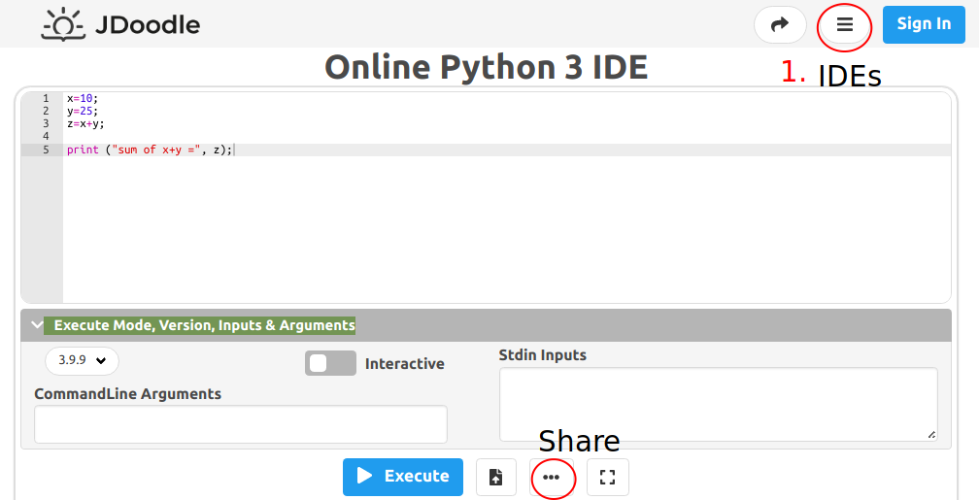

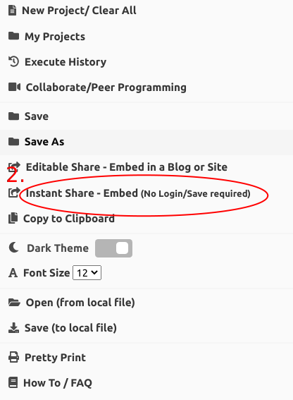

[2. Trinket Python](https://trinket.io/python3)

**Upload file not execute only mayn.py**

[3. Online-python](https://www.online-python.com/nBFTaGupMv)

**Upload file not execute only mayn.py**

**Mode show Ruby but not work.**

**https://onlinegdb.com/6kg0r2l0a**

**https://onlinegdb.com/_Nh_3paC7**

[4. OnlineGDB Ruby Python](https://onlinegdb.com/0jCJomVYn)

**Upload file not execute only mayn.rb**

Very Goot

[**5. Codingrooms Ruby Python**](https://app.codingrooms.com/w/P1OfhidppHGp)

**Work only with Goole Chrome.**

**Very Goot but slowly**