# Conceptual Design

Our aim is to create a Decentralized Autonomous Organization (DAO). The DAO's behavior is completely controlled by smart contracts and it fulfills functions similar to the ones of an energy provider today:

* Energy Management: The DAO makes sure that there is sufficient energy available for all the participants of the systems and enables all parties to trade energy freely by using the energy token.
* Trading at the energy market: The DAO sells surplus energy and buys energy if there is a shortage in the network on the traditional energy market.
* Profit distribution: The DAO uses profits realized by trading to subsidize others to install renewable energy production possibilities and participate in the system. This enlarges the current system and creates additional surplus.

Within the DAO, energy is traded freely amongst all participants by using energy tokens. Energy tokens represent the right to obtain energy from a participant of the system.

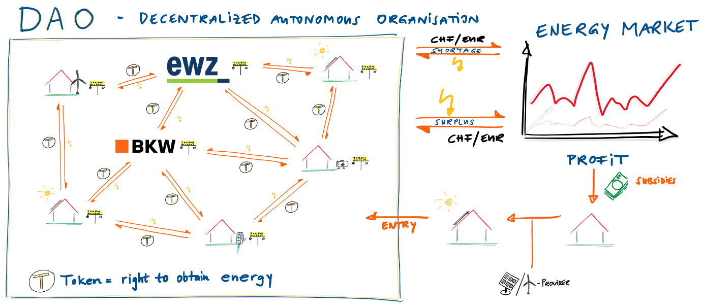

Figure 1: Conceptual Design, Source: this report

For other energy providers, the DAO can act as a virtual powerplant which generates renewable energy. Due to the energy would be generated within Switzerland, the cost and lost of transportation would be lower compared to the purchase of energy abroad.

With this concept, the monopolistic swiss energy market could be disrupted massively. Electricity could be freely traded peer to peer. The limitations through cantonal borders, would fall away, even trade across national borders could be possible at a later point. Current energy providers would take the role of a hardware provider, ensuring the maintenance of the energy grid and maybe the smart meters financed through fees for the usage of the infrastructure.

## Decentralized Autonomous Organization DAO

* A DAO's behavior is defined by smart contracts.
* Within the DAO, the means of payment is Energy Tokens.

## Energy Management

* Energy flows into the system from the different participants (households, power suppliers) or by trading on the energy market if there is a shortage.
* Energy flow out of the system by trading on the energy market if there is a surplus.
* Trading between households.
* Trading with the DAO (shortage, surplus in the system)
* What happens if a household has a negative token balance and is not able to “catch up” with its production (e.g. uses more energy during night then it can produce during the day)? Can he purchase Tokes for money from the DAO?

## Trading at the energy market

* With solar energy, energy is created when its price is the highest (daytime)
* Everything is done according to smart contracts.
* Profit range calculation: e.g. DAO buys for 10 Rp./kWh and sells for XYZ at the market

## Profit distribution

* With the profit made from trading, the DAO pays subsidies to build renewable power plants and thus enlarging its network.
* Everything is done according to smart contracts. Share of the different renewable technologies will be distinguished using voting rights. (Maybe also the government can vote?)

## Energy Token

* Token = right to obtain energy.
* Different Energy Prices (high and low tariff)

## Initialization of the Concept

At the beginning, there will be an "Initial Coin Offering" (ICO), to get the initial funds for the DAO and to distribute the tokens. This process would give the DAO its starting capital to start investing in renewable energy, and then trade on the energy stock market. A major part of the tokens will be sold to investors and given to energy producers. A smaller part could be distributed for example to core developers or held back as reserves. Only producers of renewable energy are allowed to participate in the ICO.

## Operation of the concept

* Permissioned or Permissionless blockchain?
* Mining happens on a proof of stake implementation, to keep energy consumption in check.
* Are there possibilities to invest in the DAO to get voting rights?

## Disruption Potential

* Power suppliers lose monopolistic positions
* P2P trading without (cantonal) borders
* DAO acts as a very efficient self-growing system
* DAO acts as a virtual power plant for power suppliers
* EWZ = Participant in DAO + grid, pv, meter provider

## Evaluation

* How could the concept be tested? (template of Mr. Dapp)