# Conceptual Design

## Overview

Our approach to the EWZ Challenge 3 “Virtual Energy Storage” is to create a Decentralized Autonomous Organization (DAO).

The DAO is not a potential future business model applicable for EWZ but demonstrates how the blockchain is in position to change the energy sector and illustrates the disruptive power due to the emerging areas of blockchain applications. However, our approach provides a "Virtual Energy Storage" of the participants of the DAO. In addition, we further address with the DAO an alternative for owners of real estate to the modest of governmental incentives to become a producer of renewable energy. With implementing such or a similar alternative blockchain based approach, it could be a way out of a potential electricity shortage due to the governmental regulation regarding the end of the production of electricity from nuclear sources in Switzerland by 2034. In this respect, the following DAO can be described as a catalyst of renewables.

In the real world exists initiatives such as Brooklyn Microgrid that enables residents of the Park Slope area of Brooklyn, NY to sell power generated from rooftop solar panels via a microgrid enabled by a blockchain ledger that records every transaction made with a local utility.[1] The DAO brings such an initiative a step further.

The DAO's behavior is completely controlled by smart contracts and it fulfills functions similar to the ones of an energy provider today:

* Energy Management: The DAO makes sure that there is sufficient energy available for all the participants of the systems and enables all parties to trade energy freely by using the energy token.
* Trading at the energy market: The DAO sells surplus energy and buys energy if there is a shortage in the network on the traditional energy market.
* Profit distribution: The DAO uses profits realized by trading to subsidize others to install renewable energy production possibilities and participate in the system. This enlarges the current system and creates additional surplus.

Within the DAO, energy is traded freely amongst all participants by using energy tokens. Energy tokens represent the right to obtain energy from a participant of the system.

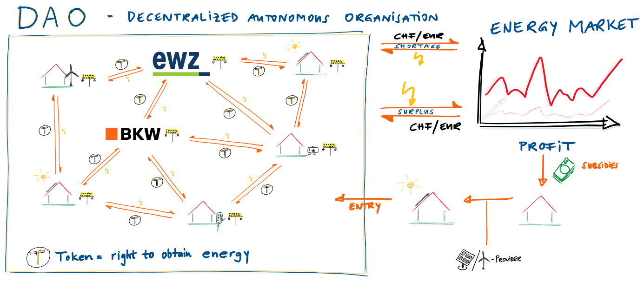

Figure 1: Conceptual Design, Source: this report

For other energy providers, the DAO can act as a virtual powerplant which generates renewable energy. Due to the energy would be generated within Switzerland, the cost and lost of transportation would be lower compared to the purchase of energy abroad.

With this concept, the monopolistic swiss energy market could be disrupted massively. Electricity could be freely traded peer to peer. The limitations through cantonal borders, would fall away, even trade across national borders could be possible at a later point. Current energy providers would take the role of a hardware provider, ensuring the maintenance of the energy grid and maybe the smart meters financed through fees for the usage of the infrastructure.

## Decentralized Autonomous Organization DAO

According to CHOHAN, a DAO, is an organization that is run through rules encoded as computer programs called “smart contracts”. A DAO's financial transaction record and programmed rules are maintained on a blockchain, which ostensibly increases transparency dramatically at the expense of security. [2]

A DAO is, according to SWAN, a potential progression to increasingly complex and automated smart contracts that become more like self-contained entity, conducting preprogrammed and eventually self-programmed operations linked to a blockchain.[3]

VITALIK BUTERIN, the visionary founder of Ethereum[4] sees three major categories where decentralized autonomous organizations may provide genuine value to society. Frist, when there are natural monopolies. Second, when there are services that violate government laws and regulations (e.g. the use of decentralized file-sharing networks for copyright infringement) and, finally, there are those cases where a decentralized network can simply maintain itself more efficiently and provides better services than any centralized alternative (i.e. peer-to-peer network).[5] The DAO, according to BUTERIN, human managerial interactivity, provided the smart contracts were supported by a Turing complete platform.[6]

In essence a DAO is a system of hard coded rules that define which actions an organization will take, so the organization may run without managerial supervision or, if the platform provided sufficient rules and flexibility, completely autonomous. All rules upon which the company functions are enforced digitally.[7] "Other decisions are made by shareholders who control a certain amount of the tokens, or smart contracts, who can vote for decisions. Preprogrammed rules describe what can happen in the system. Certain rules are hard-coded into the company like the amount of dividend payouts or determining a certain event in the company. Other things like, determining which project will receive money is decided by letting all token holders cast their vote."[8]

There exist real world DAO projects such as for example, "Dash", "The DAO", "Digix.global", "Steemit". So far, DAOs can be found mainly in the FinTech sector, where they can benefit from a sophisticated organizational structure and the resulting rapid decision-making processes in a volatile and fast-moving market.

A DAO must be able to make decisions, be liquid and communicate with internal and external bodies. After all, money must get into the organization, employees and service providers must be remunerated and interaction with the rest of the world must be possible. As a result, several components are required which are essential for a DAO:[9],[10]

Autonomy:   
Once deployed the entity is independent of its creators and cannot be influenced by outside forces. DAOs are open source, thus transparent and incorruptible. A DAO’s financial transaction record and program rules are maintained on a blockchain. This approach eliminates the need to involve a bilaterally accepted trusted third party in a financial transaction.

Currency / Tokens:   
In order not to bind the organization to a central currency, the DAO's ecosystem should have its own currency, also known as "tokens". This is used for payment, external investments and finally the accumulation of wealth within the organization. As a result, the DAO is at least internally liquid. Of course, financial interactions with the outside world take place via a change point. An indirect point of contact with traditional centralized Fiat money such as the dollar or the euro thus seems to be unavoidable so far.

Contractors:  
Members of the organization can have an influence on the development of the organization and can also be involved in the implementation of the adopted proposals. However, a DAO cannot build a product, write code or develop hardware. It needs a contractor or external service providers to accomplish its goals. Such Contractors get appointed via voting of token holders and payment can be made either in the own currency or by partial liquidation in Fiat currencies.

Proposals and Voting:   
Decisions about the future of the organization must be made before it can develop further. Proposals are the primary way for making decisions in a DAO. Proposals may be raised by any member of the organization (or a specific role in the organization). To avoid people overloading the network with proposals, a DAO could require a monetary deposit to prevent people from spamming the network. After submitting a proposal, voting takes place.

Consensus:  
In order to withdraw or move funds from a DAO, a majority of its stakeholders (this percentage could be specified in the code of the DAO) must agree on the decision. Even if bugs are found in the code, they could not be corrected until a voting procedure has taken place and the majority of voters agreed on it, which could leave known security holes open to exploitation.

Transparency:  
All processes and mechanisms must be fully transparent to members of the organization. Everyone should be able to participate and work together. By recording all aspects and processes on the blockchain, this is also possible and manipulation is made theoretically impossible.

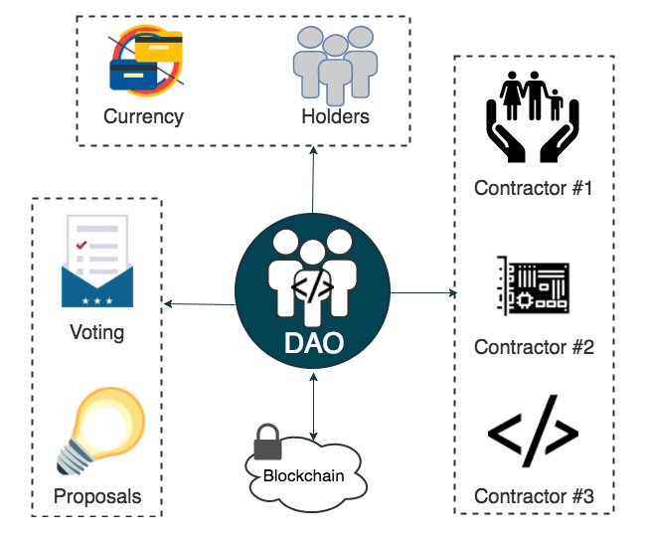

Figure 2: A DAO's components, source: Jonas Verhoelen, https://blog.codecentric.de/2017/08/decentralized-autonomous-organization-blockchain/

## Characteristics and functionalities of our proposed DAO

### Energy Management



As a precondition to be part of the system, every participant in the DAO is a user or a provider of renewable energy via wind, solar or hydropower. Such a participant is called "prosumer". The different participants such as real estate owners with solar panels or power suppliers such as EWZ with access to renewable energy provide electricity that flows into the system's grid. Electricity consumers are the producing or other households or companies of the area of the DAO. The DAO interconnects prosumers and/or provide a direct link between energy suppliers and energy consumers.

All electricity produced and consumed by a household is tracked by a smart electric meter that is connected to a virtual energy balance sheet. A Household may use its electricity produced by its own energy production facility or feed the power to the system, if it has a surplus. The household receives Tokens for a certain amount of electricity produced and it gives Tokens, if it does not produce enough own electricity, when it receives power of another energy provider's surplus. In case a household has consumed all its Tokens (e.g. uses more energy during night then it can produce during the day) and the virtual balance sheet shows a negative balance, it may buy energy Tokens from the DAO or a system participant with Fiat currency.

If the DAO's energy system provides an energy surplus the surplus may be traded on the energy market or in case of the system's energy shortage additional energy is purchased.

### Trading at the energy market



The DAO's financial transaction, how energy surplus is traded and how energy shortfall is covered, is predefined in programed rules and defined by smart contracts. This approach eliminates the need to involve a bilaterally accepted trusted third party in the financial transaction. In addition, the DOA acts fully rational and is not biased by external conditions.

If the DAO may sell its electricity surplus, e.g. when during sunny daytime the member's solar PV panels produce an electricity excess, the DAO may achieve high prices, since during daytime also electricity prices are highest.

Because the electricity exchange will not accept the tokens of the system, all financial transactions by or with the DAO are made with Fiat money (e.g. CHF, EUR).

### Profit distribution



If the system's energy surplus is bigger than the energy bought during an electricity shortage and the DAO's smart contracts are well established so that it sells the green energy to the highest prices possible, the DAO's trading activity will produce a profit. With the profit made from trading, the DAO pays subsidies to more households, companies or other renewable energy projects to build renewable power plants and thus enlarging its network.

All processes and mechanisms must be fully transparent to members of the organization. According to the DAO's governance structure and the underlying smart contracts, the DAO's members or specific roles in the organization may vote how the profit is spent. Also other important developments of the DAO need to be voted about or created consensus among the members with voting power. The members of the organization may have an influence in e.g. what share of the profit is hold reserved for electricity shortage or which share of the profit should be allocated in the form of subsidies to which type of projects (e. g. wind, water, solar energy, etc.) to make the network and its independence even stronger. A balanced network of energy suppliers (e. g. solar, water and wind power plants) can bridge the shortfall of electricity at night or in winter, which must be taken into account in investment projects in order to be as autonomous as possible and generate maximum profit.

### Energy Token

The DAO's ecosystem issues its own currency in form of Tokens. A Token holder has the right to obtain specified energy from the system in return of a specified number of Tokens or the receives Tokens in exchange of providing energy to the grid. Depending on the day or night tariff, the "electricity price" paid in tokens also changes within the DAO network.

Therefore, insofar as an electricity producer has the opportunity to regulate the amount of electricity that can be supplied to the system (e. g. electricity production by hydroelectric power plants at peak times or in times of little sunshine), an incentive arises to build such adaptive power plants and/or produce electricity, when prices are highest and the most Tokens can be generated.

## Initialization of the Concept

At the beginning, there will be an "Initial Coin Offering" (ICO), to get the initial funds for the DAO and to distribute the Tokens. This process would give the DAO its starting capital to start investing in renewable energy, and then trade on the energy stock market. A major part of the Tokens will be sold to investors and given to energy producers. A smaller part could be distributed for example to core developers or held back as reserves. Only producers of renewable energy are allowed to participate in the ICO.

## Disruption Potential

The underlying transaction model of the blockchain technology lead to a decentralized system, where energy producer and end customers or energy companies can directly start to trade. Third party intermediaries are no longer needed, if the transaction may be carried out peer-to-peer, regardless of territorial borders such as cantonal or municipal boundaries and (unless regulated) also in circumvention of a sovereign monopoly. This ensures that existing power generation capacity is utilized optimally, whilst energy is made available at the best price. And since the system's tasks are carried out automatically through smart contracts, this cuts costs and speeds up processes. The role of prosumers is strengthened considerably under such a model.[11]

Due to the rational acting and maximal efficiency the DAO acts as a very efficient self-growing system. In addition, based on the smart electric meter and the virtual energy balance sheet of every prosumer and the prosumers ability to consume the positive balance of the green electricity produced during low performance of the own power facility, the DAO acts as a virtual power plant and as virtual energy storage.

EWZ and other power plant owner’s role in a Decentralized Autonomous Organization will change dramatically. EWZ will not be a monopolist in its territory, but a participant and provider of renewable energy. And since EWZ will be the provider and owner of the grid in its territory, EWZ will be paid via a certain fee or tax levy for the constant maintenance of the grid and the DAO's use of the grid. The payments could potentially be done with Tokens. The affiliate company of EWZ selling and installing PV facilities could act as one of many providers of all physical installations such as for example solar panels, network control systems, converters, and smart electric meters. In other words, in the present presentation of this DAO system, EWZ will only be a market participant, supplier and operator of the electricity grid. Power suppliers, such as EWZ, lose their monopolistic positions.

Therefore, the potential use cases of blockchain technology in the energy sector show a lot of promise and have the potential to radically change the energy market.

## Evaluation

Although the blockchain technology is very promising, first successful projects such as BrooklynMicrogrid are emerging and a DAO seems to work in theory, the implementation and introduction of a DAO in the Zurich or Swiss electricity market is associated with many hurdles. Furthermore, the experience with the blockchain technology is limited to only a few years.

As a result, virtual energy storage should be built up step-by-step in order to gain initial experience with its underlying business model and the new blockchain technology and to reduce internal and external resistance. With this experience, EWZ, together with other electricity producers and strategic partners, can develop a sophisticated concept and system around and for a DAO that integrates consumers, prosumers and electricity producers appropriately.

As a bootstrapping procedure, the following three phases could be established by EWZ:

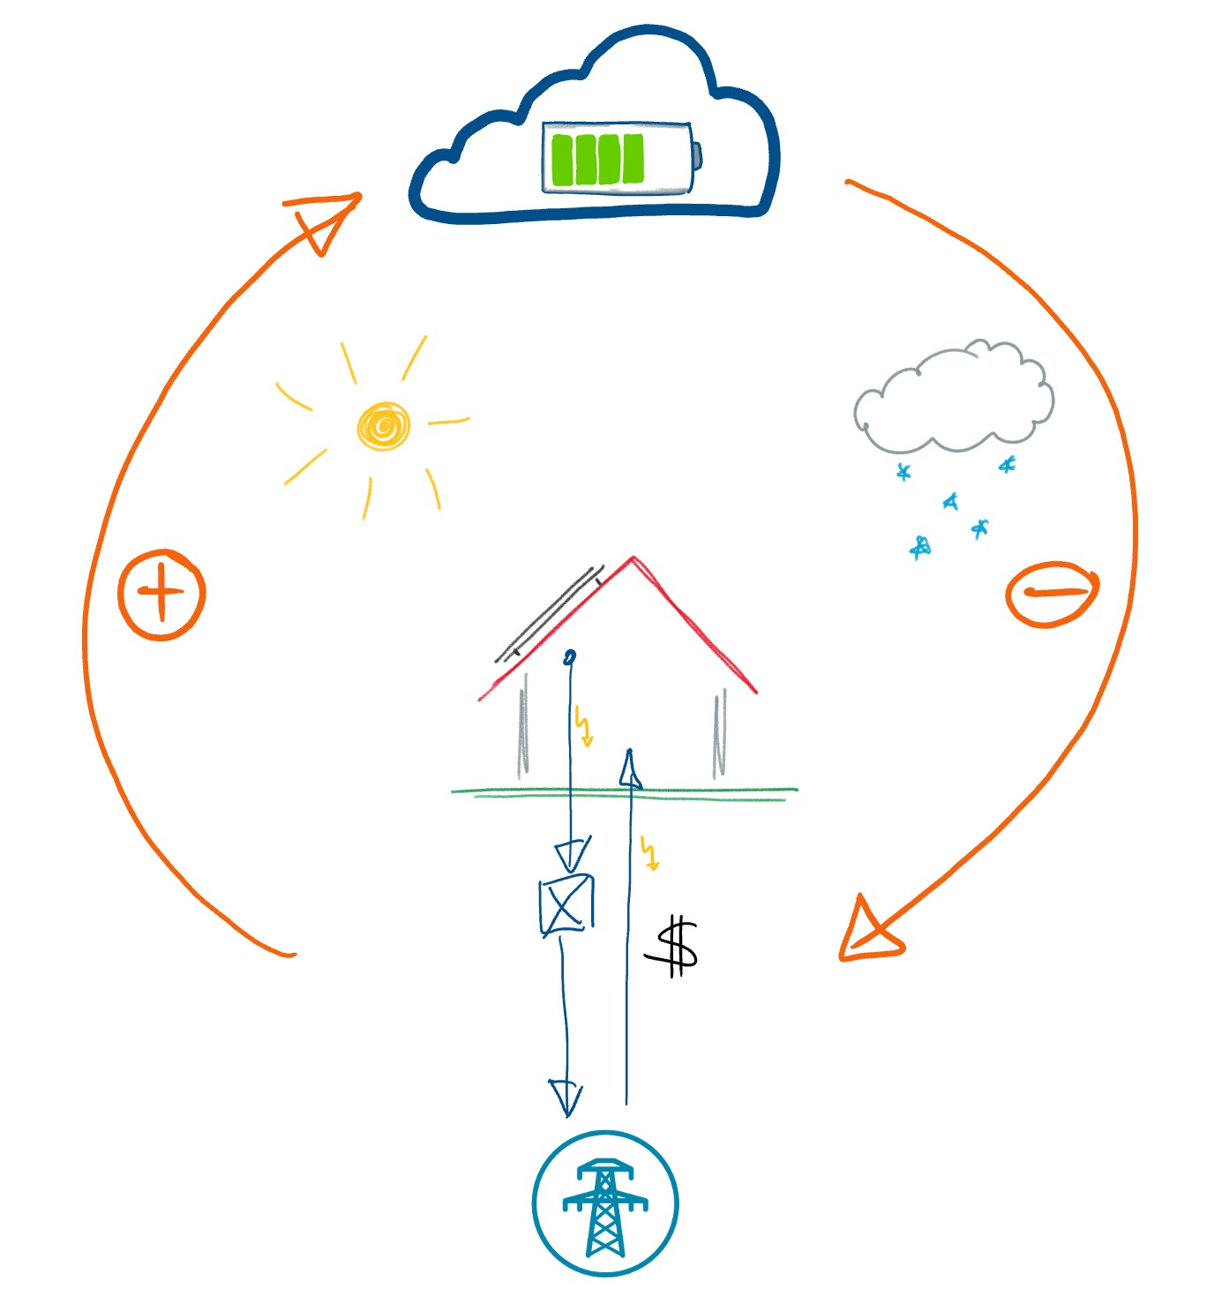  
**Phase 1**: Generating a business model of Virtual Energy Storage to create consumer’s interest

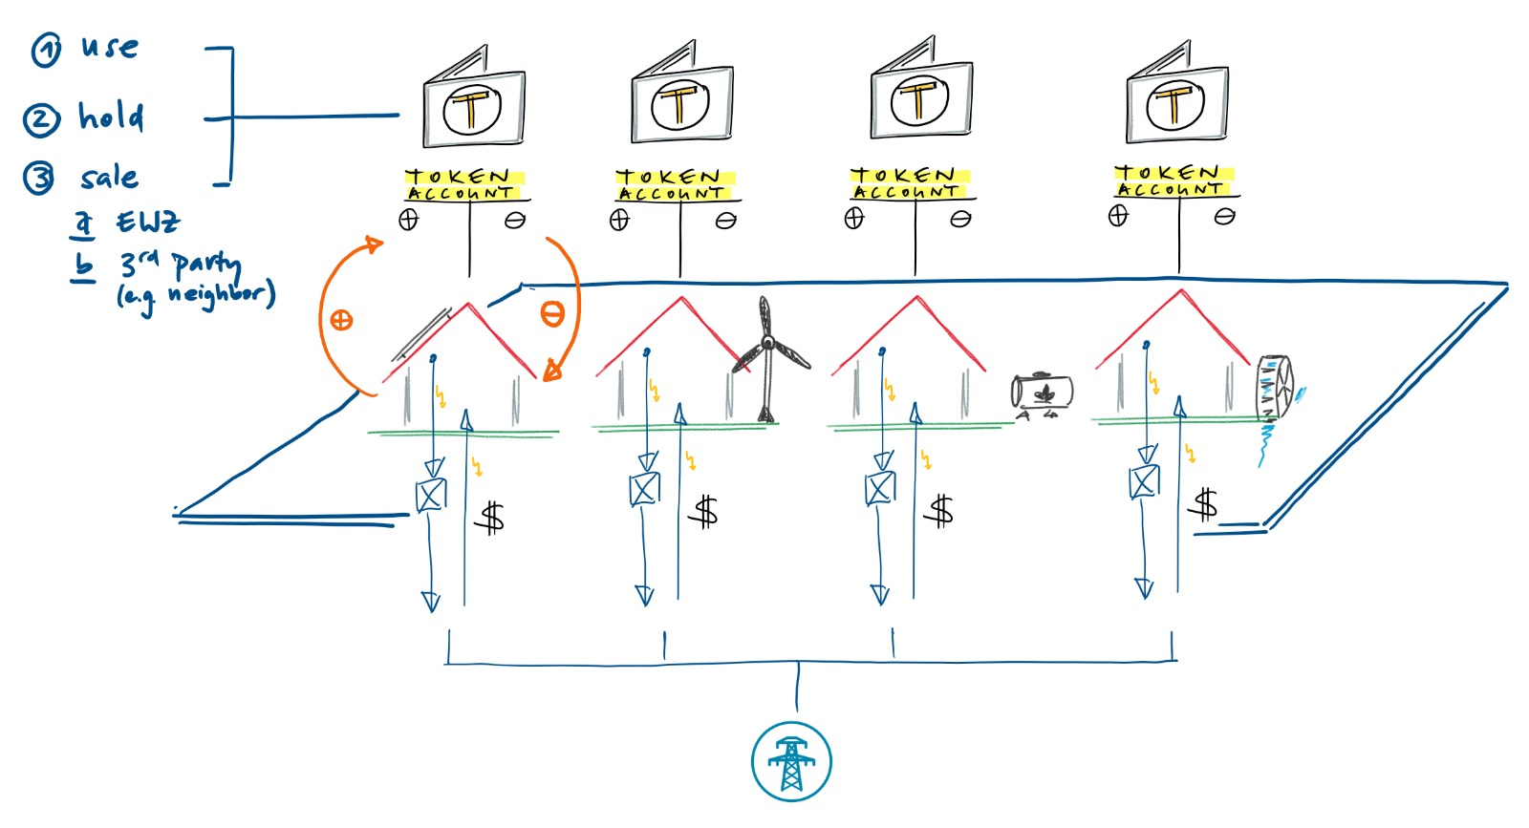  
**Phase 2**: Establish a blockchain based ecosystem for provider of renewables and accept issued Tokens as currency

  
**Phase 3**: Establish and implement a DAO

## Uncertainties, disadvantages and risks

Blockchain as a technology and its applications and extensions in the form of a DAO require or overwhelm most people. Not only because there is a need for in-depth technical understanding, but also because the disruptive upheaval is so significant that comparisons with what is known and the application of existing laws and regulations are almost impossible. Difficulties arise, for example, with the division into groups, what kind of a legal construct a DAO is, whether a "head office" of a DAO is possible at all due to the decentralized structure, how the system is taxed, whether and how transactions within the network have to be settled, what kind of liabilities exist for a physically non-existing construct owned by nobody, and so on.

Another controversial point is trust. Blockchains are supposed to build trust, so DAOs are organizations of trust, because every participant trusts that the system has been implemented fairly and is constantly improved. For example, because the system is implemented by smart contracts that are nothing more than distributed code, the entire organization is entrusted to one program. Programs continue to be developed by people who can make mistakes. Weak points in the respective blockchain software and the smart contracts executed on it are therefore a major risk. The DAO showed that a small mistake can bring down the house of cards. When it collapses, there is no saving authority or legal barrier that can help shareholders. All trust is in the code.[12]

**Topic potentially to be added:**

## Operation of the concept

* Permissioned or Permissionless blockchain?
* Mining happens on a proof of stake implementation, to keep energy consumption in check.
* What is the value of the tokens (i) internally, (ii) externally?
* How/why do Tokens increase their value?

1. www.brooklynmicrogrid.com
2. "The Decentralized Autonomous Organization and Governance Issues", Usman W. Chohan, December 4, 2017.
3. “Blockchain – Blueprint for a New Economy”, Melanie Swan, 2015, O’Reilly Media, Inc.
4. *https://www.ethereum.org/*
5. "Bootstrapping a Decentralized Autonomous Corporation", Vitalik Buterin, September 24, 2013.
6. Decentralized autonomous organization, <https://en.wikipedia.org/wiki/Decentralized_autonomous_organization>, retrieved February 25, 2018.
7. Decentralized autonomous organization — What is a DAO company?, <https://medium.com/universablockchain/decentralized-autonomous-organization-what-is-a-dao-company-eb99e472f23e>, retrieved February 25, 2018.
8. Decentralized autonomous organization — What is a DAO company?, <https://medium.com/universablockchain/decentralized-autonomous-organization-what-is-a-dao-company-eb99e472f23e>, retrieved February 25, 2018.
9. What is a DAO?, <https://blockchainhub.net/dao-decentralized-autonomous-organization>, retrieved February 25, 2018.
10. Decentralized Autonomous Organization – Organisationen auf der Blockchain, Jonas Verhoelen, https://blog.codecentric.de/2017/08/decentralized-autonomous-organization-blockchain, retrieved February 25, 2018.
11. “Blockchain – an opportunity for energy producers and consumers?”, PwC, 2015.
12. Decentralized Autonomous Organization – Organisationen auf der Blockchain, Jonas Verhoelen, https://blog.codecentric.de/2017/08/decentralized-autonomous-organization-blockchain, retrieved February 25, 2018.