**Project Scope definition**

Definition of this project’s scope is determined by gathering fundamental requirements vital to the completion of the project. An analysis on the company’s business structure and software being used currently is done by conducting interviews with the C.E.O. The information acquired is used in conception of requirement documentation based on; business application, system development and programming.

**Project Scope Statement**

This project includes business analysis, system design, programming and testing of new software for inventory keeping and warehouse management. This project will be considered complete when the deliverables, in this case compatible software capable of performing the most complex use case, are successfully implemented and tested. Also, the assumption made is that relevant resources and team members are available for the successful completion of this project.

**Work Breakdown Structure (WBS)**

To manage this project successfully, the tasks are divided into individual tasks or work packages. This ensures that the team works on the necessary tasks thus effective management of the project scope is achieved. It is divided into three stages; design phase, programming phase and the test phase. These phases are then divided further to ensure manageable implementation and emphasis on quality. The first phase will require an estimate of 1-2 weeks while the last two phases will require approximately three weeks.

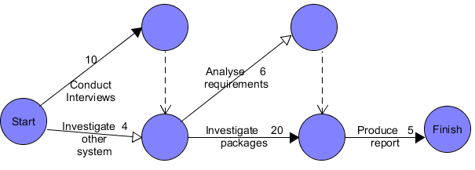

The numbers in the network diagram above signify days spent on the task.