Due to the company’s policy, access to Entafarma’s private balance sheet was not granted. The only financial statement available contains data in regards to sales made between the 52nd week of 2014 and 8th week of 2015 (10 weeks).

The data from the financial statement is visually represented in diagram ().

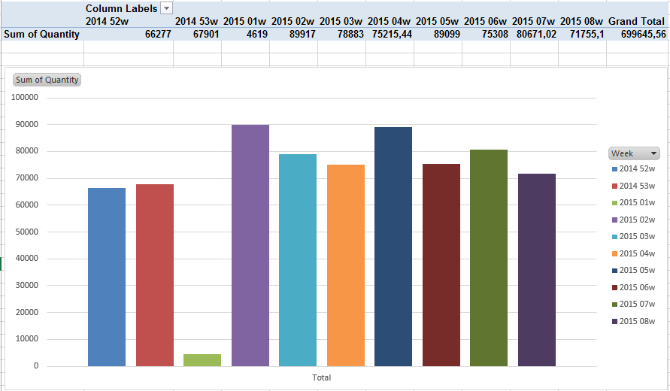

As seen in the above graph, the sales for the last 2 weeks of year 2014 are below the sales of every other week of the year 2015. This indicates a bullish trend in Entafarma’s sales. The first week of 2015 is an exception. Due to public holidays and people’s general preoccupation with partying during that time, the sales were almost nonexistent. However, the week after, the sales hit a historical high in the history of the company, as confirmed by the company’s CEO.