**Eclipse Dirigible**



A Cloud Development Platform providing development tools and runtime environment. It supports full development life-cycle of on-demand applications by leveraging in-system programming models and rapid application development techniques.

Eclipse Dirigible provides everything you need for your development project:

* Application server
* Content repository
* Web IDE
* Variety of features

**Eclipse Dirigible Capabilities:**

* Fast Prototyping
* Legacy Components
* Adaptable Software
* Open and Free
* Shortest Dev Time
* End-to-End Coverage

**Before getting started:**

The only thing you need before getting started working with Eclipse Dirigible is to be sure that you have internet and a browser.

# Eclipse Dirigible Basic Features

### These are some of the features you benefit from

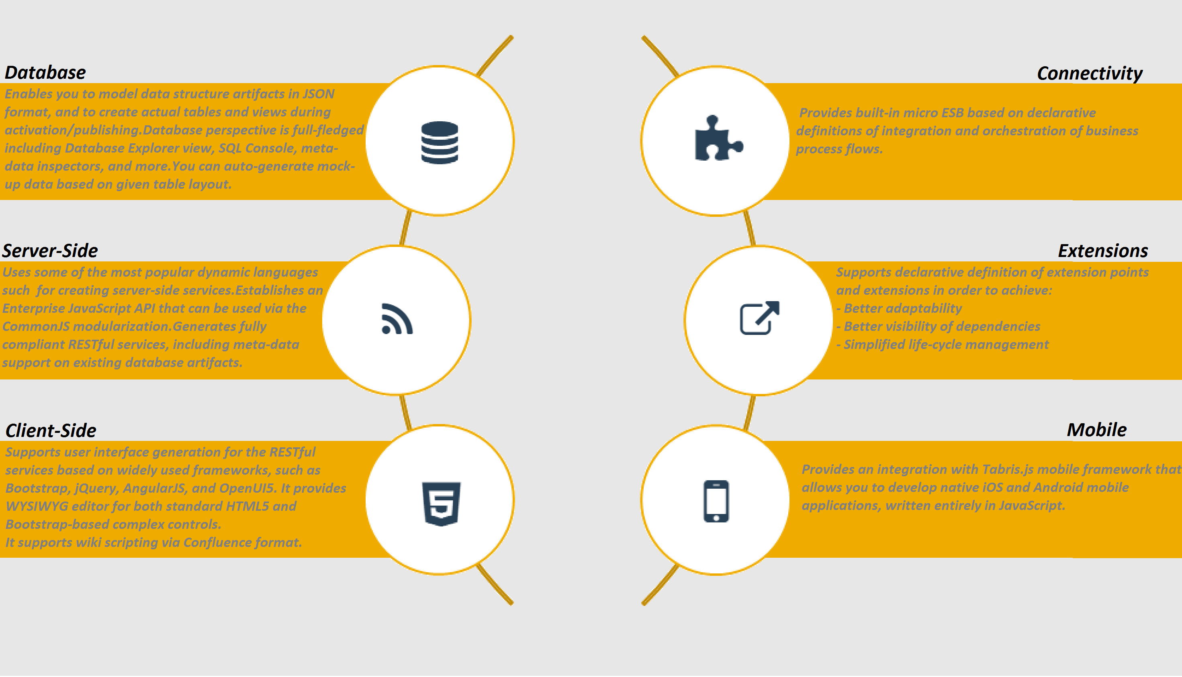

**Creating a project**

**Procedure:**

1. Go to Dirigible Home Page
   1. *To do this –* [Click here](http://www.dirigible.io/index.html#home)



1. Click on the button
2. Fill out a Nickname and click “Enter”.
   1. *Dirigible Web IDE is opened*
3. Navigate to the **Workspace** view
4. Click the 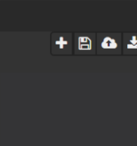 button and then choose Project.
   1. *A new dialog appears.*
5. Enter the Project name and then click “Create Project” button.

**Creating a project documentation**

After creating a project with the steps above, you can write a wiki page for the project.

The following steps can be done only with existing project.

**Procedure:**

1. Navigate to the **Workspace** view and select a project.
2. Right click on the project.
   1. Dropdown menu appears.
3. Choose **New > Wiki Page.**
4. Select a type of template and click **Next**.
5. Select a target location and choose an appropriate name for the file.
6. Add a title of the document and then click **Finish**.

**Result:**

You can now view the created file in the Eclipse Dirigible Web IDE.

**Creating data structure**

Before creating a data structure – be sure that you have a project created in Eclipse Dirigible Web IDE.

**Procedure:**

1. Navigate to the **Workspace** view and select a project.
2. Right click on the project.
   1. Dropdown menu appears.
3. Choose **New** > **Data** **Structure**.
4. Select a template type.
5. Click Add button and type all the necessary properties
6. Fill all the information and click OK to save it.
7. Repeat step 6 to add as many column definitions as you would like and click **Next**.
8. Choose a name for your data structure and then click **Finish**.

**Result:**

Now you have a saved data structured linked to the project for which it was created.