**Exercise 1: Analyze the video**

* The target viewers are people who want to learn how to manage their User Interface in Eclipse Dirigible.
* Their level of competence is conscious incompetence – these people are aware of the fact that they do not know how to manage their UI, but are prompt to learn.
* The aim of the video is how to manage your User Interface in Eclipse Dirigible.

**Exercise 2: Documentation:**

1. *Open* **Eclipse Dirigible.**
2. On your left in the **Workspace Explorer**, *expand* **ScriptingServices** folder and then, *expand* your **project folder**.
3. *Right click* on the **entity file** you want to create user interface of, **Generate** -> **User Interface for Entity Service**.

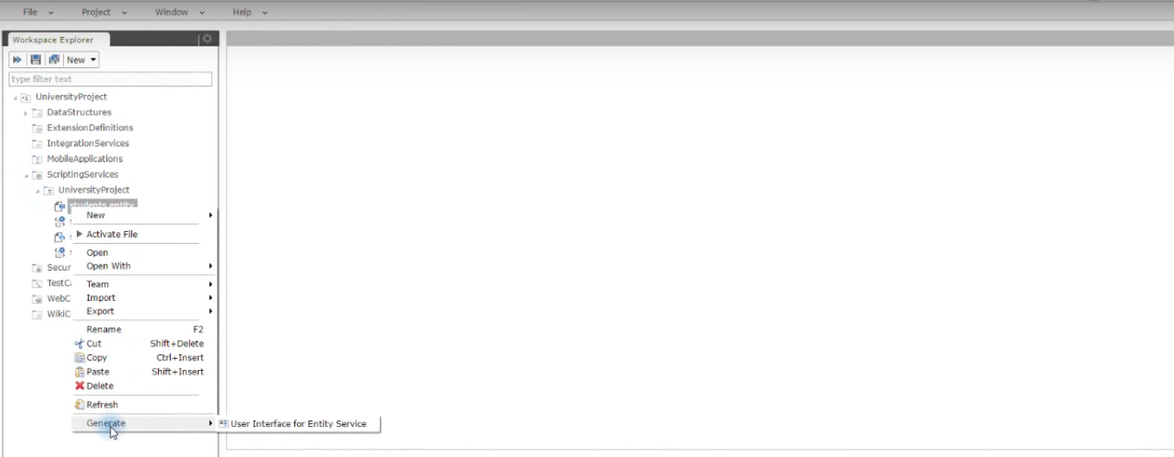

1. From the popup window, *choose* **List Entities**. *Click* **Next**.
2. *Select* the fields you want or *click* **Select All** button and *click* **Next**. E*nter* **file name**, *click* **Next**, *enter* **page title** and *choose* **Finish**.
3. On your left in the **Workspace Explorer**, *right click* on **WebContent**, **New**-> **User Interface**. From the popup *choose* the **third** option.

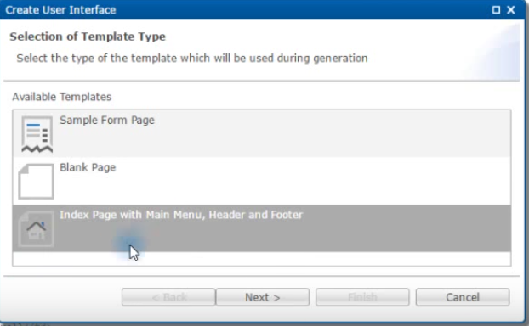

*Click* **Next** and *enter* **Page Title** and *click* **Finish**.

1. *Click* on **main.menu** file to open it in a new tab. 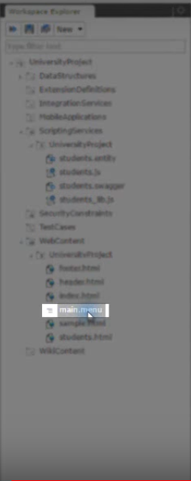
2. *Change* the information given in the second paragraph with the information from **your page**.

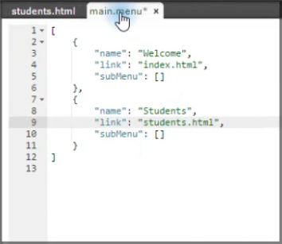

1. *Save* your changes.
2. *Right click* on **index.html** file.

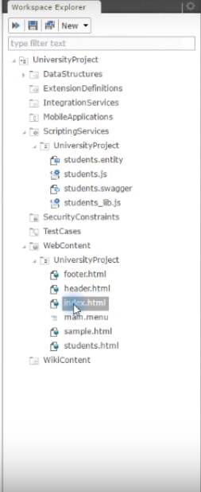

1. Down in the **Preview tab**, *copy* the **link** in your browser or *mark* the whole text, *right click* on it and *click* on **Go to http…**.