Business Story and Model

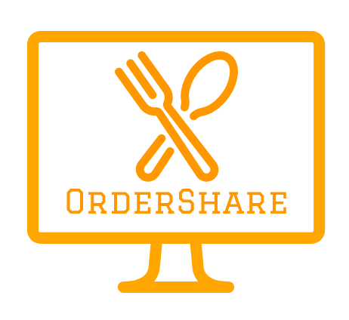

Monika Biniewicz, Emilia Chmielowska, Tautvydas Cerniauskas, Stefan Rudvin

USER STORY

Michael is hungry. He has come to his dorm after an endless day at the university and is too exhausted to cook a full meal. He slumps on the living room sofa, immediately slipping out his phone to order some well-earned pepperoni pizza. The coffee table lurks in the corner of the room, and as he glances over, a stack of fast food deals grabs his attention. They require at least two people to cash in on the deal. After a peek into the hallway he remembers that his flatmates are out of town. He is out of luck.

Working a part time shift at the local grocery store, Michael is running low on cash, and has a tough time justifying a £20 pizza. Worst of all, Friday is coming up, and his friend Sam is organising a bowling night to celebrate end of term. Suddenly, like a light bulb switching on in his brain, Michael remembers something. During their daily banter, Sam mentioned something about a new app called OrderShare. Only seconds pass as Michael downloads the app, finds his favourite fast food chain and begins a public order. He sets the deal to a 50% offer and resumes his binge of ‘Friends’ on Netflix. Within five minutes, someone else has joined his order and the purchase is sent on to the fast food company. Michael is automatically billed through his credit card. After two twenty-minute episodes, a notification from OrderShare awakes his phone. The pizza is here. Michael leaps of the sofa, heads to the collection spot by the dorm and picks up his pepperoni pizza. With the 50% off deal and free delivery, he has saved £10 and can now join the Friday bowling session with his friends.

It is people like Michael who will value the experience of OrderShare to its fullest. His requirements tick all the boxes of OrderShare’s competitive advantage: Value, availability and convenience.

COMPETITIVE ADVANTAGE

Traditional fast food can actually be deceptively expensive (Merriman, 2015). With OrderShare, customers not only qualify for free delivery, but also use deals. This results in a win-win situation; restaurants serve customers they may not otherwise attract, and customers enjoy reduced prices.

Another aspect of OrderShare’s experience is availability. As delivery restaurants are adding support for API orders (delivery.com), OrderShare can add restaurants to its menu quickly. While this requires some integration with the OrderShare platform, there are many unofficial implementations that help with the process (Domino's Pizza API).

The last competitive aspect of OrderShare is convenience. In Michael’s case, he did not need to call and arrange a group of people to order with him. In fact, he did not need to interact with others at all. OrderShare’s public orders allow anyone to join in seamlessly without having to split costs manually. Moreover, when creating an order, OrderShare automatically lets the driver know who each item in the order belongs to. This solves conflict when orders are being picked up. Additionally, private orders allow the owner to add friends and family to the order and choose to pay for other participants. This is especially useful for offices who want to order food together, or parents who make orders for the whole family.

Key Functionalities

OrderShare provides an all-inclusive platform for efficient food ordering. This section highlights key functionalities that are central to OrderShare’s competitive edge, along with how they relate to the pains and gains by our user personas (attached separately).

In-app purchasing

Before a customer makes their first order, they add their credit/debit card details to the system. When the order is completed, the customer is billed through OrderShare. This allows OrderShare to provide additional services such as applying deals automatically, providing tracking notifications, social media integration and saving previous orders. This solution also enables ‘one-click-ordering’, where the customer does not need to enter their card details for each transaction. As Louise expresses, she wants to ‘save time’ and ‘be able to complete an order in a few restaurants quickly’. If she were to create multiple orders at different restaurants, she would have to enter her post code, find available branches, create orders, enter address and payment details. OrderShare solves all of these problems with a single click.

Wide Selection of popular restaurants

By aggregating multiple restaurants and deals into a single app, users can easily compare and contrast local offerings based on their location. The application knows where the user is located via GPS, so the postcode does not need to be entered. This directly corresponds to Francesca’s, Thomas’ and Louise’s gains, who say that they want to ‘discover the best deals available’. Moreover, once more user data is collected, OrderShare can suggest restaurants to users, or let them know if any new ones are opened. Especially Thomas claims that he is bored of ordering food from the same places and does not have the time to check menus and deals for each restaurant around. Once OrderShare has implemented a variety of popular restaurants, the social media integration can begin suggesting deals based on users’ friends’ habits as well.

Payment Sharing

The main competitive advantage of OrderShare is its ability to easily split the costs on large orders automatically without user intervention. As mentioned in the Business Story, OrderShare includes functionalities such as Private Orders, Public Orders and the option for users to pay for each other. This allows large groups of people to make complex orders and take advantage of deals that would otherwise be too time-consuming to calculate by hand. For example, Louise states that ‘her family never agrees on what they want to eat’. Today, even most children have their own mobile phones. This allows parents to create a private order, add their children to it and let everyone in the family decide on what they want to eat independently.

The true power of OrderShare reveals itself once users like Stefan can take advantage of deals they would otherwise be out of their reach. By creating a public order, Stefan is allowing other users to join in on his order, eliminating delivery fees and embracing deals that require the value of an order to be above a certain threshold. Once Stefan creates the order, users in the local vicinity subscribed to the same restaurant and collection spot get a notification and can join it. The collection spot is a predetermined safe location where the food is delivered. The system automatically adds the details of the order to the driver’s delivery instructions, allowing him/her to know how to pass the meals along. Collection spots work especially well in larger communities, such as university dorms, apartment buildings and offices. Like Thomas explains, he would like to get cheap food delivered to his office- OrderShare could accomplish that on a whim.

Business Model Canvas

The Happy Startup and Value Proposition Canvases (attached as appendices) contribute to the Business Modal Canvas, which shows various aspects of the OrderShare idea.

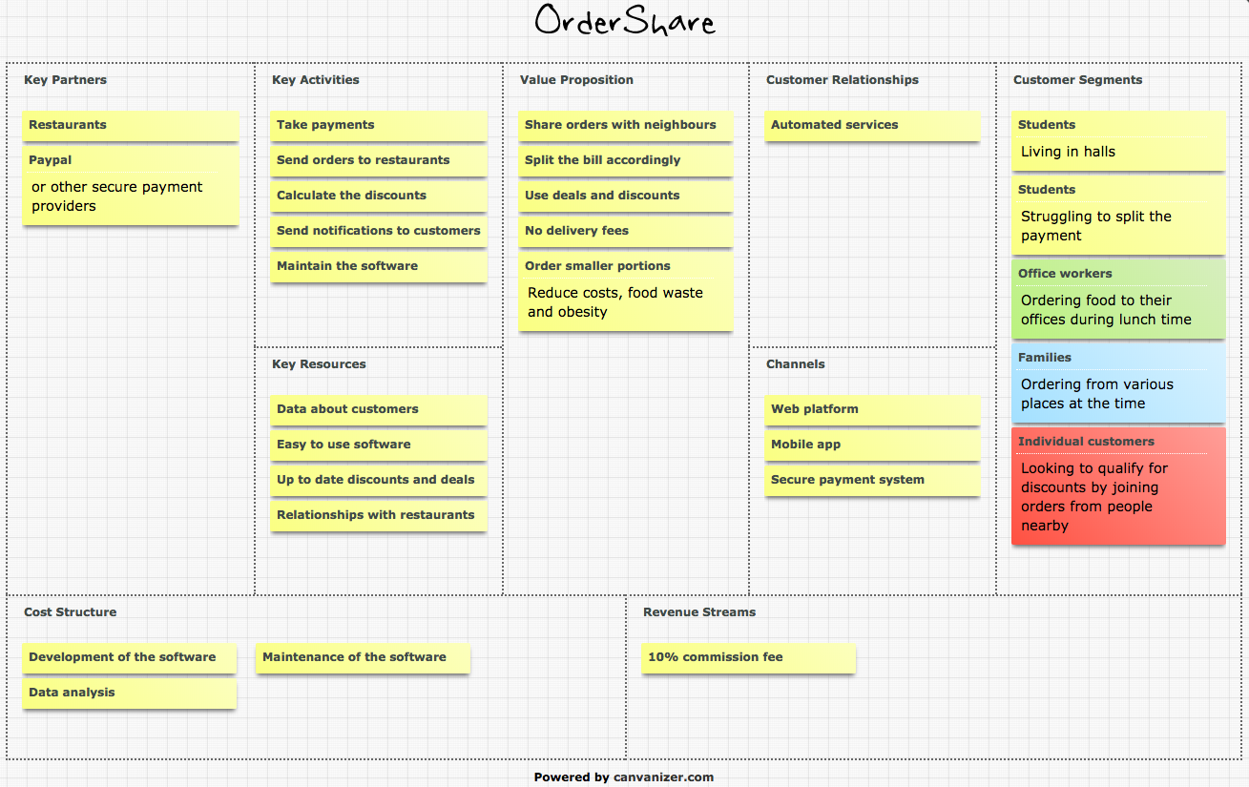

Figure 1. The business model canvas

Value Proposition

While all kinds of food ordering apps are plentiful, OrderShare is different. In order to provide customers with cheap food ordering services, we connect the orders of strangers together and conveniently split the bill and discounts accordingly. As private ordering groups can be also created, it is possible to order with friends and not worry about splitting the bill. Ordering in groups eliminates delivery fees, and it allows customers to make use of available deals that have a minimum order value limit. Moreover, it reduces food waste, overeating, and still allows customers to treat themselves. Furthermore, we enable users to order from multiple restaurants, which is beneficial for big orders made by families or partygoers.

Customer Segments

We focus on five customer segments, which are visually explained, elaborated on, and validated in our personas. The first big group we focus on is students who live in halls. Most students look for ways to save money, but still want to enjoy themselves. This could be achieved by lowering costs on take-away food. As students are up to date with technology and live close to their peers, they make a perfect target market. Living in halls also makes sharing orders with strangers much less intimidating, since all the participants will probably study at the same school. The second group we focus on is students who order food with their friends and struggle to split payments. Because our platform allows to split the bill accordingly to what everyone ordered, it neutralises the issue of calculating money or complicating the payment at delivery. The third group is office workers, who can order lunch with their co-workers and easily split the bill. The fourth group is families ordering from various places at the time. The fifth group is individual customers looking to qualify for discounts by joining orders from people nearby.

THE Customer Relationship

Nowadays, food ordering services tend to have as little human contact as possible. Our platform will have an automated relationship with customers, where data collection and analysis will automatically generate suggestions and deals to customers based on their previous transactions. We will also collect feedback (reviews, etc.) from customers to make sure our service functions at a high standard, improving brand loyalty.

Revenue Stream

Customers will not be charged additional fees to use our service. The restaurants and retailers whose offers are available benefit from minimised delivery costs, and increased revenue as discounts encourage customers to purchase more goods. Due to these benefits, we plan to charge our partners a 10% commission fee on every order generated through our system. This is a revenue model followed by other similar applications (Tyler,2013). Furthermore, if OrderShare becomes popular we may charge restaurants for appearing higher in search results and on the home page (Tyler,2013).

Key Partners

Despite the benefits OrderShare brings to its users, the key ingredient of our service are the brands we collaborate with. The restaurants and retailers whose offers are available benefit from minimised delivery costs, and increased revenue due to discounts encouraging the customers to purchase more. Another partner is providers of secure payments, such as PayPal.

Cost Structure

The initial costs are mainly the development of the website and/or application. Later, there will be costs of maintenance and data analysis, which are explained in the following data analysis report.

Channels

We will deliver our service through a website, and later a mobile application with secure payment methods.

Key Resources

In order for our platform to function, we need to establish relationships with restaurants. As competition is fierce, the software has to be intuitive and contain a comprehensive selection of menus and deals, some of which may be exclusive to the application. Furthermore, we will have to collect and analyse customer data which allows us to send individualised offers and reminders.

Key Activities

The main activities of our business are to allow users to connect, share and join orders, take payments accordingly, apply discounts evenly and then send orders to restaurants. We also have to send individualised notifications and special offers to customers, based on their previous orders and overall collected data.

References

Domino's Pizza API. Retrieved from http://riaevangelist.github.io/node-dominos-pizza-api/ [Accessed on 23 February 2018]

Merriman, C. (2015). Spending only $125 on food last month showed me that fast food is deceptively expensive. Retrieved from http://www.businessinsider.com/fast-food-is-expensive-2015-10?r=US&IR=T&IR=T [Accessed on 23 February 2018]

Tyler, J. (2013). How do delivery services like GrubHub and Seamless make a profit?. Retrieved from https://www.marketplace.org/2013/05/21/business/how-do-delivery-services-grubhub-and-seamless-make-profit [Accessed on 7 February 2018]