**Personas**

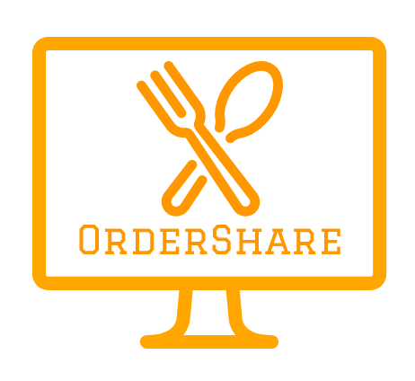

# Monika Biniewicz, Emilia Chmielowska, Tautvydas Cerniauskas, Stefan Rudvin

*The exact details of our experiments are available in the attached excel sheet Javelin-Experiment-Board.xlsx.*

*Our four personas representing the four validated market segments together with their corresponding empathy maps and value proposition canvas are available in the file Personas.pdf*

OUR TARGET MARKET

As OrderShare is a smart food ordering platform encouraging users to create group orders and enabling them to use available deals and choose the most convenient form of payment, our target market is broad. However, for the purpose of better identification of our goals we decided to focus on 4 main customer segments:

* University students in the age of 18 to 24 who live in student halls and either join their neighbours’ orders or order with their friends and struggle with splitting the payment
* Office workers ordering lunch to their offices
* Young adults in the age of 25-34 who live in their own and shared flats and who would be willing to join their neighbours’ orders
* Families who order from more than one restaurant at a time and wish to complete and pay for all the orders simultaneously

In order to better visualise our customer segments, we have created four personas representing each one of them:

* Francesca Bianchi, a 19-year-old student of Business Management in the University of Aberdeen living in the Hillhead Halls of Residence
* Thomas Reid, a 32-year-old employee of a testing department in one of the largest retail banks in the country
* Louise Dunbar, a 44-year-old mother of three who works as a Human Resources manager in a large professional services firm in Aberdeen
* Stefan Danciu, a 24-year-old recent Film and Visual Culture graduate, working full-time as a Starbucks barista

Details of the personas together with empathy maps and value proposition canvas tailored to all of them are available in the personas.pdf file.

**VALIDATION**

For the purpose of the validation of our personas we have used Javelin Experiment Board Canvas. We have identified main problems as:

* No time or inability to cook
* High costs of take-away food
* Minimum order costs resulting in having to order large portions and difficulty to split the cost between friends when ordering online

Our riskiest assumptions include:

* Users are not afraid to join orders generated by people they don’t know
* Enough people use our service for the orders to be completed and sent in a timely manner
* People are unhappy with available delivery and payment options
* People would order food more often if it was cheaper and/or more healthy options were available

In order to get a big volume of data, we have decided to conduct an internet survey among our Facebook friends, most of whom appeared to be university students who live in student halls or private flats rented with their friends or their partners. In order to reach our two remaining target segments, office workers and families, we have conducted a series of interviews on the phone and online.

Results of our customer research

As a result of our survey we have got 24 responses. For the purpose of the identification of the specific customer segments our responders belong to three of the questions refer directly to the responders’ age, occupation and living situation. The results are shown in Figure 1, Figure 2 and Figure 3.

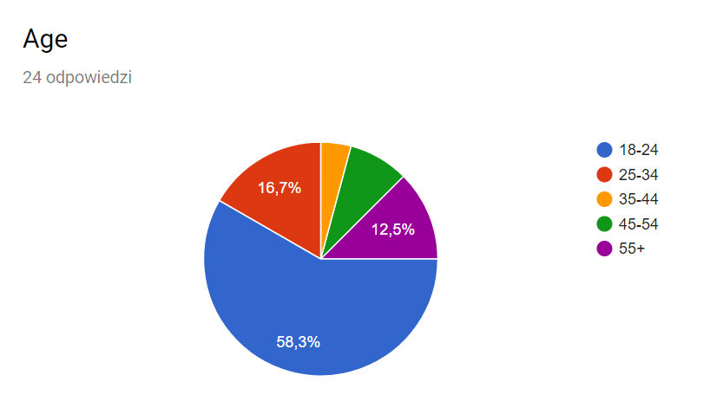

Figure BREAKDOWN OF OUR RESPONDENT'S AGE

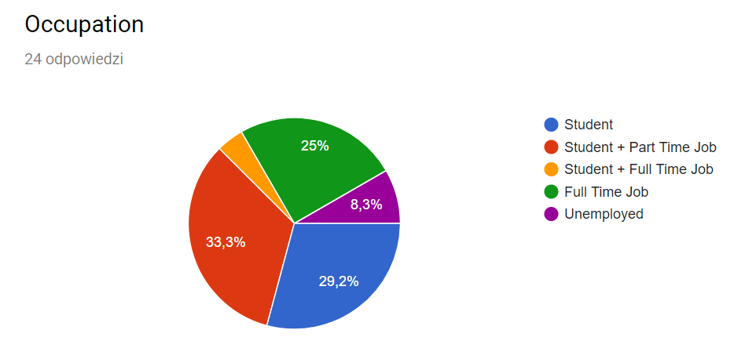

Figure BREAKDOWN OF OUR RESPONDENTS' OCCUPATION

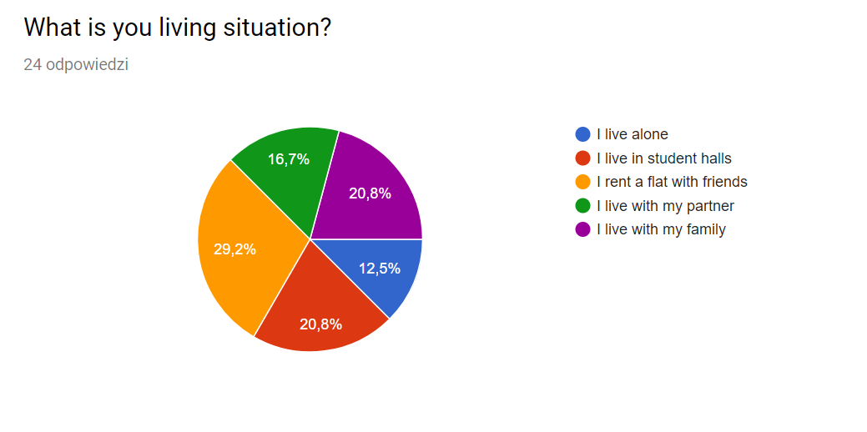

Figure BREAKDOWN OF OUR RESPONDENTS' LIVING SITUATION

The specific list of questions from our survey is available in Appendix 1. In order to validate our personas and customer segments, we have analysed our results in accordance to our four main customer segments.

Students living in halls

We have found out that students living in student halls positively responded to our business idea. Commonly mentioned reasons why they do not order food often were high delivery fees, high costs of take-away food and low variety of choice. We have also discovered that they would be more likely to order more often if there were no delivery fees and they could qualify for more deals. What is more, they were more likely to order food with their neighbours than other customer segments. 100% of responders answered “Yes” to “Would you use our app at home?” therefore we consider the segment validated.

Young people living in rented flats with their friends or their partners

The results of our survey indicated that this market segment also finds the cost of ordering food high and is more likely to order if there was no delivery fee or they had access to more deals. However, the responders were much less likely to order with their neighbours. Only 3 out of 8 responders said that they are likely to order with their neighbours. However, as 5 out of 8 responders in this customer segment responded positively to the question whether they would order food more often, were they to have access to more deals, and 11 out of 13 of the responders answered “Yes” to “Would you use our app at home?” we have decided to proceed with this market segment.

Office workers ordering lunch to work

Our online survey has not brought any quality results about the ordering behaviour of office workers. As some of us have worked as interns in companies where it was common to order lunch to work, we figured we can conduct unstructured interviews with some of our past workmates to see if they would be potential customers of our service. We spoke to 8 people in total. 6 of them responded enthusiastically to our business idea outlining such disadvantages of available food delivery services as lack of healthy options, high delivery cost or difficult payment splitting process in case of paying by card. Since our success criterion was receiving 50% of responses suggesting that the responders are not satisfied with current delivery services, we have decided to proceed with this market segment.

Families

As all of our group members come from families with more than one child, we have decided to conduct interviews with our parents to find out if they would use our idea. Out of 8 responders 5 have indicated that they would use an application that would allow them to order food and pay in multiple restaurants at a time.

Appendices

Appendix 1: OrderShare Customer Survey

Survey Description: OrderShare is an online marketplace connecting friends, neighbours and co-workers in order to enable them to make group orders from local restaurants and make use of available deals to reduce the amount spent and avoid the delivery cost.

OrderShare is a safe service that calculates the amount spent by every single individual and applies a discount accordingly. The service will notify you when order is made nearby and enables you to join them. A private order lets the user add their friends to the order, making it closed to the public.

Age:

* 18-24
* 25-34
* 35-44
* 45-54
* 55+

Gender:

* Male
* Female
* Other

Occupation:

* Student
* Student + Part Time Job
* Student + Full Time Job
* Full Time Job
* Unemployed

What is your living situation?

* I live alone
* I live in student halls
* I rent a flat with friends
* I live with my partner
* I live with my family

How often do you order takeaway?

* Every day
* Every week
* Once every two weeks
* Once a month
* Less than once a month
* Never

What prevents you from ordering take-aways?

* High prices
* Delivery fee
* Minimum spending requirements
* Unhealthy food
* Lack of choice in my area
* It does not affect me

Would you order more often, if there was no delivery fee?

* Yes
* No

Would you order more often, if you had more deals/discounts available to you?

* Yes
* No

Would you be willing to order with other people to qualify for deals/offers?

* Yes
* No

Would you be willing to use our app described above at home?

* Yes
* No

Would you be willing to use our app described above at your work place?

* Yes
* No

How likely are you to join food orders made by your neighbours?

* Very likely
* Likely
* Neutral
* Not likely
* Very unlikely