CMD

**Basic**

PWD – Print working directory

cd .. – Go up one directory

cd home/library/user/ - to go to directory

mkdir plöö – makes directory plöö

touch paa.txt – creates new file

**LS**

ls –a - show all files (hidden files too!)

ls –l – show directory in the long way(Access rights, child directories, files owner, group, size in bytes, date & time, name)

ls –t – show files in order of modification

ls –alt – show files using all three modifications to ls. (all, long, sorted by date)

**CP**

cp joo.txt ei.txt – copies contents of joo.txt to ei.txt. You can also copy a file to a directory with cp

You can copy two files to a directory too, by:

Cp joo.txt ei.txt tänne/

cd ../../action/ - If you know the directory is exactly two directories up

cd * action/ - copies *all* files to directly

cd m*.txt scifi/ - copies *all* text files that start with m

**MV**

mv a.txt b.txt c/ - moves a and b to directory c

mv a.txt b.txt – rename a to b

rm –r c/ - removes directory and all child directories

**Input/output**

echo “Hello” -> Input with echo

echo “Hello” > hello.txt – input text into hello.txt

cat hello.txt – show contents of file

cat ok.txt > hello.txt – overwrite contents from ok.txt to hello.txt

cat ok.txt >> hello.txt – appends content

cat > lakes.txt – “>” puts shit on the left program from the right

cat volcanoes.txt | wc – is a pipe that redirects standard input from left to right

sort ok.txt

$ cat lakes.txt | sort > sorted-lakes.txt

uniq lakes.txt – Filters out duplicate lines in a file

Regular Expression in CMD

grep Mount mountains.txt – grep = regular expression. Return files with the word ‘mount’ in them

grep –i – makes the command not case sensitive

grep –R Artic – searches files and lines with arctic in them

grep –Rl – limits previous search to only filenames, not contents.

Sed = stream editor – find & replace text

Sed ‘s/snow/rain/’ forest.txt

* s: stands for "substitution". it is always used when using sed for substitution.
* snow: the search string, the text to find.
* rain: the replacement string, the text to add in place.

This expression only applies to the first word snow in each line.

With:

Sed ‘s/snow/rain/g’ forest.txt

All instances are changed.

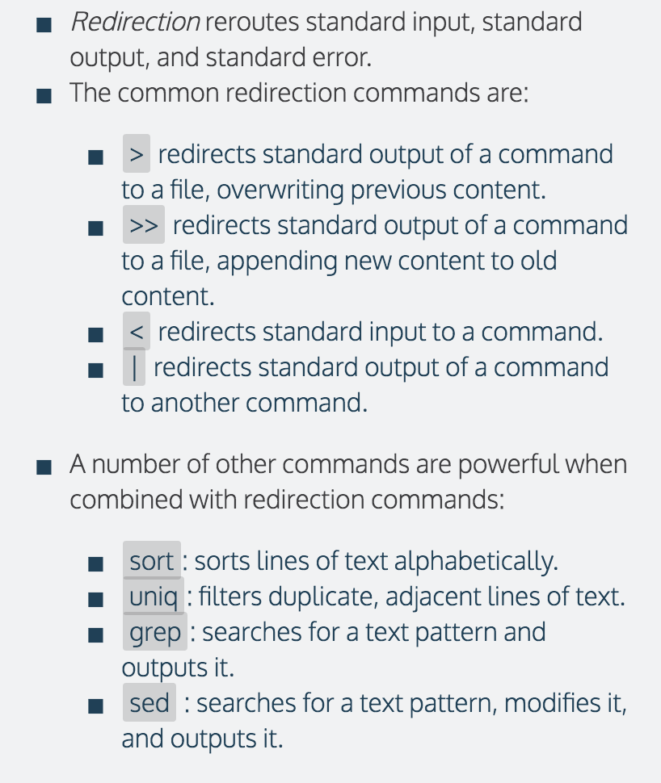

**Nano**

Nano is a text editor like notepad inside the terminal.

To open, type nano filename

Enter text, Ctr + O to save text and Ctrl + X to quit.

You can create a **~/.bash_profile** to save environment settings. A session will load these every time it starts.

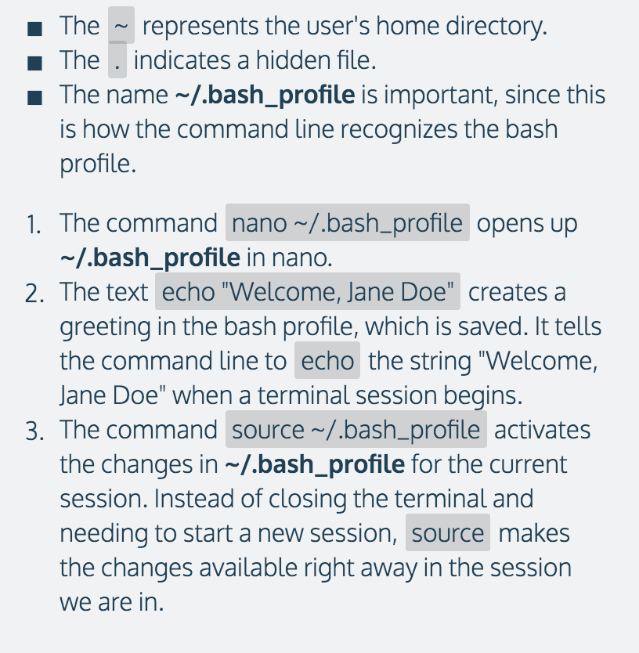

With an alias command, you can create shortcuts, keyboard shit and stuff like that.

E.g. in the bash, with:

Alias pd = “pwd”

You can get pwd by writing pd

E.g. in **~/.bash_profile,**

Alias hy = “history”

Alias ll = “ls –la”

export PS1=”>> “ -> Change the usual dollar sign start to >>

echo $HOME shows the home directory

echo $PATH shows all directories with scripts in them.

In essence, many scripts are actually different ones from the /bin/ folder, like ls

Export VARIABLE = “value” gives value to variable

USER= current user, PS1 = Command prompt, HOME = Home directory, env returns list of environment variables.