Documentation for practical application

# Problem Specification

The problem requires to compute 2 * (N – 2) linear systems over a set of matrixes until a certain number of steps are performed or when an error function returns an acceptable amount.

Scenarios:

* A test case when the limits of the problem are met N = 1000
* Various values for the error threshold

# Description of a sequential algorithm that solves the problem

## Pseudocode

Solve() {

While (steps < max_Steps && error > min_error)

solveX1()

solveX2()

computeError()

copyX2intoX0()

}

solveX1(){

for j = 1, n-1

new B

B[0] = border(0, X0)

For i = 1, n-1

B[i] = f(X0[i][j], X0[i+1][j], X0[i-1][j],X0[i][j+1],X0[i][j-1])

B[n-1] = border(1, X0)

Thomas(a, b, c, res, B)

Copy res into X1, column j

Copy colum 0 of X0 into X1

Copy column n – 1 of X0 into X1

}

Similarly for X2

Then error is computed as the maximal absolute difference of elements between X2, X0

## Complexity analysis

The main loops depends on how fast the algoritm converges. The complexity for calculating X1 is given by the main loop (N) and the inner loops (4*N), to be roughly N^2. The same applies for calculating X2, and for getting the error. The application stores all 3 matrixes in memory, so 3 * N^2 memory usage is estimated.

In conclusion the time complexity for the serial solution: O(N^2), and the space complexity O(N^2).

# Description of a parallel solution

## Informal description of the solution

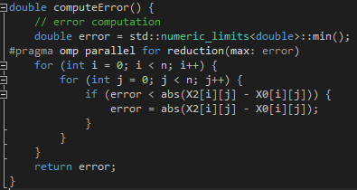The most obvious target for optimization is the error computation function which can be parallelized using the reduction pattern. Each row is processed in parallel and the resulting errors are combined.

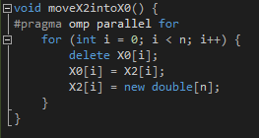

Another quick optimization is during the moving of X2 into X0. We can do the pointer moving and allocations in parallel.

For the computation of X1 and X2 we applied a message passing approach. Following the master slave pattern, a master process sends out the initial matrix to the workers. Each worker computes the B array, solves the tridiagonal system and stores the result in a buffer. The indexes for which equation systems are solved by each worker are determined from its id as follows: #workers % id, with an increment of 1 if the result is 0 (the master process). This ensures the distribution of work in a round robin fashion.

Each worker then sends the buffer containing the concatenated results to the master process. This approach was taken in favour of sending the result of each Thomas run because it implies less overhead with message passing.

The master process waits for the results, each receive in a different thread, to deal with incoming messages asynchronously. The X1 matrix is then built by parsing the incoming buffers. A very similar approach is taken for the computation of X2.

The parallel patterns used: loop parallelism, parallel reduce, master/slave, message passing.

## Time complexity analysis

For the error computation the complexity becomes N * N / #threads + overhead, and for the moving of X2 into X0 N / #threads + overhead. For building the intermediary matrixes the time complexity depends on the overhead of communication between processes. At each step 2 matrixes need to be passed along to the worker processes. Each process then does N * N / #processes steps and buffers the results. The results are gathered by the master process and rebuilds the matrixes in roughly N * N / #processes.

## Metrics

Speedup: ratio between sequenctial execution time and the parallel execution time S(p)=T(1)/T(p).

Efficiency: measure of the usage of the computational resources S(p)/p

Cost: the sum of the time that each processing element spends solving the problem p * T(p)

# Implementation

I used the following libraries: omp (for multithreading) and mpi (for message passing between different processes).

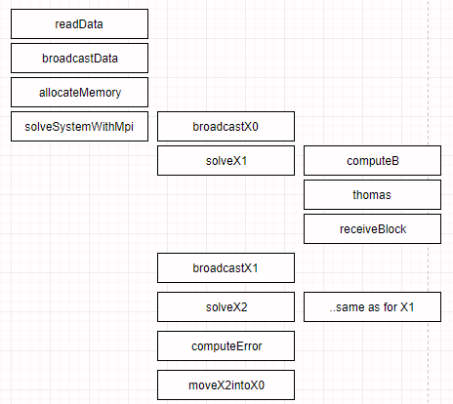The main functions are covered in the diagram on the left. The initial functions concern the input and propagation of data from master to workers. SolveX1 function is executed both by workers and master. Workers call computeB and thomas while master calls receiveBlock in separate threads (inside his process).

Error computation and copy of X2 into X0 is done by the master process.

# Verifcation and testing

In order to test the correctness of the parallel implementation, the output was checked against the output of the serial version for different ranges of the input parameter N (from 3 to 1000). The results matched.

## Performance results on the local machine

|  |  |  |  |  |  |  |
| --- | --- | --- | --- | --- | --- | --- |
| N | Parallel execution | | | | | Serial time |
| #procs | Time | Speedup | Efficiency | Cost |
| 1000 | 6 | 27410 | 1.14 | 0.19 | 164410 | 31408 |
|  | 4 | 29370 | 1.06 | 0.26 | 117480 |  |
|  | 8 | 29050 | 1.08 | 0.13 | 232400 |  |
| 100 | 6 | 420 | 1.29 | 0.21 | 2520 | 545 |
| 10 | 6 | 25 | 1.28 | 0.21 | 150 | 32 |