Laborator 3 PPD

Stefan Sebastian 235

Analiza cerintelor

Se cere sa se implementeze o lista inlantuita sortata, care contine numere reale. Aceasta lista va furniza metode pentru inserare, stergere si obtinere iterator. Sa se implementeze lista in doua variante: cu sincronizare la nivel de lista si cu sincronizare la nivel de portiune de lista.

Constrangeri

Operatia de iterare este atomica.

Proiectare

Am creat o interfata pentru lista si una pentru iterator. Exista doua clase concrete, una pentru sincronizare la nivel de lista si una pentru sincronizare la nivel de portiune de lista. Fiecare contine clase interne pentru iterator si pentru noduri.

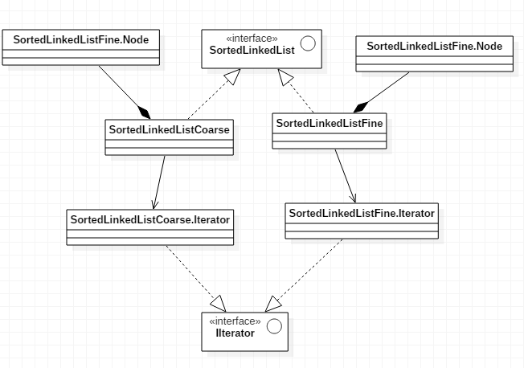

Clasesle Inserter, Printer si Remover implementeaza interfata Runnable si sunt folosite pentru a efectua operatiile in paralel pe lista. Logger se ocupa de scrierea operatiilor in fisier si InputGenerator are metode pentru generarea input-ului folosit in operatii.

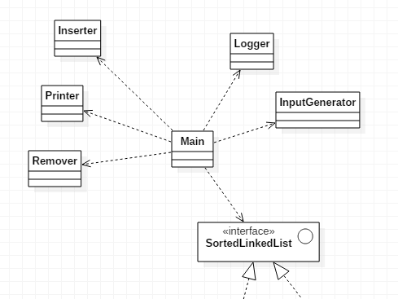

Detalii de implementare

Pentru implementarea listei cu sincronizare coarse-grained am folosit un obiect de tip ReentrantLock ca atribut al listei. Fiecare operatie incepe prin a face un lock si se termina prin unlock. In cazul iteratorului se seteaza un lock pe metoda getIterator() din lista si un unlock cand se termina iterarea (getValid returneaza null).

Pentru implementarea listei cu sincronizare fine-grained am folosit tehnica numita ‘hand-over-hand locking’. Astfel, fiecarui nod din lista i-am atasat un lock. Pentru fiecare operatie se face o parcurgere pe lista prin mentinerea a doua noduri blocate. La fiecare pas se blocheaza nodul urmator, se verifica nodul curent si apoi se deblocheaza nodul anterior. Cand se face o inserare nodurile intre care se adauga valoarea vor fi blocate iar la stergere nodul anterior si nodul care trebuie sters. Pentru a gestiona operatiile pe lista goala am folosit un ‘dummy’ node, un nod fara valoare, dar care e folosit la blocari. Astfel se evita situatia in care doua threaduri fac o adaugare pe prima pozitie. In constructorul iteratorului se blocheaza toate nodurile iar cand se termina iterarea se deblocheaza toate.

Cazuri de testare

1. Programul porneste 4 threaduri : T1 adauga 10 valori, T2 adauga 5 valori, T3 sterge 7 valori, T4 itereaza lista la 12ms.

Fisierul de log pentru sincronizarea coarse-grained :

19:05:13.204 Simulation started

19:05:13.216 T3 deletion#1 started 6.0

19:05:13.217 T2 insertion#1 started 6.0

19:05:13.218 T1 insertion#1 started 3.0

19:05:13.220 T2 insertion#1 ended 6.0

19:05:13.221 T3 deletion#1 ended 6.0

19:05:13.223 T1 insertion#1 ended 3.0

19:05:13.225 T2 insertion#2 started 6.0

19:05:13.227 T3 deletion#2 started 6.0

19:05:13.228 T4 iteration start

19:05:13.229 T2 insertion#2 ended 6.0

19:05:13.232 T4 iteration ended ; [3.0, 6.0]

19:05:13.233 T1 insertion#2 started 1.0

19:05:13.235 T1 insertion#2 ended 1.0

19:05:13.237 T3 deletion#2 ended 6.0

19:05:13.238 T2 insertion#3 started 9.0

19:05:13.240 T2 insertion#3 ended 9.0

19:05:13.242 T1 insertion#3 started 3.0

19:05:13.243 T3 deletion#3 started 3.0

19:05:13.245 T2 insertion#4 started 6.0

19:05:13.246 T3 deletion#3 ended 3.0

19:05:13.248 T1 insertion#3 ended 3.0

19:05:13.249 T4 iteration start

19:05:13.251 T3 deletion#4 started 6.0

19:05:13.252 T2 insertion#4 ended 6.0

19:05:13.254 T1 insertion#4 started 9.0

19:05:13.255 T3 deletion#4 ended 6.0

19:05:13.257 T4 iteration ended ; [1.0, 3.0, 6.0, 6.0, 9.0]

19:05:13.258 T2 insertion#5 started 1.0

19:05:13.261 T1 insertion#4 ended 9.0

19:05:13.262 T3 deletion#5 started 1.0

19:05:13.263 T3 deletion#5 ended 1.0

19:05:13.265 T2 insertion#5 ended 1.0

19:05:13.266 T1 insertion#5 started 6.0

19:05:13.268 T3 deletion#6 started 0.0

19:05:13.270 T3 deletion#6 ended 0.0

19:05:13.271 T1 insertion#5 ended 6.0

19:05:13.273 T4 iteration start

19:05:13.275 T3 deletion#7 started 6.0

19:05:13.277 T4 iteration ended ; [1.0, 3.0, 6.0, 6.0, 9.0, 9.0]

19:05:13.277 T1 insertion#6 started 0.0

19:05:13.280 T3 deletion#7 ended 6.0

19:05:13.282 T1 insertion#6 ended 0.0

19:05:13.287 T1 insertion#7 started 4.0

19:05:13.289 T1 insertion#7 ended 4.0

19:05:13.292 T4 iteration start

19:05:13.293 T4 iteration ended ; [0.0, 1.0, 3.0, 4.0, 6.0, 9.0, 9.0]

19:05:13.294 T1 insertion#8 started 8.0

19:05:13.297 T1 insertion#8 ended 8.0

19:05:13.302 T1 insertion#9 started 6.0

19:05:13.303 T1 insertion#9 ended 6.0

19:05:13.308 T4 iteration start

19:05:13.309 T1 insertion#10 started 5.0

19:05:13.309 T4 iteration ended ; [0.0, 1.0, 3.0, 4.0, 6.0, 6.0, 8.0, 9.0, 9.0]

19:05:13.309 T1 insertion#10 ended 5.0

19:05:13.326 T4 iteration start

19:05:13.326 T4 iteration ended ; [0.0, 1.0, 3.0, 4.0, 5.0, 6.0, 6.0, 8.0, 9.0, 9.0]

Logul intern al listei:

Lock acquired for deleting : 6.0

Lock released for deleting : 6.0

Lock acquired for inserting : 6.0

Lock released for inserting : 6.0

Lock acquired for inserting : 3.0

Lock released for inserting : 3.0

Lock acquired for inserting : 6.0

Lock released for inserting : 6.0

Lock acquired for deleting : 6.0

Lock released for deleting : 6.0

Lock acquired for iterator

Lock released for iterator

Lock acquired for inserting : 1.0

Lock released for inserting : 1.0

Lock acquired for inserting : 9.0

Lock released for inserting : 9.0

Lock acquired for inserting : 3.0

Lock released for inserting : 3.0

Lock acquired for deleting : 3.0

Lock released for deleting : 3.0

Lock acquired for inserting : 6.0

Lock released for inserting : 6.0

Lock acquired for iterator

Lock released for iterator

Lock acquired for deleting : 6.0

Lock released for deleting : 6.0

Lock acquired for inserting : 9.0

Lock released for inserting : 9.0

Lock acquired for inserting : 1.0

Lock released for inserting : 1.0

Lock acquired for deleting : 1.0

Lock released for deleting : 1.0

Lock acquired for inserting : 6.0

Lock released for inserting : 6.0

Lock acquired for deleting : 0.0

Lock released for deleting : 0.0

Lock acquired for iterator

Lock released for iterator

Lock acquired for deleting : 6.0

Lock released for deleting : 6.0

Lock acquired for inserting : 0.0

Lock released for inserting : 0.0

Lock acquired for inserting : 4.0

Lock released for inserting : 4.0

Lock acquired for iterator

Lock released for iterator

Lock acquired for inserting : 8.0

Lock released for inserting : 8.0

Lock acquired for inserting : 6.0

Lock released for inserting : 6.0

Lock acquired for iterator

Lock released for iterator

Lock acquired for inserting : 5.0

Lock released for inserting : 5.0

Lock acquired for iterator

Lock released for iterator

Fisierul de log pentru sincronizarea fine-grained:

19:40:12.124 Simulation started

19:40:12.146 T3 deletion#1 started 9.0

19:40:12.148 T1 insertion#1 started 5.0

19:40:12.149 T2 insertion#1 started 9.0

19:40:12.150 T1 insertion#1 ended 5.0

19:40:12.153 T3 deletion#1 ended 9.0

19:40:12.154 T2 insertion#1 ended 9.0

19:40:12.156 T3 deletion#2 started 7.0

19:40:12.157 T1 insertion#2 started 7.0

19:40:12.159 T4 iteration start

19:40:12.159 T2 insertion#2 started 6.0

19:40:12.159 T3 deletion#2 ended 7.0

19:40:12.163 T2 insertion#2 ended 6.0

19:40:12.164 T4 iteration ended ; [5.0, 7.0, 9.0]

19:40:12.166 T1 insertion#2 ended 7.0

19:40:12.169 T2 insertion#3 started 3.0

19:40:12.170 T3 deletion#3 started 3.0

19:40:12.172 T2 insertion#3 ended 3.0

19:40:12.173 T1 insertion#3 started 8.0

19:40:12.175 T3 deletion#3 ended 3.0

19:40:12.176 T1 insertion#3 ended 8.0

19:40:12.178 T3 deletion#4 started 7.0

19:40:12.180 T3 deletion#4 ended 7.0

19:40:12.182 T2 insertion#4 started 2.0

19:40:12.183 T2 insertion#4 ended 2.0

19:40:12.186 T1 insertion#4 started 7.0

19:40:12.208 T3 deletion#5 started 4.0

19:40:12.208 T3 deletion#5 ended 4.0

19:40:12.212 T4 iteration start

19:40:12.213 T4 iteration ended ; [2.0, 5.0, 6.0, 7.0, 8.0, 9.0]

19:40:12.214 T1 insertion#4 ended 7.0

19:40:12.217 T2 insertion#5 started 4.0

19:40:12.219 T2 insertion#5 ended 4.0

19:40:12.220 T3 deletion#6 started 9.0

19:40:12.222 T3 deletion#6 ended 9.0

19:40:12.224 T1 insertion#5 started 7.0

19:40:12.225 T3 deletion#7 started 6.0

19:40:12.227 T1 insertion#5 ended 7.0

19:40:12.229 T4 iteration start

19:40:12.231 T4 iteration ended ; [2.0, 4.0, 5.0, 7.0, 7.0, 8.0]

19:40:12.233 T3 deletion#7 ended 6.0

19:40:12.235 T1 insertion#6 started 9.0

19:40:12.237 T1 insertion#6 ended 9.0

19:40:12.243 T1 insertion#7 started 9.0

19:40:12.246 T1 insertion#7 ended 9.0

19:40:12.249 T4 iteration start

19:40:12.251 T4 iteration ended ; [2.0, 4.0, 5.0, 7.0, 7.0, 8.0, 9.0, 9.0]

19:40:12.254 T1 insertion#8 started 10.0

19:40:12.254 T1 insertion#8 ended 10.0

19:40:12.263 T1 insertion#9 started 8.0

19:40:12.265 T1 insertion#9 ended 8.0

19:40:12.270 T4 iteration start

19:40:12.270 T1 insertion#10 started 1.0

19:40:12.270 T1 insertion#10 ended 1.0

19:40:12.276 T4 iteration ended ; [2.0, 4.0, 5.0, 7.0, 7.0, 8.0, 8.0, 9.0, 9.0, 10.0]

19:40:12.291 T4 iteration start

19:40:12.291 T4 iteration ended ; [1.0, 2.0, 4.0, 5.0, 7.0, 7.0, 8.0, 8.0, 9.0, 9.0, 10.0]

Logul intern al listei:

Lock acquired for deleting 9.0

Lock released for deleting 9.0

Lock acquired for inserting 5.0

Lock released for inserting 5.0

Lock acquired for inserting 9.0

Lock released for inserting 9.0

Lock acquired for deleting 7.0

Lock released for deleting 7.0

Lock acquired for inserting 7.0

Lock released for inserting 7.0

Lock acquired for iterator

Lock released for iterator

Lock acquired for inserting 6.0

Lock released for inserting 6.0

Lock acquired for inserting 3.0

Lock released for inserting 3.0

Lock acquired for deleting 3.0

Lock released for deleting 3.0

Lock acquired for inserting 8.0

Lock released for inserting 8.0

Lock acquired for deleting 7.0

Lock released for deleting 7.0

Lock acquired for inserting 2.0

Lock released for inserting 2.0

Lock acquired for inserting 7.0

Lock released for inserting 7.0

Lock acquired for deleting 4.0

Lock released for deleting 4.0

Lock acquired for iterator

Lock released for iterator

Lock acquired for inserting 4.0

Lock released for inserting 4.0

Lock acquired for deleting 9.0

Lock released for deleting 9.0

Lock acquired for inserting 7.0

Lock released for inserting 7.0

Lock acquired for deleting 6.0

Lock released for deleting 6.0

Lock acquired for iterator

Lock released for iterator

Lock acquired for inserting 9.0

Lock released for inserting 9.0

Lock acquired for inserting 9.0

Lock released for inserting 9.0

Lock acquired for iterator

Lock released for iterator

Lock acquired for inserting 10.0

Lock released for inserting 10.0

Lock acquired for inserting 8.0

Lock released for inserting 8.0

Lock acquired for iterator

Lock released for iterator

Lock acquired for inserting 1.0

Lock released for inserting 1.0

Lock acquired for iterator

Lock released for iterator

1. Programul porneste 4 threaduri : T1 adauga 100 valori, T2 adauga 50 valori, T3 sterge 50 valori, T4 itereaza lista la 20 milisecunde(timp necesar inserarii a 10 valori determinat experimental).

Rezultate simulare coarse-grained in milisecunde:

Iteration1 time : 582.0

Iteration2 time : 691.0

Iteration3 time : 416.0

Iteration4 time : 385.0

Iteration5 time : 401.0

Iteration6 time : 438.0

Iteration7 time : 401.0

Iteration8 time : 413.0

Iteration9 time : 569.0

Iteration10 time : 422.0

Average time for coarse grained: 471.8

Rezultate simulare fine-grained in milisecunde:

Iteration1 time : 606.0

Iteration2 time : 740.0

Iteration3 time : 692.0

Iteration4 time : 726.0

Iteration5 time : 669.0

Iteration6 time : 541.0

Iteration7 time : 404.0

Iteration8 time : 418.0

Iteration9 time : 424.0

Iteration10 time : 432.0

Average time for fine grained: 565.2