**Guide to R-code for QC plots / tables Stefan Stender 20-05-2021**

Required data for ‘qc_cobas’ or ‘qc_cobas_summarytable’ rmarkdown scripts to run:

|  |  |
| --- | --- |
| File name | Description |
| cvmax.csv | Cvmax for internal controls used in the Cobas section |
| qc_output_sampledata.csv | QC-data for one month (raw data export from Roche Infinity middleware) |

Both files are available in the github folder.

Place the two files in your folder of choice and change the address in lines #21 and #24 of the R-code accordingly.

Before running the R-code (by pressing knit), make sure the following packages are installed:

ggplot2, data.table, bit64, pander, tidyverse, tinytex, kableExtra, formattable, rmarkdown

If not, they can be installed by:

install.packages(c(‘ggplot2’, ’data.table’, ’bit64’, ’pander’, ’tidyverse’, ’tinytex’, ‘kableExtra’, ‘formattable’, ‘rmarkdown’))

For ‘qc_cobas’, pressing knit will make a pdf with 1 A4 page for each analysis in qc_output_sampledata.csv. Levey-Jennings plots are generated for each analysis, stratified by instrument and controls:

Instruments

+2SD

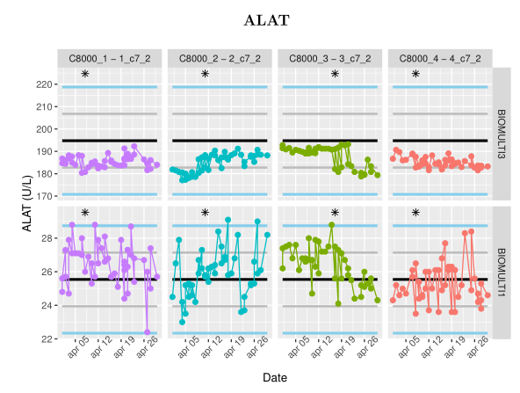

Controls

+1SD

Target

Change of reagent lot

Change of reagent lot

Change of reagent lot is marked by *, and change of control lot is marked by ▼. Please note that in its current version, the code only displays the first change of reagent and/or control lot during the analyzed time period. The black line depicts the target value for the respective controls, and blue lines depict +/- 1 and 2 SD.

The Table in the bottom half depicts the mean, CV (in %), CVmax, and difference in mean from the mean on the master instrument, both absolute (Abs_Diff) and in terms of SD (Diff_SD), stratified by controls and instruments.

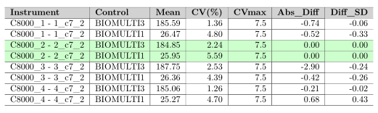

Green marks the master-instrument. The master instrument is defined in the R-code (lines #124-140), reflecting our lab’s choice and instrument names. Users from other labs will have to revise these lines so the right master instrument for their lab is selected. Fields with CV>Cvmax and/or Diff_SD>1.5 or Diff_SD<-1.5 are colored red. The +/-1.5 SD deviation rule reflects the maximum bias from the master instrument allowed in our lab.

************************************************************************************************

For ‘qc_cobas_summarytable’, pressing knit will make a table with all deviations from Cvmax and bias for all the tested analyses, thus providing an overview of the total deviations during the examined period.

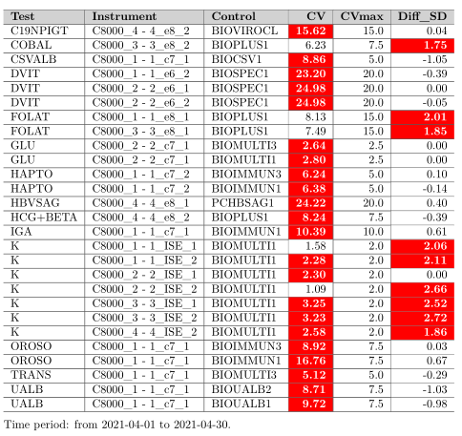

Please address questions or comments to stefan.stender@regionh.dk