Create VM from image customer guidance.

Author(s) : Klaas Jan de Jager

Version : 1.0

Status : Final

Source : Eviden Landing Zones for Azure

Document date : 4 September 2023

Number of pages :

Contents

[List of changes 3](#_Toc143614457)

[1. Introduction 4](#_Toc143614458)

[2. Shared Image Gallery concepts 5](#_Toc143614459)

[2.1 Image definitions 5](#_Toc143614460)

[2.2 Image versions 6](#_Toc143614461)

[2.3 Overview custom image in the Shared Image Gallery 6](#_Toc143614462)

[3. How to create a VM 7](#_Toc143614463)

[3.1 Using code 7](#_Toc143614464)

[3.2 From the portal; step-by-step description 10](#_Toc143614465)

[3.3 Virtual Machines blade 10](#_Toc143614466)

[3.4 Shared Image gallery blade. 16](#_Toc143614467)

# List of changes

|  |  |  |  |
| --- | --- | --- | --- |
| **Version** | **Date** | **Description** | **Author(s)** |
| 1.0 | 22-08-2023 | Initial Eviden version | K.J. de Jager |
|  |  |  |  |
|  |  |  |  |

# Introduction

This manual explains the Shared Image Gallery functionality which is part of the VM OS Management Service.

# Shared Image Gallery concepts

Shared Image Gallery is a service that helps to build structure and organization around custom images. Shared Image Galleries provide:

* Global replication of images.
* Versioning and grouping of images for easier management.
* Highly available images with Zone Redundant Storage (ZRS) accounts in regions that support Availability Zones. ZRS offers better resilience against zonal failures.
* Premium storage support (Premium\_LRS).
* Sharing across subscriptions, and even between Active Directory (AD) tenants, using Azure RBAC.
* Scaling your deployments with image replicas in each region.

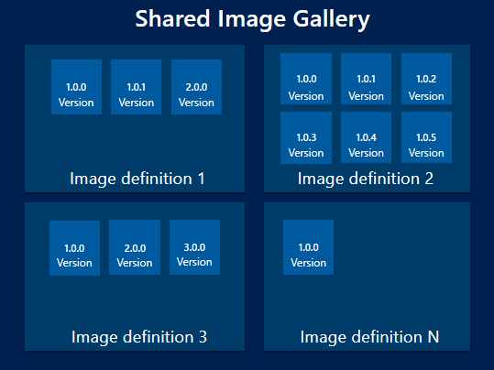

Diagram 2.1 Schematic overview Shared Image Gallery.

## Image definitions

Image definitions are a logical grouping for versions of an image. The image definition holds information about why the image was created, what OS it is for, and other information about using the image. An image definition is like a plan for all of the details around creating a specific image. You don't deploy a VM from an image definition, but from the image versions created from the definition.

## Image versions

An image version is what you use to create a VM. There can be multiple versions of an image as needed. When using an image version to create a VM, the image version is used to create new disks for the VM.

## Overview custom image in the Shared Image Gallery

The high-level overview of all parts needed to create (and start) a VM from a Shared Image Gallery is provided in diagram 2.2.

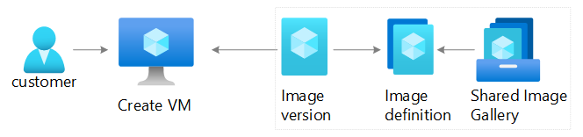   
Diagram 2.2 high-level overview.

# How to create a VM

Creating a VM, which utilizes a custom image from the Shared Image Gallery, can be done in multiple ways.

The following table sums up the different ways to create a VM and provides the URLs where the step-by-step manuals can be found.

|  |  |  |
| --- | --- | --- |
| **Nr** | **Method/technology** | **URL** |
| **1.** | VM creation using Azure CLI | [https://docs.microsoft.com/en-us/azure/virtual-machines/vm-generalized-image-version-cli#create-the-vm](https://docs.microsoft.com/en-us/azure/virtual-machines/vm-generalized-image-version-cli" \l "create-the-vm" \t "_blank) |
| **2.** | VM creation using Powershell | [https://docs.microsoft.com/en-us/azure/virtual-machines/vm-generalized-image-version-powershell](https://docs.microsoft.com/en-us/azure/virtual-machines/vm-generalized-image-version-powershell" \t "_blank) |
| **3.** | VM creation using ARM templates | Example ARM templates;  [https://github.com/Azure/azure-quickstart-templates/tree/master/101-vm-from-sig](https://github.com/Azure/azure-quickstart-templates/tree/master/101-vm-from-sig" \t "_blank) |
| **4.** | VM creation using the Portal | This document, in the next sub paragraphs. |

Table 3.1 overview ways to create VMs.

## Using code

When using code (nr 1. – 3. as described in table 3.1) to create a VM, the Resource ID of the image version in the Shared Image Gallery is necessary.

The Resource ID of an image version can be found on the VMOSManagementReporting dashboard.

The steps to acquire the Resource ID are as follows:

|  |  |
| --- | --- |
| **Nr** | **Activity** |
| **1.** | Log in to the Azure portal  Browse to https://portal.azure.com and login with the appropriate credentials. |
| **2.** | In the portal menu (up left in the Azure portal), select **Dashboard.**      And select the **VMOSManagmentReportingDashboard**. |
| **3.** | On the **VMOSManagmentReportingDashboard** dashboard, scroll down to the **VM OS Image Gallery** tile and select it. |
| **4.** | In the **VM OS Image Gallery** blade all image versions configured in the Azure environment are displayed. |
| **5.** | Click the entry in the last column **ResourceId,** for the desired image version Resource ID. |
| **6.** | In the **Details** blade click the copy button to copy the Resource ID.      The Resource ID can be pasted and used with code. |

## From the portal; step-by-step description

This step-by-step description focuses on the VM image and other related details of VM creation.

There are several extra sections (Disks, Networking, Management, Advanced & Tags) which are out of scope.

When using the portal to create resources there are multiple ways which lead to Rome.    
This sub paragraph will describe two.

1. Creation using the Virtual Machines blade.
2. Creation starting from the Shared Image gallery blade.

**Note**: When creating a VM from the portal, the latest version of the image is automatically selected. Creation of VMs from other versions of the image is currently not possible from the portal.

## Virtual Machines blade

|  |  |
| --- | --- |
| **Nr** | **Activity** |
| **1.** | Log in to the Azure portal  Browse to https://portal.azure.com and login with the appropriate credentials. |
| **2.** | In the top search bar of the Azure portal page, type 'virtual machines’        Choose **Virtual machines** from the results.  This will take you to an overview (blade) of all the created virtual machines visible to the logged in user. |
| **3.** | In the **Virtual machines** blade select **Add** button, then click **Virtual machine**, to start the process of creating a VM. |
| **4.** | In the **Create Virtual machine** blade.    In the **Basics** tab, under **Project details**, make sure the correct **Subscription** is selected and then choose to **Create new** **Resource group** and type ‘<resourcegroupname>’ for the name or select the correct resource group from the list. |
| **5a.** | Under **Instance details**, type ‘<the desired VM name>’ for the **Virtual machine name** and choose ‘<the region name>’ for your **Region**.    For the **Image**; select **See all images**. |
| **5b.** | From the new **Select an image** blade, select My Items and click **Shared Images.**      From the **Select an image** blade, select the desired image definition in the **Shared Image** gallery. |
| **5c.** | The selected image is displayed in the **Image** field.        Select the ‘<the desired Size>’ for the Size. Leave the other defaults. |
| **6** | For Linux OS’:  Under **Administrator account**, select **SSH public key**.  In **Username** type the ‘<desired admin username>’.  For **SSH public key source**, leave the default of Generate new key pair, and then type ‘<the desired key name>’ for the **Key pair name**.      During the VM creation process (after selecting the **Review+ create** button), the **Generate new key pair window** opens, select **Download private key and create resource**. Your key file will be download as ‘<the desired key name>’.pem. This is needed when connecting to the VM. |
| **7** | For Windows OS’:  Under **Administrator account**, provide a username, and a password. |
| **8.** | Under **Inbound port rules** > **Public inbound ports**, choose **Allow selected ports** and then select the desired ports to allow, for example HTTPS (443), from the drop-down. |
| **9.** | Leave the remaining defaults and then select the **Review + create** button at the bottom of the page. |

## Shared Image gallery blade.

The step-by-step guide(s) for creating a VM from the Shared Image gallery blade can be found on docs.microsoft.com.

The Linux guide is [here](https://docs.microsoft.com/en-us/azure/virtual-machines/linux/shared-images-portal#create-vms) and the Windows guide [here](https://docs.microsoft.com/en-us/azure/virtual-machines/windows/shared-images-portal#create-vms).