EVIDEN LANDING ZONES FOR AZURE PAAS SERVICES REPORTING DASHBOARD AND WORKBOOK INSTRUCTION MANUAL

Author(s) : Klaas Jan de Jager

Version : 1.0

Status : Final

Source : Eviden Landing Zones for Azure

Document date : 5 September 2023

Number of pages :

Contents

List of changes 4

1. Eviden Landing Zones for Azure PaaS Services Reporting Dashboard 5

2. SQL Database workbook 8

3. Data factory workbook 9

3.1 Azure Data Factory Overview 9

3.2 Azure Data Factory Analytics 10

4. Analysis Service workbook 12

5. App Service workbook 14

6. SQL Managed Instance workbook 15

7. Cosmos DB workbook 17

8. Cache for Redis workbook 19

9. Cache for Redis Ent. Workbook 21

10. Application Gateway workbook 22

11. MySQL Server workbook 23

11.1 Overview of the Azure Database for MySQL servers 23

11.2 Health information of the Azure Database for MySQL servers 24

12. MySQL Flex Server workbook 25

13. PostgreSQL Server workbook 26

13.1 Overview of the Azure Database for PostgreSQL servers 26

13.2 Health information of the Azure Database for PostgreSQL servers 27

14. PostgreSQL Flex. Svr workbook 28

15. MariaDB workbook 29

15.1 Overview of the Azure Database for MariaDB servers 29

15.2 Health information of the Azure Database for MariaDB servers 30

16. Databricks workbook 31

16.1 Overview of the Azure Databricks environment 31

16.2 Overview of the Azure Databricks clusters and VMs 32

17. Synapse Analytics workbook 33

17.1 Azure Synapse Workspaces 33

17.2 Synapse Workspace Health 34

17.3 Synapse Analytics pools 34

18. SQL Srv Stretch DB workbook 35

18.1 SQL Server Stretch databases 35

18.2 SQL database health 36

19. Dedicated SQL pools workbook 37

19.1 Dedicated SQL databases 37

19.2 SQL database health 38

20. Cosmos DB for PostgreSQL workbook 39

21. Data explorer cluster workbook 40

21.1 Overview of the Azure Data Explorer clusters 40

21.2 Health information of the Azure Data explorer cluster 41

22. Container Registry workbook 42

22.1 Azure Container Registry Overview 42

22.2 Azure container registry operations 43

23. AKS-Overview workbook 44

23.1 Overview Azure Kubernetes Services Deployed 44

23.2 Azure Kubernetes Services Metrics 45

24. AKS-Workloads workbook 46

24.1 Overview Azure Kubernetes Services Deployed 46

24.2 Azure Kubernetes Services Workloads 47

25. Azure Function workbook 50

25.1 Azure Functions Configuration Overview 50

25.2 Azure Function Workloads 51

# List of changes

|  |  |  |  |
| --- | --- | --- | --- |
| **Version** | **Date** | **Description** | **Author(s)** |
| 1.0 | 22-08-2023 | Initial Eviden version | K.J. de Jager |
|  |  |  |  |
|  |  |  |  |

# Eviden Landing Zones for Azure PaaS Services Reporting Dashboard

This dashboard is an entry point that guides you to get most of the insights on PaaS services of your cloud environment. The dashboard consists of multiple tiles that direct you to the concerning Azure Blade or Workbook. You can scroll up and down through the dashboard to see all tiles. In the following paragraphs and chapters all tiles and Workbooks will be shortly described.

To access the shared dashboard simply click on the menu on the top left in the portal. By default, “Dashboard” button is set on the top, see image below.

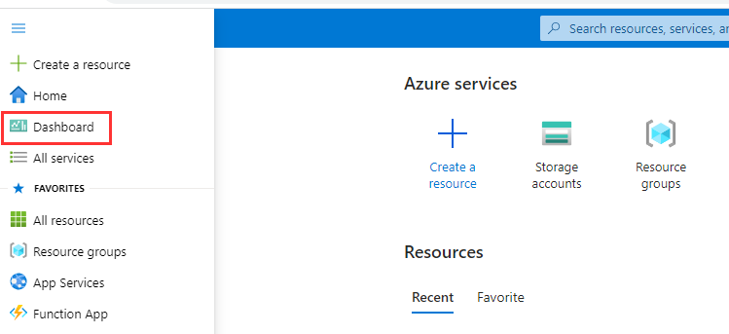

This should directly send you to the correct dashboard. If this is not the case, change the dashboard add the left top corner by clicking on the dashboard title and select PaaSServicesReportingDashboard, see image below.

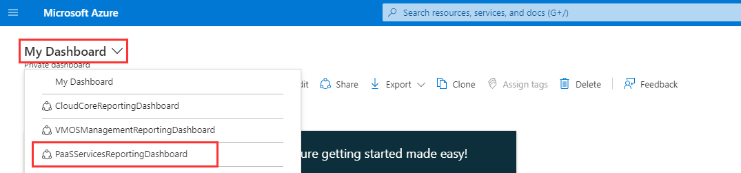

**Note:** In case the environment has been upgraded from a previous release, it is possible that 'old dashboard names' may still appear in this overview. Once one of these is selected, an error message should be shown, and after that, the dashboard will disappear from the dropdown menu.

The PaaS Services Reporting dashboard, as in the next picture, now appears:

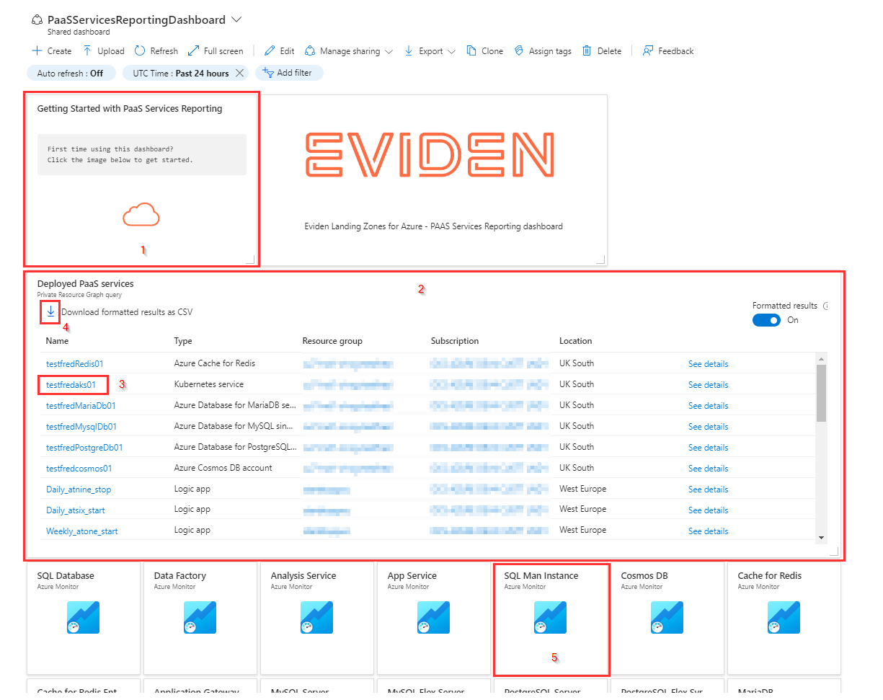

The **Getting Started tile [1]** is an informational tile that directs to an instruction manual on the Eviden Landing Zones for Azure reporting storage account (this document).

Below the Getting Started tile you will find an overview with **Deployed Paas Services [2]**. In this overview you will find all deployed Paas services in the environment together with the configuration information for the Paas resource, like:

* Name
* Type
* Resource group
* Subscription
* Location

By selecting the **Name [3]** in this overview you will be redirected to the Paas resource blade in Azure.  
The overview also provides the option **"Download formatted result as CSV" [4]** to export the overview as a CSV file and import this file in Excel.

As in Azure resource names for PAAS services are very long we use abbreviated names for the **tiles [5]** of the workbooks to make them fit in the tile.

Here is an overview of the abbreviated names we use for the workbooks.

|  |  |
| --- | --- |
| Report name in Tile | PAAS Resource |
| SQL Database | Azure SQL Databases |
| Data Factory | Azure Data Factory |
| Analysis Service | Azure Analysis Service |
| App Service | Azure App Service |
| SQL Man Instance | Azure SQL Managed Instance |
| Cosmos DB | Azure Cosmos DB |
| Cache for Redis | Azure Cache for Redis |
| Cache for Redis Ent | Azure Cache for Redis (Enterprise) |
| Application Gateway | Azure Application Gateway |
| MySQL Server | Azure Database for MySQL server |
| MySQL Flex Server | Azure Database for MySQL flexible server |
| PostgreSQL Server | Azure Database for PostgreSQL servers |
| PostgreSQL Flex. Svr | Azure Database for PostgreSQL flexible servers |
| MariaDB | Azure Database for MariaDB servers |
| Databricks | Azure Databricks |
| Synapse Analytics | Azure Synapse Analytics |
| SQL Svr Stretch DB | SQL Server stretch databases |
| Dedicated SQL pools | Dedicated SQL pools |
| Cosmos DB PostgreSQL | Cosmos DB for PostgreSQL clusters |
| Data explorer cluster | Data explorer clusters |
| Container Registry | Azure Container Registry |
| AKS-Overview | Azure Kubernetes Services Overview |
| AKS-Workloads | Azure Kubernetes Services Workloads |
| Azure Function | Azure Function configuration overview and workload details |

# SQL Database workbook

This report is used to give an overview of the available Azure SQL Databases in the environment with its configuration, the name of the SQL server, if the Azure SQL database is managed by Eviden, if the database is part of an elastic pool and if so, the state of the elastic pool.

It is possible to filter [1] on **Subscription**, **Location**, **ResourceGroup**, **SQL Server** or if the SQL Database is **Managed by Eviden**.

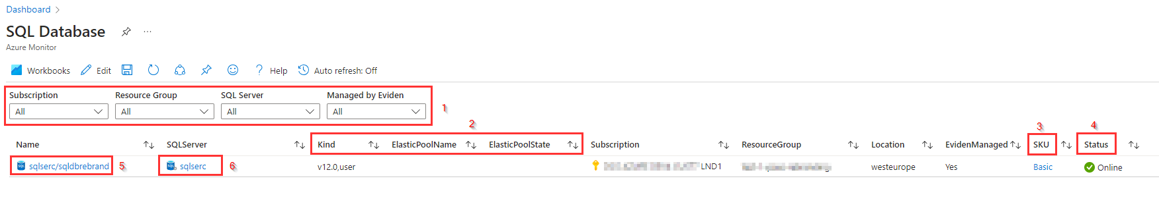

The SQL Database can be part of an Elastic Pool as will be shown in both the **Kind [2]** and **SKU[3]** column. In that case the **ElasticPoolName and the ElasticPoolState [2]** is also displayed in the report.  
For the SQL databases is displayed if the database is **Online or Offline** in the **Status [4]** column.

# Data factory workbook

The Data Factory workbook provides an overview of the Azure Data Factories that are created in the Azure environment with the most important configuration information and operational information based on a selected time range.  
To provide this information, the Data Factory report is divided in 2 parts:

* **Azure Data Factory Overview** with some essential configuration information
* **Azure Data Factory Analytics** with a summary of the overall health of the Data Factories and with detailed information about the health of the Data Factories

Both parts are now described in more detail

## Azure Data Factory Overview

In the upper part of the report there is an overview of all **Data Factories**. It is possible to **filter [1]** on **Subscription**, **Location**, **ResourceGroup**, **Public Network Access** or if the Data Factory is **Managed by Eviden**.

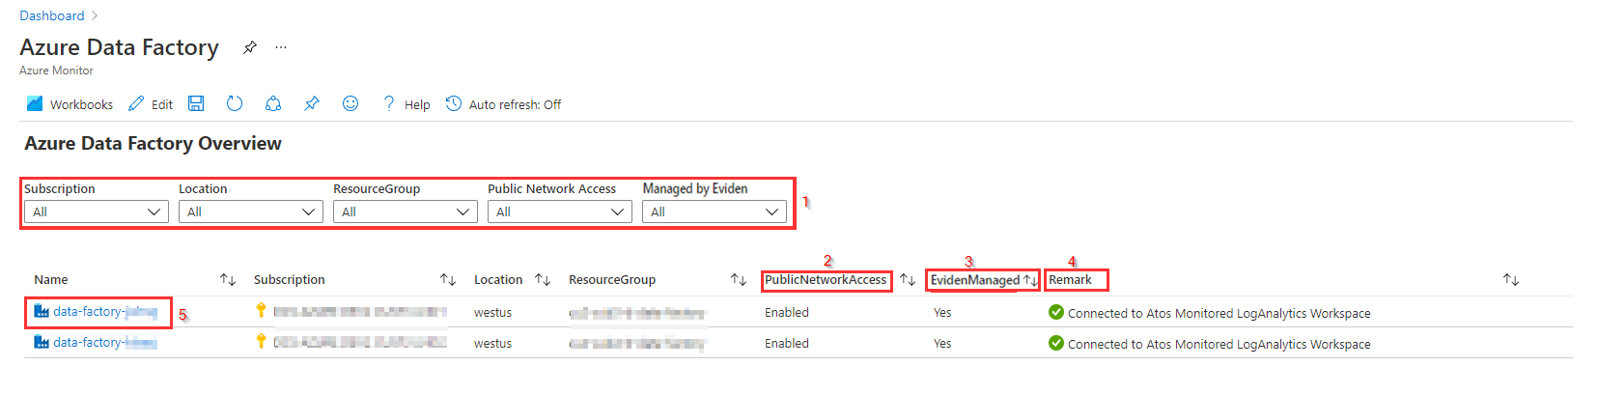

The **PublicNetworkAccess [2]** column shows if public network access is allowed for the Data Factory. This means that all networks, including the internet can access this Data Factory.

If the Azure Data factory has the tag **EvidenManaged** set to **true** then the **EvidenManaged [3]** column shows **Yes** in the report.

In the **Remark [4]** column there are 2 possible options:

* **Connected to Eviden Monitored Log Analytics Workspace**: The Data Factory sends its diagnostics information like metrics and logs to the Log Analytics Workspace that is monitored by Eviden. This means that EvidenManages this Data Factory. In this case you will also find additional Azure Data Factory Analytics information in the second part of this report.
* **Not connected to Eviden Monitored Log Analytics Workspace or no data logged yet**: This means that the Data Factory doesn't send its logs and metrics to the Log Analytics Workspace that is monitored by Eviden or, if the Azure Data Factory was just created and didn't start any pipeline, there was not send any data to the Log Analytics Workspace yet. In this case you will not find any data in the Azure Data Factory Analytics part of this report.

In the **Name [5]** column you can select a name of a Data factory to be redirected to the Data Factory blade in Azure.

## Azure Data Factory Analytics

In the second part of the report there is a summary of the overall health of the Data Factories with detailed information about the health of the Data Factories and to troubleshoot unexpected behaviour patterns.  
The following metrics are available:

* ADF Runs - 1) Pipeline Runs by Data Factory
* ADF Runs - 2) Activity Runs by Data Factory
* ADF Runs - 3) Trigger Runs by Data Factory
* ADF Errors - 1) Top 10 Pipeline Errors by Data Factory
* ADF Errors - 2) Top 10 Activity Runs by Data Factory
* ADF Errors - 3) Top 10 Trigger Errors by Data Factory
* ADF Statistics - 1) Activity Runs by Type
* ADF Statistics - 2) Trigger Runs by Type
* ADF Statistics - 3) Max Pipeline Runs Duration

The data shown in this report is based on a **Selected Time Range [1]** (from Last 30 minutes till Last 30 days) and are displayed per **metric [2]** first in **graphical format [3]** with **detailed information underneath [5]**.

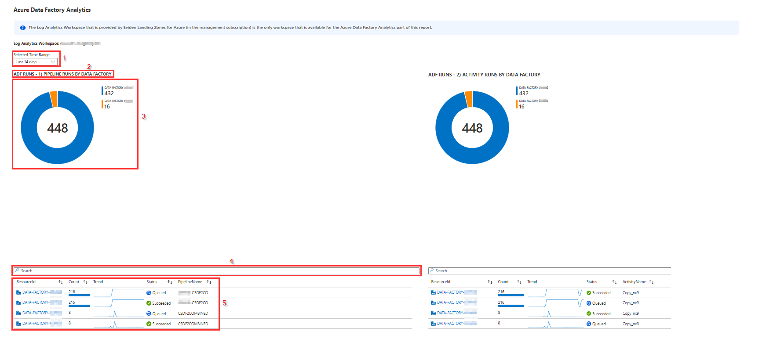

Using the **Searchbar [4]** above the detailed information for each metric you can search of filter on specific information.

This part of the report is based on the Azure Data Factory Analytics solution from Azure marketplace: <https://docs.microsoft.com/en-us/azure/data-factory/monitor-using-azure-monitor#install-azure-data-factory-analytics-solution-from-azure-marketplace>

More information about each metric can be found [here](https://learn.microsoft.com/en-us/azure/data-factory/monitor-metrics-alerts#data-factory-metrics)

**Known Issue’s**

If the report is opened it will sometimes take some time before all parts of the report are available.

# Analysis Service workbook

The Analysis Service workbook provides an overview of the Azure Analysis Services that are created in the Azure environment with the most important configuration information and status information.  
If the Azure Analysis Service is connected to the Eviden Managed Log Analytics Workspace the status of the service (Active or Paused) is also shown in the report.

In the report there is an overview of all **Analysis Services**. It is possible to **filter [1]** on **Subscription**, **Location**, **ResourceGroup**, if the Analysis Services is **Managed by Eviden**, **Pricing Tier** or **Managed Mode**.

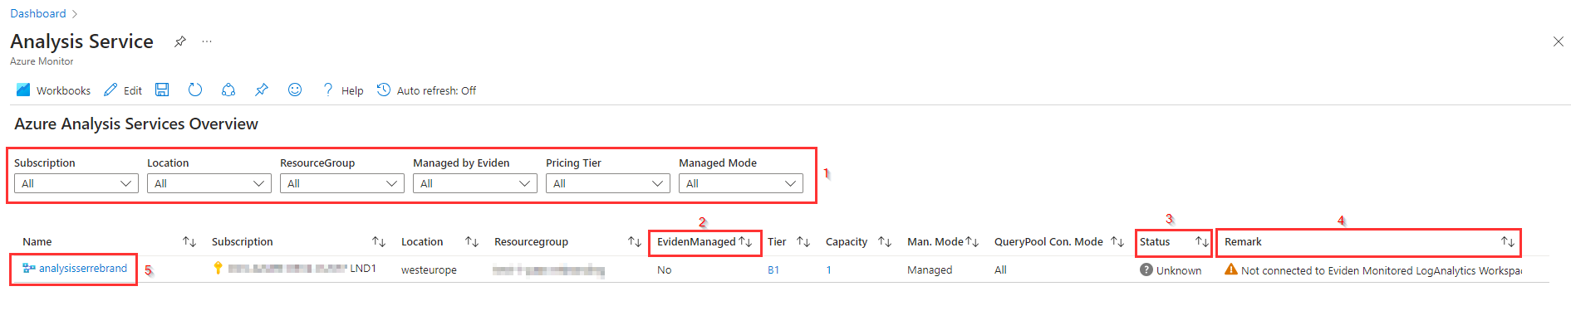

If the Azure Analysis Service has the tag ****EvidenManaged****set to ****true****, then the column ****EvidenManaged [2]**** displays ****Yes**** in the report. If the Azure Analysis Service is connected to the Eviden Managed ****Log Analytics Workspace**** the ****Status [3]****of the service (Active or Paused) is also shown in the report.

In the ****Remark [4]**** column there are 2 possible options:

* ****Connected to Eviden Monitored Log Analytics Workspace****: The Analysis Service sends its diagnostics information like metrics and logs to the Log Analytics Workspace that is monitored by Eviden. This means that Eviden Manages this Analysis Service. In this case the report also shows the status of the Analysis Service. The status is obtained from the log analytics workspace.
* ****Not connected to Eviden Monitored Log Analytics Workspace or no data logged yet****: This means that the Analysis Service doesn't send its logs and metrics to the Log Analytics Workspace that is monitored by Eviden or. It is also possible that the Analysis Service hasn't been active in the past 30 days, so there was not send any data to the Log Analytics Workspace in the past 30 days. In this case the ****status**** is not available in this report and ****Unknown**** is shown in the Status column.

When the ****Name [5]****of the Analysis Service is selected, the blade for the Analysis Service in the portal is opened.

**Known Issue's**

If the report is opened it will sometimes take some time before all parts of the report are available.

# App Service workbook

In the report there is an overview of all **Azure App Services**. It is possible to filter [1] on **Subscription**, **ResourceGroup**, **App Service**, **App Service Plan** or if the App Services is **Managed by Eviden**.

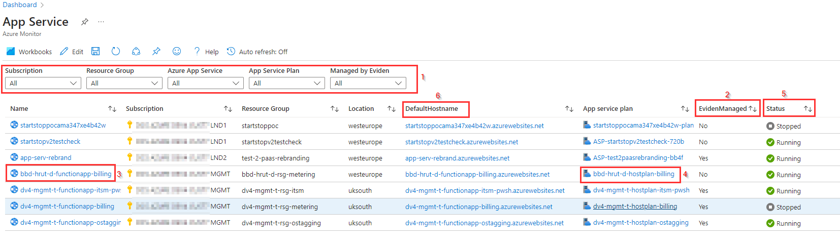

If the Azure App Service has the tag ****EvidenManaged**** set to ****true**** then the ****EvidenManaged [2]**** shows ****Yes**** in the report.  
When the ****Name [3]**** of the App Service is selected, the ****blade for the App Service**** is opened. When clicking on the name of the ****App Service Plan [4]**** the ****Apps Service Plan blade**** is opened.  
In the ****Status [5]**** column you will find the status of the App Service. By copying the hostname in the ****DefaultHostName [6]**** column and preceding this name with "https://" you can check the status of the App Service using a webbrowser also.

**Known Issue's**

If the report is opened it will sometimes take some time before all parts of the report are available.

# SQL Managed Instance workbook

This report is used to give an overview of all deployed Azure SQL Managed instances in the environment with current configuration and the state.  
The bottom part of the report shows all deployed databases for the select SQL managed instance(s)

It is possible to **filter [1]** on **Subscription**, **Resource group**, **SQL managed instance name**, and on **Managed by Eviden**.

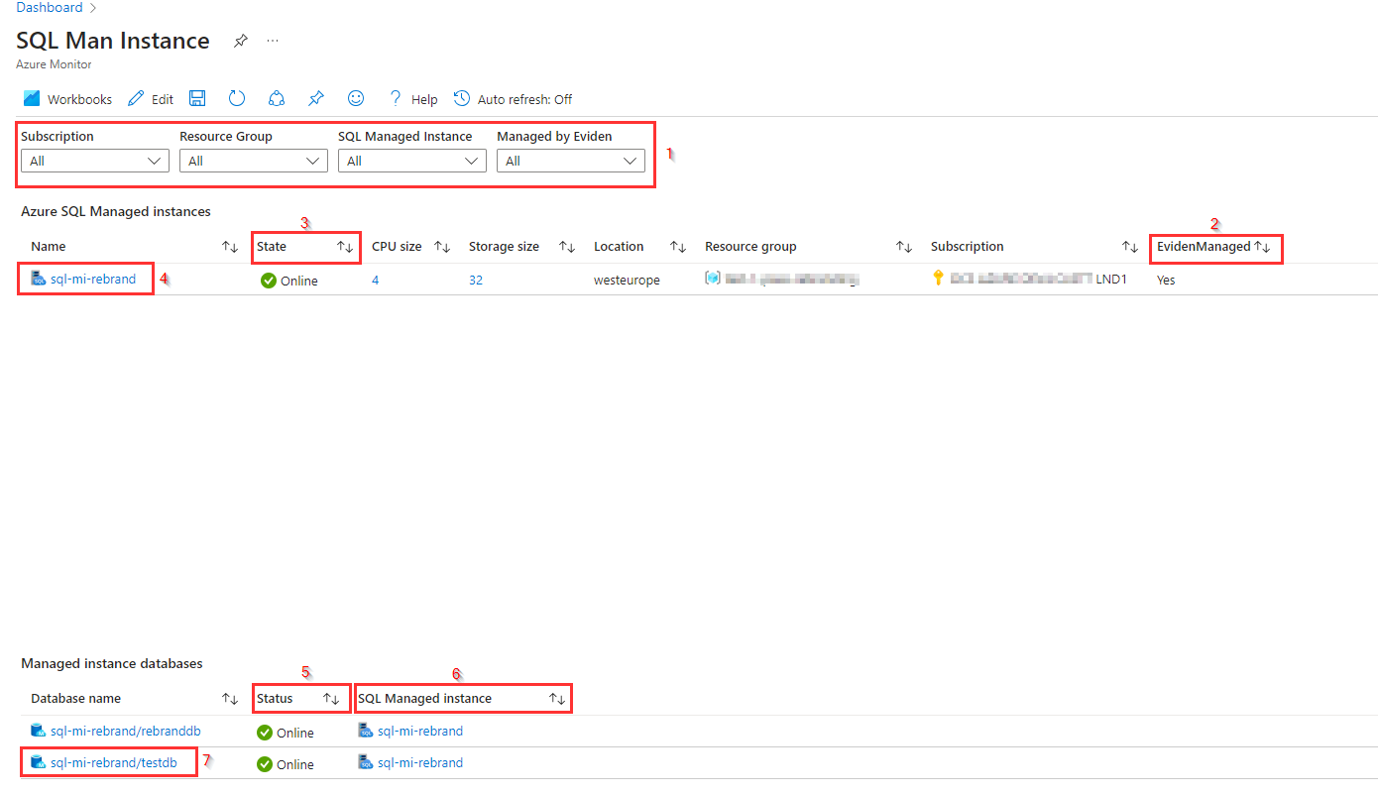

If the Azure SQL Managed instance has tag **EvidenManaged** set to **true** then the **EvidenManaged [2]** column is set to **Yes** in the report. If tag EvidenManaged is not set or has value "false" or any other value, then **EvidenManaged [2]** column is set to "No" in the report.  
In the **State [3]** column is visible if the SQL managed instance is **Ready**. As the creation of a SQL Managed instance takes several hours it is possible that **State** still shows **Creating** if the SQL managed Instance has just created or **Deleting** if the SQL Managed Instance is being deleted, which can also take up to 2 hours.  
For the SQL Managed Instances the **CPU size** and the **Storage Size** are also shown in separate columns.

The bottom part of the report shows all deployed databases for the select SQL managed instance(s) together with the **State [5]** and the **SQL Managed Instance [6]** it belongs to.

Left-clicking on name of the **SQL Managed instance name[4]** and/or **Database Name [7]** will open the associated standard Azure Portal blade for the corresponding Azure resource.

**Known Issues.**

If the report is opened it will sometimes take some time before all parts of the report are available.

# Cosmos DB workbook

In the top part of the report there is an overview of all **Azure Azure Cosmos DB accounts** in the environment. It is possible to **filter [1]** on **Subscription**, **ResourceGroup**, **Cosmos DB account** or if the service is **Managed by Eviden**.

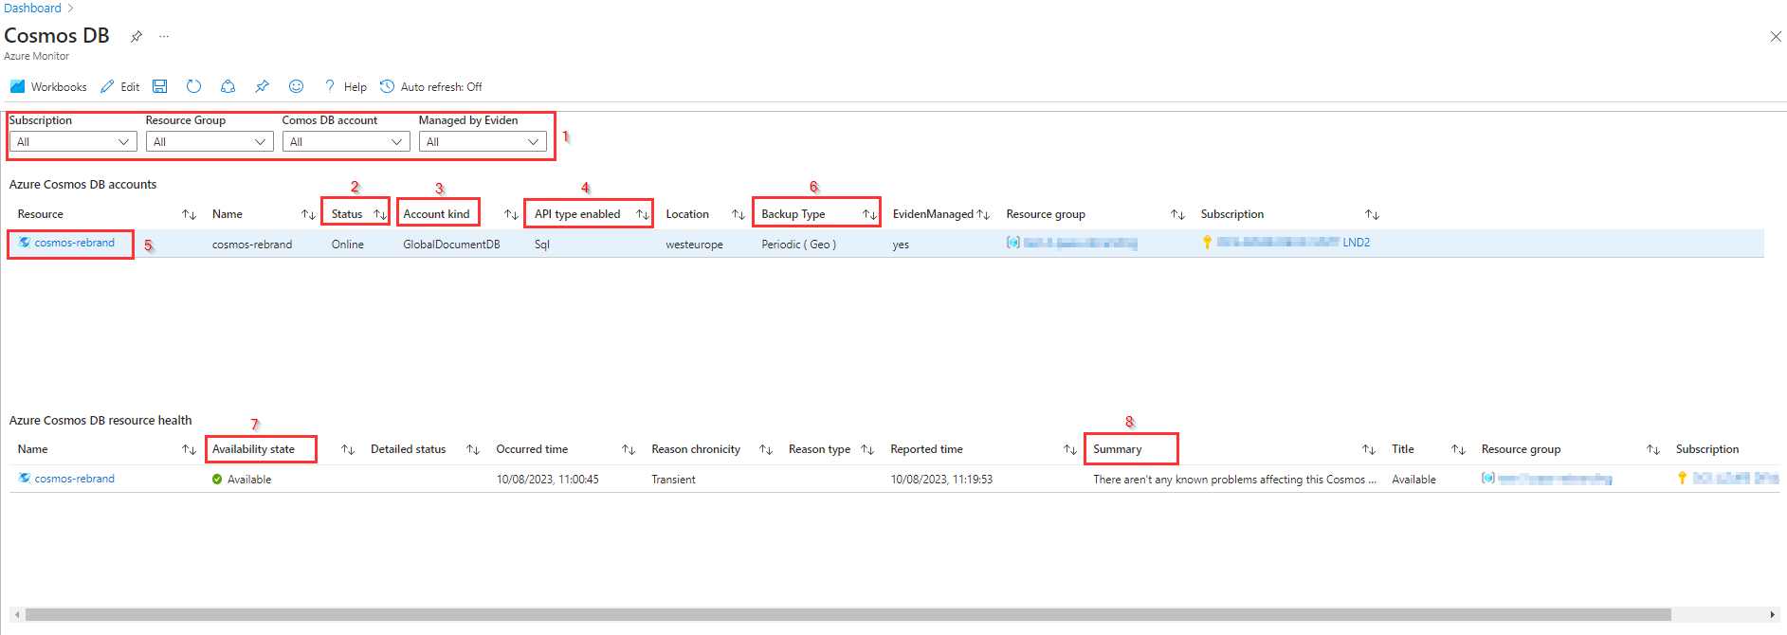

In the report the **Account kind [2]**, **Api type enabled [3]** and **Backup Type [4]** information is available together with **Location**, **Resource group** and **Subscription**. By clicking on the **name of the Resource [5]** you are redirected to the Azure blade of the Cosmos DB account.  
If the **Azure Cosmos DB account** has the tag **EvidenManaged** set to **true** then the **Eviden Managed** column is set to **Yes** in the report.

In the **bottom overview** the **Availability state [7]** of the Cosmos DB account is displayed together with **Detailed status**, **Occurred time** (moment state was changed to current state), **Reason**, **Reported time**, **Summary [8]**, **Title**, **Resource Group** and **Subscription** Information.

**Availability State [6]** as shown in bottom overview can have the following value's:

* **Available** means that there are no events detected that affect the health of the resource.
* **Unavailable** means that the service detected an ongoing platform or non-platform event that affects the health of the resource.
* **Unknown** means that Resource Health hasn't received information about the resource for more than 10 minutes.
* **Degraded** means that your resource detected a loss in performance, although it's still available for use.

**Summary [8]** provides a short description about the **Availability State**.

**Known Issue's**

As the **Cosmos DB account** is not a resource that can be stopped or paused no **Detailed status** information is available in the report, only **Availability state** is available.

# Cache for Redis workbook

In the report there is an overview of all **Azure Cache for Redis services** in the environment. It is possible to **filter [1]** on **Subscription**, **ResourceGroup**, **Redis Account** or if the service is **Managed by Eviden**.

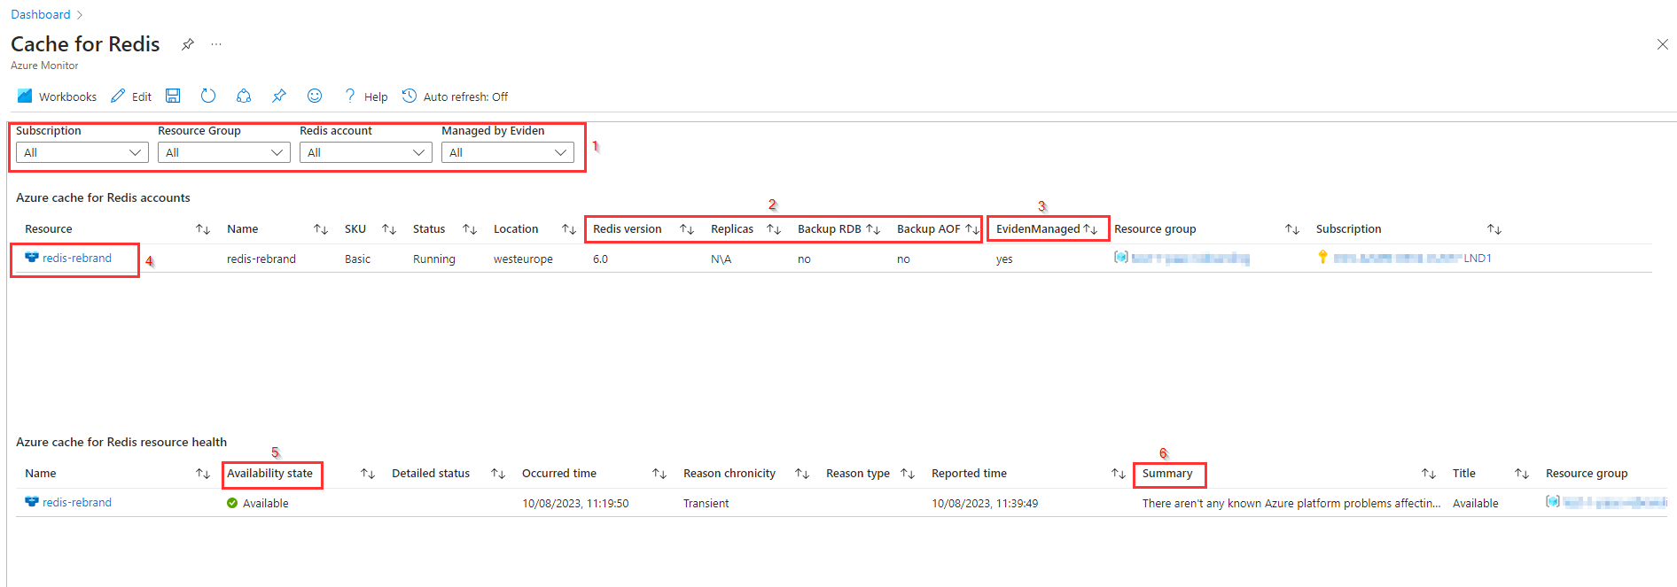

In the report the **SKU**, **Location**, **Redis Version, Replicas and backup information [2]** is available together with the **Resource group** and **Subscription**. If the **Cache for Redis service** has the tag **EvidenManaged** set to **true** then the **Eviden managed [3]** column is set to **Yes** in the report.  
By clicking on the **name of the Resource [4]** you are redirected to the Azure blade of the Cache for Redis Service.

In the **bottom overview** the **Availability state [5]** of the Cache for Redis account is displayed together with **Detailed status**, **Occurred time** (moment state was changed to current state), **Reason**, **Reported time**, **Summary [6]**, **Title**, **Resource Group** and **Subscription** Information.

**Availability state [5]** as shown in bottom overview can have the following value's:

* **Available** means that there are no events detected that affect the health of the resource.
* **Unavailable** means that the service detected an ongoing platform or non-platform event that affects the health of the resource.
* **Unknown** means that Resource Health hasn't received information about the resource for more than 10 minutes.
* **Degraded** means that your resource detected a loss in performance, although it's still available for use.

**Summary [6]** provides a short description about the **Availability State**.

**Known Issue's**

As **Cache for Redis** is not a resource that can be stopped or paused no **Detailed status** information is available in the report, only **Availability state** is available.

# Cache for Redis Ent. Workbook

In the report there is an overview of all **Azure Cache for Redis Enterprise-tier** services in the environment. It is possible to **filter [1]** on **Subscription**, **ResourceGroup**, **Redis Enterprise** cache name or if the service is **Managed by Eviden**.

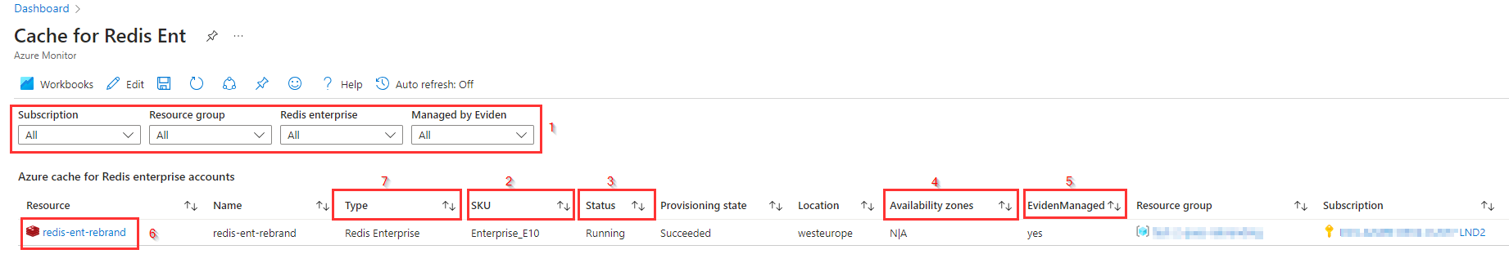

In the report the ****SKU [2]**** and ****Status [3]**** are displayed together with ****Resource location****, ****Availability zones [4]****, ****Resource group**** and ****Subscription****. Note that ****Type [7]**** is hardcoded set to "Redis Enterprise".  
The ****SKU [2]**** for a Cache for Redis Enterprise always starts with ****Enterprise_**** followed by ****E10, E20, E50** or **E100****. ****E10**** is the cheapest SKU. For more information and pricing check this [link](https://azure.microsoft.com/en-us/pricing/details/cache/) .

If the Azure Cache for Redis Enterprise is available, the ****Resource state [3]****shows ****Running****. If Zone Redundancy is enabled, this is visible in the ****Availability zones [4]****column.

If the Azure Cache for Redis Enterprise-tier service has the tag ****EvidenManaged**** set to****true,**** then the ****EvidenManaged [5]**** column is set to **Yes** in the report. When the Resource name of the **Cache for **Redis Enterprise [6]**** is selected the ****Azure portal blade for Cache for Redis Enterprise**** is opened for that resource.

# Application Gateway workbook

The Azure Application Gateway report provides an overview of Azure Application Gateways that are deployed in the Azure environment with the most important configuration and status information.  
It is possible to **filter [1]** on **Subscription**, **Resource group**, **Application Gateway name**, and on **Managed by Eviden**.

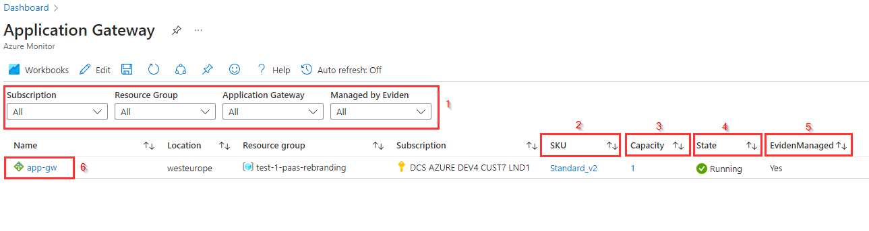

The **SKU [2]** column shows if the Application gateway is a standard application gateway (**Standard**) or if it has the Web Application Firewall (**WAF**) enabled.  
The **Capacity [3]** column shows the instance count for the application gateway.  
In the **State [4]** column the operational state is shown. this can be **Running** or **Stopped**.

If the Azure Application Gateway has tag **EvidenManaged** set to **true** then **EvidenManaged [5]** is set to **Yes** in the report. If tag EvidenManaged is not set or has value "false" or any other value, then "Managed by Eviden" is set to "No" in the report.

Left-clicking on **name of the Azure Application Gateway [6]** will open the associated standard Azure Portal blade for the corresponding Azure Application Gateway resource.

**Known issues and limitations.**

If the report is opened it will sometimes take some time before all parts of the report are available.

Note that this report will just show state for the Application Gateway instance itself and does not include details and health of configured backend resources. This information is available in the standard Azure Portal blade for each Azure Application Gateway instance.

# MySQL Server workbook

The MySQL Server report provides an overview of Azure Database for MySQL Servers that are deployed in the Azure environment with the most important configuration information and status information.

For this the report consists of 2 parts:

* An overview of the configuration information of the Azure Database for MySQL servers
* The health information of the Azure Database for MySQL servers

It is possible to filter[1] on **Subscription**, **Resource group**, **MySQL Database name**, and on **Managed by Eviden**.  
The filters apply to both parts of the report.

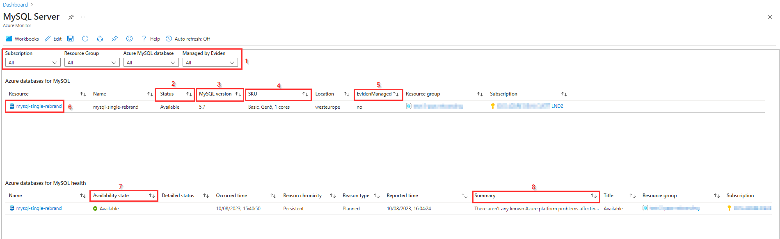

## Overview of the Azure Database for MySQL servers

In the overview part of the report you find the **Status [2]** column for the MySQL servers. The status can be **Available**, **Stopping**, **Stopped** or **Starting**. The **MySQL version [3]** column shows the version of MySQL that is deployed and the **SKU [4]** column shows information about the Tier, Family and Cores for the MySQL server.

If the Azure MySQL server instance has tag **EvidenManaged** set to **true** then **EvidenManaged [5]** is set to **Yes** in the report. If tag EvidenManaged is not set or has value "false" or any other value, then *EvidenManaged [5]*\* is set to **No** in the report.  
By selecting the **name of the MySQL server [6]** in the **Resource** column you are redirected to the blade of the MySQL server in Azure.

## Health information of the Azure Database for MySQL servers

In the health information part you will find the **Availability state [7]** column that shows the health of the MYSQL server and a **Summary [8]** column with a short description about the Availability state.

**Availability state [7]** can have the following value's:

* **Available** means that there are no events detected that affect the health of the resource.
* **Unavailable** means that the service detected an ongoing platform or non-platform event that affects the health of the resource.
* **Unknown** means that Resource Health hasn't received information about the resource for more than 10 minutes.
* **Degraded** means that your resource detected a loss in performance, although it's still available for use.

**Known issues and limitations.**

If the report is opened it will sometimes take some time before all parts of the report are available.

# MySQL Flex Server workbook

The MySQL Flex Server report provides an overview of Azure Databases for MySQL Flexible Servers that are deployed in the Azure environment with the most important configuration information and status information.

It is possible to **filter [1]** on **Subscription**, **Resource group**, **Azure MySQL Database name**, and on **Managed by Eviden**.

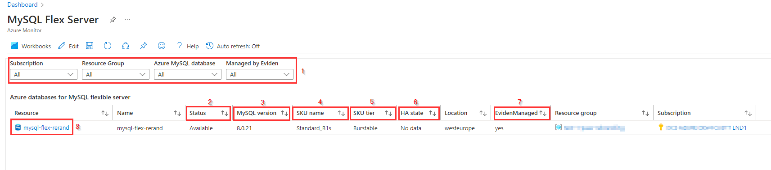

In the overview part of the report you find the ****Status [2]**** column for the MySQL Flexible Servers. The status can be ****Available****, ****Stopping****, ****Stopped**** or ****Starting****. The ****MySQL version [3]**** column shows the version of MySQL that is deployed, the ****SKU name[4]**** column shows **Compute size** of the MYSQL flexible server while ****SKU Tier [5]**** shows the **Compute Tier**. The Compute tier can be ****Burstable****, ****General Purpose**** or ****Business Critical****.  
The ****HA state [6]**** column shows if for the MYSQL Flexible server High Availability is enabled. If it shows ****No data**** then High Availability is not enabled. High Availability is not supported for the **Burstable** tier.

If the Azure MySQL Flexibel Server has tag ****EvidenManaged**** set to ****true**** then ****EvidenManaged [7]**** is set to ****Yes**** in the report. If tag EvidenManaged is not set or has value ****false**** or any other value, then ****EvidenManaged [7]**** is set to ****No**** in the report.

Left-clicking on ****name of the Azure MySQL Flexible Server [8]**** will open the associated standard Azure Portal blade for the corresponding Azure MySQL Flexible Server resource.

**Known issues and limitations.**

If the report is opened it will sometimes take some time before all parts of the report are available.

# PostgreSQL Server workbook

The PostgreSQL Server report provides an overview of Azure Databases for PostgreSQL single servers that are deployed in the Azure environment with the most important configuration information and status information.

For this the report consists of 2 parts:

* An overview of the configuration information of the Azure Database for PostgreSQL servers
* The health information of the Azure Database for PostgreSQL servers

It is possible to **filter [1]** on **Subscription**, **Resource group**, **Azure PostgreSQL Database name**, and on **Managed by Eviden**. The filters apply to both parts of the report.

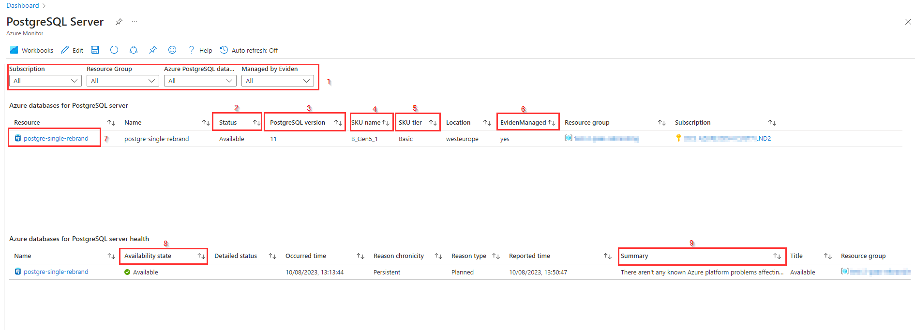

## Overview of the Azure Database for PostgreSQL servers

In the overview part of the report, you find the ****Status [2]**** column for the Azure Database for PostgreSQL servers. The status can be ****Available****, ****Stopping****, ****Stopped**** or ****Starting****. The ****PostgreSQL version [3]**** column shows the version of PostgreSQL that is deployed and the ****SKU name[4]**** column shows ****Compute size**** of the PostgreSQL server while ****SKU Tier [5]**** shows the ****Compute Tier****. The Compute tier can be ****Basic****, ****General Purpose**** or ****Memory Optimized****.

If the Azure Database for PostgreSQL server has tag ****EvidenManaged**** set to ****true,**** then ****EvidenManaged [6]**** is set to ****Yes**** in the report. If tag **EvidenManaged** is not set or has value "false" or any other value, then ****EvidenManaged [6]**** is set to ****No**** in the report.

Left-clicking on ****name of the Azure Database for PostgreSQL server [7]**** will open the associated standard Azure Portal blade for the corresponding Azure Database for PostgreSQL server resource.

## Health information of the Azure Database for PostgreSQL servers

In the health information part you will find the **Availability state [7]** column that shows the health of the PostgreSQL server and a **Summary [8]** column with a short description about the Availability state.

**Availability state [7]** can have the following value's:

* **Available** means that there are no events detected that affect the health of the resource.
* **Unavailable** means that the service detected an ongoing platform or non-platform event that affects the health of the resource.
* **Unknown** means that Resource Health hasn't received information about the resource for more than 10 minutes.
* **Degraded** means that your resource detected a loss in performance, although it's still available for use.

**Known issues and limitations**

If the report is opened it will sometimes take some time before all parts of the report are available.

# PostgreSQL Flex. Svr workbook

The PostgreSQL Flex. srv report provides an overview of Azure Databases for PostgreSQL Flexible servers that are deployed in the Azure environment with the most important configuration information and status information.

It is possible to **filter [1]** on **Subscription**, **Resource group**, **Azure PostgreSQL Database name**, and on **Managed by Eviden**.

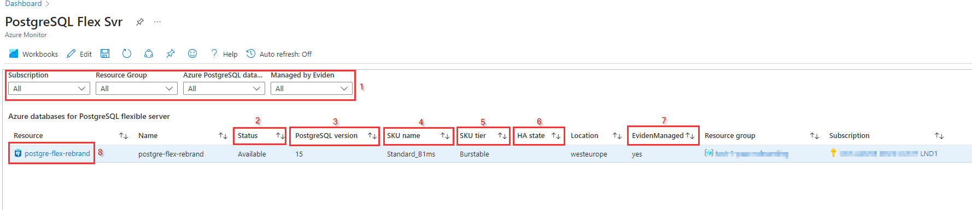

In the overview part of the report you find the **Status [2]** column for the PostgreSQL Flexible Servers. The status can be **Available**, **Stopping**, **Stopped** or **Starting**. The **PostgreSQL version [3]** column shows the version of PostgreSQL that is deployed, the **SKU name[4]** column shows **Compute size** of the PostgreSQL flexible server while **SKU Tier [5]** shows the **Compute Tier**. The Compute tier can be **Burstable**, **General Purpose** or **Memory Optimized**.  
The **HA state [6]** column shows if for the PostgreSQL Flexible server High Availability is enabled. High Availability is not supported for the **Burstable** tier.

If the Azure MySQL Flexibel Server has tag **EvidenManaged** set to **true** then **EvidenManaged [7]** is set to **Yes** in the report. If tag EvidenManaged is not set or has value **false** or any other value, then **EvidenManaged [7]** is set to **No** in the report.

Left-clicking on **name of the Azure MySQL Flexible Server [8]** will open the associated standard Azure Portal blade for the corresponding Azure MySQL Flexible Server resource.

# MariaDB workbook

The MariaDB report provides an overview of Azure Databases for MariaDB server that are deployed in the Azure environment with the most important configuration information and status information.

For this the report consists of 2 parts:

* An overview of the configuration information of the Azure Database for MariaDB servers
* The health information of the Azure Database for Azure Database for MariaDB servers

It is possible to **filter [1]** on **Subscription**, **Resource group**, **Azure MariaDB database name**, and on **Managed by Eviden**. The filters apply to both parts of the report.

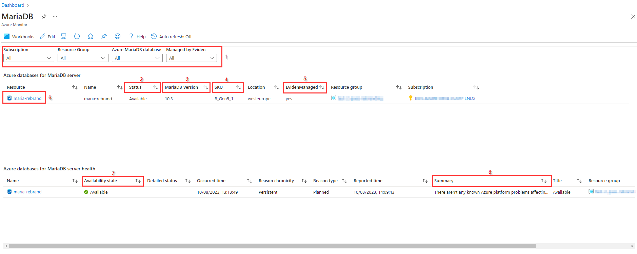

## Overview of the Azure Database for MariaDB servers

In the overview part of the report you find the **Status [2]** column for the Azure Database for MariaDB servers. The status can be **Available**, **Stopping**, **Stopped** or **Starting**. The **MariaDB version [3]** column shows the version of MariaDB that is deployed and the **SKU [4]** column shows information about the Compute size for the MariaDB server.

If the Azure Database for MariaDB server has tag **EvidenManaged** set to **true,** then **EvidenManaged** is set to **Yes** in the report. If tag EvidenManaged is not set or has value **false** or any other value, then **EvidenManaged** is set to **No** in the report.  
By selecting the **name of the MariaDB server [6]** in the **Resource** column you are redirected to the blade of the MySQL server in Azure.

## Health information of the Azure Database for MariaDB servers

In the health information part, you will find the **Availability state [7]** column that shows the health of the MariaDB server and a **Summary [8]** column with a short description about the Availability state.

**Availability state [7]** can have the following value's:

* **Available** means that there are no events detected that affect the health of the resource.
* **Unavailable** means that the service detected an ongoing platform or non-platform event that affects the health of the resource.
* **Unknown** means that Resource Health hasn't received information about the resource for more than 10 minutes.
* **Degraded** means that your resource detected a loss in performance, although it's still available for use.

**Known issues and limitations.**

If the report is opened it will sometimes take some time before all parts of the report are available.

# Databricks workbook

The Databricks report provides an overview of Azure Databricks Workspaces and Azure Databricks clusters that are deployed in the Azure environment with the most important configuration information and status information.

For this the report consists of 2 parts:

* An overview of the configuration information of the Azure Databricks environments
* An overview of the configuration information of the Azure Databricks clusters and VMs

It is possible to filter [1] on **Subscription**, **Resource group**, **Databricks Workspace**, **Workspace ID** and on **Managed by Eviden**. The filters **Subscription**, **Resource group**, **Managed by Eviden**, **Databricks Workspace** apply to the **first part** (Azure Databricks environments) of the report.  
The **Subscription** and **Workspace ID** apply to the **bottom part** (Azure Databricks clusters and VMs) of the report.

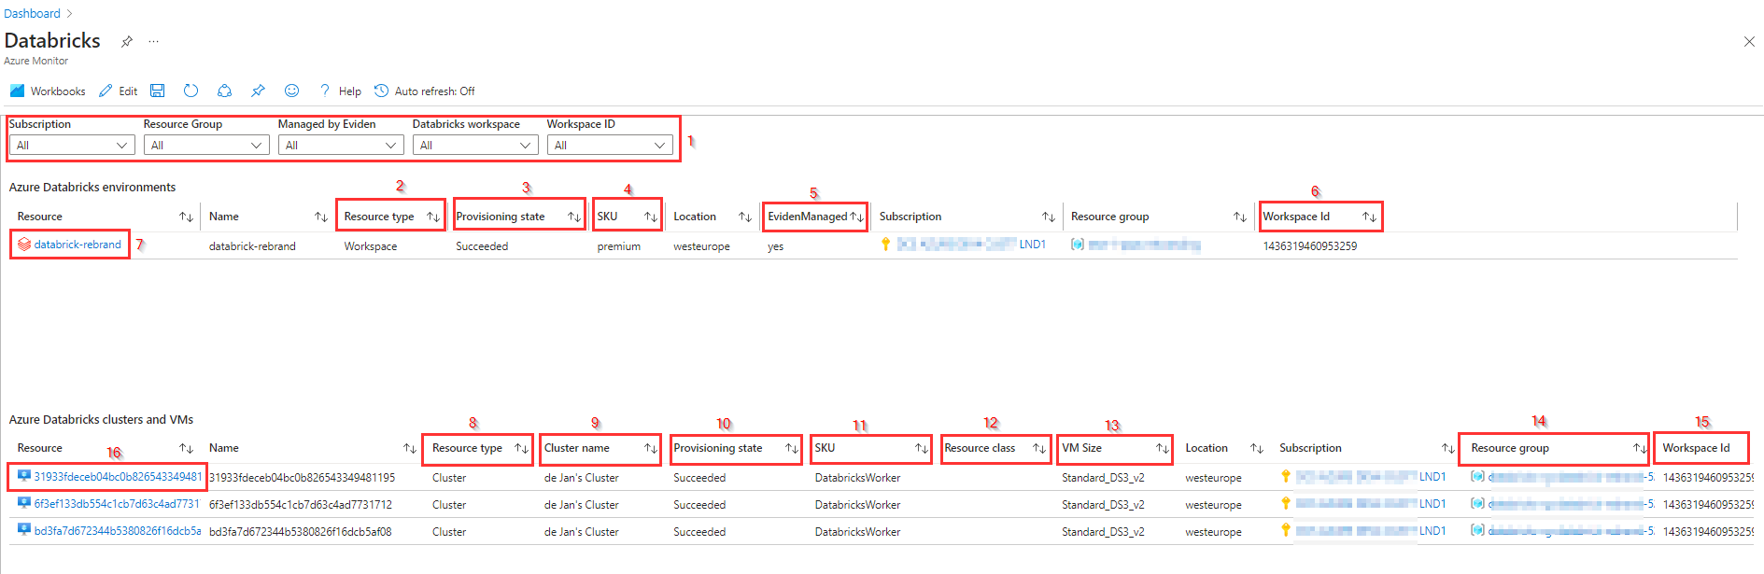

## Overview of the Azure Databricks environment

The **Resource type [2]** column for databricks will always show Workspaceas a resource type in the first part of the report. The **Provisioning state [3]** column shows **Succeeded** if the databricks workspace is available. Other values can be **Creating** or **Deleting**.  
The **SKU [4]** column shows the Pricing Tier for the Databricks workspace. SKU can be:

* **Trial** (Premium - 14 days Free DBU's)
* **Premium** (+ Roel-based access controls)
* **Standard** (Apache Spark, Secure with Azure AD)

If the Azure Databricks workspace has tag **EvidenManaged** set to **true** then **EvidenManaged [5]** is set to **Yes** in the report. If tag EvidenManaged is not set or has value "false" or any other value, then **EvidenManaged [5]** is set to **No** in the report.

In the last column you will find the **Workspace Id [6]** of the Databricks workspace. By using the **Workspace ID filter [1]** at the top, to select the Workspace Id as is visible in this column, the clusters and Vm's that belong to a specific Databricks workspace can be selected for the bottom part of the report.  
By selecting the **name of the Databricks Workspace [7]** in the **Resource** column you are redirected to the blade of the Databricks Workspace in Azure.

## Overview of the Azure Databricks clusters and VMs

This bottom part of the report shows the configuration information of the **Azure Databricks clusters** and **VMs** based on the **Subcription** and **Workspace ID** filters at the top of the report.

In this part for the Azure Databricks clusters and Vm's you also find the **Resource type [8]** column. In this part the Resource type is **Cluster** even if its only consisting of one virtual machine. In that case it will be a single node cluster. For a cluster you will find the name in the **Cluster name [9]** column. If the cluster or VM is available **Provisioning state [10]** is **succeeded**. Other values for this column are **Creating** or **Deleting**.  
For a Databricks cluster the **SKU [11]** will be **DataBricksWorker**. The **Resource class [12]** column shows if its a SingleNode or MultiNode cluster and in the **VM Size [13]** column the Size of the VM/Node is shown.  
For Databricks clusters, automatically a separate resource group is created in the same Subscription as the Databricks workspace. The name of this resourcegroup can be found in the **Resource group [14]** column.  
In the last column you will find the **Workspace Id [15]** of the Databricks workspace. By using the **Workspace ID filter [1]** at the top, to select the Workspace Id as is visible in this column, the clusters and Vm's that belong to a specific Databricks workspace can be selected for the bottom part of the report.

Left-clicking on name of the **Azure Databricks Cluster [16]** will open the associated standard Azure Portal blade for the corresponding Azure Databricks environment.

**Known issues and limitations.**

If the report is opened it will sometimes take some time before all parts of the report are available.

# Synapse Analytics workbook

This report shows an overview of all deployed Azure Synapse Analytics Workspaces in the environment with current configuration, health state and Synapse Analytic pools.

For this the report consists of 3 parts:

* Azure Synapse Workspaces: An overview of the configuration information of the Azure Synapse Analytics Workspaces
* Synapse Workspace Health: The health information of the Azure Synapse Analytics Workspaces
* Synapse Analytics pools: An overview of the Synapse Analytic pools

It is possible to **filter [1]** on **Subscription**, **Resource group**, **Managed by Eviden**, **Synapse Workspaces** and on **Synapse Analytics Pools**. The filters **Subscription**, **Resource group**, **Managed by Eviden**, **Synapse Workspaces** apply to the first part of the report. **Synapse Workspaces** applies to the second part of the report and filter **Synapse Analytics Pools** only applies to the bottom part of the report as this is the only part where the pools are visible.

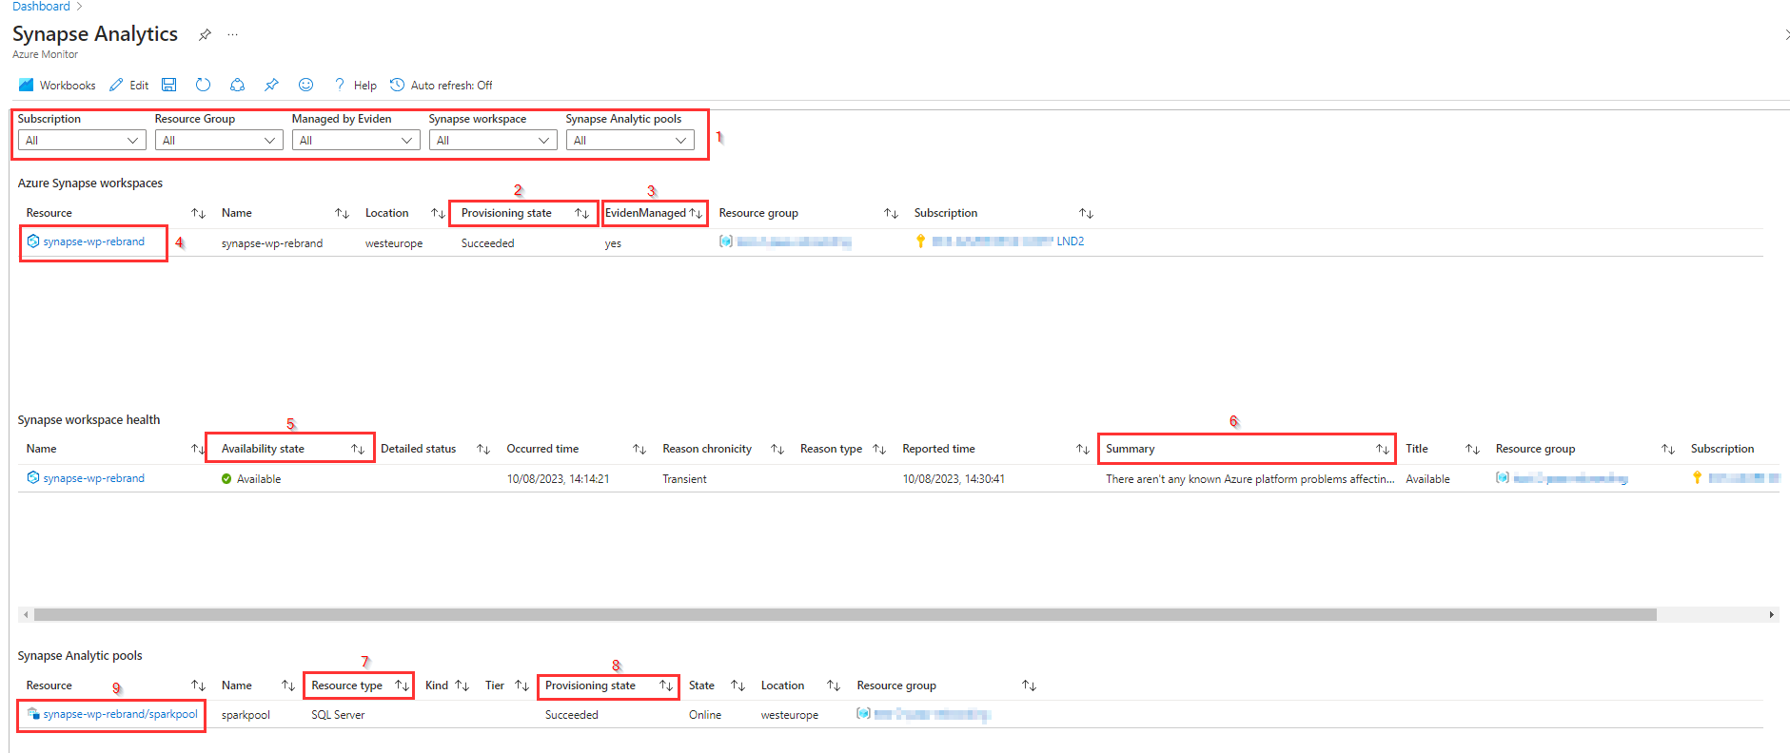

## Azure Synapse Workspaces

In this overview part of the report the **Provisioning state [2]** column shows **Succeeded** if the Synapse workspace is available. Other values can be **Creating** or **Deleting**.

If the Azure Synapse Analytics Workspace has tag **EvidenManaged** set to **true** then **EvidenManaged [3]** is set to** Yes** in the report. If tag EvidenManaged is not set or has value **false** or any other value, then **EvidenManaged** is set to **No** in the report.

Left-clicking on **name of the Azure Synapse Analytics Workspace** in the **Resource [4]** column will open the associated standard Azure Portal blade for the corresponding Azure Synapse Analytics Workspace resource.

## Synapse Workspace Health

In the health information part you will find the **Availability state [5]** column that shows the health of the Synapse Workspace and a **Summary [6]** column with a short description about the Availability state.

**Availability state [5]** can have the following value's:

* **Available** means that there are no events detected that affect the health of the resource.
* **Unavailable** means that the service detected an ongoing platform or non-platform event that affects the health of the resource.
* **Unknown** means that Resource Health hasn't received information about the resource for more than 10 minutes.
* **Degraded** means that your resource detected a loss in performance, although it's still available for use.

## Synapse Analytics pools

In the bottom part of the report you find the deployed Synapse Analytic pools based on the Synapse Analytic pools [1] filter. The Resource type [7] columns show the type of pool. This can be a SQL pool, Apache Spark pool or a Data Explorer pool.  
In the **Provisioning state [8]** you find the Status of the pool.

Left-clicking on **name of the Azure Synapse Analytics pool** in the **Resource [9]** column will open the associated standard Azure Portal blade for the corresponding Azure Synapse Analytics pool resource.

**Known issues and limitations**.

If the report is opened it will sometimes take some time before all parts of the report are available.

# SQL Srv Stretch DB workbook

****N.B. Stretch Database is deprecated in SQL Server 2022 (16.x). This feature will be removed in a future version of Microsoft SQL Server. Avoid using this feature in new development work, and plan to modify applications that currently use this feature.** For more information check this**[**link**](https://learn.microsoft.com/en-us/sql/sql-server/stretch-database/stretch-database?view=sql-server-ver16)**.**

The SQL Svr Stretch DB report provides an overview of Azure SQL Server stretch databases that are deployed in the Azure environment with the most important configuration information and status information.

This report consists of 2 parts:

* An overview of SQL Server Stretch databases with the configuration information
* The health state of the SQL server stretch databases.

## SQL Server Stretch databases

This top part shows the SQL Server Stretch databases with their configuration information.

It is possible to filter [1] on **Subscription**, **Resource group**, **Stretch database**, and on **Managed by Eviden**.

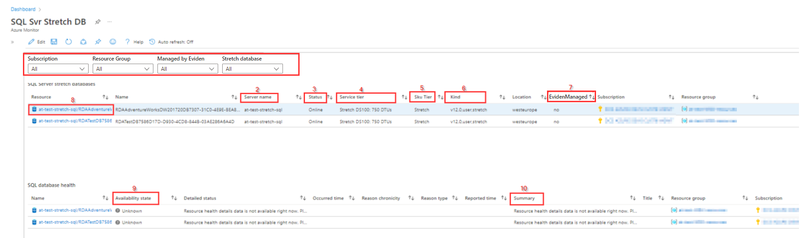

The **Server name [2]** column shows the name of the SQL server that hosts the stretch database. The **Status [3]** columns shows if the database is **Online**.  
The compute size for the stretched database is shown in the **Service tier [4]** column. The **SKU Tier [5]** column will shows Stretch for this type of SQL database, while the **Kind [6]** column shows the SQL type and version.

If the Stretch database has tag **EvidenManaged** set to **true,** then **EvidenManaged [7]** column is set to **Yes** in the report. If tag EvidenManaged is not set or has value **false** or any other value, then **EvidenManaged** is set to **No** in the report.

Left-clicking on **name of the Stretch database [8]** will open the associated standard Azure Portal blade for the corresponding Azure Stretch database.

## SQL database health

In the health information part you will find the **Availability state [9]** column that shows the health of the Stretch database and a **Summary [10]** column with a short description about the Availability state.

**Availability state [9]** can have the following value's:

* **Available** means that there are no events detected that affect the health of the resource.
* **Unavailable** means that the service detected an ongoing platform or non-platform event that affects the health of the resource.
* **Unknown** means that Resource Health hasn't received information about the resource for more than 10 minutes.
* **Degraded** means that your resource detected a loss in performance, although it's still available for use.

**Known issues and limitations.**

If the report is opened it will sometimes take some time before all parts of the report are available.

# Dedicated SQL pools workbook

This report shows an overview of all deployed Dedicated SQL pools in the environment with current configuration and the SQL database health state.

This report consists of 2 parts:

* An overview of Dedicated SQL Databases with the configuration information
* The health state of the Dedicated SQL pools.

In the report it is possible to **filter [1]** on **Subscription**, **Resource group**, **Dedicated databases**, and on **Managed by Eviden**.

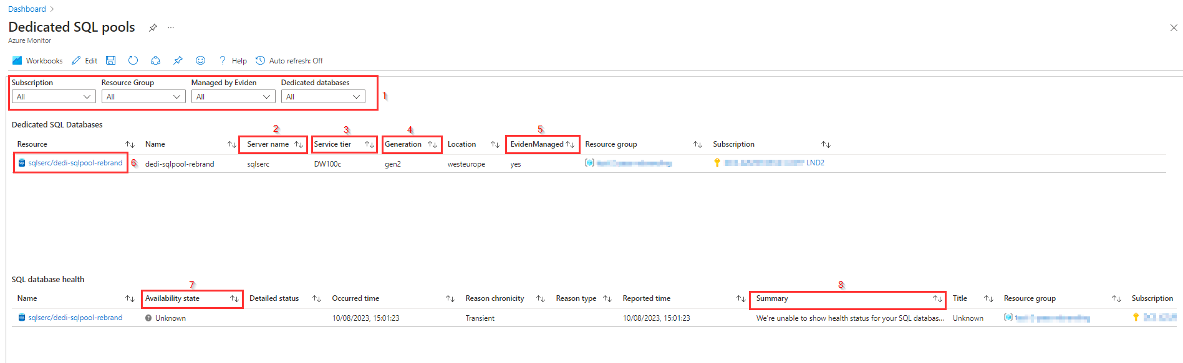

## Dedicated SQL databases

In the **Server name [2]** column the name of the SQL server that hosts the Dedicated SQL pool is shown. The **Service tier [3]** column shows the scale compute (to meet performance demands) in data warehouse units. In the **Generation [5]** column the performance level is shown. Generation can be **Gen2** or **Gen1**, where Gen2 offers the highest performance and storage scalability options for intensive workloads. The settings for **Service tier and Generation** together determines the **performance level** for the dedicated SQL database.

If the Dedicated SQL pool has tag **EvidenManaged** set to **true** then **EvidenManaged [5]** is set to **Yes** in the report. If tag EvidenManaged is not set or has value **false** or any other value, then **EvidenManaged [5]** is set to **No** in the report.

Left-clicking on name of the Dedicated SQL pool in **Resource [6]** will open the associated standard Azure Portal blade for the corresponding Azure Dedicated SQL pool resource.

## SQL database health

In the health information part you will find the **Availability state [7]** column that shows the health of the SQL database and a **Summary [8]** column with a short description about the Availability state.

**Availability state [7]** can have the following value's:

* **Available** means that there are no events detected that affect the health of the resource.
* **Unavailable** means that the service detected an ongoing platform or non-platform event that affects the health of the resource.
* **Unknown** means that Resource Health hasn't received information about the resource for more than 10 minutes.
* **Degraded** means that your resource detected a loss in performance, although it's still available for use.

**Known issues and limitations.**

If the report is opened it will sometimes take some time before all parts of the report are available.

# Cosmos DB for PostgreSQL workbook

The Cosmos DB for PostgreSQL report provides an overview of Azure Cosmos DB for PostgreSQL clusters that are deployed in the Azure environment with the most important configuration information and status information.

It is possible to filter [1] on **Subscription**, **Resource group**, **Cosmos DB for PostgreSQL cluster**, and on **Managed by Eviden**.

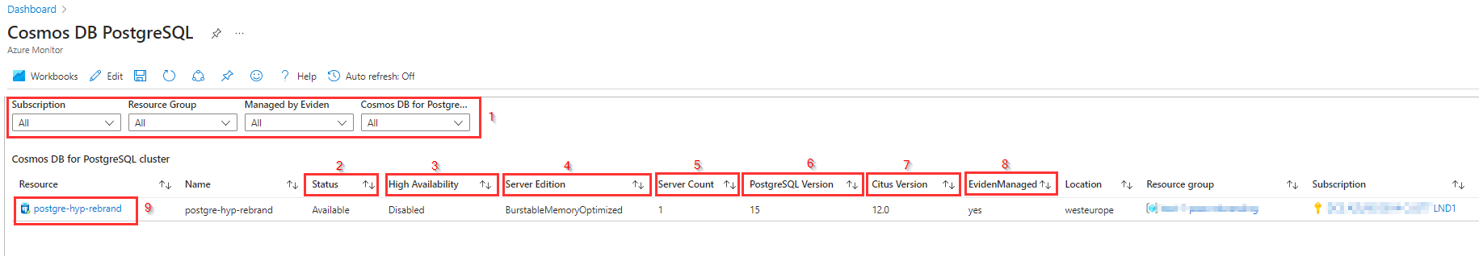

The **Status [2]** column shows if the PostgreSQL Hyperscale server group is available. The **High Availability [3]** column shows if the PostgreSQL Hyperscale server group is **Enabled** or **Disabled**.  
In the **Server Edition [4]** column you will find the Cosmos DB for PostgreSQL cluster Scale, based on the node compute and RAM configuration, while the number of nodes can be found in the **Server count [5]** column.

The **PostgreSQL Version [6]** shows the PostgreSQL version while the **Citus version [7]** column shows the Citus version for the PostgreSQL Hyperscale server group.

If the Azure Database for PostgreSQL Hyperscale (Citus) server group has tag **EvidenManaged** set to **true** then **EvidenManaged [8]** is set to **Yes** in the report. If tag EvidenManaged is not set or has value **false** or any other value, then **EvidenManaged** is set to **No** in the report.

Left-clicking on **name of the Azure Database for PostgreSQL Hyperscale (Citus) server group [9]** in the Resource column will open the associated standard Azure Portal blade for the corresponding Azure Database for PostgreSQL Hyperscale (Citus) server group.

**Known issues and limitations.**

If the report is opened it will sometimes take some time before all parts of the report are available.

# Data explorer cluster workbook

The Data Explorer report provides an overview of Azure Data Explorer clusters that are deployed in the Azure environment with the most important configuration information and status information.

For this the report consists of 2 parts:

* An overview of the configuration information of the Azure Data Explorer clusters
* The health information of the Azure Data Explorer clusters

It is possible to **filter [1]** on **Subscription**, **Resource group**, **Data explorer cluster**, and on **Managed by Eviden**.

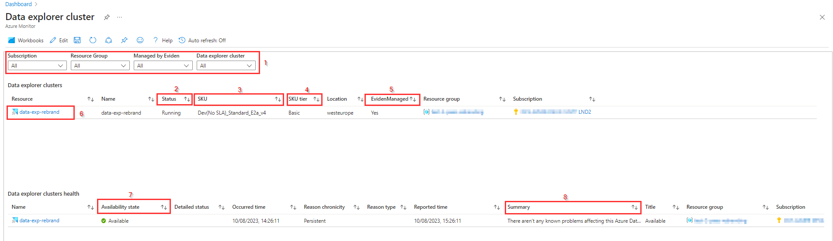

## Overview of the Azure Data Explorer clusters

In the overview part of the report you find the **Status [2]** column for the Azure Data Explorer cluster. The status can be **Running**, **Stopping**, **Stopped** or **Starting**.  
The **SKU [3]** column shows the SKU for the Data cluster. Azure Data Explorer offers two types of clusters: Production (with SLA) and Dev/Test (no SLA). As part of the SKU the compute size is also shown. In the **SKU tier [4]** column the tier for the SKU is shown.

If the Azure Data explorer cluster has tag **EvidenManaged** set to **true** then **EvidenManaged [5]** is set to **Yes** in the report. If tag EvidenManaged is not set or has value **false** or any other value, then **EvidenManaged** is set to **No** in the report.

Left-clicking on **name of the Azure Data explorer cluster [6]** in the Resource column will open the associated standard Azure Portal blade for the corresponding Azure Database for PostgreSQL Hyperscale (Citus) server group.

## Health information of the Azure Data explorer cluster

In the health information part you will find the **Availability state [7]** column that shows the health of the Azure Data explorer cluster and a **Summary [8]** column with a short description about the Availability state.

**Availability state [7]** can have the following value's:

* **Available** means that there are no events detected that affect the health of the resource.
* **Unavailable** means that the service detected an ongoing platform or non-platform event that affects the health of the resource.
* **Unknown** means that Resource Health hasn't received information about the resource for more than 10 minutes.
* **Degraded** means that your resource detected a loss in performance, although it's still available for use.

**Known issues and limitations.**

If the report is opened it will sometimes take some time before all parts of the report are available.

# Container Registry workbook

The Container Registry report provides in the upper part of the report an overview of Azure Container Registry that are deployed in the Azure environment with the most important configuration information, status information and operational information.

For this the report consists of 2 parts:

* An overview of the configuration information of the Azure Container Registries
* Operational information about the Azure Container Registries

It is possible to **filter [1]** on **Subscription**, **Resource group**, **Location**, **SKU**, **Public Network Access**, **Provisioning State** and on **Managed by Eviden**.

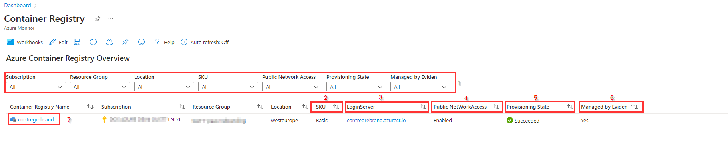

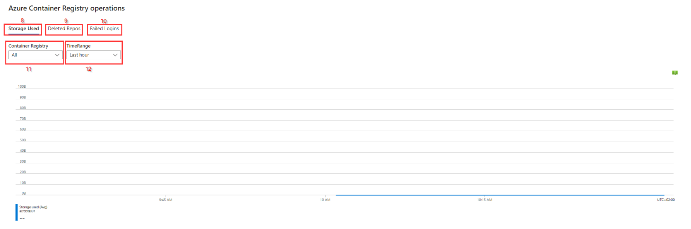

## Azure Container Registry Overview

The **SKU [2]** column shows the SKU for the container registry. The SKU can be **Basic**, **Standard** or **Premium**. The **LoginServer [3]** column contains the name of the registry login server that is needed for logging in. The **Public NetworkAccess [4]** column shows if public network access is enabled or disabled. **Public network access** can only be disabled with **Premium SKU**.  
The **Provisioning State [5]** column shows if the deployment of the Azure Container Registry is **Succeeded** or **Failed**. For failed Azure Container Registries there will be no operational information available in the second part of this report.

If the Azure Container Registry has tag **EvidenManaged** set to **true** then **EvidenManaged [6]** column is set to **Yes** in the report. If tag **EvidenManaged** is not set or has value **false** or any other value, then **EvidenManaged [6]** is set to **No** in the report.

Left-clicking on **name of the Azure Container Registry [7]** in the **Container Registry Name** column will open the associated standard Azure Portal blade for the corresponding Azure Container Registry.

## Azure container registry operations

In the second part of the report there is operational information displayed about the container registries. Here you will find 3 different tabs with the following information:

* **Storage Use [8]**: a graphical overview of the storage used for the selected **Container Registry [11]** and selected **TimeRange[12]**
* **Deleted Repos [9]**: a table overview of the deleted repos, if any, for the selected **Container Registry [11]** and selected **TimeRange[12]**
* **Failed Logins [10]**: a table overview of the failed logins, if any, for the selected **Container Registry [11]** and selected **TimeRange[12]**

The **TimeRange** can be selected between 5 minutes and 90 days.

**Known issues and limitations.**

If the report is opened it will sometimes take some time before all parts of the report are available.

The tab for Deleted Repos and Failed Logins will only show information for Container Registries that have **EvidenManaged tag** set to **True** as this information comes form the log analytics workspace that is managed by Eviden.

# AKS-Overview workbook

The AKS-Overview report consists of 2 parts:

* An overview of Azure Kubernetes Services that are deployed in the Azure environment with the most important configuration information and status of the Kubernetes service
* Azure Kubernetes Services Metrics with more detailed information displayed about a selected kubernetes service

For both parts a separate set of filters is available.

## Overview Azure Kubernetes Services Deployed

In the top part of the workbook it is possible to **filter [1]** on **Subscription**, **Resource group**, **Location**, **SKU**, **Status**, on **Managed by Eviden** and if **Monitoring Insights** is enabled.

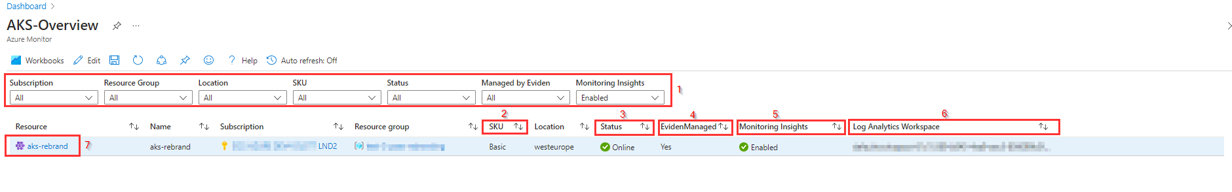

For the Azure Kubernetes Service (AKS) the **SKU [2]** columns shows if the SKU tier is **Basic** (free) or **Standard**. The **Status [3]** column shows if the AKS is **Online**. Other options for Status are **Failed** or **Creating**.

If the Azure Kubernetes Service has tag **EvidenManaged** set to **true** then the **EvidenManaged [4]** column is set to **Yes** in the report. If tag **EvidenManaged** is not set or has value **false** or any other value, then **EvidenManaged** column is set to **No** in the report.

If **Monitoring Insights** is enabled for a Kubernetes Service **Enabled** will be visible in the **Monitoring Insights [5]** column in the workbook and the selected **Log Analytics workspace** will be displayed in the **Log Analytics Workspace [6]** column.

For the second part of this report **Monitoring Insights** should be **Enabled** and the metrics should be send to the **Eviden Managed log analytics workspace**.

Left-clicking on **name of the Azure Kubernetes Service [7]** will open the associated standard Azure Portal blade for the corresponding Azure Kubernetes Service. If not, no metrics are visible.

## Azure Kubernetes Services Metrics

In the bottom part of the report a **Time Range [1]** and a specific Kubernetes Service (**ClusterId [2]**) can be selected. The name of the selected Kubernetes Service will be visible under the ClusterId filter and for that specific Kubernetes Service it is possible to **filter [4]** on **namespace**, **deploymentName**, **PV type**, **Storage Class** and **AccessMode**.

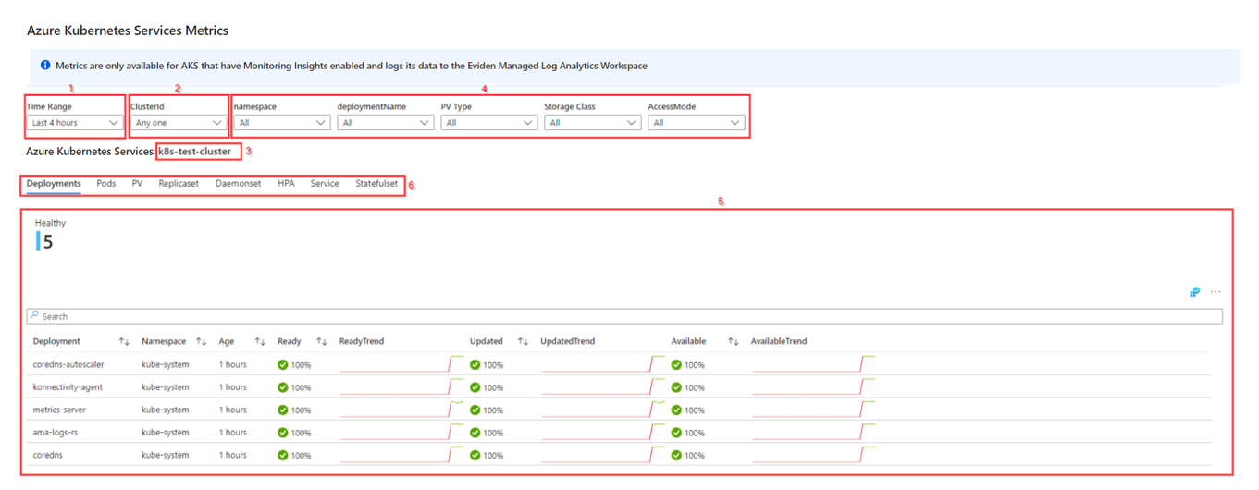

Based on the selected Kubernetes Service and filters you find the following **overview [5]** for the Kubernetes Service in each of the **tabs [6]**:

* **Deployments**, an overview of the Deployments for selected Kubernetes Service and Time Range.
* **Pods**, an overview of the Pods.
* **PV**, Persistent Volumes Claims.
* **Replicaset**, an overview of the Replica Sets of the selected Kubernetes Service.
* **Daemonset**, the Daemonsets of the selected Kubernetes Service.
* **HPA** the Horizontal Pod Autoscalers (HPA), if any configured.
* **Services**, the Services of the selected Kubernetes Service.
* **Statefulset**, the Statefulsets, if any configured.

**Known issues and limitations.**

If the report is opened it will sometimes take some time before all parts of the report are available.

The bottom part of the report will only display information if Monitoring Insights is enabled for the selected ClusterId. After Monitoring Insights is enabled it will take about 10 minutes before any information will be available in the tabs.

# AKS-Workloads workbook

The AKS-Workload report consists of 2 parts:

* An overview of Azure Kubernetes Services that are deployed in the Azure environment with the most important configuration information and status of the Kubernetes service
* Azure Kubernetes Services Workloads with more detailed workload information displayed about a selected kubernetes service

For both parts a separate set of filters is available.

## Overview Azure Kubernetes Services Deployed

In the top part of the workbook it is possible to **filter [1]** on **Subscription**, **Resource group**, **Location**, **SKU**, **Status**, on **Managed by Eviden** and if **Monitoring Insights** is enabled.

In the bottom part of the report a **Time Range** and a specific Kubernetes Service (**ClusterId**) can be selected and for that specific **ClusterId** it is possible to filter on **workloadType**, **namespace**, **podStatus**, **workloadName** and **podName** when one of the tabs is selected.

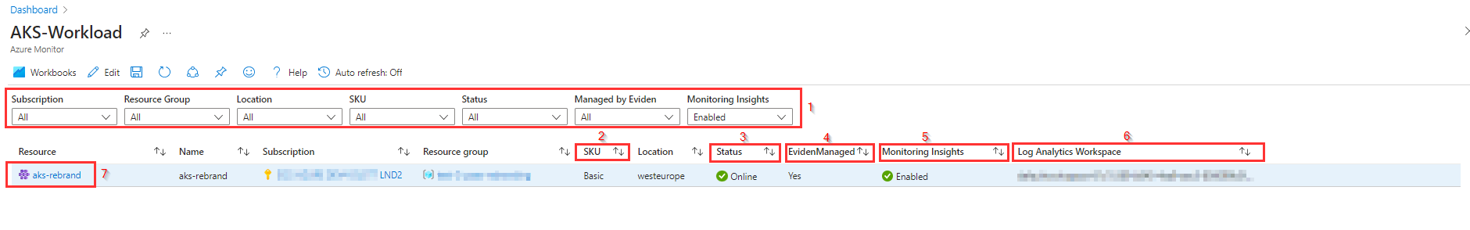

For the Azure Kubernetes Service (AKS) the **SKU [2]** columns shows if the SKU tier is **Basic** (free) or **Standard**. The **Status [3]** column shows if the AKS is **Online**. Other options for Status are **Failed** or **Creating**.

If the Azure Kubernetes Service has tag **EvidenManaged** set to **true** then the **EvidenManaged [4]** column is set to **Yes** in the report. If tag **EvidenManaged** is not set or has value **false** or any other value, then **EvidenManaged** column is set to **No** in the report.

If **Monitoring Insights** is enabled for a Kubernetes Service **Enabled** will be visible in the **Monitoring Insights [5]** column in the workbook and the selected **Log Analytics workspace** will be displayed in the **Log Analytics Workspace [6]** column.

For the second part of this report **Monitoring Insights** should be **Enabled** and the metrics should be send to the **Eviden Managed log analytics workspace**.

Left-clicking on **name of the Azure Kubernetes Service [7]** will open the associated standard Azure Portal blade for the corresponding Azure Kubernetes Service. If not, no metrics are visible.

## Azure Kubernetes Services Workloads

In the bottom part of the report a **Time Range [1]** and a specific Kubernetes Service (**ClusterId [2]**) can be selected. The **name of the selected Kubernetes Service [3]** will be visible under the ClusterId filter and for that specific Kubernetes Service it is possible to **filter [4]** on **workloadType**, **namespace**, **podStatus**, **workloadName** and **podName**.

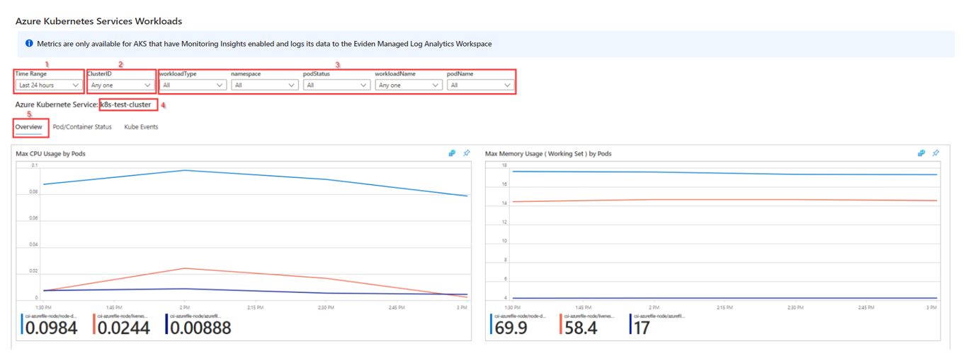

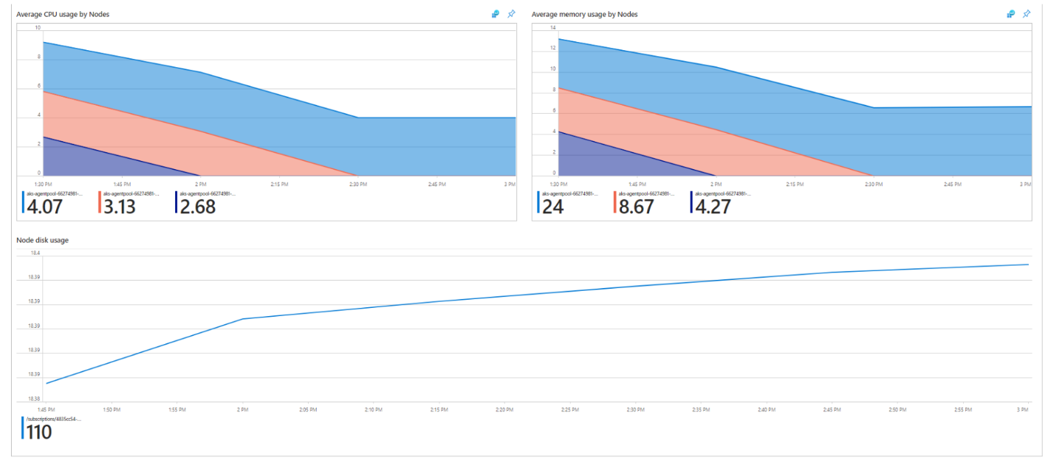

Based on the selected Kubernetes Service and filters you find the following **overviews** for the Kubernetes Service in each of the **tabs**:

* **Overview [5]**, with an overview of the CPU and Memory usage for Pods and Nodes and Node Disk usage.
* **Pod/Container Status [6]**, with an overview of POD and Container status for the selected Kubernetes Service.
* **Kube Events [7]** for the Kube events (if any) for the selected Kubernetes Service and Time Range.

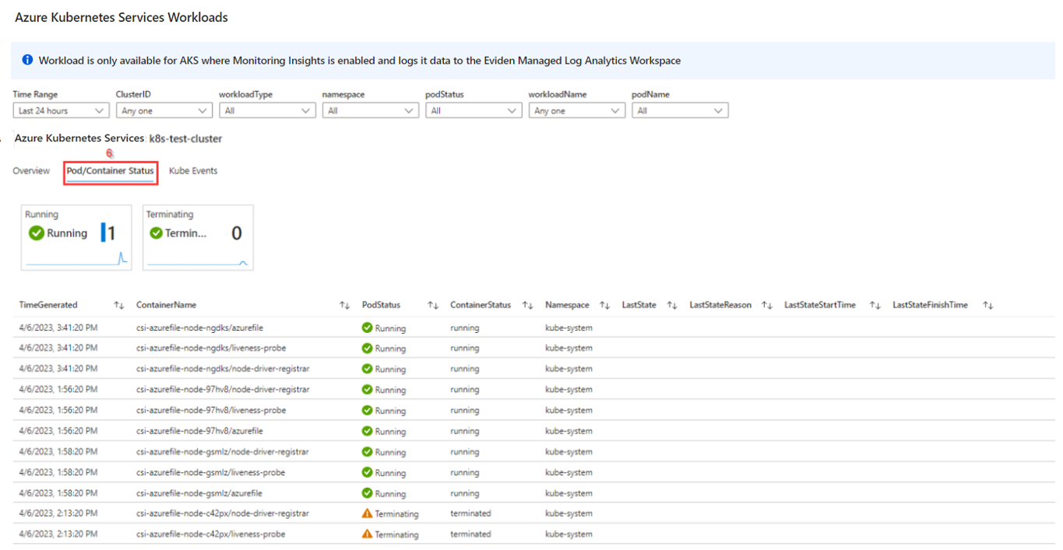

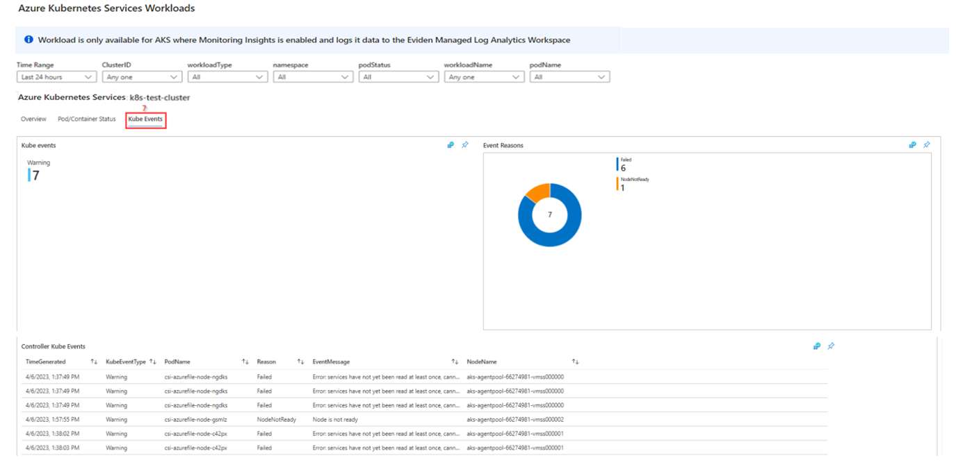

**Known issues and limitations.**

If the report is opened it will sometimes take some time before all parts of the report are available.

The bottom part of the report will only display workload information if Monitoring Insights is enabled for the selected ClusterId. After Monitoring Insights is enabled it will take about 10 minutes before any information will be available in the tabs.

# Azure Function workbook

The Azure Function report consists of 2 parts:

* ****Azure Function Configuration Overview**** provides an overview of the Azure Functions that are created in the Azure environment with the most important configuration and status information.
* ****Azure Function Workspace Workloads**** provides an overview of the Azure Functions with operational data divided in 3 Metric Graphics

Each part of the report has its own set of filters at the top each part.

## Azure Functions Configuration Overview

The top part of this report is used to give an overview of the available Azure Functions in the environment with its configuration.  
It is possible to ****filter [1]**** on ****Subscription**, **ResourceGroup**, **Azure Function**, **Eviden Purpose**** tag or if the Azure Function is ****Managed by Eviden****.

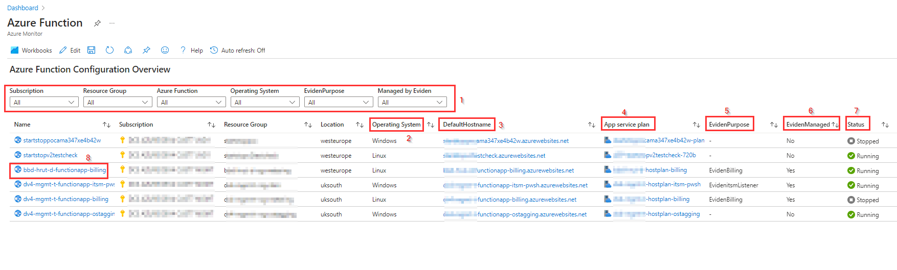

In the **Operating System [2]** column the operating system used for the function is shown. This can be **Windows** or **Linux**.  
The **DefaultHostname [3]** column shows the default hostname for the function. By pasting this hostname in a browser, the status of the function can be checked, like in this picture:

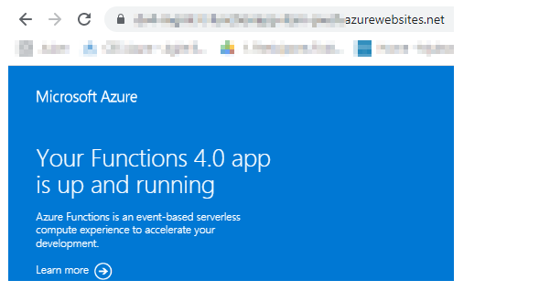

The ****App Service Plan [4]**** column shows the App service plan for the function. By selecting the name of an app service plan in the ****App Service Plan [4]**** column you are redirected to the app service plan blade in Azure.  
If an Azure Function is part of the Eviden Azure Framework a short description of the purpose of the Azure Function is visible in the ****EvidenPurpose [5]**** column that shows the value of the ****EvidenPurpose tag****.

If the Azure Function has the tag ****EvidenManaged**** set to ****true****, then the value in the ****EvidenManaged [6]**** column is set to ****Yes**** in the report.  
The ****Status [7]**** column shows the status of the Azure Function. The Status can be ****Running**, **Stopped**, **Starting****or ****Stopping****.  
When the ****Name of the Azure Function [8]**** in the Name column is selected, the ****blade for the Azure Function**** is opened.

## Azure Function Workloads

The bottom part of the Azure Function report provides workload data on some important metrics of the Azure Function.  
Using the **filters [1]** for **Subscription** and **Azure Function**, one specific Azure Function can be selected to view the following metrics for the selected **TimeRange**:

* ****Memory working count [2]****: The current amount of memory used by the application.
* ****Function execution count [3]****: The number of functions executed
* ****Function execution units [4]****: The number of function units executed in MB per milliseconds.

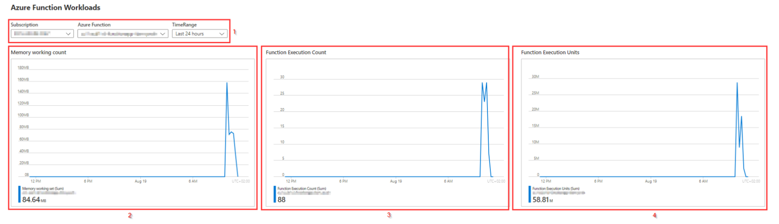

When checking the overview blade of the Azure Function it selves you will find the same metrics, but instead of showing only the last hour the Azure Function report supports selection of different time ranges **between **Last hour and Last 30 days****.