PREPARE CUSTOM IMAGE CUSTOMER GUIDANCE.

Author(s) : Klaas Jan de Jager

Version : 1.0

Status : Final

Source : Eviden Landing Zones for Azure

Document date : 22 August 2023

Number of pages :

Contents

List of changes 3

1. Introduction 4

2. Azure Compute Gallery concepts 5

2.1 Image definitions 5

2.2 Image versions 6

2.3 Managed Image 6

2.4 Overview custom image to Azure Compute Gallery 6

2.4.1 Scope 7

3. Custom image preparations 8

3.1 Eviden Landing Zones for Azure recommendations 8

3.2 Preparations & adjustments for Linux 8

3.3 Preparations & adjustments for Windows 9

4. Custom image information to provide. 10

4.1 Image definition 10

4.2 Image version 11

4.3 How to provide image information 12

4.3.1 Csv file details 12

4.3.2 Best practice 13

4.3.3 Naming convention 14

5. How to upload a .vhd to Azure storage 15

5.1 Prerequisites 15

5.2 Step by step description 15

5.3 How to monitor the upload 21

5.4 Notify the ELZ Azure team 21

# List of changes

|  |  |  |  |
| --- | --- | --- | --- |
| **Version** | **Date** | **Description** | **Author(s)** |
| 1.0 | 22-08-2023 | Initial Eviden version | K.J. de Jager |
|  |  |  |  |
|  |  |  |  |

# Introduction

This manual explains Shared Image Gallery functionality which is part of the Managed OS Cloud service.

It describes how to prepare custom images (.vhd files) for use within Azure.

It also describes how to use Azure Storage Explorer preview in the Azure portal, to upload the .vhd and .csv files to a blob container.

# Azure Compute Gallery concepts

Azure Compute Gallery is a service that helps to build structure and organization around custom images. Azure Compute Galleries provide:

* Global replication of images.
* Versioning and grouping of images for easier management.
* Highly available images with Zone Redundant Storage (ZRS) accounts in regions that support Availability Zones. ZRS offers better resilience against zonal failures.
* Premium storage support (Premium_LRS).
* Sharing across subscriptions, and even between Active Directory (AD) tenants, using Azure RBAC.
* Scaling your deployments with image replicas in each region.

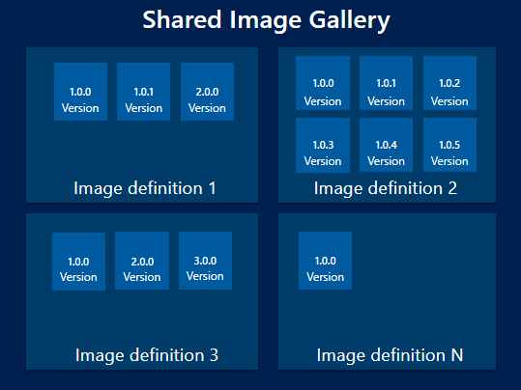

Diagram 2.1 Schematic overview Shared Image Gallery.

## Image definitions

Image definitions are a logical grouping for versions of an image. The image definition holds information about why the image was created, what OS it is for, and other information about using the image. An image definition is like a plan for all of the details around creating a specific image. You don't deploy a VM from an image definition, but from the image versions created from the definition.

## Image versions

An image version is what you use to create a VM. There can be multiple versions of an image as needed. When using an image version to create a VM, the image version is used to create new disks for the VM.

## Managed Image

The Managed Image functionality which Azure provides, can be used to deploy virtual machines and virtual machine scale sets. It does not provide the versioning, replication and sharing capabilities the Shared Image Gallery has.

The Eviden Landing Zones for Azure utilizes the Managed Image functionality to be able to convert the customer provided .vhd files into a Azure Compute Gallery image version.

The Managed Image is a temporary resource. When the image version creation has been completed successfully, the Managed Image resources will be deleted.

## Overview custom image to Azure Compute Gallery

The high-level steps to upload a custom image (in .vhd format) into a Azure Compute Gallery image version are as described in diagram 2.2.

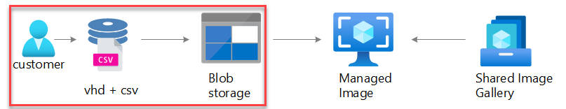   
Diagram 2.2 high-level steps.

The steps are:

1. The customer starts with a .vhd file locally or in the Cloud.    
   Prepares, generalizes and makes it Azure ready.
2. Upload the .vhd file and a .csv file to an Azure blob storage container.   
   The .csv file will contain all necessary information to create resources with the .vhd file.
3. Create a Managed image from the uploaded .vhd file (and the provided information) in the blob storage container.
4. Import/create an image version of the Managed Image in the Shared Image Gallery.

### Scope

The scope for the following chapters is:

* To describe how to prepare a custom .vhd file according to Microsoft best practices.
* Description of the necessary information to provide for the custom image being uploaded to Azure storage.
* Step-by-step guide on how to use the Storage Explorer preview in the Azure portal to upload the custom .vhd and .csv files.

# Custom image preparations

A prerequisite for using custom images within Azure is that the custom images be prepared and generalized in accordance with Microsoft best practices. 

Custom images made locally, on-premise, or somewhere non-Azure needs a specific set of actions to be taken on the OS for it to be ready to run smoothly in a virtual machine (VM) on Azure.

Custom images built from Azure marketplace images, which are already running in an Azure VM only needs to be generalized.

Which actions are needed for Linux and Windows OS’ images are described in the following paragraphs.

## Eviden Landing Zones for Azure recommendations

The Eviden Landing Zones for Azure team have recommendations for custom images being uploaded to be used by Azure VMs and stored in the Shared Image Gallery.

These recommendations are:

* Use Azure VMs to create custom images.   
  Using Azure VMs is the preferred way of creating custom images.   
  All preparations, optimalizations and agents needed for an optimal operation in Azure are built-in to Azure VMs.
* Prepare the OS, always.   
  Always prepare the OS, to be uploaded, according to Microsoft best-practices.   
  These preparations are intended to optimize the OS (within the .vhd file) for maximum performance within the Azure environment.
* Use the Microsoft best-practices for preparing, optimizing and generalizing custom images.

## Preparations & adjustments for Linux

The best-practices for optimizing and generalizing Linux distros are documented on the Microsoft Docs website. Start at this website URL <https://docs.microsoft.com/en-us/azure/virtual-machines/linux/create-upload-generic>. The generic steps needed to be taken are described here.

Where to find the corresponding documentation on the steps needed for specific Linux distributions are also mentioned on this page.

If a pre-configured Linux image from the Azure marketplace is being used to create a custom image, only the generalization needs to be executed. The Azure Linux Agent (waagent) is needed to perform the generalization. This will be available in the Azure marketplace image.

The command to execute the generalization can be found on the above-mentioned URL.    
It is located at the [bottom](https://docs.microsoft.com/en-us/azure/virtual-machines/linux/create-upload-generic#code-try-10:~:text=Run%20the%20following%20commands%20to%20deprovision%20the%20virtual%20machine.) of the page as step **nr.5** of **General Linux System Requirements**.

## Preparations & adjustments for Windows

The best-practices for optimizing and generalizing Windows can also be found on the Microsoft Docs website. The URL for Windows preparations is <https://docs.microsoft.com/en-us/azure/virtual-machines/windows/prepare-for-upload-vhd-image>.

If a pre-configured Windows image from the Azure marketplace is being used to create a custom image, only the generalization needs to be executed. The Windows built-in executable, sysprep.exe is used to generalize the Operating System. The options to use with this executable are documented on the same page near the [bottom](https://docs.microsoft.com/en-us/azure/virtual-machines/windows/prepare-for-upload-vhd-image#generalize-a-vhd) under the **Generalize a VHD** heading.

# Custom image information to provide.

In this chapter the information needed to create resources in Azure with the provided custom image, is described.

## Image definition

During the creation process of an image definition in the Shared Image gallery there are several configuration parameters which need to be defined. The parameters are described and explained in table 4.1.

|  |  |  |
| --- | --- | --- |
| **Parameter** | **Description** | **Example** |
| Resource Group name | A resource group is a collection of resources that share the same lifecycle, permissions, and policies | - (inherited from Image Gallery) |
| Region | The location of the image definition.   While the image is defined in a single region, image versions can be replicated to multiple regions. | Choose Azure region <westeurope> |
| Target shared image gallery | The name of the gallery where this image will be placed. | <SIG001> |
| Image definition name | The name of the definition | <Windows2016CRM> |
| OS | The operating system for the image. | Choose between <windows> or <linux> |
| VM generation | Generation 2 VMs use the new UEFI-based boot architecture rather than the BIOS-based architecture used by generation 1 VMs. | Choose between <gen1> or <gen2> |
| OS state | Generalized images have had the machine and user specific information removed via running a command on the VM. Specialized images have not been through the process to remove machine and user specific information. | Choose between <Generalized> or <Specialized> |
| Publisher | The name of the image definition publisher | <ContosoBU1> |
| Offer | The name of the image definition offer. | <Accounting> |
| Sku | The name of the image definition SKU. | <Middleware> |

Table 4.1 Image definition parameters.

## Image version

During the creation process of an image version in the Shared Image gallery there are several configuration parameters which need to be defined. The parameters are described and explained in table 4.2.

|  |  |  |
| --- | --- | --- |
| Parameter | Description | Example |
| Region | The default location of the image version. | Inherited from image definition region. |
| Target Image definition | The parent image definition for this version. | <Windows2016CRM> |
| Version number | The image version name in semantic version pattern. The allowed characters are digit and period. For example: 0.0.1, 15.35.0 | <7.8.1> |
| Source Image | The name of the image (which is being uploaded) + the defined version number. | <Win2016CRM7.8.1> |
| Exclude from latest | If this flag is set to "Yes", VMs created using the latest version will omit this version. | <Yes> or <none> |
| End of life date | Inform version consumers of the end of life date for this version. This date is informational only; users will still be able to create VMs from this version past the end of life date. | <DD-MM-YY> |
| Default storage sku | The default storage sku to be used for the image per region. | <standardhdd>, <premiumssd> or <zoneredundant> |
| Default replica count | The default number of replicas to be created per region | <1..50> |
| Target regions | The source region is always configured and bound to the Shared Image gallery location.  Other regions the image should be replicated to depending on where the image will be used. | Default location: <westeurope>  Other locations: (for example)  <northeurope>  <eastus>  <ukwest>    Multiple regions:  <[northeurope,eastus,ukwest]> |
| Target region replica count | The number of replicas to be created per region. | <1..50>    Multiple regions: (using example from target regions in the cell above)  <[2,1,4]> |
| Target region Storage account type | The storage sku to be used for the image per region. | <standardhdd>, <premiumssd> or <zoneredundant> |

Table 4.2 Image version parameters.

## How to provide image information

The necessary information (the described parameters in paragraph 4.1 & 4.2) for creating image definitions and versions in the Shared Image gallery can be provided via a .csv file.

Provide all the necessary image definition & version configuration information.   
The .csv file should then be uploaded to the **vhdupload** container, together with the custom .vhd file.

For instructions on how to upload files to azure storage, use the description in [chapter 5](bookmark://_How_to_upload) of this document or go to this [URL](https://docs.microsoft.com/en-us/azure/storage/blobs/storage-quickstart-blobs-portal#upload-a-block-blob).

### Csv file details

In this paragraph an overview of the structure and contents of the .csv file is described.

The structure is as follows.

A header row with configuration items as described in paragraphs 4.1 & 4.2.

And a content row where all the configuration entries corresponding to the header, are placed.

In the following table all the headers are described. (In the csv file, these will all be on one line separated by a ;) The corresponding parameters (from paragraphs 4.1 & 4.2) are mapped to the headers in the Parameter column.

|  |  |  |
| --- | --- | --- |
| **Csv Header** | **Parameter** | **Used by** |
| signame | Azure Compute Gallery | Image definition |
| rgname | Resourcegroup name | Image definition (inherited) |
| os | OS | Image definition |
| osstate | OS state |
| vmgeneration | VM generation |
| datadisk1lun | Data disk 1 Lun position | Image version (indirectly via Managed Image) |
| datadisk2lun | Data disk 2 Lun position |
| imagedefregion | Image definition region | Image definition |
| imagedefname | Image definition name |
| publisher | Publisher |
| offer | Offer |
| sku | Sku |
| imageversionnr | Image version number | Image version |
| sourceimage | Source Image |
| excludefrlatest | Exclude from latest |
| eoldate | End of life date |
| defstoragesku | Default storage sku |
| defreplcount | Default replica count |
| targetregions | Target regions |
| targetregionsreplcount | Target region replica count |
| targetregionstoretype | Target region storage account type |

Excel can be used to see and add the necessary information in the .csv file.

### Best practice

There is a Microsoft best practice for .vhd file location, managed image placement and the default source image version to be considered. All these resources should be configured in the same region. This is to optimize and have streamlined resource creation for the default source image version. Having all necessary resources close together will minimize possible issues with latency.

The managed image that is being used as the base image to create the image version, is in the same location as the location in which the image version is going to be created.

The image definition location should be the same as the default source image version location.

For the information (within the .csv file) provided with the .vhd file upload, please consider;

* The default source image version region should be the same as the image definition region.
* The region configured for the .vhd file uploading storage account, should be the same as the intended default source image version region.

### Naming convention

There are a few requirements for naming of files.

* The naming of the files being uploaded should be;

Image definition name + Image version number + file extension.

For example, **Win2016CRM** + **7.8.1** + **.vhd**

* The .csv file name and the .vhd file name should be exactly the same.    
  For example, Win2016CRM7.8.1.csv & Win2016CRM7.8.1.vhd.
* If there are data disks which are part of the custom images, these should be named the same as the OS disk + datadisk<nr>.vhd.

For example:

OS disk: Win2016CRM7.8.1.vhd

Data disk 1: Win2016CRM7.8.1.datadisk1.vhd

Data disk 2: Win2016CRM7.8.1.datadisk2.vhd

**Important**: These requirements are crucial to the automation of resource creation.

# How to upload a .vhd to Azure storage

## Prerequisites

* Permissions - To be able to upload files to Azure Storage, access to the Management Azure subscription and the storage account to upload the .vhd file(s), is required.
* VHD file - The generalized .vhd file intended for use on the Azure environment is ready and accessible.
* CSV file – a .csv file with all necessary information for the required resources (as described in paragraph 4.3).

## Step by step description

|  |  |
| --- | --- |
| **Nr** | **Activity** |
| **1.** | Log in to the Azure portal  Browse to https://portal.azure.com and login with the appropriate credentials. |
| **2.** | In the top search bar of the Azure portal page, type 'storage account'        Choose **Storage accounts** from the results. This will take you to an overview (blade)of all the created storage accounts visible to the logged in user. |
| **3.** | In the **Storage accounts** blade, find the correct storage account for uploading your .vhd file.  Add a filter to find the storage account based on tagging.        Select **Add filter**.  Select **EvidenPurpose** under the **Tags** section. And for **Value** select **EvidenSharedImageGallery**.      Finally select **Apply** to apply the filter.  The correct storage account is now the filtered in the view. |
| **4.** | Click the storage account to open the corresponding blade with details. |
| **5.** | To upload the .vhd file, click **Containers** in the left pane. |
| **6.** | In the **Containers** section, click select the **vhdupload** container to upload the .vhd and .csv files. |
| **7.** | Click **Upload** in the selected container (right section of the screen)      A new **Upload blob** blade appears. |
| **8.** | Click the **Browse for files** text and browse to the .vhd file required for upload.       Select the vhd file and click **Open** to open the .vhd file to be uploaded. |
| **9.** | Click the arrow in front of **Advanced** to configure an extra option needed. |
| **10.** | In the **Advanced** section, for **Blob type** select **Page blob**.        Select **Upload** to start the upload. |
| **11.** | Repeat steps 8 to 10, for uploading the .csv file.  Make sure to change the **Blob type** to **Block blob** while performing step 10. |

## How to monitor the upload

In the **Upload blob** blade there is a section beneath the **Upload** button where the upload progress can be monitored.

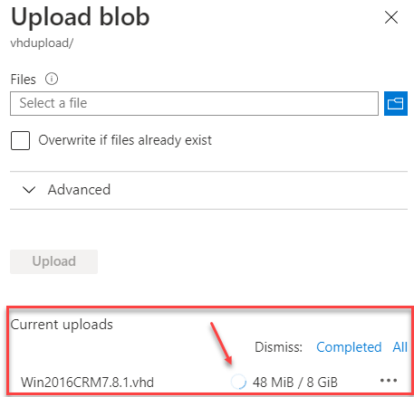

Screenshot upload progress.

**Be aware!** Do not close this **Upload blob** blade until the upload is finished or the upload will not complete.

When the upload completes, a green checkmark will appear.

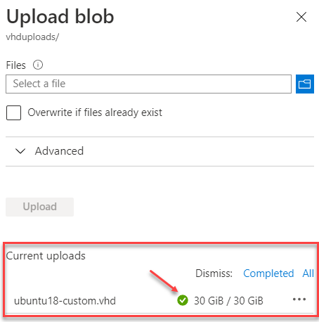

Screenshot upload completed.

## Notify the ELZ Azure team

After the .vhd & .csv file have been uploaded to the vhdupload storage container, contact your Eviden Landing Zone for Azure team representative.

Notify them of the upload, so they can take the further necessary actions to convert the uploaded .vhd file to an image version in the Azure Compute Gallery.