DPR

**Documentation**

Strategy Pattern: Disk Scheduling

Juraj Korbacka 2893940

Stefan Todorov 2701979

horizontal line

## UML Diagram:

Picture of the UML Diagram for the Strategy Pattern.

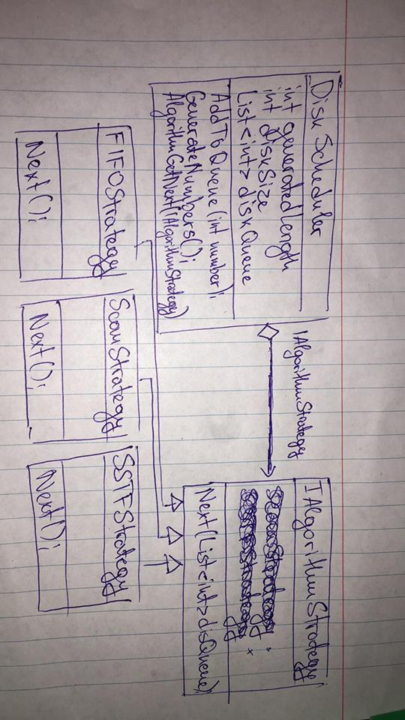

## 

## 

## 

## Functionality:

It is possible to generate a list of example values if the user just wants random dummy data. Dummy data can be inserted by clicking the “Example” button.

In order to check every number and to be visually perceived, our program is using a timer which is set to tick on every second.

The timer is automatically enabled when you click the “Run” button. Then you can observe how the different algorithms work.

Also when the button “Stop” is clicked or the list of data is empty, the times is automatically disabled.

Using the drop down menu which is labeled “Algorithms:” and is above the “Run” and “Stop” buttons, you can choose which algorithm you want the disk scheduling program to use. Currently there are 3 and they are listed.

Using the strategy pattern we are able to change the scheduling algorithm during run time, so it will not be a problem to click on a different algorithm even if you have already clicked the “Run” button.

The number that is currently being processed is displayed under the “Requests:” label in the textbox.

The simulation of the process is being displayed and visualized using the track bar on the left most side of the application.

Users can add new number values between the range of 0-100, values can repeat. That can be achieved by filling the desired value in the text field which is next to the “Add” button.