Zeroing Out curvatures

https://roadcurvature.com/2020/10/25/avoiding-congestion-and-conflict-zones/
“Curvature looked only at the geometry of roads, their highway classification (motorway, primary, secondary, …, parking aisle, driveway), and their surface (paved/unpaved) …

Potential conflicts or collisions at intersections, with merging traffic streams, at pedestrian crossings, and along street-side parking require much concentration and can make these roads much less “fun” to ride than a road with the same geometry would be in a less urban environment. A sharp 90° corner on a rural road is a lot of fun to swoop through, the same geometry at an intersection with a stop sign or traffic signal is a delay…

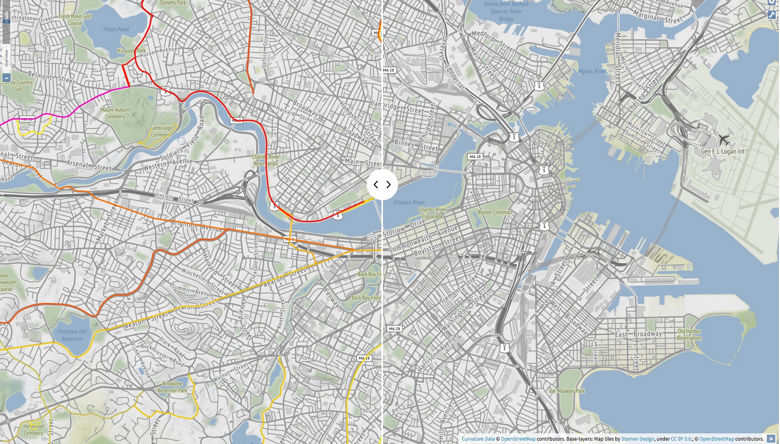
I’ve recently added a filtering stage to Curvature that zeros-out the curvature rating for 30 meters (~100 feet) in both directions from each conflict point along the roadway. By zeroing out curves near these conflict zones Curvature can avoid suggesting roads that really aren’t very “fun”.
”

“As hoped, this new processing step of zeroing-out curvature values in conflict zones has a dramatic effect of the results in urban areas, but almost no effect on the results in more rural areas. ”

https://roadcurvature.com/2016/11/26/new-legend/

How it works
https://roadcurvature.com/how-it-works/
OpenStreetMap is a community driven project that anyone can add and edit

At the beginning I tried strategies such as calculating the ratio of distance traveled on a road versus the distance between the start and end points. Unfortunately all of these initial methods had situations that confused the algorithms (such as circular roads) or didn’t distinguish between fun curves and boring broad changes of direction that would only be exciting at far beyond the speed limit

What I eventually came up with is a process of calculating the radius of curvature at every segment of every road and then adding up the length of the most curvy segments to get a total distance spent cornering. The twistier the road, the more distance (and time) is spent cornering.

Each sequence of three points makes up a triangle where two of the sides are road segments with a hypotenuse between the 1st and 3rd points. Since the points aren’t evenly spaced the angle between the three points doesn’t tell us anything. Instead, we must go to the geometric relationship that says for every triangle there is a circumcircle that intersects its three points. Using the equations for the circumcircle, we can plug in the distances between the three points and come up with the radius of that circle. That circle’s radius corresponds to the radius of the road’s curve at the middle of the three points.
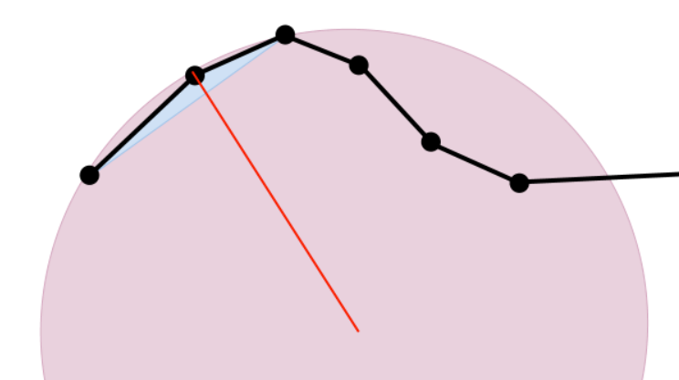

https://www.mathopenref.com/trianglecircumcircle.html
The circumcircle always passes through all three vertices of a triangle. Its center is at the point where all the perpendicular bisectors of the triangle's sides meet. This center is called the circumcenter.

- Each way is made up of a series of points
- Every sequence of three points forms a triangle
- For every triangle, there is a circle that intersects all three points
- The radius of that circle corresponds to the radius of the curve at that point
- We can through every sequence of points and calculate the curve radius at each
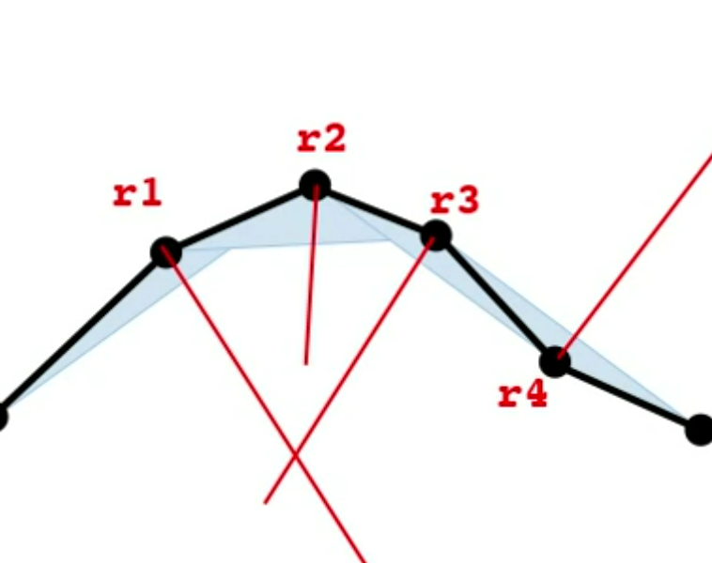

- the curve radius of each segment is the average of the radii for the triangles it is part of
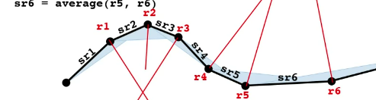

- the curvature of the line as a whole is found by adding up the lengths of each segment whose segment-radius is less than a certain threshold above which the road feels mostly straight

Large-radius turns that we’ll consider “straight” and give a weight of “0”.
(Green segments in the image below)
- Broad, sweeping turns that we’ll give a weight of “1”.
(Yellow segments in the image below)
- Tighter turns that we’ll give a weight of “2”.
(Orange segments in the image below)
- Super-tight corners that we’ll give a weight of “4”.
(Red segments in the image below)
Since numbered highways may go hundreds or thousands of miles, only a portion of which are twisty, each road is subsequently split into sections if it goes more than two miles without any curves that push a segment out of the straight bucket. This splitting process allows twisty sections to be highlighted alone without their adjoining long straightaways

With each segment classified into a weighted bucket we can then multiply the length of each segment by its weight and sum the weighted lengths into a single number. This number is the curvature value of the road section and corresponds roughly to the number of kilometers that a motorcycle would be leaning into a turn when traveling the road section.

Once each road section has had its curvature value calculated, the entire data set is filtered to remove any road-sections below a given threshold. In the map and the KML downloads I provide two thresholds: curvature ≥ 1000 and curvature ≥ 300. The roads in the dataset are color-coded into a spectrum from yellow (least twisty) to pink (most twisty).
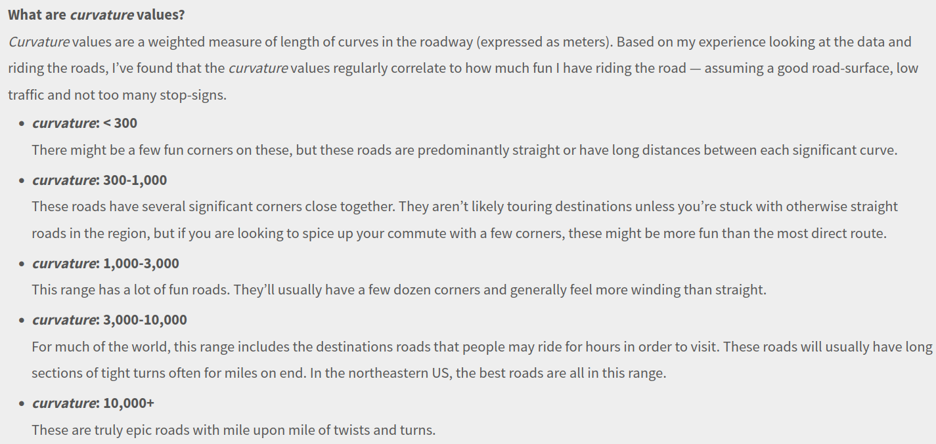
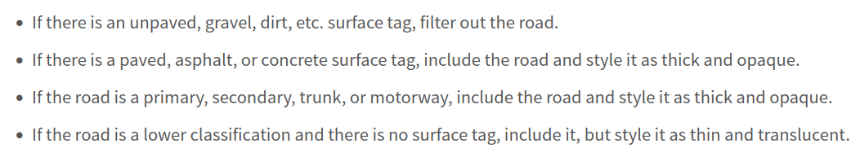

The map and downloads are automatically refreshed approximately every month

Readme from Github
The "curvature" of a way is determined by iterating over every set of three points in the line. Each set of three points form a triangle and that triangle has a circumcircle whose radius corresponds to the radius of the curve for that set. Since every line segment (between two points) is part of two separate triangles, the radius of the curve at that segment is considered to be the smaller, larger, or average of the radii for its member sets. Now that we have a curve radius for each segment we can categorize each segment into ranges of radii from very tight (short radius turn) to very broad or straight (long radius turn). Once each segment is categorized its length can be multiplied by a weight to increase the influence of the most curvy segments. By default a weight of 0 is given for straight segments, 1 for broad curves, and up to 2 for the tightest curves. The sum of all of the weighted lengths gives us a number for the curvature of the whole line that corresponds proportionally to the distance (in meters) that you will be in a turn.*
* If all weights are 1 then the curvature parameter will be exactly the distance in turns. The goal of this project however is to prefer tighter turns, so sharp corners are given an increased weight.
Additionally, this script allows rendering of ways as a sequence of segments color-coded based on the curvature of each segment. These 'colorized' KML files provide a neat look at the radius of turns and are especially useful when tuning the radii and weights for each level to adjust which ways are matched. The color-coding is as follows: straight segments are green and the four levels of curves are color-coded from yellow to red with decreasing turn radii.

How to Use
Curvature is a program that highlights twisty roads, helping motorcyclists and driving enthusiasts plan trips that pack in fun curves.
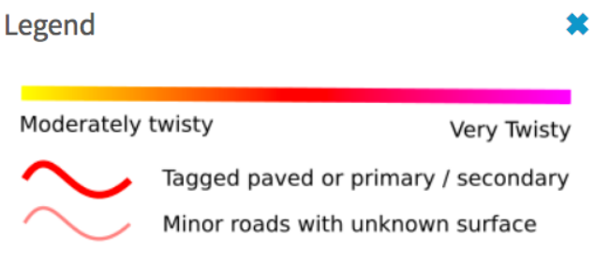

When zoomed in to the “Details” range highlighted roads become clickable and provide more information and links.
The Curvature map is backed by a database of over 10 million road segments that have been analyzed by the Curvature algorithm and determined to be at least moderately curvy.
In addition to displaying the most twisty roads by default (those with a curvature value greater than 1000), the map also allows users to view moderately twisty roads when zoomed in. This is particularly useful for those who live in flat areas where most roads are straight

