Modeling the Behavior of Platoons of Motorcyclists Driving in the Black Forest
In 1992, Nagel and Schreckenberg presented a cellular model of traffic that with just four rules describes quite well highway traffic behavior. In the proposed project, the idea is to research a similar model for motorcycle platooning. Starting from maps of winding roads of the black forest, the goal is to build a cellular automata model of a platoon of motorcycles driving through those roads; i.e., to model the behaviour of a group of motorcyclists that are driving together without passing each other.
Possible metrics for evaluation are the acceleration/deceleration of vehicles depending on position in the platoon, how fun a road is based on the patter of curves and the size of the platoon and how often it is necessary to brake beacuse of a motorcycle in front, comparison with original car traffic model.

A cellular automaton model for freeway traffic (Schreckenberg)

2221:
stochastic discrete automaton model with monte carlo simulations to show transition fram laminar traffic flow to start-stop waves with increasing vehicle density

2222:
model is defined on a one-dimensional array of L sites with periodic boundary conditions. Each site may be occupied by one vehicle or it may be empty. Each vehicle has an integer velocity.
Beginning with an arbitrary configuration the spped change is:
1.) Acceleration 2.) Slowing down 3.) Randomization 4.) Car motion
these properties are modeled on the basis of integer valued probabilistic automaton rules.
Step 3 is essential in simulating traffic flow since otherwise the dynamics is completely deterministic. It takes into account natural velocity fluctuations due to human behavior or due to varying external conditions. Without this randomness the system reaches a stationary pattern which is shifted backwards.
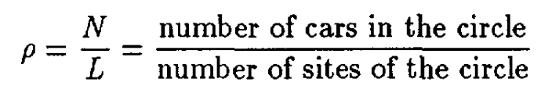

Constant overall system density factor

2223:
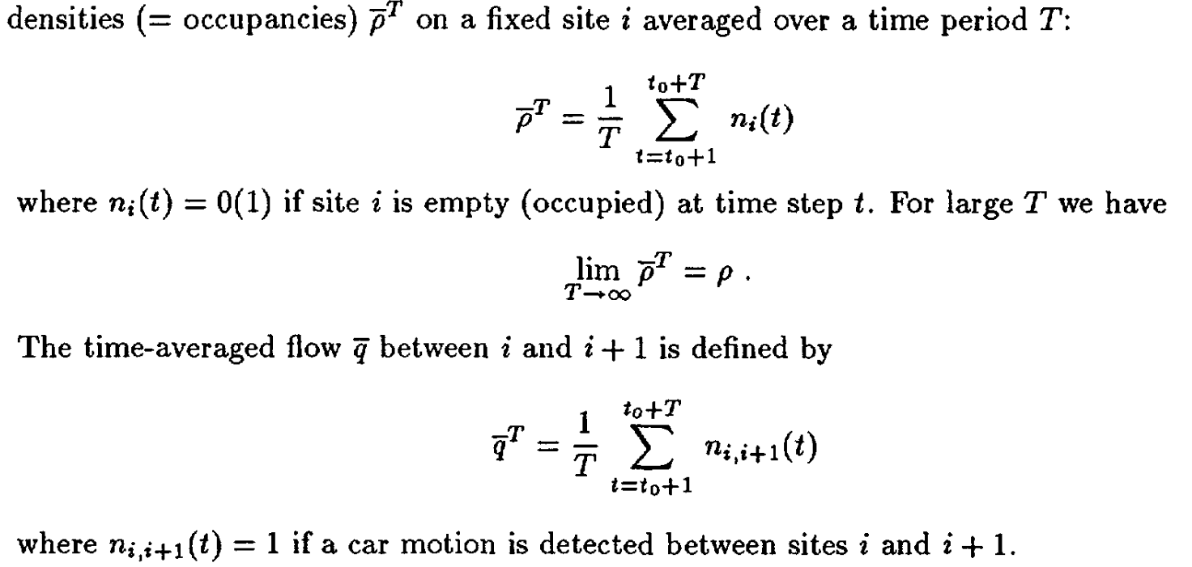

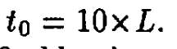
initial time running

observation: in space-time-lines (trajectories) laminar traffic at low density and congestion clusters at higher overall system density (start stop waves)

2224:
fundamental diagram: flow-density diagram whereas the line indicates the results of averaging 10^6 time steps and the dots represents averages over only 10^2 time steps. There is a peak. This maximum q(p) depends on the system site. Simulations without randomization do not show a dependence on the system size

2227:
quantitative comparison with realistic traffic: each jam a car occupies 7.5m of place ~ 1 site
4.5 sites per time step max ~ 120 km/h
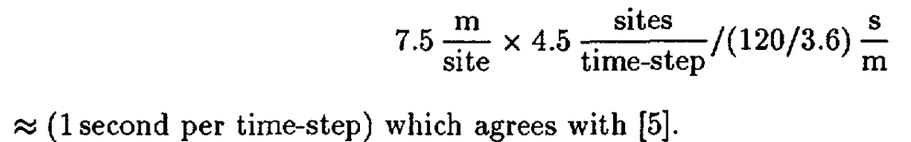

2228:
all estimates agree in order of magnitude: time steps corresponds to seconds

2229:
the discrete model approach for traffic flow is not only computationally advantageous but it contains some of the important aspects of the fluid dynamical approach. Thereby it retains more elements of individual behavior of the driver

Two Lane Traffic Simulation (Rickert)

2:
our approach here is to search for minimal sets of rules which reproduce certain macroscopic facts.

3:
single lane model: at the beginning of each time step the rules are applied to all vehicles simultaneously (parallel update, in contrast to sequential updates which yield slightly different results).
But Introducing different vehicles with different max speed would lead to platooning on a single lane model and the average velocity reduced to the free flow velocity of the slowest vehicle

4:
the update step is split into:
1.) vehicles are moved sideways, they do not advance in switching lanes.
2.) perform independent single lane updates on both lanes according to the single lane update rules
important Parameters:
- Symmetry
- Stochasticity: lack of it leads in a platoon to a collective change sidewise
- Direction of Causality: looking behind leads to that the causlity travveling downstream

5:
passing rules: - T1 -T4
looking ahead is proportional to its own speed whereas looking back is not. It depends on the expected velocity of other cars. In the symmetry case cars stay at their lane as long as they don’t see somebdy ahead. If they switch they stay on the other lane. In the asymmetric case cars always try to return to the right lane, independent of their own situation on the left lane

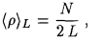
6:
avg density for two lanes:
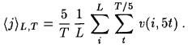
flow with eatch fifth step only, since subsequent time steps are correlated:

7:
Flow Behavior: nicht so wichtig da zwischen symmetric and asymmetric verglichen
Lane Changing Behavior:
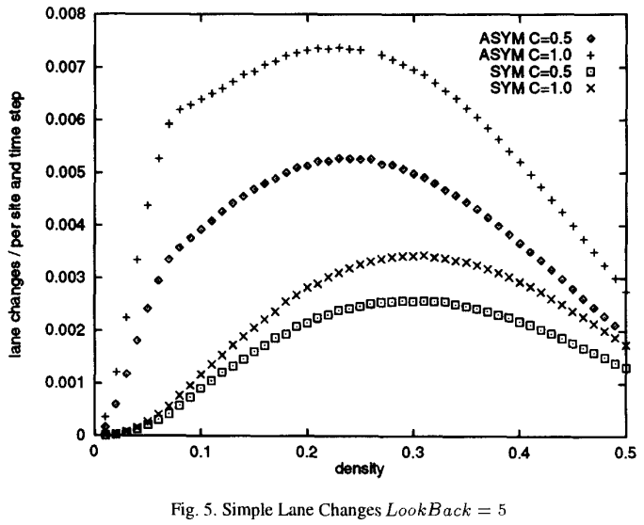
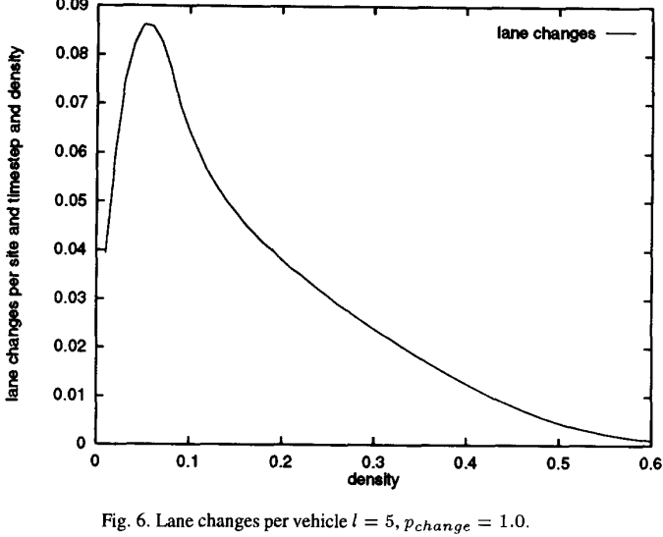

8:
Ping-Pong lane changes:
By randomizing lane changing decisions, patterns of cooperative ping pong effect is avoided
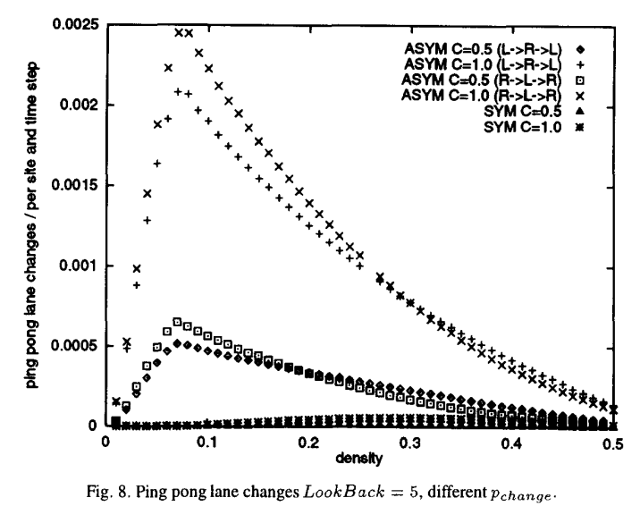

9:
this gives strong indication that most lane changes are actually caused by the tailgating effect (all vehicles have the same max speed here!) → Broken by Bikes and Motorcyclists

10:
Parameter combinations:
look ahead at l=v instead of l=v+1. Negligible for vehicles at higher velocities. Crucial in a jam. Current velocity zero look ahead is zero, will not try to change lane even the other lane is completely free.
Look back = 0: egoistic driving behavior unrealistic braking maneuvers. Look back = 0 completely disrupts the laminar flow regime. → causes the obstructed vehicles to make sudden stops
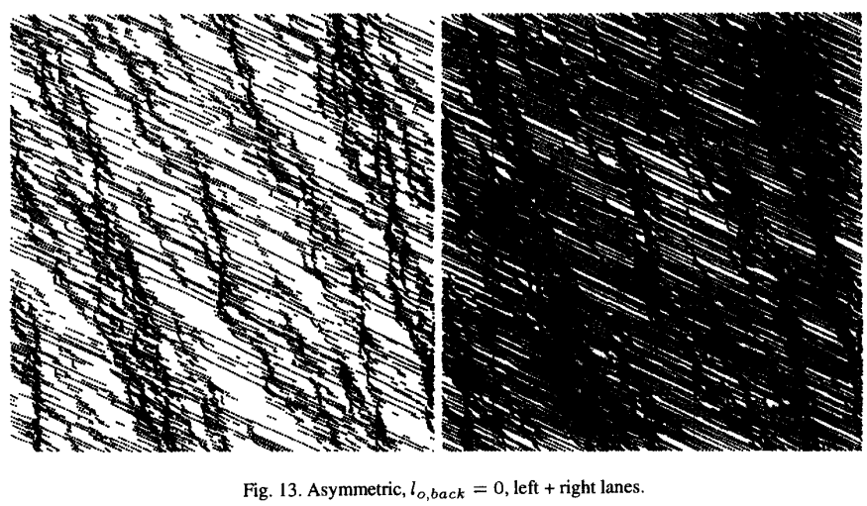

Discussion: p_change = 0.1 seems to be more realistic, but is dynamically not a good fix. It would mean that a driver follows a car in the average for 10 sex before he decides to change lanes. Besides it was shown that about 90% of the lane changes in the asymmetric models here are produced by an artificial tail gating dance-→ introduce memory one stays longer on the left lane before changing back
everyday observation show that real traffic shows a density inversion long before maximum flow, that is, more cars drive on the left lanes than on the right

11:
Summary: look back is important if one wants to maintain the dynamics consisting of laminar traffic plus start-stop waves which is so typical for traffic
Countries with high speed limits: density is higher on the left lane than on the right lane. This is not reproduced in this model

Cellular automaton model for mixed traffic flow with motorcycles

470:
it is found that the maximum car flow decreases because of the lane changing behavior of motorcycles. The lane changing first increases then decrease to zero with the increase of motorcyclists.

471:
Traffic Flow Research History:
In 1992 Nasch proposed the well known CA traffic model. The model could be used to model some basic phenomena encountered in real traffic (start-stop waves in congested traffic…
motorcyclist have a smaller width making above models not so appropriate for the simulation.

472:
each motorcycly occupies about 3.75m of road in a complete traffic jam, which is half of a cars.
3 sublanes on a single lane model. Cars cannot change lanes
motorcycles do not move forward in the lane-changing step. Only together with the forward movement rule our update make physically sense

474:
a system of 2000 sites, length if each site is set to be 3.75m ~ 7.5km long. One iteration time step is taken as 1s.

Cellular automaton simulations for mixed traffic with erratic motorcycles behaviors

2078:
One crucial defect aroused from such a coarse cell system would be difficult to implement the mixed traffic simulations where vehicles have different sizes (length and width). It is ubiquitous in many Asian urban streets that motorcycles oftentimes move concurrently with the cars by sharing the same lane (not important for me)-→ urban traffic simulations , maybe Ausweichmanöver zwischen Cars möglich
Another shortcoming is that in urban streets the speed limits are usually low (Nasch uses 7.5m per cell). This paper analyzes microscopic traffic features

2081:
incentive criteria, safety criteria
transverse crossing of motorcyclists stuck in a traffic jam.

Traffic dynamics of carnival processions

1:
the preparation of the measured data requires an adjustment by a specially adapted algorithm. A higher average velocity is observed for the last participant than the leading participant.
One would expect spontaneous jam formation in a carnival procession, but we observed shorter travel times at the rear than those at the front.
If the parade if interpreted as a on-lane traffic jam, the further back a participant id located the more frequently he has to stop because of velocity breakdowns in front of him. But it is the other way around.

3:
Time-Distance Diagram: x axis represents the pathway and the y.axis the inverted time
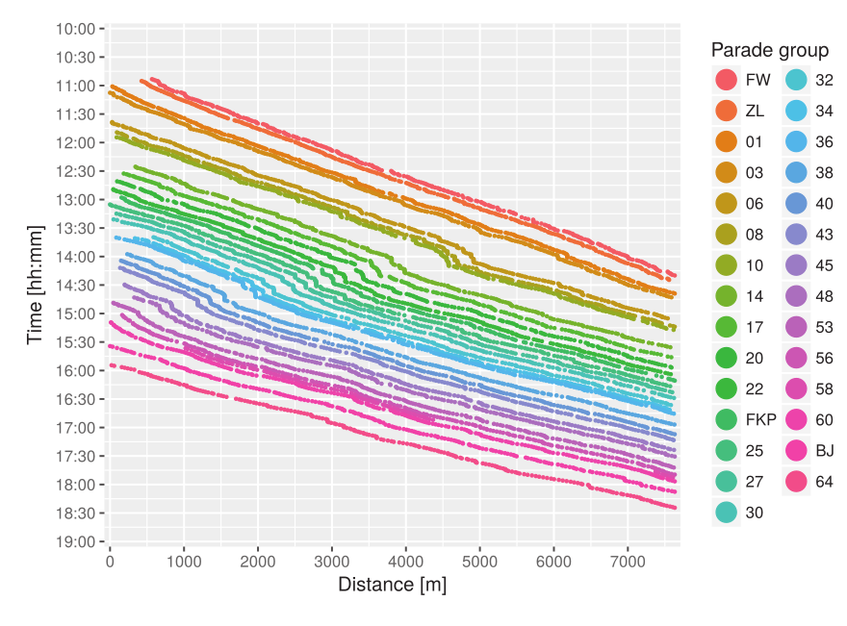

Knick is caused by the propagation of a disturbance, which is triggered within the first group s and develops into a traffic jam

Velocity-Distribution:
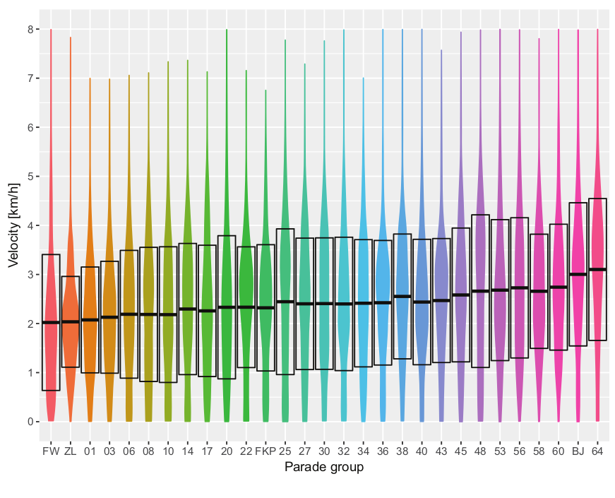

4:
Velocity-time Diagram:
average velocity of the whole parade as a function of time:
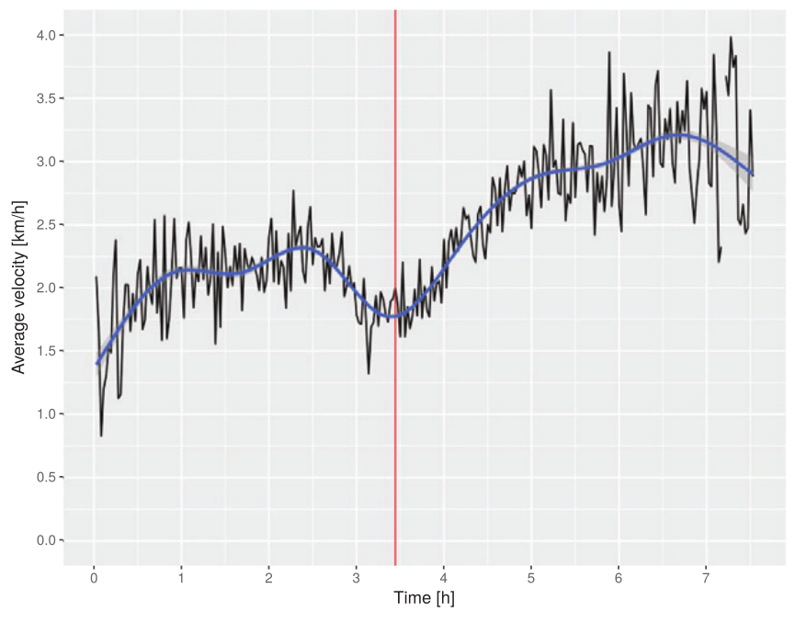

A smooth movement of a queue depends on the leaders escape velocity. A faster leader generates vacant space, whereas a slower leader limits the walking velocity of the follower. An increase of the variance in the velocity distribution is partly caused by the spatial contraction of the parade

5:
develop a CA model for groups in a procession based on the Nasch model. The spatial discretiasation in the model is determined by maintaining the temporal update of 1 sec.
Group compression:
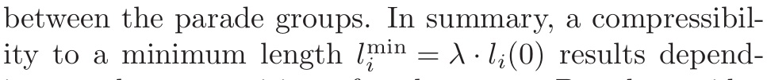
(in relation of free traffic)

A CA Model for Simulating Vehicle Platooning

1:
CA models are widely used to reveal the effects of microscopic vehicular behavior changes on
macroscopic traffic flow characteristics. Lane-changing behavior of CAV platoons was not considered in this study
The main focus of this work is to analyze how platooning settings affect the macroscopic characteristics of mixed traffic flow:
→ characteristics: platoon formation, platoon maintenance, lane-changing, platoon split.
maximum platoon size, intra-platoon spacing, etc
→ influencing factors: traffic demand, platoon site, penetration rate, platooning related configurations

2:
platoon leader may control the driving parameters and coordinates the movements of all following vehicles in the platoon. Vehicle platoons employ tighter space gap between vehicles, which not only improves the road capacity
three operating modes are defined for the CAV, including normal driving mode, platoon formation mode, and platooning mode

5:
Two-State Safe-Speed Model:
- Deterministic speed acceleration:
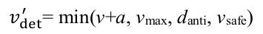
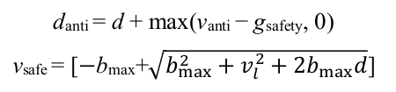

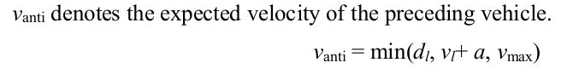

- Stochastic deceleration:
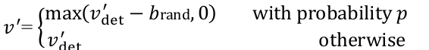

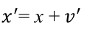
- Position update:

- Symmetry lane-changing:
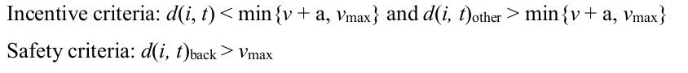

7:
this study assumes that CAVs maintain a constant distance from each other in the platoon, referring to the intra-platoon spacing d_{intra}

8:
During this process, the speed difference between the target vehicle and its target partner is required to reduce the distance between the two vehicles to facilitate the platoon-formation process. The speed difference can be realized through the catch-up strategy of the following CAV or the slow-down strategy of the preceding CAV.
The conditions for the CAV to switch from normal driving mode to platoon-formation mode are as follows:
i. If its preceding vehicle is a CAV.
ii. If its preceding vehicle is already running in an existing platoon and the size of the leading
platoon is less than the maximum platoon size Lmax.
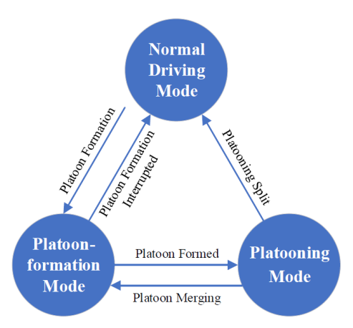

Switch from normal to platoon formation mode:

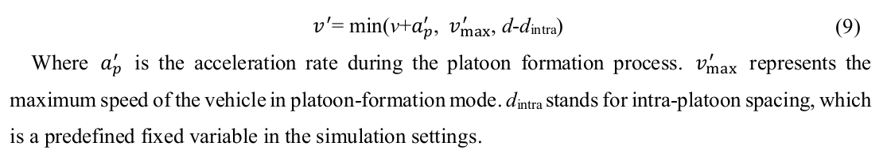

For vehicles in the platoon-formation mode, the lane-changing probability is zero, as priority is given to catching up with the target CAV or platoon in front of it. he platoon-formation process will
be interrupted if either a vehicle appears in the gap between the target CAV in front of it, or if neither of the above two conditions are met

9:
Platooning mode:
Platooning mode means that following CAVs apply the same driving parameters as their platoon
leader and maintain constant intra-platoon spacing.
For the platoon leader, the same deterministic speed update applies as for conventional vehicles,
skipping the stochastic deceleration step.

Platoon Merging:
Platoon merging also follows the catch-up strategy in this model. For the platoon leader, if the size
of the target platoon is smaller than the maximum platoon size Lmax, the platoon leader has the ability to leave the current platoon with the merging probability of Pm, and switch to the platoon-formation mode to join the front platoon

10:
Platoon Split:
Platoon splits are modeled by lane-changing rules set specifically for vehicles in platooning mode.
Pd represents the probability that a platooning vehicle will leave the current platoon, which may be
due to deviating from the current platoon's route or intending to get off the highway when approaching an interchange (affected by surrounding traffic, especially in congested conditions.)
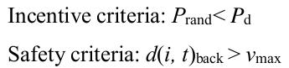

If the vehicle is the platoon leader and the number of
following vehicles in the platoon is greater than 2, the following vehicle immediately behind it will
become the new platoon leader; otherwise, the following vehicle will switch to the normal driving
mode

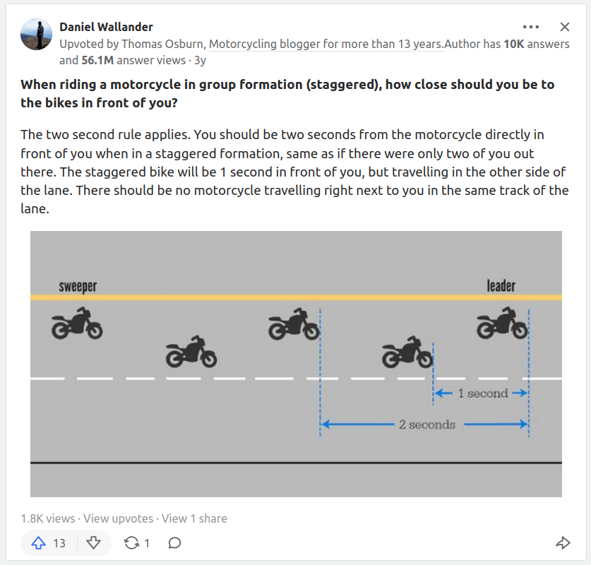
https://www.quora.com/When-riding-a-motorcycle-in-group-formation-staggered-how-close-should-you-be-to-the-bikes-in-front-of-you

