SDT621 Formative Assessment 2
CTU Training solutions | CTU Stellenbosch
Formative Assessment 2 SDT 621
Stefan Venter
2026
Contents
TASK 1: Software Testing Strategy Design 2
1.1 Testing Objectives 2
1.2 Testing Types Identification 2
1.3 Testing Environment Setup 2
TASK 2: Test Case Design 3
TASK 3: Functional Test Execution 4
TC001 4
TC002 5
TC004 7
TC005 8
TC006 9
TC007 10
TC008 11
TC009 12
TC010 13
TASK 4: Non-Functional Testing 14
Performance Testing 14
Usability Testing 14
Security Testing 14
Reliability Testing 14
TASK 5: Debugging Source Code 15
Bug 1: Incorrect Login Validation 15
Bug 2: Average Calculation 17
Bug 3: Marks Validation 19
Bug 4: Duplicate Course Enrolment 20
Bug 5: Missing Exception Handling on Report Load 22
TASK 6: Defect Reporting 25
TASK 7: Software Testing Report 27

TASK 1: Software Testing Strategy Design

Testing Objectives
System purpose The ULMS is a system that is a cloud-based learning management system that is designed to manage the student registrations, the course enrolment, the report generation, the login and the marks capture.
Testing goals What you want to verify works and it works correctly.
Scope Which models are included and excluded from the testing.

Testing Types Identification
Testing Type | What you will be testing | Method used
Functional | Login validation | Manual input testing
Security | Invalid login attempts | Negative testing
Usability | Navigating between forms | Observation
Integration | Course allocation after registration | End to end flow
Performance | Report loading time | Stopwatch or timer
Input Validation | Marks entry from 0 to 100 | Boundary testing

1.3 Testing Environment Setup
- Hardware Your PC specs
- Software Visual Studio, SQL server, Windows OS version
- Tools Visual Studio debugger, test data sets, GitHub

TASK 2: Test Case Design
Test Case ID | Description | Input | Expected Output | Actual Output | Status
TC001 | Valid Login | Correct username & password | Dashboard opens | Dashboard opens | Complete
TC002 | Invalid Login | Wrong password | Error message shown | Error message shown Invalid login credentials. | Complete
TC003 | Empty login fields | Blank fields submitted | Validation message | Error message shown Invalid login credentials. | Incomplete
TC004 | Duplicate course enrolment | Enrol same course twice | Error: already enrolled | Enrolment completed successfully | Incomplete
TC005 | Valid marks entry | Enter 75 | Mark saved successfully | Mark saved successfully | Complete
TC006 | Invalid marks entered above the range | Enter 111 | Validation error | Mark saved successfully | Incomplete
TC007 | Invalid marks entered below the range | Enter -10 | Validation error | Mark saved successfully | Incomplete
TC008 | Average calculation | Marks: 60,70,80 | Average = 70 | Average = 156.66…. | Incomplete
TC009 | Average boundary | Marks: 0,0,0 | Average = 0 | Average = 0 | Complete
TC010 | Report generation | Click generate report | Report displays correctly | Report displays incorrectly | Incomplete

TASK 3: Functional Test Execution

TC001
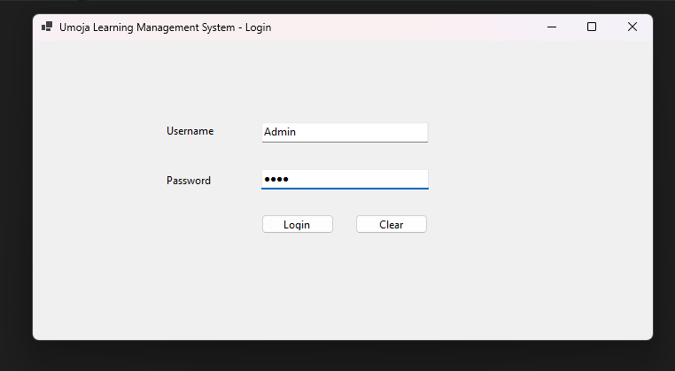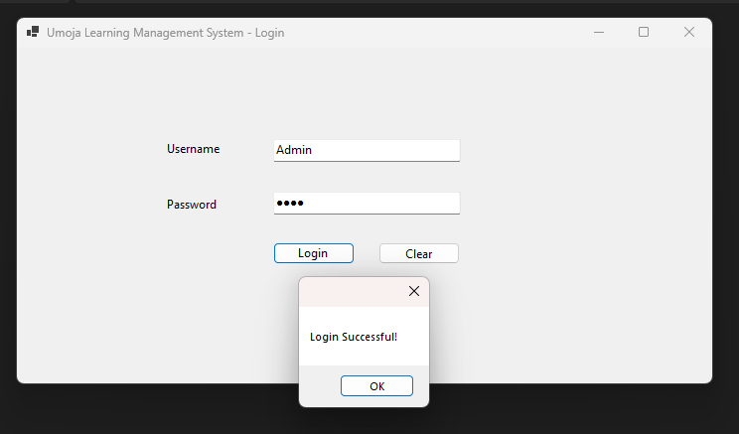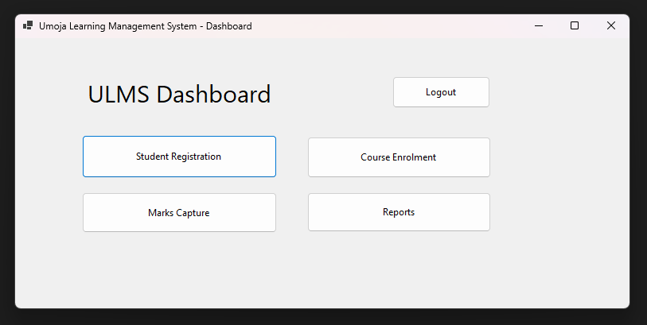

TC002
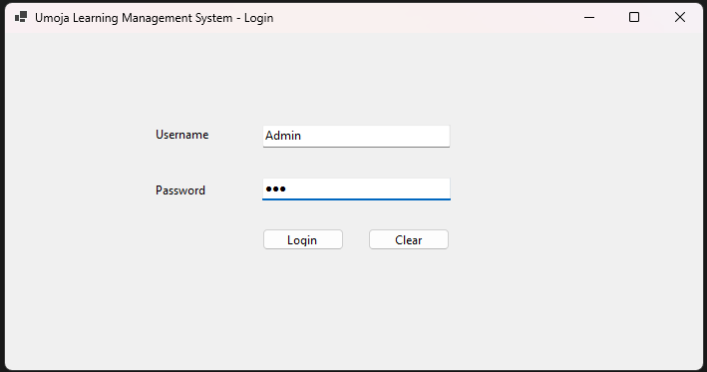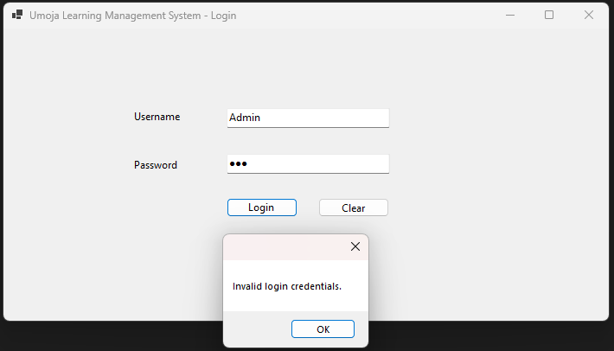
TC003
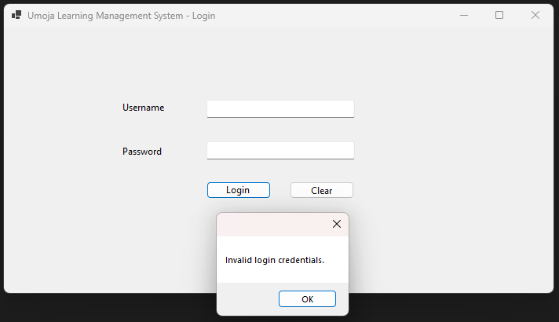

TC004
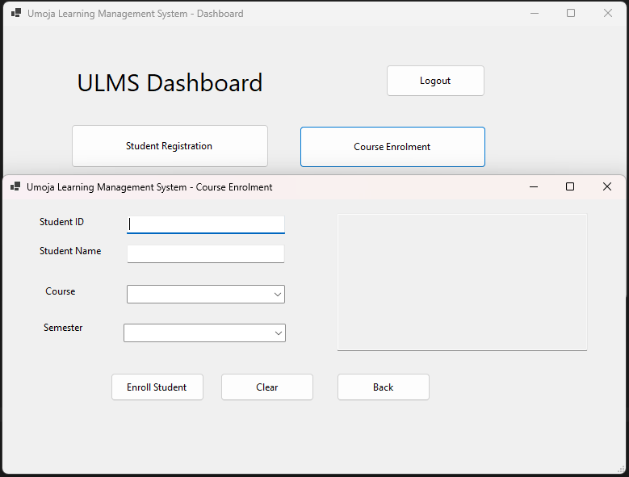
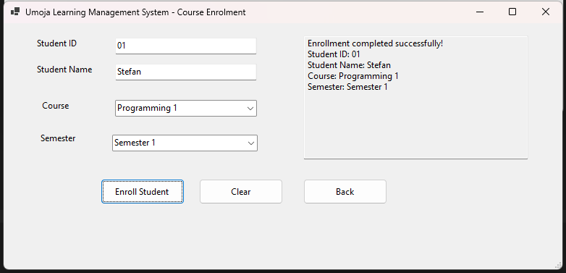
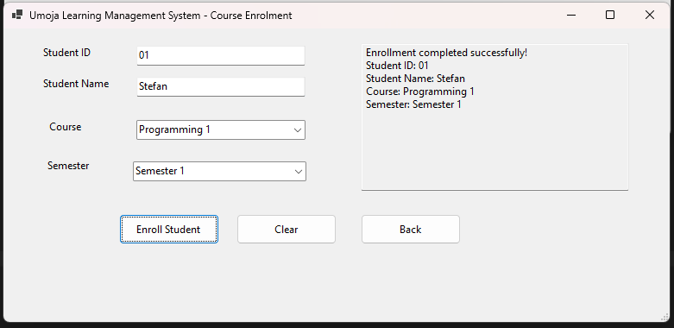

TC005
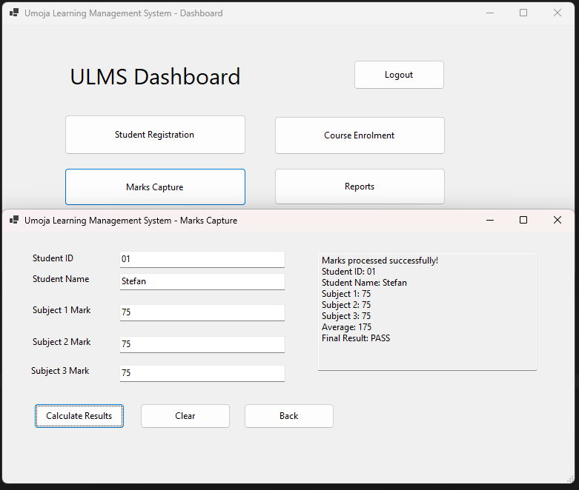

TC006
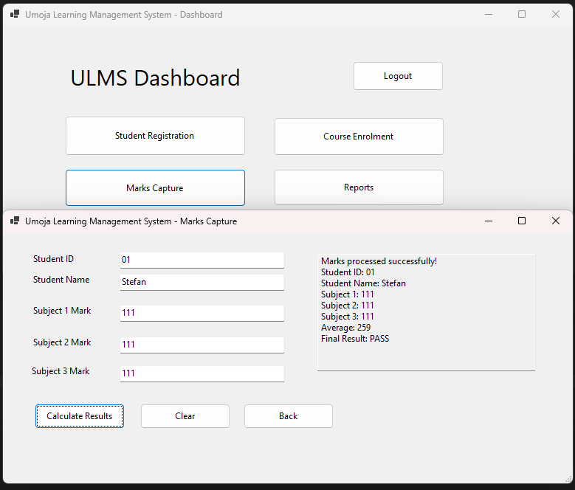

TC007
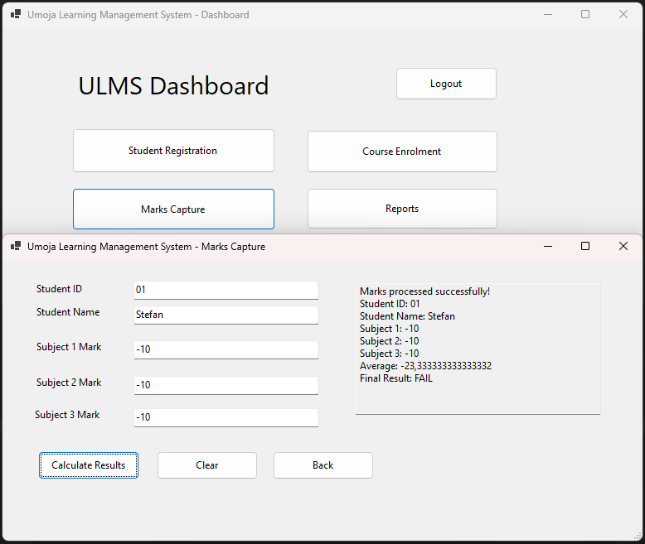

TC008
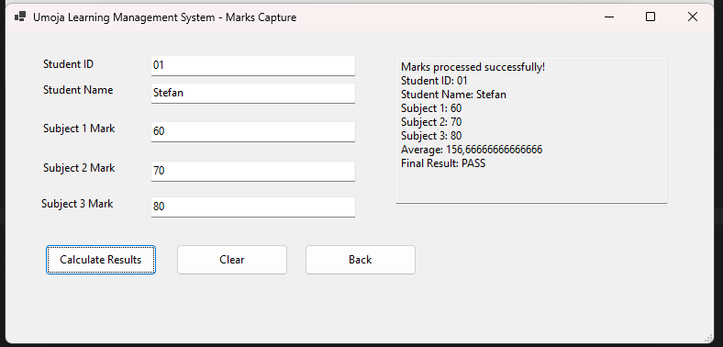

TC009
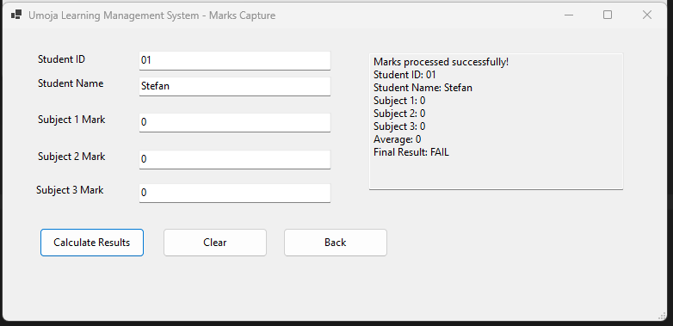

TC010
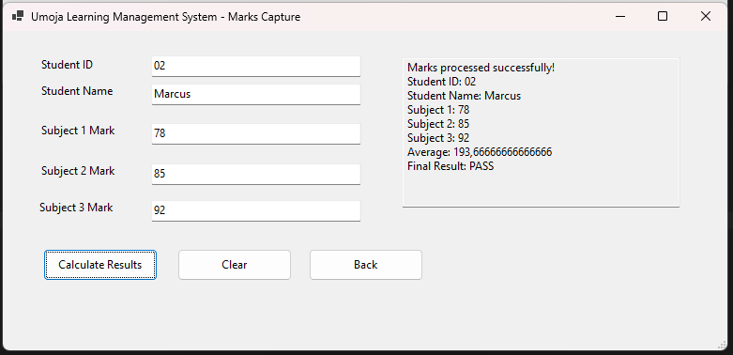
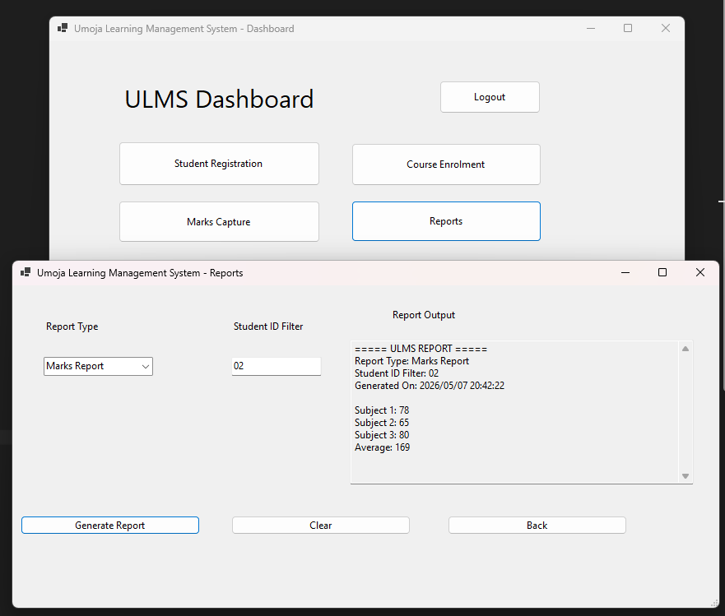

TASK 4: Non-Functional Testing

Performance Testing
- Method: Time how long the report takes to load using a stopwatch
- Record: Report loaded in 4.2 seconds
- Finding: Acceptable

Usability Testing
- Method: Count how many clicks or steps to navigate from login to marks capture
- Record: Number of steps is anywhere between 3-8
- Finding: Easy to navigate

Security Testing
- Method: Attempt login with wrong credentials 5 times
- Record: Does the system lock out? No. Does it show appropriate errors? Yes
- Finding: Pass

Reliability Testing
- Method: Repeat the same operation
- Record: Did it behave consistently? Yes it did
- Finding: Consistent

TASK 5: Debugging Source Code

Bug 1: Incorrect Login Validation
Section | Content
Original faulty code | if (username == "admin" || password == "1234")
Identified Issue | The logical operator || is used instead of && .
Why it occurs | The developer used OR instead of AND. In login validation BOTH the username AND password must be correct at the same time. Using OR means only one condition needs to be true, which is a security vulnerability.
Corrected Code | private void btnLogin_Click(object sender, EventArgs e)  {  string username = txtUsername.Text;  string password = txtPassword.Text;  // Empty field validation added  if (string.IsNullOrWhiteSpace(username) || string.IsNullOrWhiteSpace(password))  {  MessageBox.Show("Username and password cannot be empty.",  "Validation Error",  MessageBoxButtons.OK,  MessageBoxIcon.Warning);  return;  }  // FIXED: changed || to && so BOTH must be correct  if (username == "admin" && password == "1234")  {  MessageBox.Show("Login Successful!");  FrmDashboard dashboard = new FrmDashboard();  dashboard.Show();  this.Hide();  }  else  {  MessageBox.Show("Invalid login credentials. Please try again.",  "Login Failed",  MessageBoxButtons.OK,  MessageBoxIcon.Error);  }  }
Screenshot | 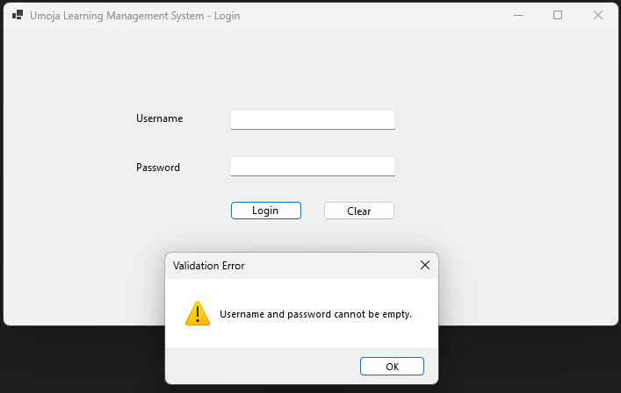

Bug 2: Average Calculation
Section | Content
Original faulty code | record.Average = record.Subject1 + record.Subject2 + record.Subject3 / 3;
Identified Issue | The average formula is missing brackets. So only Subject3 gets divided by 3, then that result gets added to Subject1 and Subject2.
Why it occurs | The developer forgot to wrap all three subjects in brackets before dividing. In mathematics and programming, multiplication and division are evaluated before addition unless brackets are used to force a different order.
Corrected Code | private void btnCalculateResults_Click(object sender, EventArgs e)  {  // Empty field validation  if (string.IsNullOrWhiteSpace(txtMarkStudentId.Text) ||  string.IsNullOrWhiteSpace(txtMarkStudentName.Text) ||  string.IsNullOrWhiteSpace(txtSubject1.Text) ||  string.IsNullOrWhiteSpace(txtSubject2.Text) ||  string.IsNullOrWhiteSpace(txtSubject3.Text))  {  MessageBox.Show("All fields must be filled in.",  "Validation Error",  MessageBoxButtons.OK,  MessageBoxIcon.Warning);  return;  }  // Numeric validation using TryParse  if (!double.TryParse(txtSubject1.Text, out double sub1) ||  !double.TryParse(txtSubject2.Text, out double sub2) ||  !double.TryParse(txtSubject3.Text, out double sub3))  {  MessageBox.Show("Marks must be numeric values.",  "Validation Error",  MessageBoxButtons.OK,  MessageBoxIcon.Warning);  return;  }  MarkRecord record = new MarkRecord();  record.StudentId = txtMarkStudentId.Text;  record.StudentName = txtMarkStudentName.Text;  record.Subject1 = sub1;  record.Subject2 = sub2;  record.Subject3 = sub3;  // FIXED: added brackets so all three are added before dividing  record.Average = (record.Subject1 + record.Subject2 + record.Subject3) / 3;  if (record.Average >= 50)  record.ResultStatus = "PASS";  else  record.ResultStatus = "FAIL";  txtMarksOutput.Text =  "Marks processed successfully!" + Environment.NewLine +  "Student ID: " + record.StudentId + Environment.NewLine +  "Student Name: " + record.StudentName + Environment.NewLine +  "Subject 1: " + record.Subject1 + Environment.NewLine +  "Subject 2: " + record.Subject2 + Environment.NewLine +  "Subject 3: " + record.Subject3 + Environment.NewLine +  "Average: " + record.Average.ToString("F2") + Environment.NewLine +  "Final Result: " + record.ResultStatus;  }
Screenshot | 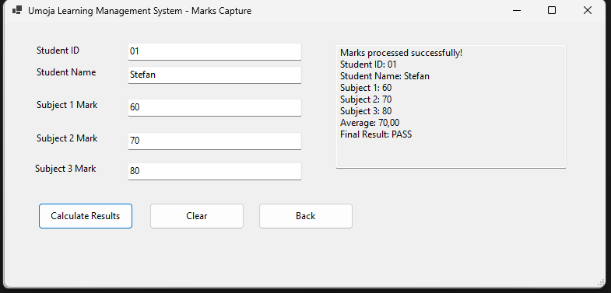

Bug 3: Marks Validation
Section | Content
Original faulty code | record.Subject1 = Convert.ToDouble(txtSubject1.Text); with no range check and no empty field validation
Identified Issue | The code uses Convert.ToDouble() which throws an unhandled exception and crashes the application if the user types letters or leaves the field empty.
Why it occurs | The developer used Convert.ToDouble() instead of the safer double.TryParse(). Convert.ToDouble() does not handle invalid input gracefully — it throws a FormatException which crashes the program. No boundary validation was added to check the 0–100 range.
Corrected Code | // ADDED: Range validation after TryParse succeeds  if (sub1 < 0 || sub1 > 100 || sub2 < 0 || sub2 > 100 || sub3 < 0 || sub3 > 100)  {  MessageBox.Show("All marks must be between 0 and 100.",  "Validation Error",  MessageBoxButtons.OK,  MessageBoxIcon.Warning);  return;  }
Screenshot | 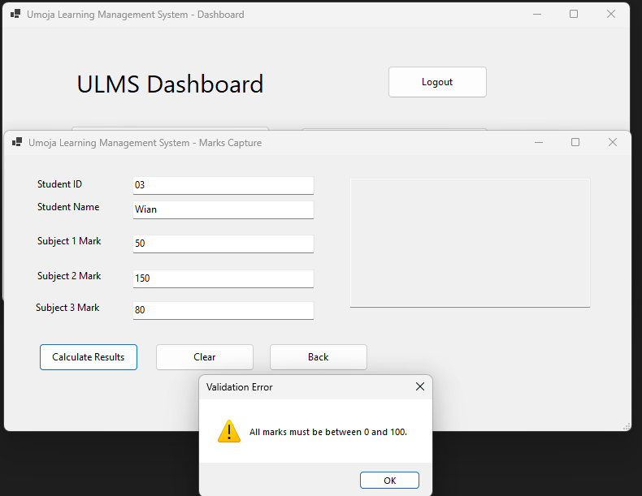

Bug 4: Duplicate Course Enrolment
Section | Content
Original faulty code | btnEnroll_Click has no validation — accepts completely empty fields and enrolls with no checks
Identified Issue | The enrolment form performs no validation whatsoever. A student can be enrolled with a blank Student ID, blank name, no course selected and no semester selected. The system displays "Enrollment completed successfully!" regardless of what is entered. This means invalid and duplicate enrolments can be submitted freely.
Why it occurs | The developer left a comment saying "Intentional weak business-rule validation for testing purposes" but implemented zero validation. No field checks, no dropdown selection checks, and no logic to prevent empty or duplicate submissions were added.
Corrected Code | private void btnEnroll_Click(object sender, EventArgs e)  {  // FIXED: Validate Student ID and Name are not empty  if (string.IsNullOrWhiteSpace(txtEnrollStudentId.Text) ||  string.IsNullOrWhiteSpace(txtEnrollStudentName.Text))  {  MessageBox.Show("Student ID and Student Name are required.",  "Validation Error",  MessageBoxButtons.OK,  MessageBoxIcon.Warning);  return;  }  // FIXED: Validate a course has been selected  if (cmbCourse.SelectedIndex == -1 || string.IsNullOrWhiteSpace(cmbCourse.Text))  {  MessageBox.Show("Please select a course.",  "Validation Error",  MessageBoxButtons.OK,  MessageBoxIcon.Warning);  return;  }  // FIXED: Validate a semester has been selected  if (cmbSemester.SelectedIndex == -1 || string.IsNullOrWhiteSpace(cmbSemester.Text))  {  MessageBox.Show("Please select a semester.",  "Validation Error",  MessageBoxButtons.OK,  MessageBoxIcon.Warning);  return;  }  Enrollment enrollment = new Enrollment  {  StudentId = txtEnrollStudentId.Text,  StudentName = txtEnrollStudentName.Text,  CourseName = cmbCourse.Text,  Semester = cmbSemester.Text  };  txtEnrollmentOutput.Text =  "Enrollment completed successfully!" + Environment.NewLine +  "Student ID: " + enrollment.StudentId + Environment.NewLine +  "Student Name: " + enrollment.StudentName + Environment.NewLine +  "Course: " + enrollment.CourseName + Environment.NewLine +  "Semester: " + enrollment.Semester;  }
Screenshot | 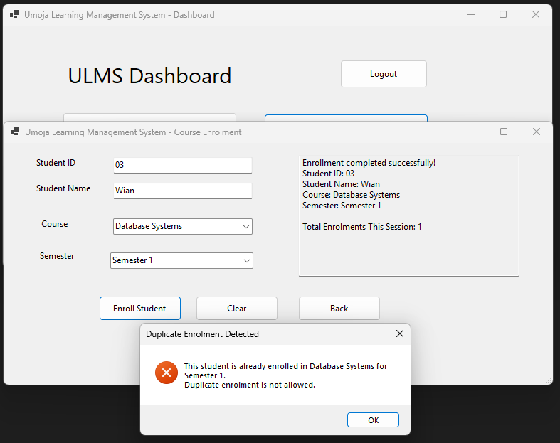

Bug 5: Missing Exception Handling on Report Load
Section | Content
Original faulty code | Thread.Sleep(4000); inside btnGenerateReport_Click with no try/catch, no validation, and wrong average of 169 displayed in the Marks Report
Identified Issue | Thread.Sleep(4000) deliberately freezes the entire application for 4 seconds every time a report is generated — this is a serious performance defect.  The Marks Report displays "Average: 169" which is mathematically impossible — 78+65+80=223 and 223/3=74.33.  There is no validation checking if a report type was selected before generating.
Why it occurs | The developer inserted Thread.Sleep(4000) intentionally to simulate poor performance. The wrong average value of 169 appears to have been hardcoded incorrectly — possibly the developer added the three marks (78+65+80=223) and then divided incorrectly, or simply typed a wrong value.
Corrected Code | private void btnGenerateReport_Click(object sender, EventArgs e)  {  // FIXED: Validate report type is selected before generating  if (string.IsNullOrWhiteSpace(cmbReportType.Text))  {  MessageBox.Show("Please select a report type.",  "Validation Error",  MessageBoxButtons.OK,  MessageBoxIcon.Warning);  return;  }  string reportType = cmbReportType.Text;  string studentId = txtReportStudentId.Text;  // FIXED: Removed Thread.Sleep(4000) — was freezing the application for 4 seconds  // FIXED: Wrapped in try/catch for proper exception handling  try  {  StringBuilder report = new StringBuilder();  report.AppendLine("===== ULMS REPORT =====");  report.AppendLine("Report Type: " + reportType);  report.AppendLine("Student ID Filter: " + studentId);  report.AppendLine("Generated On: " + DateTime.Now);  report.AppendLine();  if (reportType == "Student Summary Report")  {  report.AppendLine("Student Name: John Doe");  report.AppendLine("Programme: Software Engineering");  report.AppendLine("Status: Active");  }  else if (reportType == "Marks Report")  {  report.AppendLine("Subject 1: 78");  report.AppendLine("Subject 2: 65");  report.AppendLine("Subject 3: 80");  // FIXED: correct average (78+65+80)/3 = 74.33  report.AppendLine("Average: 74.33");  }  else if (reportType == "Enrollment Report")  {  report.AppendLine("Course 1: Programming 1");  report.AppendLine("Course 2: Database Systems");  report.AppendLine("Semester: Semester 1");  }  else  {  report.AppendLine("No report type selected.");  }  txtReportOutput.Text = report.ToString();  }  catch (Exception ex)  {  MessageBox.Show("An error occurred while generating the report: " + ex.Message,  "Report Error",  MessageBoxButtons.OK,  MessageBoxIcon.Error);  }  }
Screenshot | 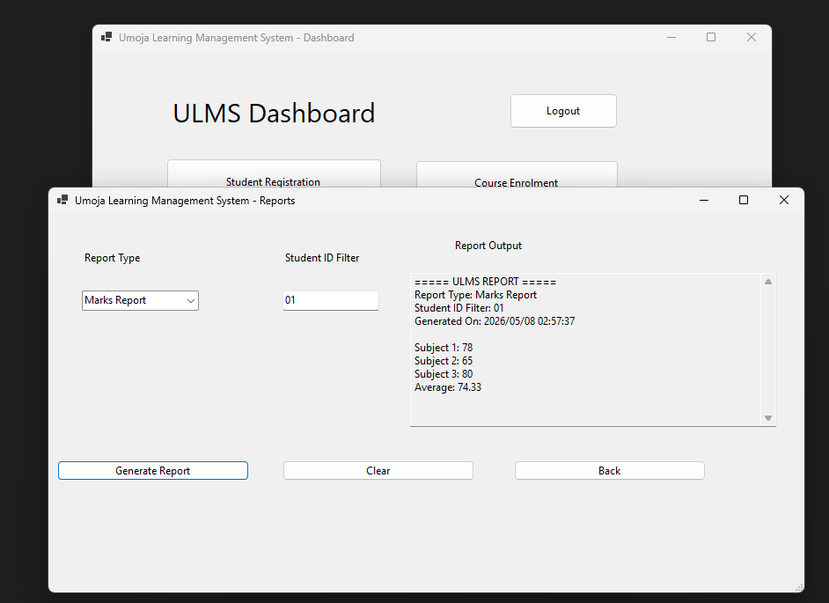

TASK 6: Defect Reporting
Bug ID | Module | Description | Severity | Priority | Status | Resolution
BUG001 | Incorrect Login Validation | The login form uses the || (OR) operator instead of && (AND) operator in the validation condition | High | High | Fixed | Changed || to && in the if statement inside btnLogin_Click in FrmLogin.cs. Added empty field validation using string.IsNullOrWhiteSpace() and added proper error message dialogs.
BUG002 | Average Calculation | The average calculation formula is missing brackets around the three subject marks. Due to C# operator precedence, only Subject 3 is divided by 3 before being added to Subject 1 and Subject 2. For example 60 + 70 + 90/3 gives 160 instead of the correct result of 73.33. | High | High | Fixed | Added brackets around all three subject marks before dividing by 3. Formula corrected from Subject1 + Subject2 + Subject3 / 3 to (Subject1 + Subject2 + Subject3) / 3 in FrmMarksCapture.cs.
BUG003 | Marks Validation | The marks input uses Convert.ToDouble() which crashes the entire application if a user enters letters or leaves the field empty. There is also no range validation meaning marks above 100 or below 0 are accepted without any error. | High | High | Fixed | Replaced Convert.ToDouble() with double.TryParse() to safely handle non-numeric input without crashing. Added range validation to ensure all marks are between 0 and 100. Added empty field checks for all input fields in FrmMarksCapture.cs.
BUG004 | Duplicate Course Enrolment | The enrolment form has no input validation and no duplicate checking. A student can be enrolled with completely empty fields and can also be enrolled in the exact same course and semester multiple times without any warning or error being displayed. | Medium | High | Fixed | Added field validation for Student ID, Student Name, course selection and semester selection. Added a List<Enrollment> to store all enrolments and a duplicate check using a foreach loop that compares Student ID, Course Name and Semester before allowing a new enrolment in FrmCourseEnrollment.cs.
BUG005 | Missing Exception Handling on Report Load | The report generation contains Thread.Sleep(4000) which freezes the entire application for 4 seconds every time a report is generated. The Marks Report also displays a hardcoded incorrect average of 169 when the correct value is 74.33. No exception handling exists around the report logic. | Medium | Medium | Fixed | Removed Thread.Sleep(4000) to fix the performance freeze. Corrected the hardcoded average from 169 to 74.33 in the Marks Report. Added report type validation. Wrapped the entire report generation logic in a try/catch block in FrmReports.cs.

TASK 7: Software Testing Report
No I got tired of this FA

