Supplementary materials
This file contains the supplementary materials for the article entitled “Unpacking differential item functioning in executive functioning performance using computational modeling”. The supplemental materials include supporting information relating to more detailed descriptive statistics, model convergence and fit, and details on confounders.

Section 1 - Psychometric properties of cognitive tasks

1.1 Performance distributions
Figure S1 and S2 show the distributions of mean response times and mean error rate for each cognitive task.
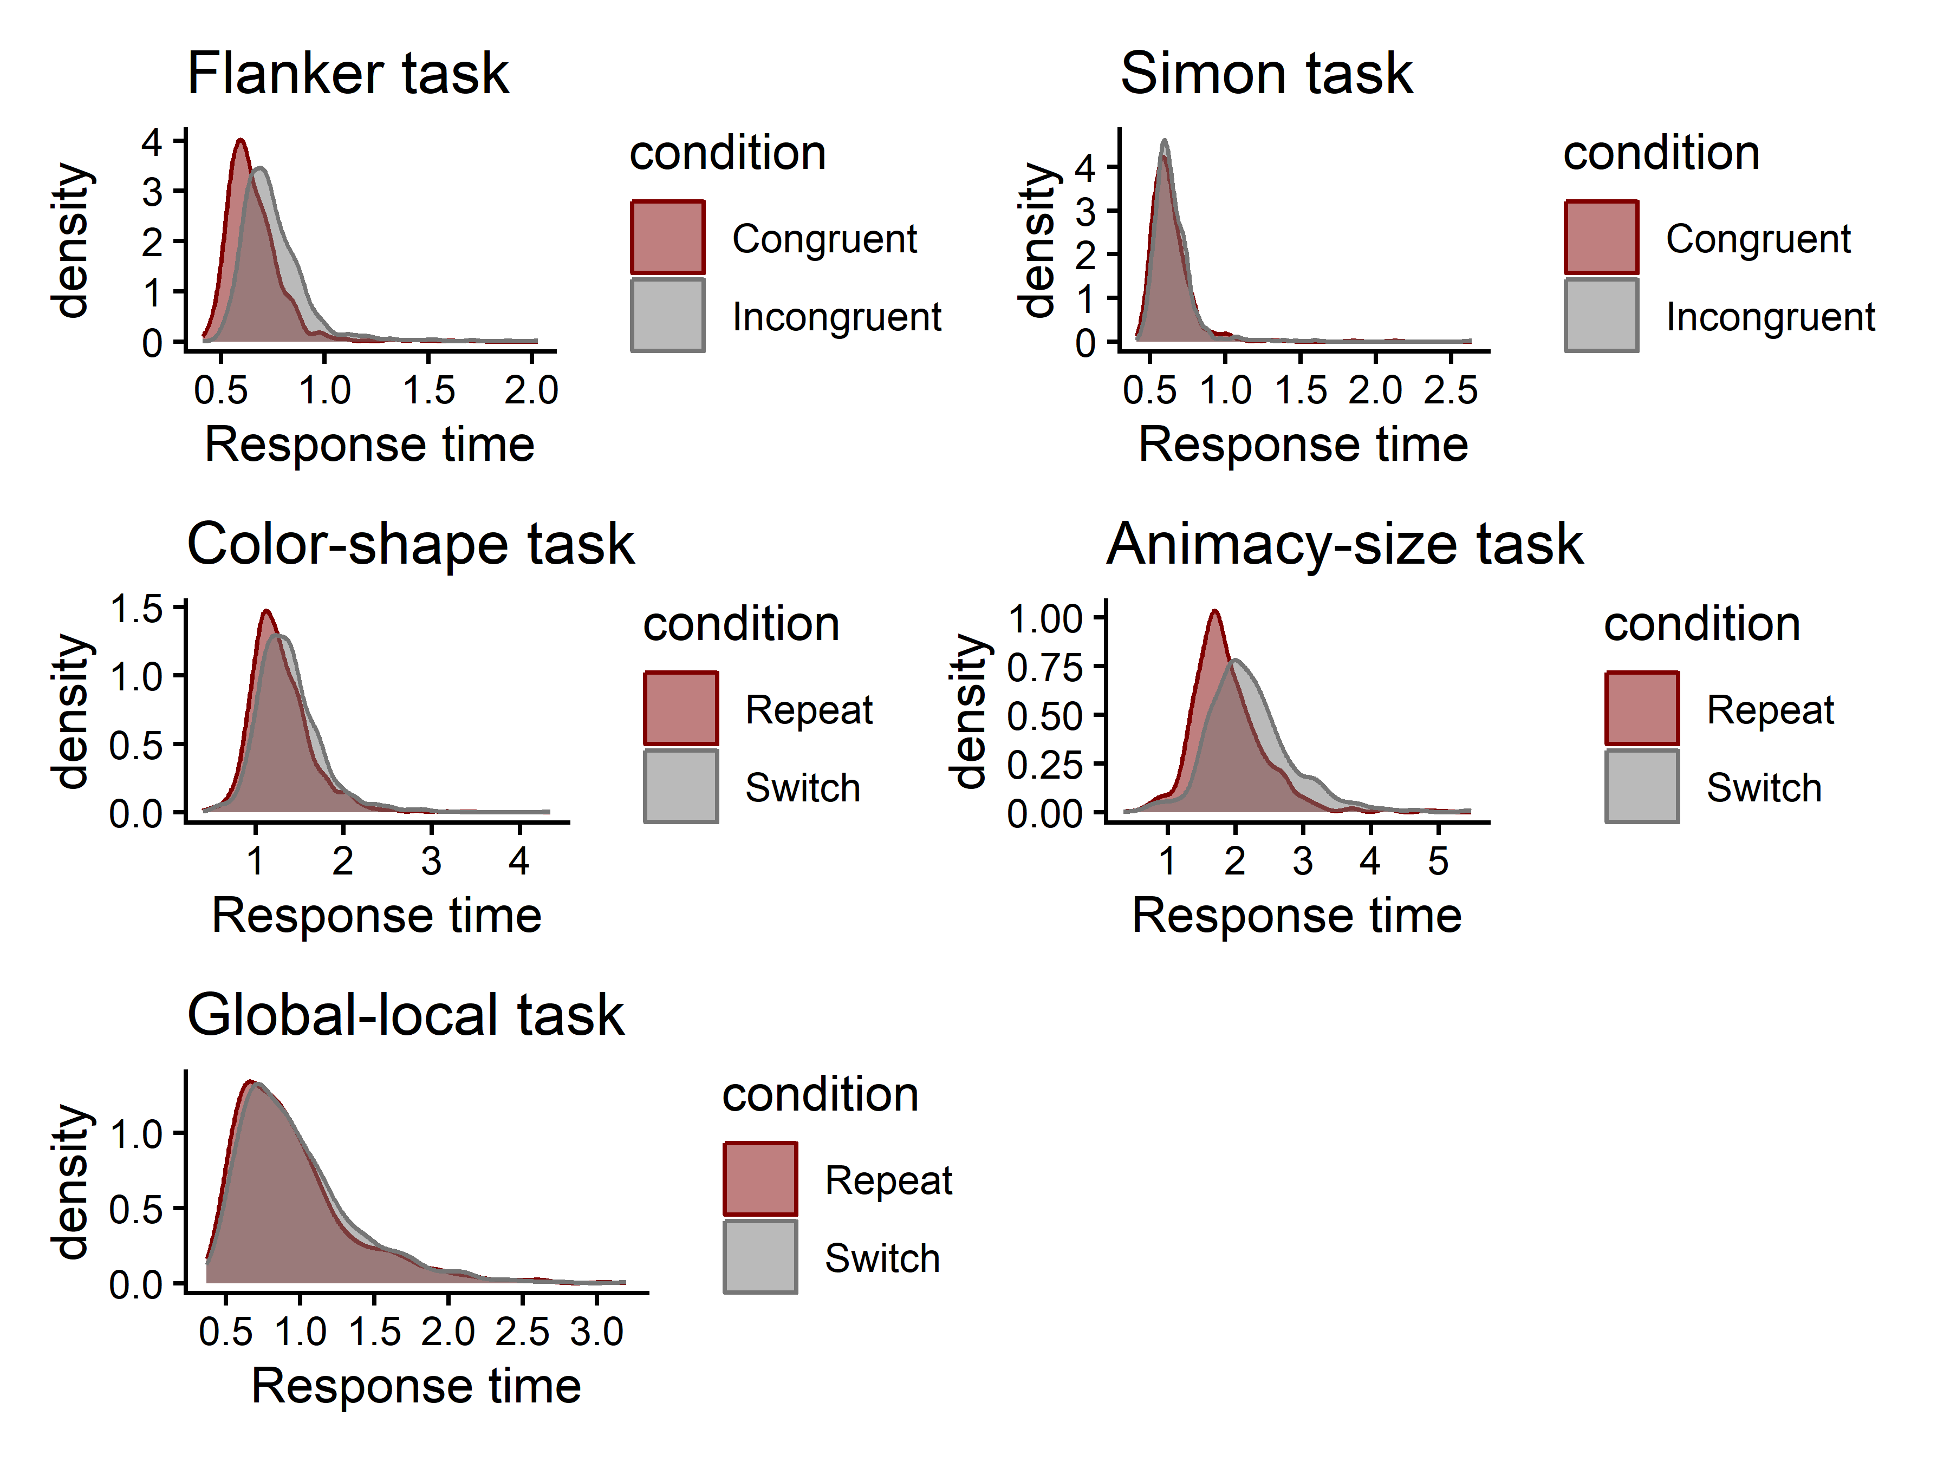
Figure S4. Distributions of response times for all tasks.
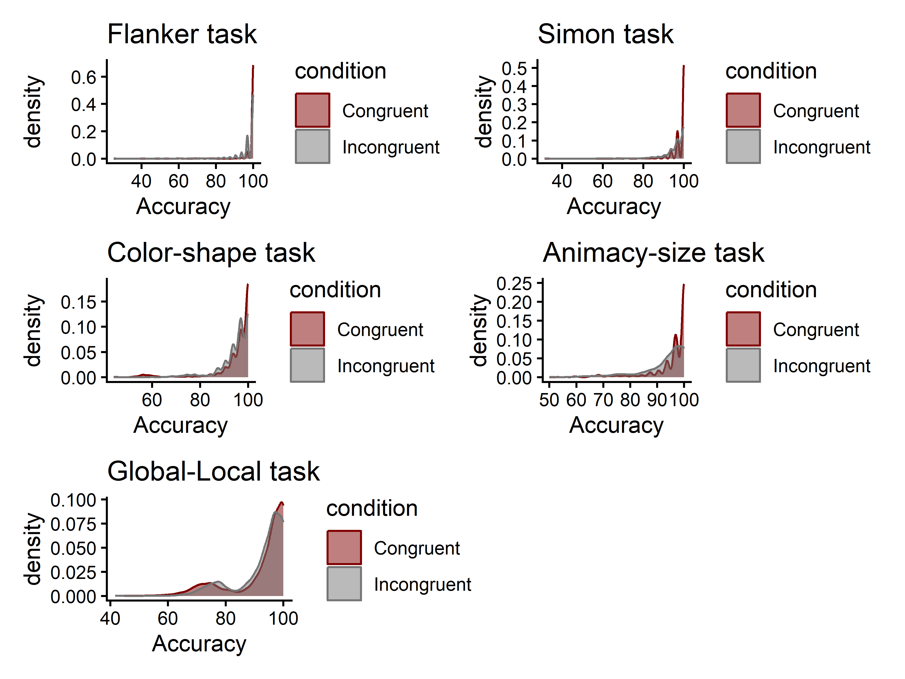
Figure S5. Distributions of error rates for all tasks.

1.2 Condition effects
Table S1 presents tests of condition effects for response times for the five cognitive tasks. Specifically, we tested whether incongruent/switch trials led to significantly slower average correct responses relative to congruent/repeat trials. The manipulation checks were based on mean log-transformed response times using paired-sample t-tests. For each task, we tested whether there was a significant difference in mean log-transformed response time between the congruent (repeat) condition and the incongruent (switch) condition. All tasks showed a significant difference in the expected direction, with participants on average being faster on the congruent (repeat) condition compared to the incongruent (switch) condition (all ps < .001).
Table S1. Log-transformed response time differences across conditions for each task.
Task | Estimate | t | p
Flanker task | 0.13 | 55.61 | < .001
Simon task | 0.02 | 7.96 | < .001
Color-shape task | 0.07 | 19.19 | < .001
Global-local task | 0.04 | 9.08 | < .001
Animacy-size task | 0.16 | 39.76 | < .001

1.3 Split-half reliability
For each cognitive task, we calculated split-half reliabilities using the splithalf package (Parsons, 2021). We calculated split-half reliabilities for mean response times and error rates, separately for each condition (see Table S1). The split-half reliability of mean response times was high across all tasks and conditions. For error rates, the reliability estimates were generally lower, which is likely due to ceiling effects (see also Figure S5).
Table S2. Split-half reliabilities of mean response times for all cognitive tasks.
 | Split-half reliability |  |  | Spearman-Brown corrected
Task | Congruent/Repeat | Incongruent/Switch |  | Congruent/Repeat | Incongruent/Switch
Flanker task | 0.90 [0.85, 0.93] | 0.89 [0.86, 0.92] |  | 0.95 [0.92, 0.96] | 0.94 [0.92, 0.96]
Simon task | 0.89 [0.85, 0.91] | 0.89 [0.82, 0.92] |  | 0.94 [0.92, 0.95] | 0.94 [0.90, 0.96]
Color-shape task | 0.82 [0.80, 0.84] | 0.85 [0.83, 0.87] |  | 0.90 [0.89, 0.91] | 0.92 [0.91, 0.93]
Animacy-size task | 0.83 [0.81, 0.85] | 0.87 [0.85, 0.88] |  | 0.91 [0.90, 0.92] | 0.93 [0.92, 0.94]
Global-local task | 0.84 [0.81, 0.87] | 0.83 [0.79, 0.86] |  | 0.91 [0.90, 0.93] | 0.91 [0.88, 0.93]

Table S3. Split-half reliabilities of error rates for all cognitive tasks.
 | Split-half reliability |  |  | Spearman-Brown corrected
Task | Congruent/Repeat | Incongruent/Switch |  | Congruent/Repeat | Incongruent/Switch
Flanker task | 0.61 [0.46, 0.70] | 0.66 [0.61, 0.70] |  | 0.76 [0.63, 0.82] | 0.79 [0.76, 0.82]
Simon task | 0.35 [0.29, 0.41] | 0.46 [0.42, 0.51] |  | 0.52 [0.45, 0.58] | 0.63 [0.59, 0.67]
Color-shape task | 0.74 [0.71, 0.77] | 0.46 [0.41, 0.50] |  | 0.85 [0.83, 0.87] | 0.63 [0.58, 0.67]
Animacy-size task | 0.67 [0.63, 0.72] | 0.59 [0.55, 0.63] |  | 0.81 [0.77, 0.83] | 0.74 [0.71, 0.77]
Global-local task | 0.67 [0.63, 0.71] | 0.57 [0.52, 0.61] |  | 0.80 [0.77, 0.83] | 0.72 [0.69, 0.76]

Section 2 - DDM convergence and fit

2.1 Model convergence
Figures S3-S7 present the convergence of MCMC chains of the Hierarchical Drift Diffusion Models for all tasks. The figures should resemble a “fat, hairy caterpillar”, which was the case for all tasks.
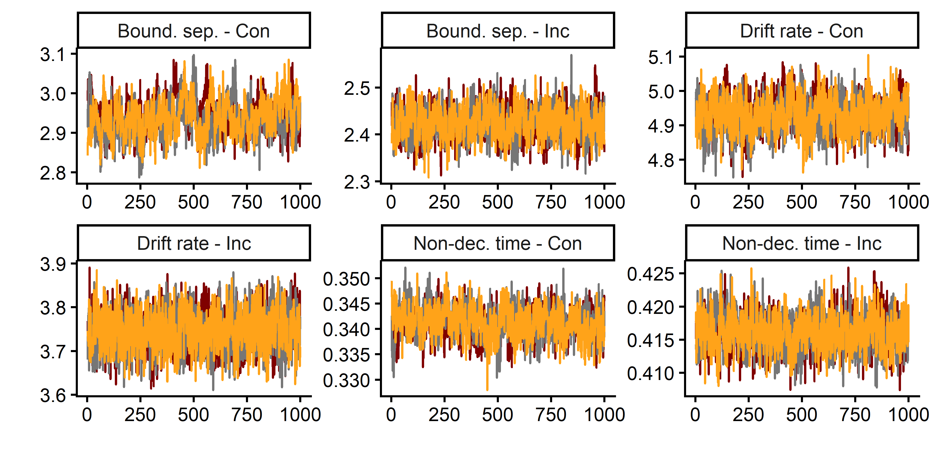
Figure S3. Trace convergence across three chains for the Flanker Task.
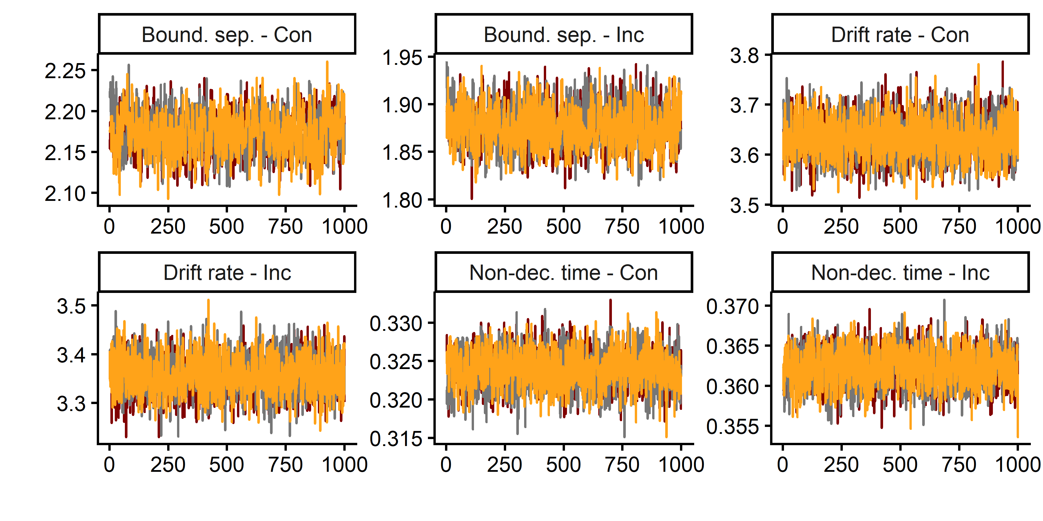
Figure S4. Trace convergence across three chains for the Simon Task.
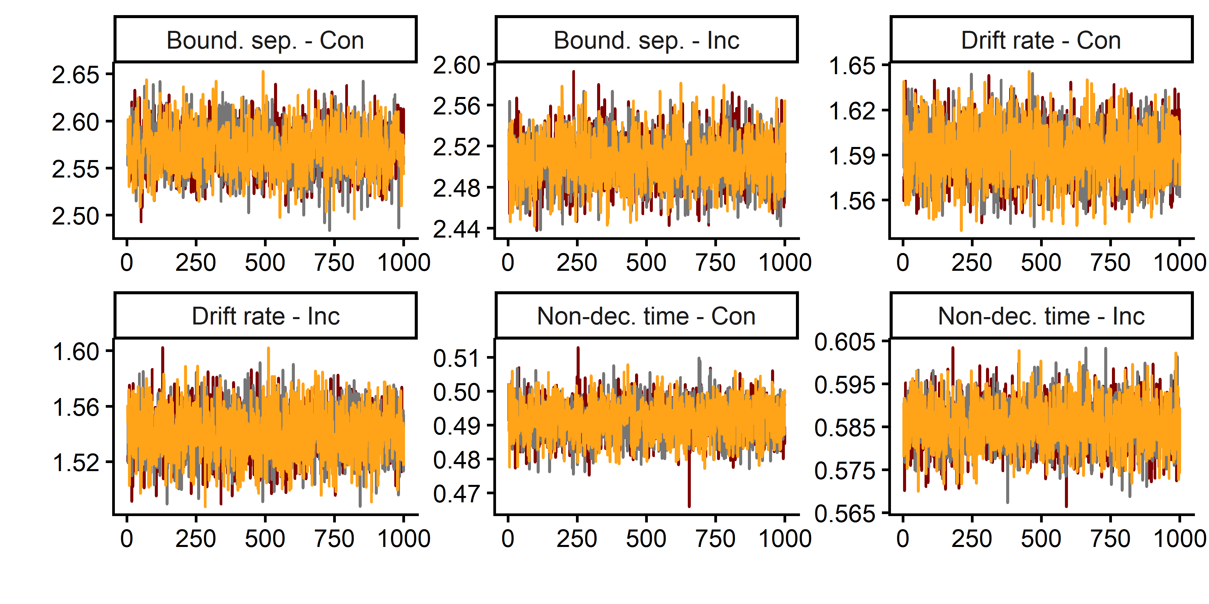
Figure S5. Trace convergence across three chains for the Color-shape Task.
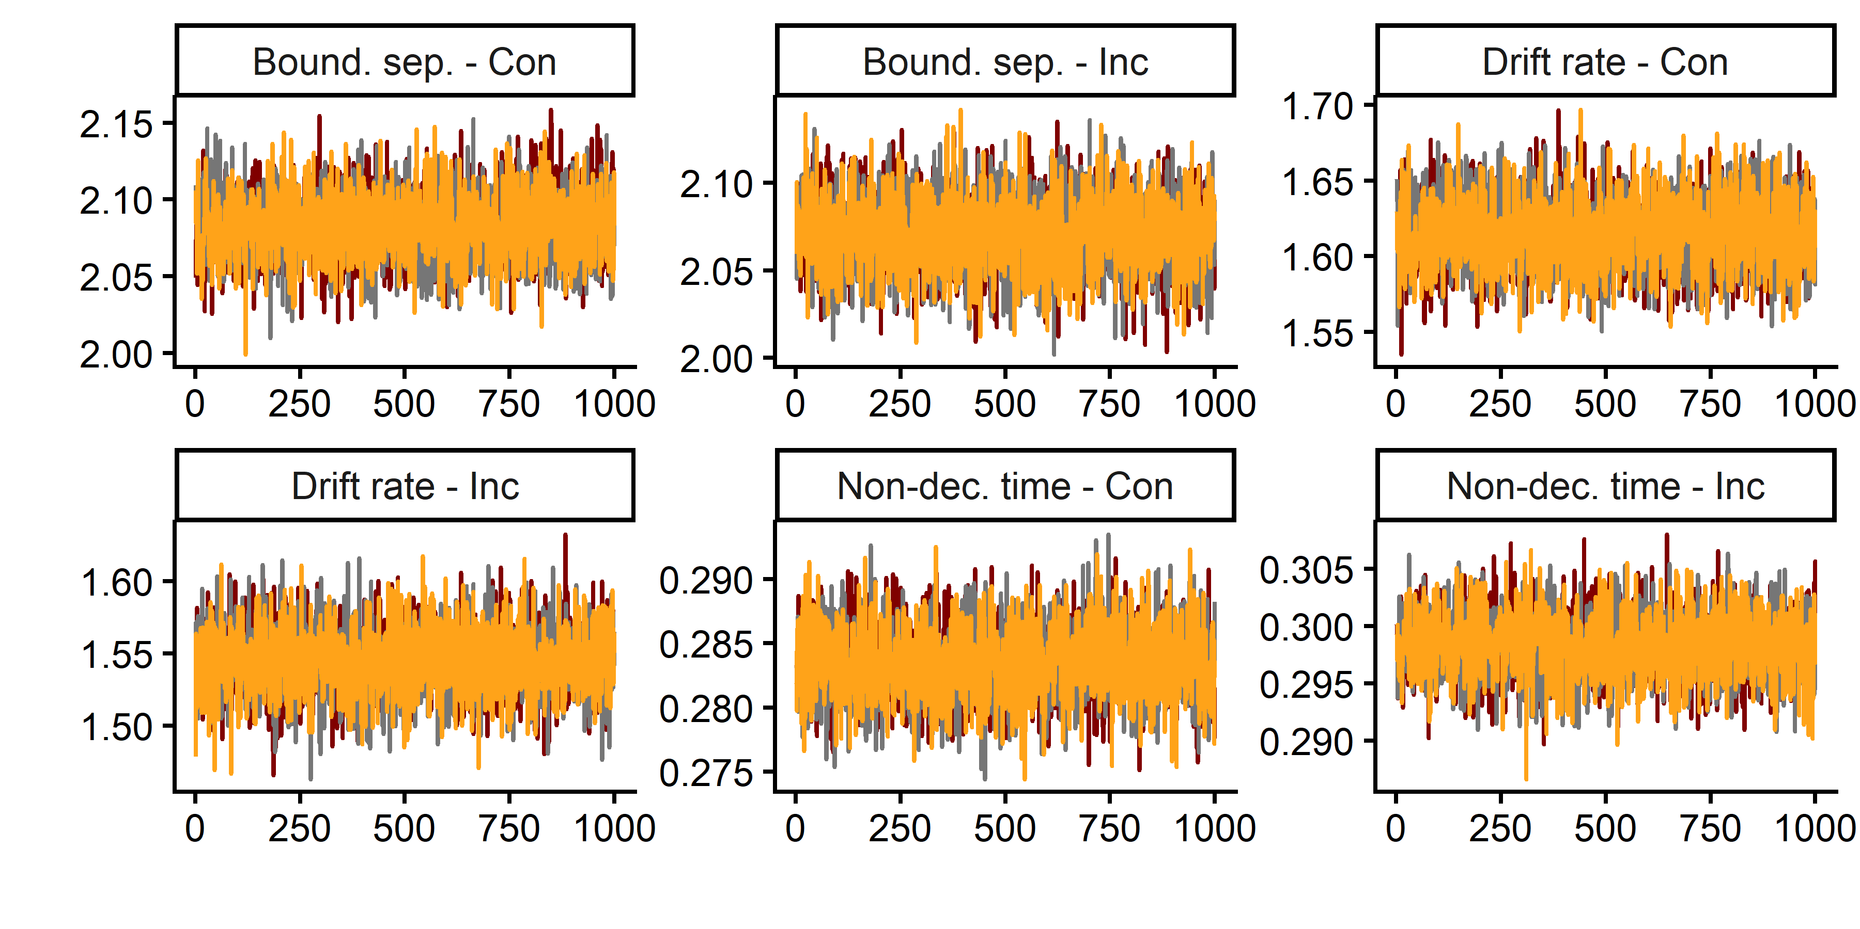
Figure S6. Trace convergence across three chains for the Global-local Task.
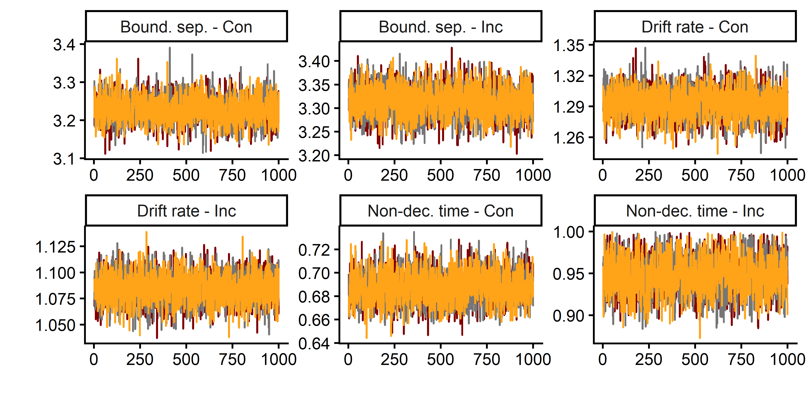
Figure S7. Trace convergence across three chains for the Animacy-size Task.

2.2 Model fit
Table S3 presents simulation-based model fit results.

Table S3. Model fit assessment.
Task | Condition | RT - 25th Percentile | RT - 50th Percentile | RT - 75th Percentile | Accuracy | R^
Flanker task | Congruent | 0.97 | 0.98 | 0.97 | 0.90 | 1.006
Flanker task | Incongruent | 0.97 | 0.97 | 0.97 | 0.94 | 1.006
Simon task | Congruent | 0.97 | 0.97 | 0.97 | 0.86 | 1.007
Simon task | Incongruent | 0.95 | 0.97 | 0.97 | 0.91 | 1.007
Color-shape task | Repeat | 0.97 | 0.96 | 0.96 | 0.98 | 1.003
Color-shape task | Switch | 0.97 | 0.97 | 0.97 | 0.95 | 1.003
Animacy-size task | Repeat | 0.95 | 0.96 | 0.96 | 0.98 | 1.005
Animacy-size task | Switch | 0.95 | 0.96 | 0.96 | 0.97 | 1.005
Global-local task | Repeat | 0.95 | 0.96 | 0.96 | 0.98 | 1.001
Global-local task | Switch | 0.95 | 0.95 | 0.96 | 0.97 | 1.001
Note: Simulation-based model fit assessment compared observed and predicted data using 100 simulated trials (accuracy, 25th, 50th, 75th percentile). In addition, we calculated R^ values, which should be below 1.1 to indicate adequate chain convergence.

3. References
Parsons, S. (2021). Splithalf: Robust estimates of split half reliability. Journal of Open Source Software, 6(60), 3041. https://doi.org/10.21105/joss.03041

