Table of Contents

# Table of contents

dddddddddddddddddddddddddddddddddddddddddddddddddddddddddddddddddddddddddddddddd

# Task distributions after cleaning  
list(pcps_clean, flanker_clean, lmt_clean, dccs_clean) |>   
 map_df(function(x) x |> select(RT, task, correct)) |>   
 mutate(  
 task = case_when(  
 task == 1 ~ "Mental Rotation",  
 task == 2 ~ "Flanker",  
 task == 3 ~ "Attention Shifting",  
 task == 4 ~ "Processing Speed",  
 ),  
 correct = ifelse(correct == 0, "Incorrect", "Correct")  
 ) |>   
 ggplot(aes(RT, group = factor(correct), fill = factor(correct))) +  
 geom_density(alpha = 0.6) +  
 facet_wrap(~task, scales = 'free') +  
 theme_classic() +  
 labs(  
 x = "RT (s)",  
 y = "Density",  
 fill = "Accuracy"  
 )

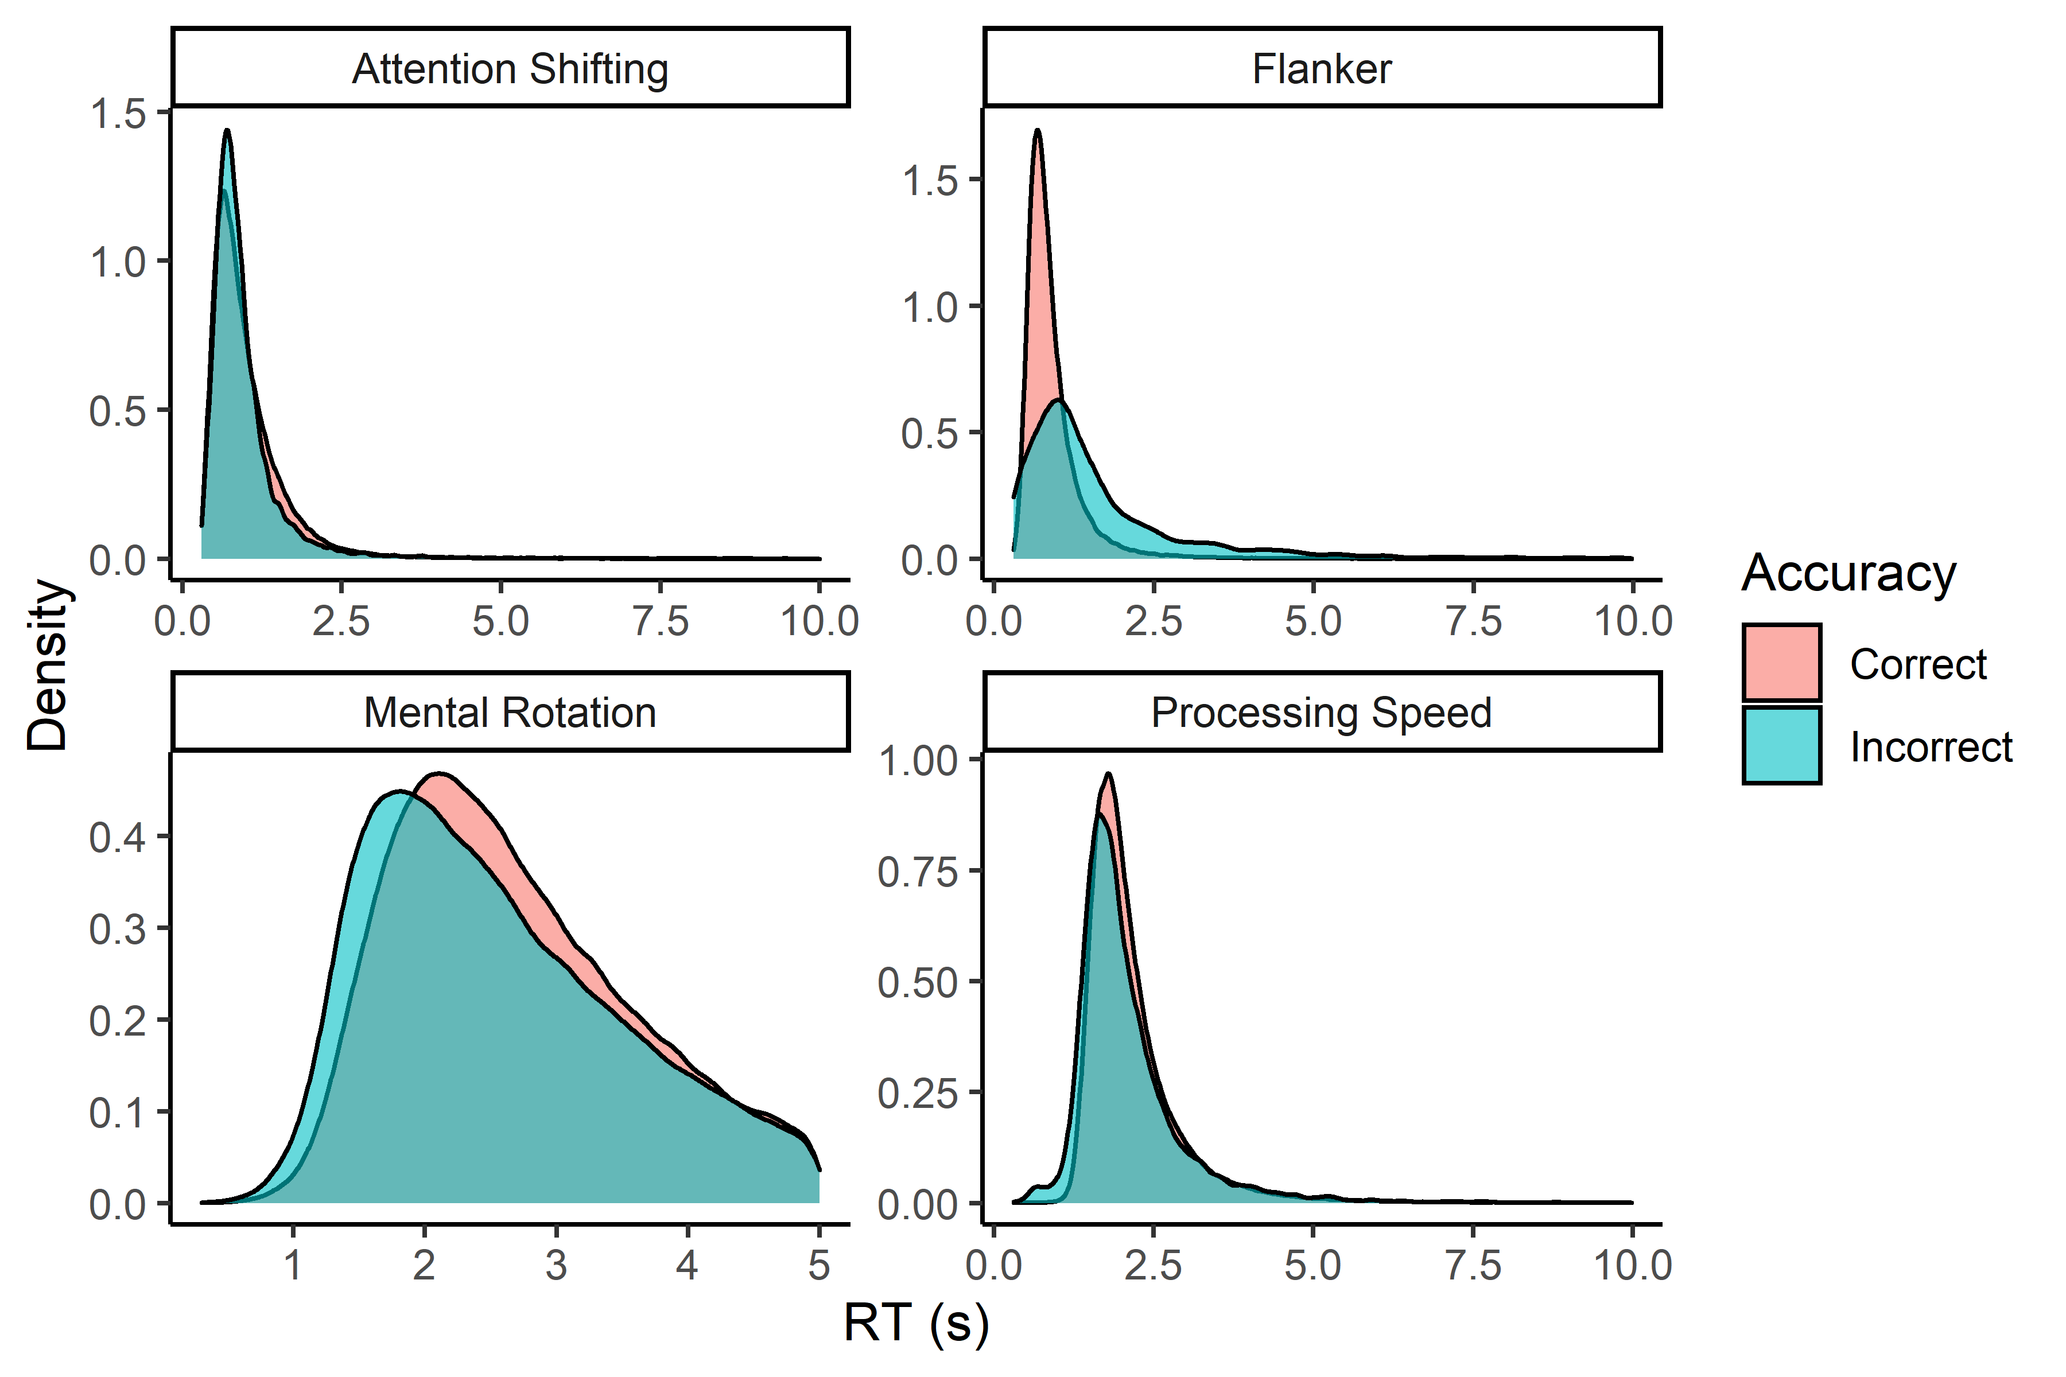

* Open Science workflow
* Full pre-post workflow
* Full RT distributions - before and after planned cleaning
* Mean RT distributions and mean acc distributions
* Details on DDM model fitting