The Superinvestors on the Corner of Berkshire-and-Fairfax

The internet has brought us many invaluable websites, such as Facebook, Google, YouTube and many more. However, one of my favorites is a small online investing forum called ‘Corner of Berkshire and Fairfax’ - named after Warren Buffett’s und Prem Watsa’s companies. The forum provides investors a platform to exchange and discuss stock ideas. As you can imagine, many members post incredible ideas that have performed extraordinarily well. As a result I wondered - what are actually the best ideas? Which members have the best ideas? To find out, I scraped all the postings and checked yahoo finance for the respective tickers. Unfortunately, many companies have gone private or have been sold. As a result, the data for those companies is not as easily accessible and therefore not considered in this blog post. Furthermore, yahoo finance had some difficulties to find foreign companies. Nevertheless, the sample is big enough to do some exploratory data analysis!

##### Total Return

To start off, let’s look at the best performing users. Bmichaud is the clear leader, with an average return of 279.72%! However, as you can see, most of his returns actually came from one big idea - Netflix! The same is true for Viking, whose returns are mainly driven by Visa. Nevertheless, his ideas, on average, are up 169.48%! Visa was written up in early 2011 and achieved an annualized rate of return of 33% and got 257 replies on the message board. Interestingly, Mastercard, which was submited by Liberty in September 2011 compounded at a similar annualized rate, but got much less attention from the community with only 55 replies. The average return of all posts, is 46% and shown as the thin line in the chart.

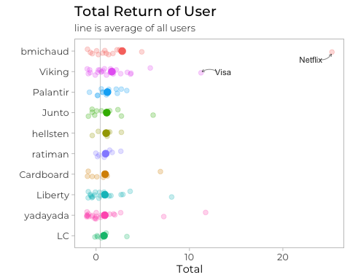

Let’s now zoom in a bit to ignore extreme outliers and get a better understanding of the average idea. Furthermore, to acknowledge the time trend that affects the stock market, I coloured the respective idea by the year it was posted. As can be expected, most best performing ideas were posted before 2016 and include large cap companies like Cisco, McDonald’s, Sony and Morgan Stanley. As was mentioned in the introduction, many companies were not found by yahoo finance. What’s even worse, is finding the wrong stock - such as CSU, which is ‘Capital Senior Living Corporation’, even though the original poster meant Constellation Software (CSU.TO), which would have performed tremendously.

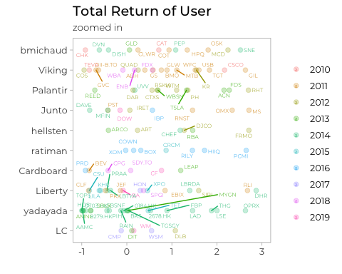

##### Compounded Growth

Of course, what really matters is the compounded growth rate. Therefore, I annualized the performance of all users, which was only 1.4%! Since most ideas are long only anyways, there is little evidence that short ideas had a big effect on the the annualized performance. To make sure that the published ideas aren’t purely based on luck, I excluded users with less than 5 posts and required that the post was published more than 180 days ago.

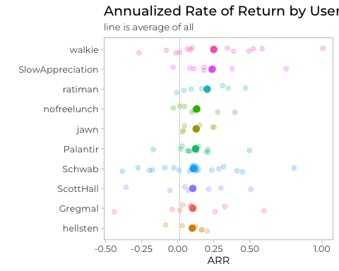

Let’s now take a look at the 10 best performing ideas. Interestingly, most are still relatively new and have performed tremendously since then.

## user name arr year  
## 1 walkie AT&T 1.0065324 2018  
## 2 Schwab Dyadic 0.8062190 2017  
## 3 SlowAppreciation ETSY.com 0.7514150 2017  
## 4 Gregmal NVR Inc. 0.5981401 2018  
## 5 walkie Blue Capital Re 0.5854961 2019  
## 6 walkie Willis Lease 0.5235765 2017  
## 7 ScottHall California Orchard Company 0.5067107 2018  
## 8 Palantir Crestwood Equity Midstream Partners LP 0.4972527 2016  
## 9 walkie Altice USA 0.4934519 2018  
## 10 ratiman PCM 0.4694506 2016

Let’s look at another visualisation to better understand how time impacts the compounded annual growth rate. The visualisation clearly shows higher variance in the data for more recent ideas. It can therefore be argued, that newer ideas might both have better and worse performance. However, after applying statistical models, there was no significant evidence that blindly following those users will have an impact on annualized returns! Therefore, always do your own due diligence!

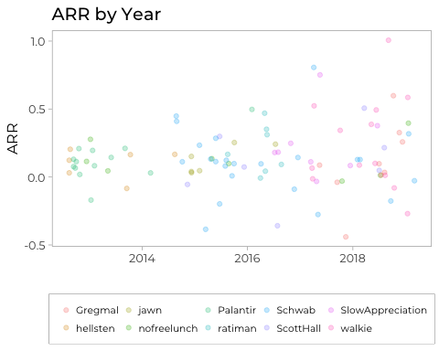

Lastly, I wanted to analyze whether replies have an effect on overall returns. A member of the forum put forward the hypothesis, that ideas with less comments generally perform better. This, can again can be tested with statistical models. The results are highly significant and indicate that ideas with a comment perform better by 0.001. However, each additional comment reduces performance by -0.00000013! Therefore, if you want to improve your performance you will do well by sticking to ideas with fewer comments.

##### Conclusion

This post showed, that there truly are some superinvestors on the Corner of Berkshire and Fairfax! However, the average return of all posts underperformed the market by a huge margin. Admittedly, there might be various factors - such as a general underperformance of the value factor or missing data. Nevertheless, I hope that we all gained some interesting insights with this short, but nevertheless time-consuming, analysis.

You will find all the code and data here (link). Maybe you will find even better insights. If you do, feel free to share it with the community!

A huge thanks to Editor in Chief Liz (link to twitter if you want to), xyz.