CSCI445

Stefana Rusu

Assignment 5

Convex Hull (Graham scan) Algorithm Used:

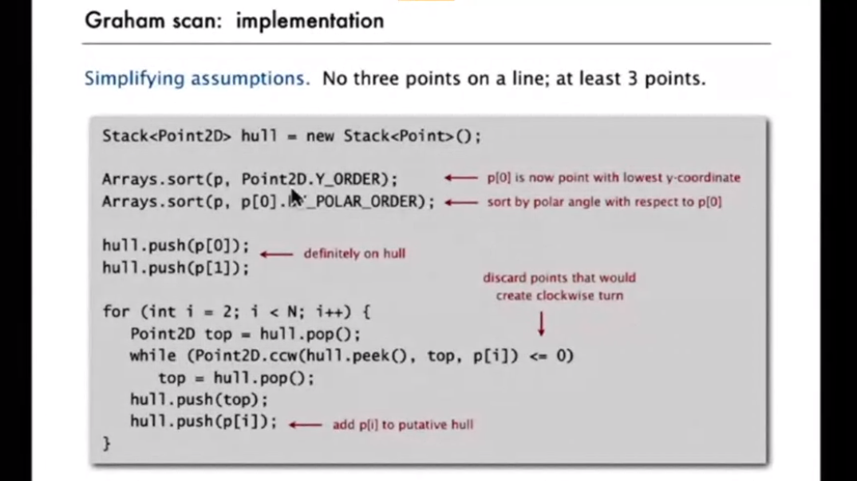

Reference: Princeton Lecture on Convex Hull - <https://www.coursera.org/learn/algorithms-part1/lecture/KHJ1t/convex-hull>

* Input:
  + No input required.
  + The program will run with a given set of points (Use case 1 by default).
* Use cases:
  + Use case 1 input:

(0, 3)

(1, 1)

(2, 2)

(4, 4)

(0, 0)

(1, 2)

(3, 1)

(3, 3)

* + Use case 2 input:

(116, 68)

(162, 226)

(158, 193)

(326, 288)

(200, 152)

(305, 212)

(254, 135)

(365, 167)

(307, 97)

(527, 96)

* Output:
  + Use case 1:

(527, 96)

(326, 288)

(162, 226)

(116, 68)

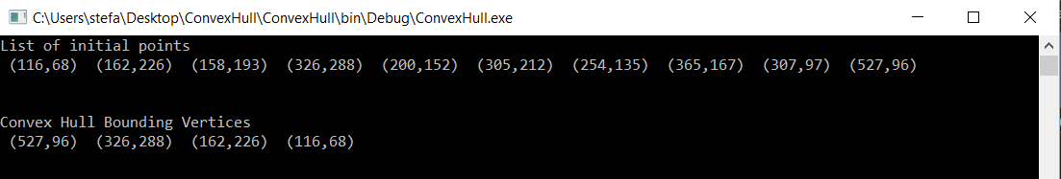

* + Use case 2:

(0, 3)

(4, 4)

(0, 0)

(3, 1)

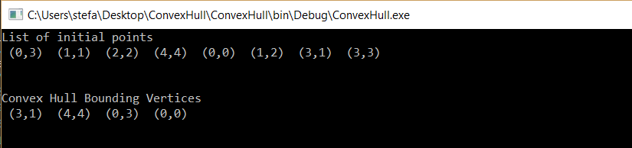

* Graphs: To check the work, I graphed the two sets of points and these are the results.

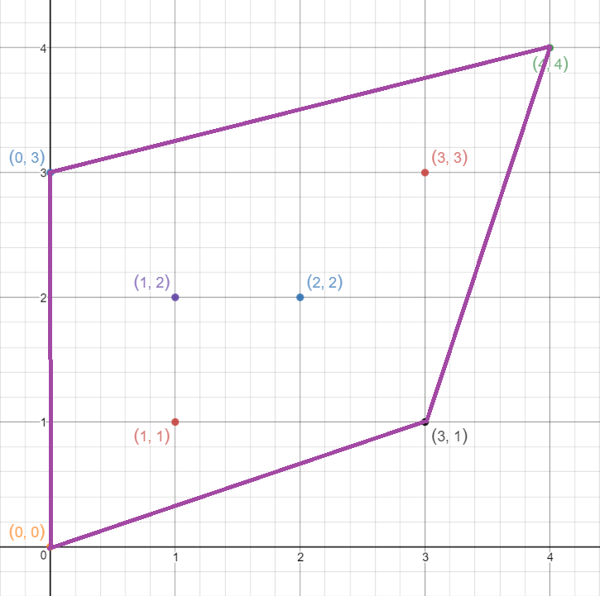 (Use case 1)

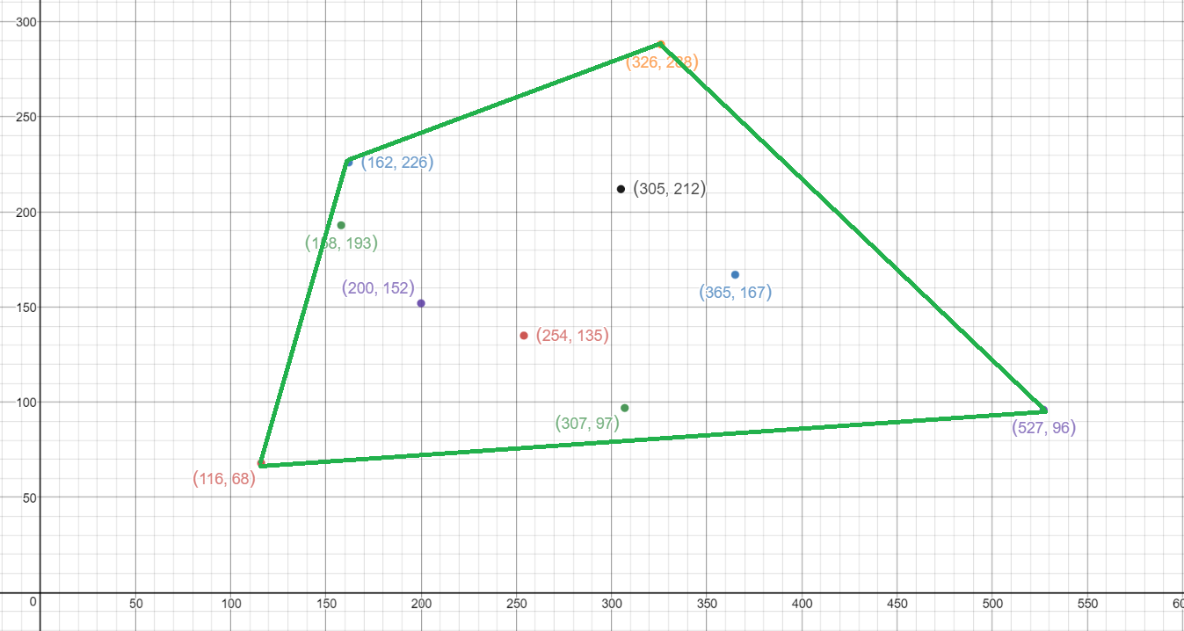

(Use case 2)

Reference: Software used to graph - Desmos

<https://www.desmos.com/calculator>