CSCI410

Stefana Rusu - Assignment 6

In all four trials:

* Matrix ‘C’ is the output of the built in MATLAB ‘k-means’ function.
* Matrix ‘centroids’ is the output of my implementation of the algorithm.

The performance of the built-in function is, as you can see, faster than my implementation in all four trials.

Trial 1:

* Number of iterations = 50
* K = 3
* The results (centroids) are exactly the same for both implementations (for a number of iterations of 50)

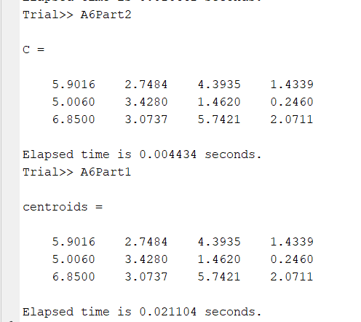

Trial 2:

* Number of iterations = 150
* K = 3
* The values are pretty close, and they do seem to be mixed up (rows do not match).

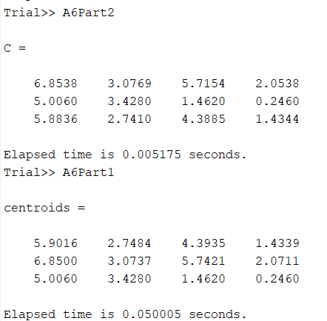

Trial 3:

* Number of iterations = 100
* K = 3

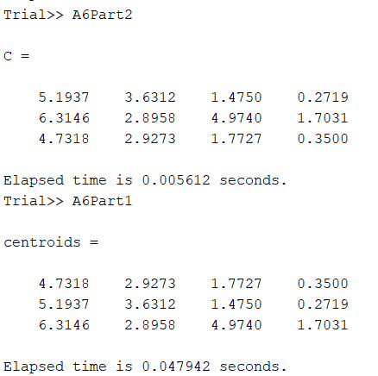

Trial 4:

* Number of iterations = 100
* K = 3
* The numbers seem to be the same, except the rows do not match. Not sure why that is.

