DOCUMENTATION

ASSIGNMENT ASSIGNMENT_2

QUEUES MANAGEMENT APPLICATION USING THREADS AND SYNCHRONIZATION MECHANISMS

STUDENT NAME: MOLDOVAN STEFANA-MARIA
GROUP: 30424

CONTENTS

1. Assignment Objective 3
2. Problem Analysis, Modeling, Scenarios, Use Cases 3
3. Design 5
4. Implementation 6
5. Results 9
6. Conclusions 9
7. Bibliography 10

Assignment Objective
The objective of this assignment is to design and implement a queues management application which assigns clients to queues such that the waiting time is minimized.

Problem Analysis, Modeling, Scenarios, Use Cases
- Use case diagrams

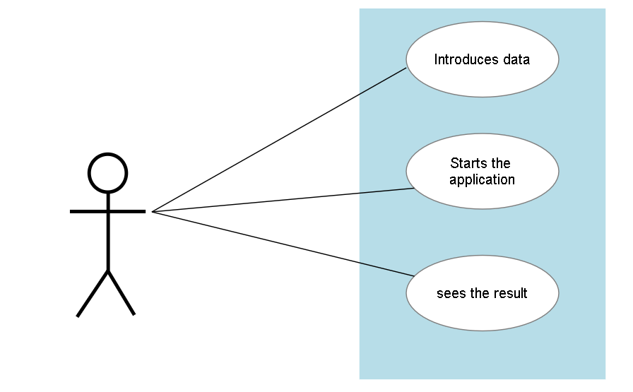

The diagram illustrates the actions which can be performed by the user, more specifically, it represents the order in which they should be performed.’
A use diagram is a type of UML (Unified Modeling Language) diagram that is used to model the interactions between users or external systems and a system or a set of systems. The main purpose of a use diagram is to illustrate the functionality of the system from the user's perspective and to identify the different use cases or scenarios that the system supports. In this case, the user should be able to interact with a queue simulation, by also being able to see the process in which it works.
The main purpose of a queue management application is to simulate and manage a system with a queue where tasks are added and removed dynamically. This type of application is commonly used in areas such as call centers, customer service, and other service-oriented industries where customers or clients need to wait in line to be served. By implementing a queue management system, businesses can improve their efficiency by reducing customer wait times, managing resources more effectively, and improving overall customer satisfaction. In addition, queue management applications can help businesses make data-driven decisions about resource allocation, staffing, and other operational decisions.
Unfortunately, because of some personal problems, my time for this assignment was very limitated and I didn’t manage to achieve everything that I wanted for this project, the interface being one of those things. Anyhow, this is how it looks and I will also explain what it should have done if I would have been able to finish it in time.

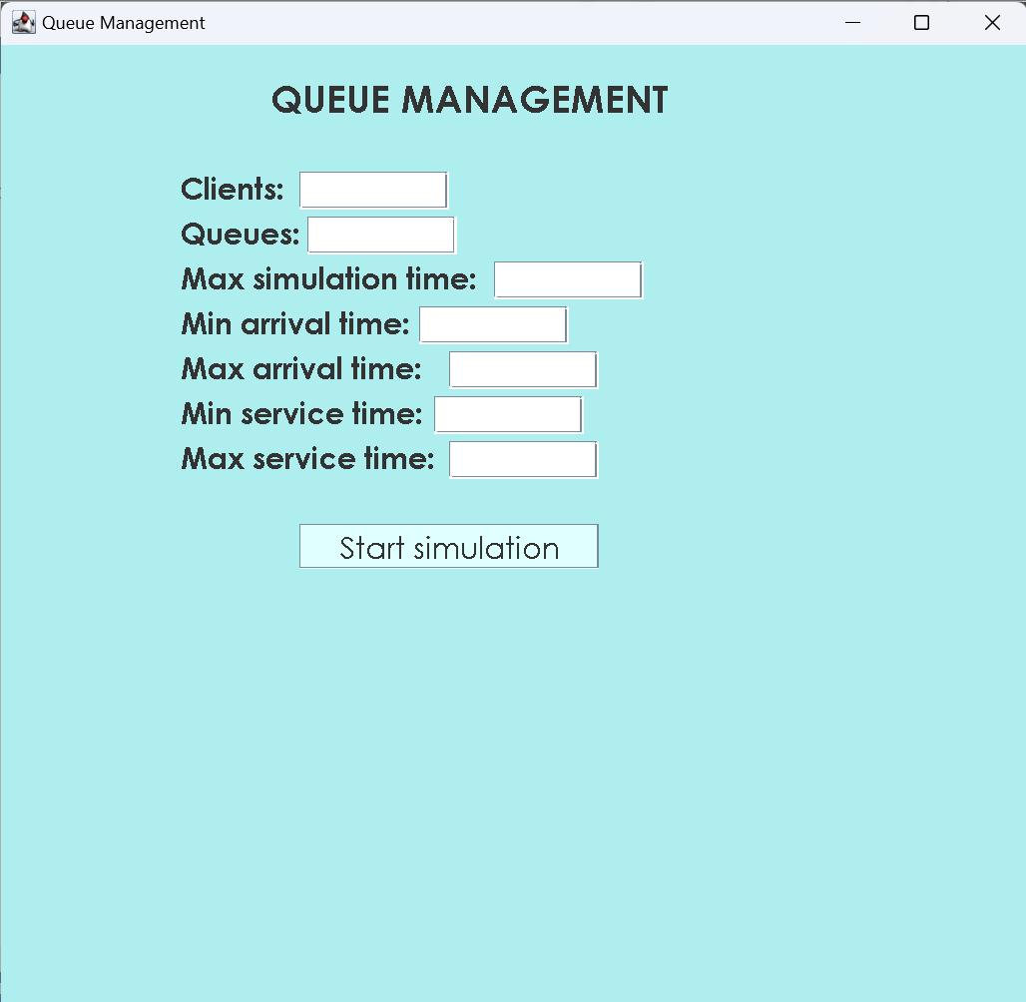

In this application, the user is able to input values for the following parameters of a queue management simulation:
• Number of clients
• Number of queues
• Maximum simulation time
• Minimum arrival time for clients
• Maximum arrival time for clients the user is able to input values for the following parameters of a queue management simulation:
• Number of clients
• Number of queues
• Maximum simulation time
• Minimum arrival time for clients
• Maximum arrival time for clients
• Minimum service time for clients
• Maximum service time for clients
• The user can then start the simulation by clicking the "Start simulation" button. The simulation is managed by the SimulationManager class, and runs on a separate thread to prevent the GUI from freezing.
•
• Minimum service time for clients
• Maximum service time for clients
The user can then start the simulation by clicking the "Start simulation" button. The simulation is managed by the SimulationManager class, and runs on a separate thread to prevent the GUI from freezing.

Design
a) Class Diagrams and Packages
Class diagrams are one of the primary types of diagrams used in Unified Modeling Language (UML) to represent the structure of object-oriented systems. They provide a visual representation of the classes, interfaces, associations, and other relationships between objects that make up a system. Also, they are useful for communicating the design of a system and identifying potential issues inconsistencies in the relationships between classes.
In this project, I’ve designed three packages: BusinessLogic, Model and View

- BusinessLogic - contains the core logic of the simulation program, including the implementation of the scheduling strategy, server management, and task handling;
- ConcreteStrategyQueue
- ConcreteStrategyTime
- Scheduler
- SelectionPolicy
- SimulationManager
- Strategy
- Model - is responsible for defining the basic data structures and functionality of the simulation model
- Server
- Task
- View - represents the user interface of the application. It contains the code for creating and displaying the graphical user interface (GUI) elements such as windows, panels, labels, buttons, and text fields. It also defines the layout of the elements on the screen using the Java Swing framework.
- SimulationFrame

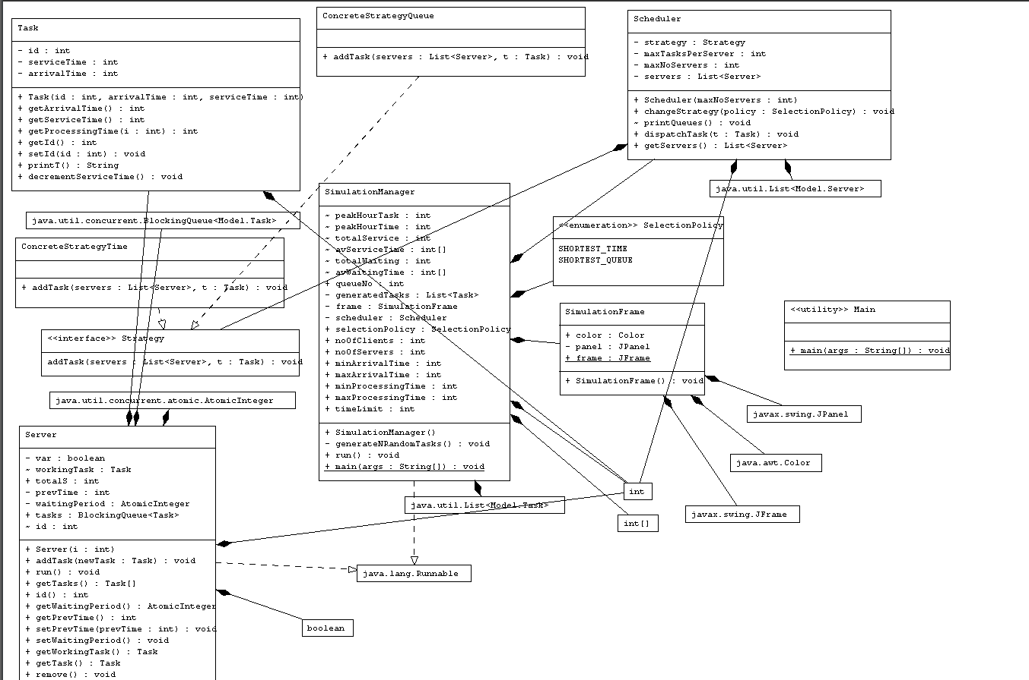

b) Data Structures
In this code, I’ve used several data structures, including:
- LinkedList: This is used to store the generated tasks (client shopping in the store).
- List: This is an interface for implementing dynamic arrays, and it is used to represent the pool of tasks.
- Array: This is used to store the average waiting time and average service time for each server.
- Random: This class is used to generate random numbers for processing time and arrival time.
- FileWriter: This is used to write output to a file.
- Iterator: This is used to iterate through the generated tasks and remove tasks that have been dispatched to a server.
- AtomicInteger: This is used to keep track of the number of clients that are being served by the servers.
- Comparator: This is used to sort the generated tasks based on their arrival time.

Implementation
Class design is the process of creating a plan or blueprint for the classes that will be used in a software application. This process involves identifying the objects and their properties and methods, and determining how they will interact with each other. Also, effective class design is crucial for building maintainable, extensible, and scalable software applications. It helps to ensure that the software is well-organized, easy to understand, and easy to modify as requirements change over time.
As I presented before, I have three packages:
- BusinessLogic

- ConcreteStrategyQueue - The purpose of this class is to provide a concrete implementation of a strategy that adds a task to the server with the shortest queue.
- The addTask method takes in a list of servers and a task to be added. It iterates through the list of servers to find the server with the shortest queue by comparing the length of the queues of each server. The server with the shortest queue is then selected, and the task is added to that server's queue using the addTask method of the Server class.
- The ConcreteStrategyQueue class is likely to be used in a larger application that requires a strategy for adding tasks to servers in an efficient way. By using this class, the application can dynamically select the server with the shortest queue, which can help to balance the workload and prevent overload on any particular server.

- ConcreteStrategyTime - implements the Strategy interface and represents a concrete strategy for adding a task to a server queue based on the waiting time of the servers.
- The addTask method takes a list of Server objects and a Task object as parameters. It iterates over the list of servers to find the server with the shortest waiting time, where the waiting time is represented by an AtomicInteger object obtained from the getWaitingPeriod method of the Server class. The server with the shortest waiting time is then selected, and the addTask method is called on it to add the given task to its queue. If there are multiple servers with the same shortest waiting time, the first one encountered in the list is selected.

- Strategy - represents the main component of the application which manages the servers and assigns tasks to them based on a selected scheduling strategy. It contains a list of servers, an upper bound on the number of servers (maxNoServers), an upper bound on the number of tasks per server (maxTasksPerServer), and a strategy object to select the scheduling policy.
- has two constructors. The first constructor initializes a list of servers and creates a new thread for each server. The second constructor is similar to the first, but also initializes the maxNoServers variable.
- The changeStrategy() method is used to change the current scheduling strategy to either SHORTEST_QUEUE or SHORTEST_TIME.
- The printQueues() method prints the queues of each server along with their working task and waiting tasks.
- The dispatchTask() method assigns a given task to a server according to the selected scheduling strategy.
- The getServers() method returns the list of servers.

- SelectionPolicy - This is a simple enumeration that defines two constants, "SHORTEST_QUEUE" and "SHORTEST_TIME". These constants are used to specify the selection policy for dispatching tasks to servers in the system. The "SHORTEST_QUEUE" policy selects the server with the shortest queue, while the "SHORTEST_TIME" policy selects the server with the shortest waiting time.

- SimulationManager - SimulationManager() is the constructor of the class, which initializes the scheduler, frame, and generatedTasks objects and starts a thread for each server in the scheduler.
- generateNRandomTasks() creates a list of Task objects with random arrival times and processing times within the specified bounds. The generated tasks are sorted by their arrival time.
- run() is the main method of the class, which runs the simulation. It starts by initializing some variables and opening a file to write the simulation output. Then, for each time step in the simulation, it writes the current state of the simulation to the file, dispatches any tasks that have arrived, updates the waiting time of each server, and prints the state of the simulation to the console. At the end of the simulation, it calculates and prints some statistics to the console.

- Strategy – is an interface which defines a single method called "addTask". The purpose of this interface is to provide a common interface for different strategies that can be used for assigning tasks to servers.
- The "addTask" method takes in two parameters: a list of Server objects and a Task object. The method doesn't return anything, but instead, it modifies the list of Server objects based on the strategy implemented by the implementing classes.

- Model

- Server - is a model class that represents a server in a simulation. It implements the Runnable interface, which allows it to run as a separate thread.
- The class has the following attributes:
- id: an integer that represents the server's id.
- tasks: a BlockingQueue of Task objects that represents the tasks assigned to the server.
- waitingPeriod: an AtomicInteger that represents the total waiting time of all tasks in the tasks queue.
- prevTime: an integer that represents the previous time the server was checked for new tasks.
- totalS: an integer that represents the total service time of all tasks assigned to the server.
- workingTask: a Task object that represents the task currently being worked on by the server.
- var: a boolean variable that is used to control the server's thread.
- The class has the following methods:
- Server(int i): a constructor that takes an integer parameter i and initializes the server's id, tasks, and waitingPeriod.
- addTask(Task newTask): a method that adds a new Task to the tasks queue and updates the waitingPeriod.
- run(): a method that implements the Runnable interface and represents the server's main logic. The method continually checks for new tasks in the tasks queue and works on them by sleeping for the duration of the task's service time.
- getTasks(): a method that returns an array of all the Task objects in the tasks queue.
- id(): a method that returns the server's id.
- getWaitingPeriod(): a method that returns the waitingPeriod.
- getPrevTime(): a method that returns the prevTime.
- setPrevTime(int prevTime): a method that sets the prevTime to the given integer parameter prevTime.
- setWaitingPeriod(): a method that decrements the waitingPeriod by 1.
- getWorkingTask(): a method that returns the workingTask.
- getTask(): a method that returns the first Task object in the tasks queue.
- remove(): a method that removes the first Task object in the tasks queue.

- Task - contains three fields: arrivalTime, serviceTime, and id.
- arrivalTime represents the time at which the task arrives to the system.
- serviceTime represents the time needed to complete the task, and id is a unique identifier for the task.
- The class has a constructor that takes in three parameters to set the values of arrivalTime, serviceTime, and id. It also has a method getArrivalTime() that returns the arrival time of the task, a method getServiceTime() that returns the service time of the task, and a method getId() that returns the id of the task.
- The class also has a method getProcessingTime(int i) that takes in an integer parameter i representing the current time and returns the time at which the task will be completed. The method printT() returns a string representation of the task.
- Finally, the class has a method decrementServiceTime() that decrements the service time of the task by 1

- View
- SimulationFrame - It contains the graphical user interface (GUI) elements for setting up and starting the simulation.
- this is where the GUI components are created, like: buttons, labels and text fields, and also handles user inputs from the GUI. The user inputs are then used to create a "SimulationManager" object and start the simulation. The class extends the JFrame class and uses various other Swing components for GUI design.

Results

Taking in consideration this chapter, I have done the three tests that were proposed and I stored the results in three different files.

Conclusions
As a conclusion, this project was an emotional rollercoaster for me, but I’ve also learnt a lot from it, and I am glad that I had to go through with it. This kind of assignments are good examples of different tasks that we might get in future internships or jobs and they represent a good start.

Bibliography
1. geeksforgeeks.org
2. stackoverflow.com
3. https://www.tutorialspoint.com/java/util/timer_schedule_period.htm
4. https://www.javacodegeeks.com/2013/01/java-thread-pool-example-using-executors-and-threadpoolexecutor.html

