Test Results

SerhTest_ShouldReturnCorrectSpans: Passed

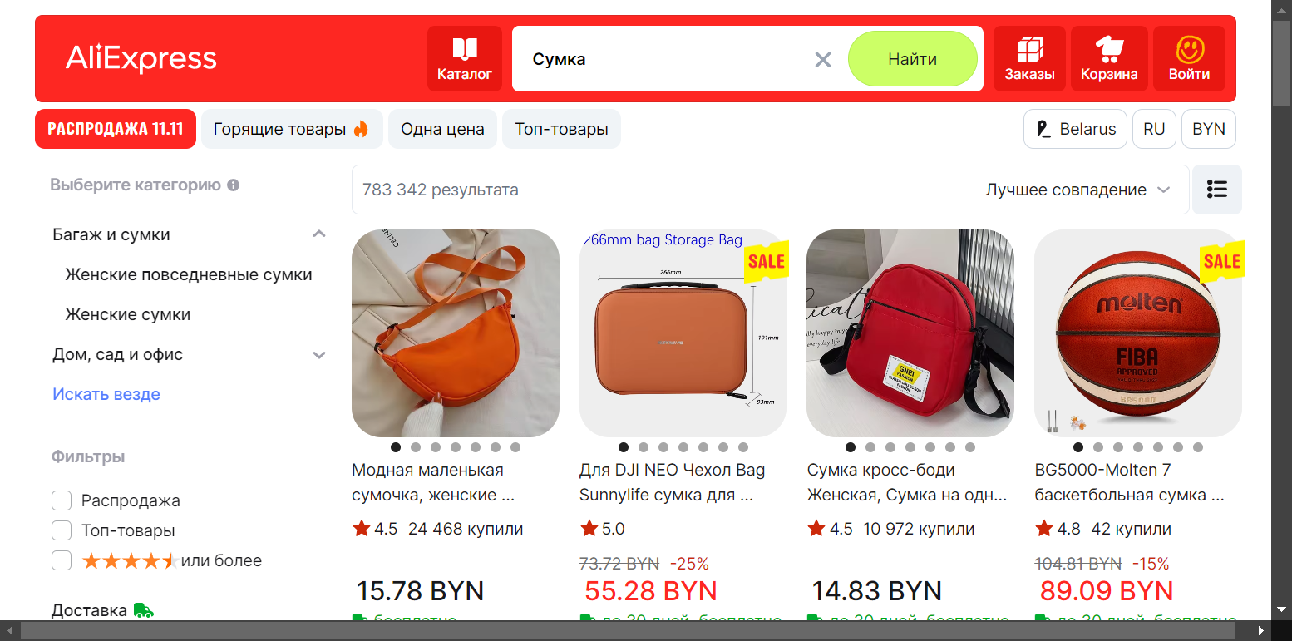

CurrencyChangingTest_CurrencyShouldChangeCorrectly: Passed

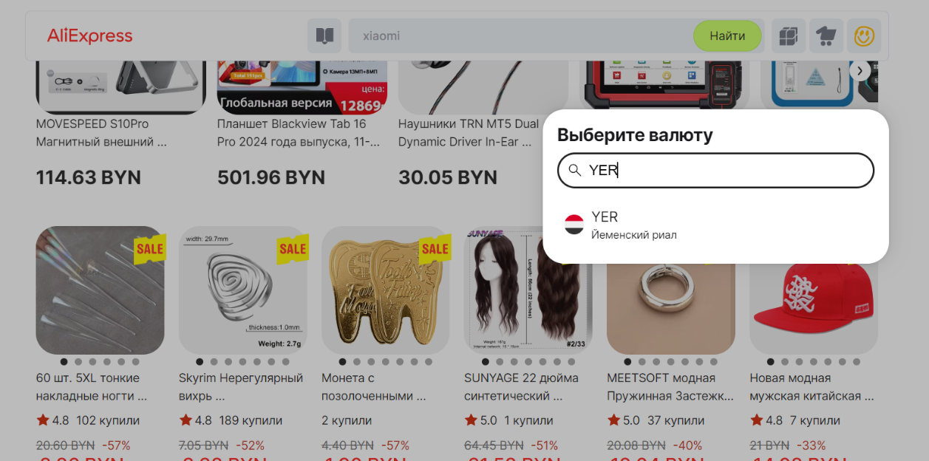

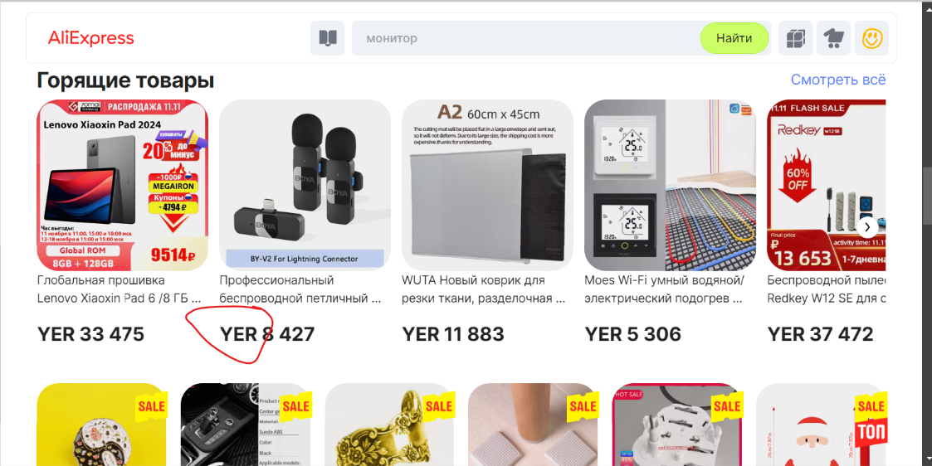

CurrencyChangingTest_CurrencyShouldChangeCorrectly: Passed

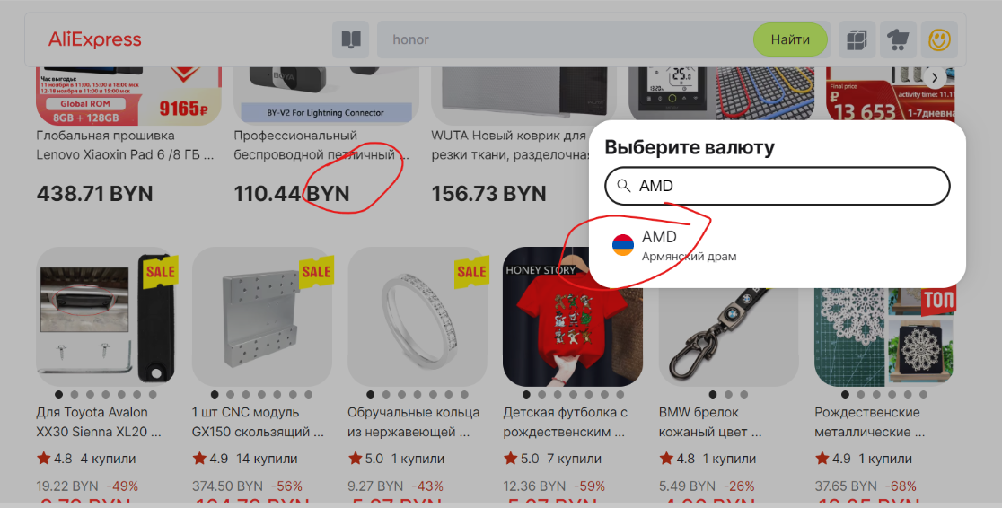

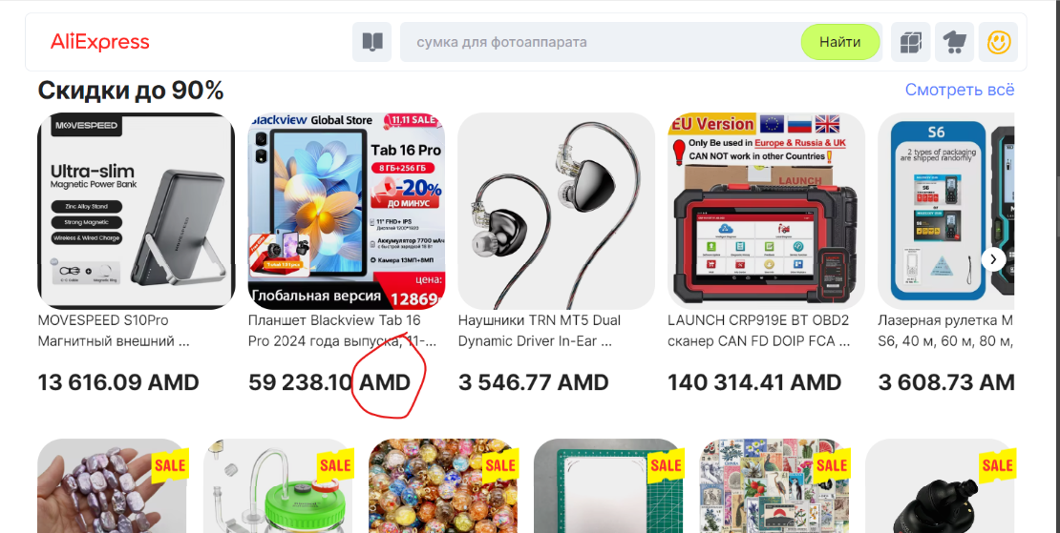

ShoppingCartTest_ItemShouldBeInCart: Passed

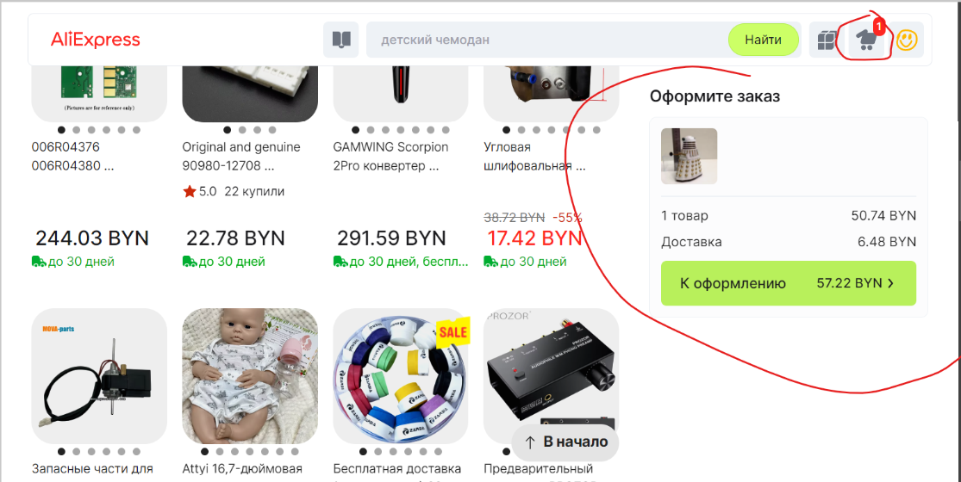

FilterPriceTest_ShouldReturnOnlyRelevantItems: Passed

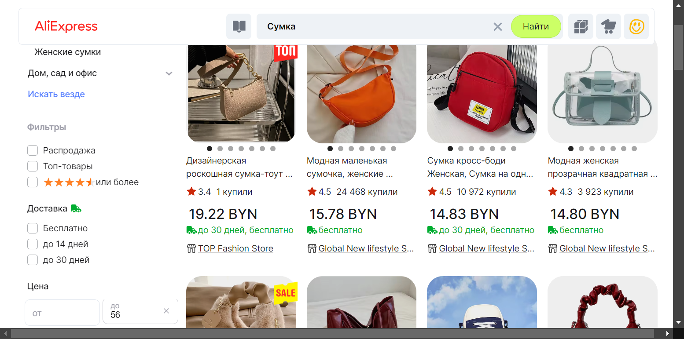

FilterPriceTest_ShouldReturnOnlyRelevantItems: Failed

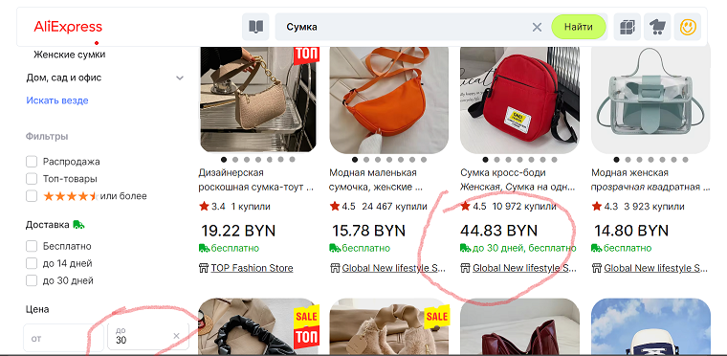

TicketProAuthorization_ShouldReturnCookie: Passed

