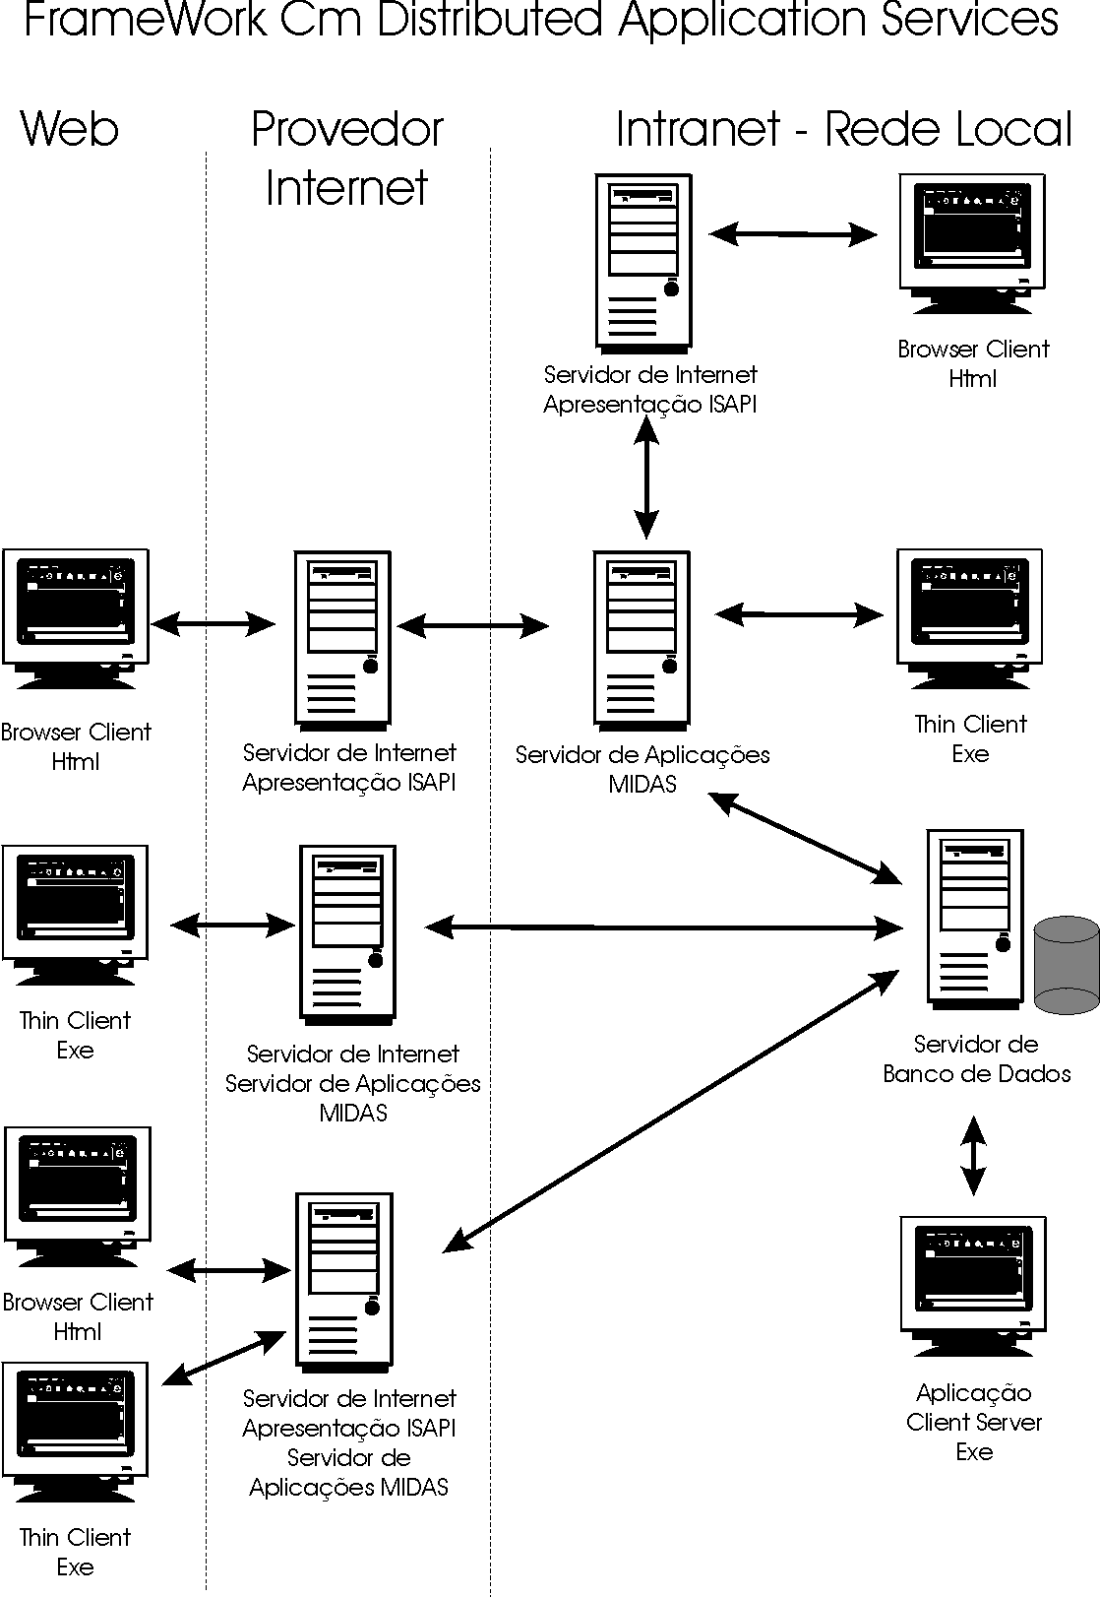
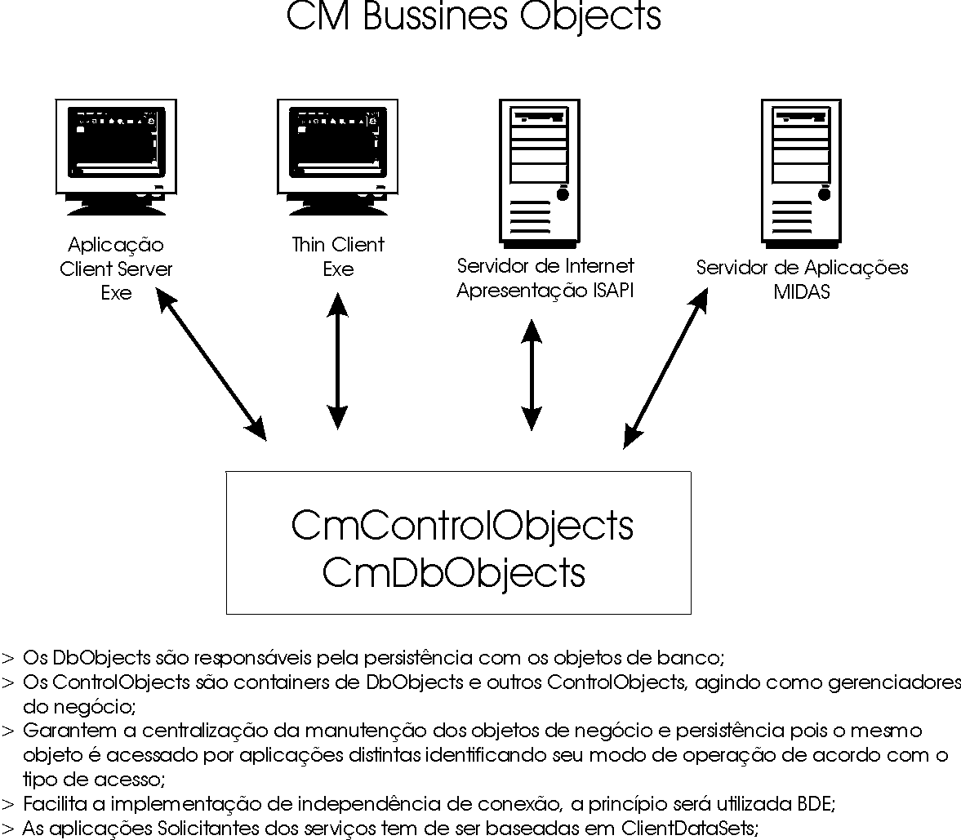
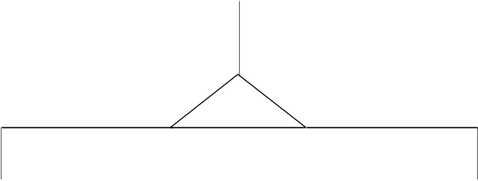
TCmCustomCdbObject
protected
function GetDataBaseName: String; Virtual;
procedure SetDataBaseName(const Value: String); Virtual;
procedure SetDbAdoConnection
(const Value: TADOConnection); Virtual;
public
property DbConnectionType :TDbConnectionType
property DataBaseName :String
property MessageInfo :String
property ConnetionSide :TConnetionSide
Property OnMessageInfo :TOnMessageInfo
property DbAdoConnection :TADOConnection

TCmControlObject
protected
procedure DoChangeDataBase; Virtual;
function GetDataBaseName: String; Override;
public
procedure StartTransaction;
procedure Commit;
procedure Rollback;
function ConnectaDb:Boolean;
property Connection :TDispatchConnection
property DataBase :TDataBase
property DataBaseName :String
property OpenTransaction :Boolean
property DllName :String

TCmDBObject
protected
_ListDbField :TList;
_QryExecute :TwwQuery;
_QrySelect :TwwQuery;
function ExecuteSql:Boolean;
function CreateCmDbField:TCmDbField;
function ValidateNullFields :Boolean;
function GetSequence:Cardinal;
procedure SetDataBaseName; Override;
Public
function Insert :Boolean; virtual;
function Delete :Boolean; virtual;
function Update :Boolean; virtual;
function LoadFromDb :Boolean; virtual;
property SqlSelect :String read fSqlSelect;
property SqlInsert :String read fSqlInsert;
property SqlUpdate :String read fSqlUpdate;
property SqlDelete :String read fSqlDelete;
property ErrorIfNoRowsAffected :Boolean
property TableName :String

TCmDbField
public
property Owner :TCmDbObject
property ColumName :String
property Key :Boolean
property DataType :TFieldType
property Required :Boolean
property ReadOnly :Boolean
property Index :Integer
property IsNull: Boolean
property AsString :String
property AsFloat :Double
property AsInteger :Integer
property AsDateTime :TDateTime
property Value :Variant

