Menu

Bill

Sundae……………………..3,99

Cheesecake with blueberries………………..4,39

Chocolate cake…………..4,79

6 cupcakes ………………..4,29

6 cupcakes ………………..4,29

Biscuit cake………………..4,49

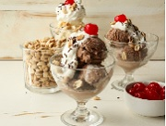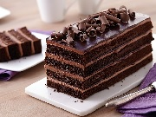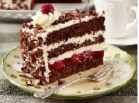

Schwarzwälder Kirschtorte Chocolate cake Sundae

4,99 lv 4,79 lv 3,99 lv

Order

Order

Order

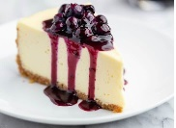

Eclaires with raspberries Cheesecake with blueberries 6 cupcakes

4,39 lv 4,39 lv 4,29 lv

Order

Order

Order

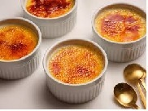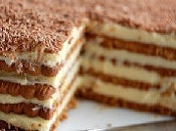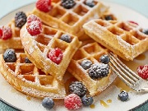

Bill:

26,24 lv

Goodbye

Biscuit cake Crème brulee 3 waffles with berries

4,49 lv 4,39 lv 4,29 lv

Order

Order

Order