**Kisi - Kisi UTS IBDA4311 – Computer Vision**

✅: Ada di cheatsheet

1. Kode Pemrograman: OpenCV, Numpy, Matplotlib ✅
2. Deteksi Batas (Edge Detection) Page 9 PPT Cheat Sheet ✅
   1. Turunan (Page 10)
   2. Gradient (Page 10)
      1. Gradien adalah vektor yang menunjukkan arah dan besarnya perubahan intensitas dalam gambar. Dalam gambar ini, gradien digambarkan sebagai garis-garis berwarna yang mengarah dari kiri ke kanan. Semakin panjang garis, semakin besar gradien.
      2. Arah dari gradien (arah normal dari batas) dideskripsikan oleh A math equation with numbers and symbols

         Description automatically generated

Ini berarti bahwa arah dari gradien adalah sama dengan arah normal dari batas di titik tersebut. Batas adalah daerah di mana intensitas dalam gambar berubah dengan cepat. Arah normal dari batas menunjukkan arah yang menjauhi batas.

* + 1. Gradien mengarah pada perubahan intensitas yang paling besar. Ini berarti bahwa garis gradien menunjukkan arah di mana intensitas dalam gambar berubah dengan kecepatan paling cepat. Misalnya, jika Anda memiliki gambar yang menunjukkan gradien yang mengarah ke atas, maka intensitas dalam gambar meningkat dengan kecepatan paling cepat di sepanjang garis gradien.
  1. Filter (Page 10)
     1. Median Filter

Kalo kernel nya dia minta 3 x 3 pastiin dulu dia ga lewat bates, kalo dia lewat bates tinggal ditambahin padding 0 di sekitaran matrix nya, caranya tinggal di konvolusi biasa, contoh ambil dulu yang pojok kiri atas di sort ascending / descending terserah.

* 1. Konvolusi (Page 10)

1. Deteksi Garis (Line Detection) ✅
   1. hough transform (pasti keluar dan solusi latian soal ada dibawah)
   2. Tranformasi hough transform yang sinus ga masuk ujian, better parameterization juga ga masuk
2. Proses Segmentasi (Segmentation) ✅
   1. week 5 & 6, tapi teori2 ga keluar, mevislab ga keluar
   2. Langkah2 segmentasi, kayak dilasi, erosi, dll tu keluar di ujian

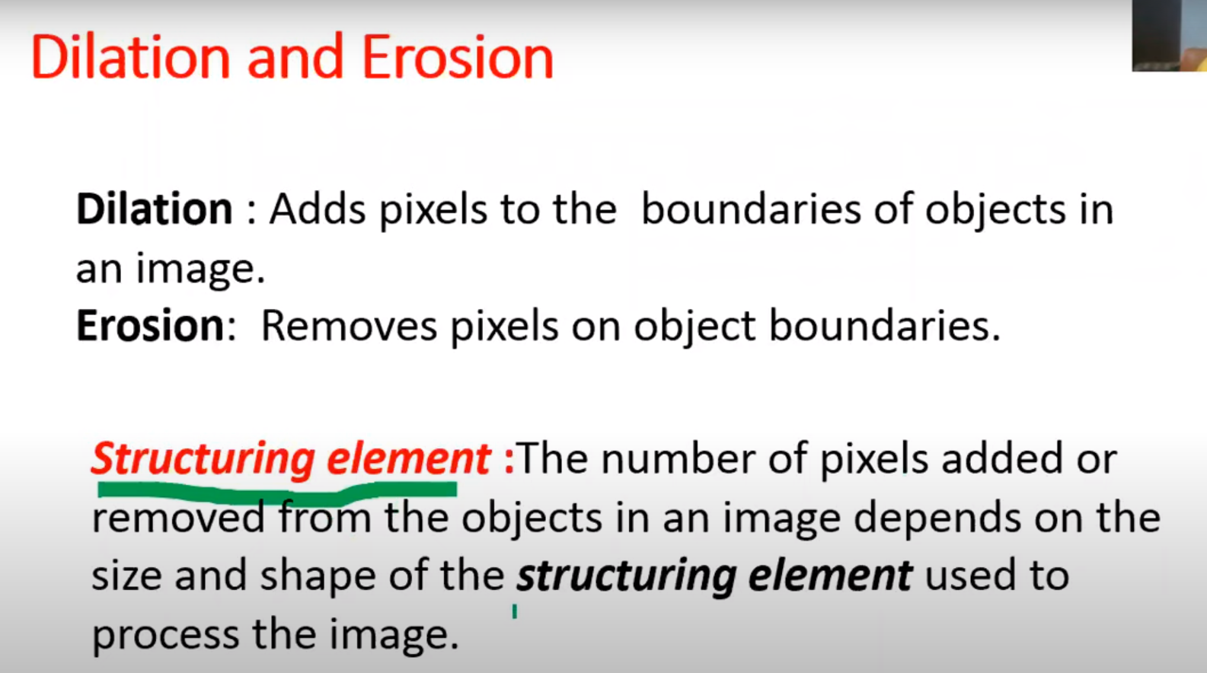

Dilation:

* Fills in holes
* Smoothes object boundaries
* Adds an extra outer ring of pixels onto object boundary, ie, object becomes slightly larger
* Expands the connected sets of 1s of a binary image
* It can be used for
  + Expanding Shapes
  + Filling Holes, Gaps, and gulfs

Erosion:

* Removes isolated noisy pixels
* Smothes object boundary
* Removes the outer layer of object pixels, ie, object becomes slightly smaller

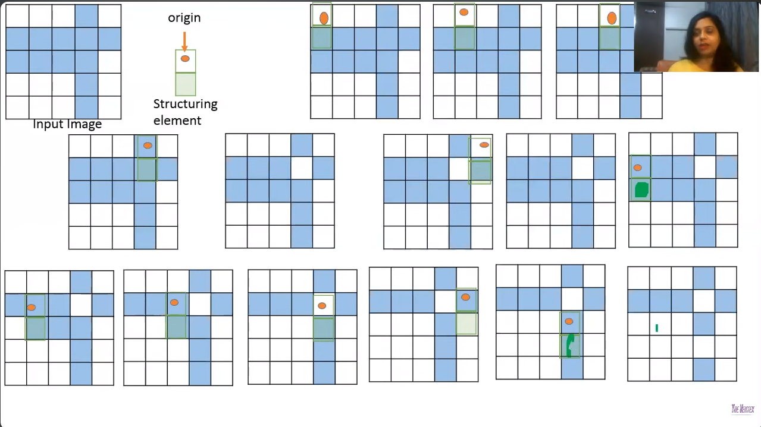

1. Image J ✅
2. Laplasian of gussian (LoG) ✅
3. Canny ✅

**Non-maximum suppression (NMS) is a technique used in Canny edge detection to thin out edges and remove spurious edges. It works by comparing each pixel in the edge map to its neighbors in the direction of the gradient. If a pixel has a higher gradient magnitude than its neighbors, then it is considered to be a strong edge and is kept. Otherwise, the pixel is suppressed. The image that you sent shows a good example of how NMS works. The image on the left shows the edge map before NMS has been applied. The image on the right shows the edge map after NMS has been applied. The image on the right shows that NMS has removed the spurious edges from the image and preserved only the strong edges.**

**Here are some of the benefits of using NMS in Canny edge detection:**

1. **It thins out edges and removes spurious edges.**
2. **It produces more accurate edge maps.**
3. **It is relatively easy to implement.**
4. **It is computationally efficient.**

**NMS is a powerful technique that can be used to improve the performance of Canny edge detection in a variety of applications.**

**To apply NMS to the edge map, we can use the following algorithm:**

* **For each pixel in the edge map:**
  + **Find the pixel's neighbors in the direction of the gradient.**
  + **If the pixel has a higher gradient magnitude than its neighbors, then keep the pixel.**
  + **Otherwise, suppress the pixel.**

**This algorithm can be implemented in a variety of ways. One common approach is to use a 3x3 mask. For each pixel, we compare the pixel to its 8 neighbors. If the pixel has a higher gradient magnitude than all of its neighbors, then we keep the pixel. Otherwise, we suppress the pixel.**

**NMS is an important part of the Canny edge detection algorithm. It helps to produce more accurate and informative edge maps.**

**Hysteresis thresholding is a technique used in Canny edge detection to suppress noise and produce more accurate edge maps. It works by using two thresholds: a high threshold and a low threshold. Any pixels with a gradient magnitude above the high threshold are considered to be strong edges. Any pixels with a gradient magnitude below the low threshold are considered to be non-edges. Pixels with a gradient magnitude between the high and low thresholds are considered to be weak edges.**

**Hysteresis thresholding works by following these steps:**

1. **Start at a strong edge pixel.**
2. **Follow the edge until you reach a weak edge pixel.**
3. **If the weak edge pixel is connected to another strong edge pixel, then keep following the edge.**
4. **If the weak edge pixel is not connected to another strong edge pixel, then stop following the edge.**

**This process ensures that only edges that are connected to strong edges are preserved. This helps to suppress noise and produce more accurate edge maps.**

**The image that you sent shows a good example of how hysteresis thresholding works. The image on the left shows the gradient magnitude of the image. The image on the right shows the edge map after hysteresis thresholding has been applied.**

**The image on the right shows that hysteresis thresholding has removed the noise from the image and preserved only the strong edges.**

**Here are some of the benefits of using hysteresis thresholding in Canny edge detection:**

* **It suppresses noise and produces more accurate edge maps.**
* **It is relatively easy to implement.**
* **It is computationally efficient.**

**Hysteresis thresholding is a powerful technique that can be used to improve the performance of Canny edge detection in a variety of applications.**

1. Threshold Theory

**Soal yang pasti keluar**

1. Konvolusikanlah gambar berikut ini dengan Filter Prewitt. Isilah bagian yang diberikan tanda “?” pada bagian kanan dari gambar di bawah ini.

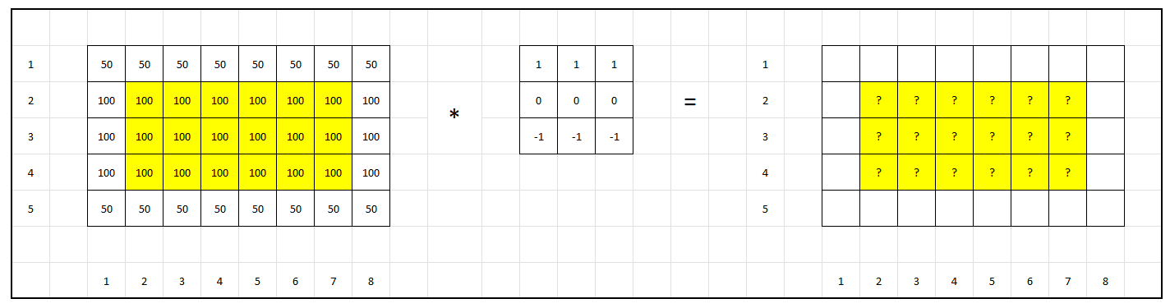

Solusinya

Screenshot dari Latihan Konvolusi

1. Terdapat 4 titik pada sebuah gambar, yaitu A(1,2), B(1,1), C(2,4), D(3,6). Gunakanlah transformasi Hough untuk mendeteksi garis yang terdapat pada gambar tersebut:

1. Isilah Accumulator Array berikut ini:
   1. Pertama, cari rumus dari semua koordinat 🡪 caranya masukin aja ke rumus c = -mx + y

* 1. Abis itu tinggal liat accumulator array nya, di soal ini bapaknya cuman minta m dari (-4,4), yauda tinggal dimasukin ke rumus satu” aja. Misalnya contoh yang m = 2, Nah masukin aja m = 2 ke semua koordinat nya
     1. A 🡪 c = 2 – 2 = 0
     2. B 🡪 c = 1 – 2 = -1
     3. C 🡪 c = 4 – 2*2 = 0
     4. D 🡪 c = 6 – 3*2 = 0
  2. Nah, dari hasil diatas tinggal di masukin ke akumulator arraynya, yang c = 1 m = 2 dimasukin 1, terus yang m = 2 c = 0 nya kan ada 3 makanya di masukin 3.

|  |  |  |  |  |  |  |  |  |  |
| --- | --- | --- | --- | --- | --- | --- | --- | --- | --- |
| **4** | 0 | 1 | 1 | 0 | 1 | 0 | 0 | 0 | 0 |
| **3** | 0 | 0 | 1 | 1 | 0 | 1 | 0 | 0 | 0 |
| **2** | 0 | 0 | 0 | 1 | 1 | 1 | 0 | 0 | 0 |
| **1** | 0 | 0 | 0 | 0 | 1 | 1 | 0 | 0 | 0 |
| **0** | 0 | 0 | 0 | 0 | 0 | 1 | **3** | 0 | 0 |
| **-1** | 0 | 0 | 0 | 0 | 0 | 0 | 1 | 1 | 0 |
| **-2** | 0 | 0 | 0 | 0 | 0 | 0 | 0 | 2 | 1 |
| **-3** | 0 | 0 | 0 | 0 | 0 | 0 | 0 | 1 | 1 |
| **-4** | 0 | 0 | 0 | 0 | 0 | 0 | 0 | 0 | 1 |
|  | **-4** | **-3** | **-2** | **-1** | **0** | **1** | **2** | **3** | **4** |

1. Sebutkan pasangan m dan c yang mendapatkan voting terbesar.
   1. Cara cepet:
      1. pake rumus gradien m = (y2-y1) / (x2-x1)
         1. pertama gambar dulu koordinat nya di kertas
         2. kalo bapaknya baik nanti bakal langsung keliatan garis nya yang mana (yang warna kuning)A grid with numbers and a number in the center

            Description automatically generated with medium confidence
         3. nah dari titik titik yang ngebuat garis nya itu tinggal di cari gradien nya
         4. let say aku ambil titik (3,6) dan (1,2), both titk ini warna nya kuning artinya dia garisnya, terus tinggal diitung gradiennya. (2 – 6) / (1 - 3) = (-4)/(-2) = **2**
         5. terus tinggal cari c nya. Let say ambil x = 3, y = 6 terus tinggal masukin ke rumus c = -**m**x + y -> c = -**2**\*3 + 6 = -6 + 6 = 0
         6. jadi pasangan m dan c yang mendapatkan voting terbesar adalah **m = 2, c = 0**
   2. Cara lama: liat accumulator array nya aja cari maximum nya 😊
2. Tuliskanlah rumus garis yang ditemukan.
   1. Ini tinggal masukin ke rumus y = mx + c aja
   2. y = 2x + 0 🡪 **y = 2x**
3. Gambarkan garis yang ditemukan pada sistem koordinat kartesius dengan sumbu x dan y.

