# **IMAGE COMPRESSION ALGORITHMS FOR PROCESS OPTIMIZATION IN LIVESTOCK FARMING**

# **PRECISION**

|  |  |  |  |
| --- | --- | --- | --- |
| Sara Gallego Villada  Universidad Eafit  Colombia  sgallegov@eafit.edu.co | David González Idárraga  Universidad Eafit  Colombia  dgonzalezi@eafit.edu.co | Stefanny Escobar  Universidad Eafit Colombia [jsescobarr@eafit.edu.co](mailto:jsescobarr@eafit.edu.co) | Mauricio Toro  Simón Marín  Universidad Eafit  Colombia  smaring1@eafit.edu.co  Universidad Eafit  Colombia  mtorobe@eafit. edu.co |

# **ABSTRACT**

## Currently we are aware of the difficult access to information networks in rural areas, where there is an increasing need to make use of new technologies to make life easier in the countryside. In this case, we are looking for the use of an algorithm capable of identifying whether a cow is healthy or sick by means of images used as a basis, but there is a need to compress these images to make them lighter and easier to process files, since in the field there is not always the necessary capacity to process heavy files efficiently. Without an algorithm of this capacity, the work of livestock farmers would be affected and slowed down, which affects not only them but the entire industry. Currently there is evidence of different systems related to agriculture and livestock, see "A systematic literature review on the use of machine learning in precision livestock farming", "An Animal Welfare Platform for Extensive Livestock Production Systems" or "Cloud services integration for farm animals' behavior studies based on smartphones as activity sensors", by which, it is noted that the problem is something of modern interest.

**INTRODUCTION**

The motivation for this project is to allow an easier management of images in an algorithm that identifies healthy and sick animals, by means of CVS type image compression, since lighter and easier to handle files are required due to the low efficiency and capacity of the technology usually used in rural areas (where livestock activities are carried out). Initially, the first algorithm is required to constantly monitor the animals in real time, since it saves time and effort for the person in charge of the animals

**PROBLEM**

The problem that is being look at is the development of an algorithm of compression of images to classify animal health in the context of precision livestock farming, to be used by systems with lower specifications and with greater ease. It is a problem that affects not at small, but at large-scale livestock industry, because if solved it could save a lot of time and resources invested in constantly checking the health of animals used in this industry, which has a direct influence on the entire food trade. And after all, an important part of how our society is built.

**2. RELATED WORK**

**2.1 Classification of behaviour in housed dairy cows using an accelerometer-based activity monitoring system [Vázquez-Diosdado et al. 2015]**- The problem this article is aiming to solve is to both classify biologically important behavior in dairy cows and to detect transition events between lying and standing.

- In this article used an algorithm called Decision-tree algorithm.

- The algorithm is able to classify three types of biological behaviors:

1. Lying (77.42 % sensitivity, 98.63 % precision).

2. Standing (88.00 % sensitivity, 55.00 % precision).

3. Feeding (98.78 % sensitivity, 93.10 % precision).

Transitions were also detected with (96.45 % sensitivity, 87.50 **%** precision).  
 **2.2 Precision Livestock Farming in Swine Welfare: A Review for Swine Practitioners [Benjamin and Yik 2019]** - The problems this article is aiming to solve are group pig welfare challenges: lameness, body condition, prolapse, pig comfort, antagonistic behavior and recognition of illness.

- In this article they talk about an algorithm referred as Hansen’s algorithm: it recognized pigs from three regions: the snout and wrinkles above the snout, prevalent marking at the top of the head, and the eye regions.

- The mounted program used digital photos and differentiated 10 pigs (Figure 3) [47], with 96.7% accuracy **2.3 A Combined Offline and Online Algorithm for Real-Time and Long-Term Classification of Sheep Behaviour: Novel Approach for Precision Livestock Farming [Vázquez-Diosdado et al. 2019]**- The problem this article is aiming to solve is “concept drift”, which occurs when systems are presented with new or changing conditions, and/or in scenarios where training data is not live sensed.

- In this article used many algorithms: Offline KNN algorithm, Online MeanAMag calculation and Online combined algorithm.  
  
- The combined algorithm shows a 25.90% higher performance when compared to using the offline algorithm only, and a 10.88% higher performance when using the online algorithm only. The average accuracy of the combined algorithm was 85.18%.  
  
**2.4 A Combined Offline and Online Algorithm for Real-Time and Long-Term Classification of Sheep Behaviour: Novel Approach for Precision Livestock Farming [Vázquez-Diosdado et al. 2019]**

## - The problem this article is aiming to solve is “concept drift”, which occurs when systems are presented with new or changing conditions, and/or in scenarios where training data is not live sensed.

## - In this article used many algorithms: Offline KNN algorithm, Online MeanAMag calculation and Online combined algorithm.

## - The combined algorithm shows a 25.90% higher performance when compared to using the offline algorithm only, and a 10.88% higher performance when using the online algorithm only. The average accuracy of the combined algorithm was 85.18%.

.

## **3.3 Lossless Image-compression alternatives**

**3.2.1 Image Scaling**

Image scaling is a computer graphics process that increases or decreases the size of a digital image.

When scaling a raster graphics image, a new image with a higher or lower number of pixels must be generated.

Image scaling can be interpreted as a form of image resampling or image reconstruction from the view of the Nyquist sampling theorem.

An image size can be changed in several ways:

Nearest-neighbor interpolation:

One of the easy ways of increasing image size is nearest-neighbor interpolation, replacing every pixel with the nearest pixel in the output; his means multiple pixels of the same color will be present.

Bilinear and bicubic algorithms:

This algorithm reduces contrast (sharp edges) in a way that may be undesirable for line art.

Box sampling:

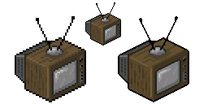

is to consider the target pixel a box on the original image, and sample all pixels inside the box. This ensures that all input pixels contribute to the output. The major weakness of this algorithm is that it is hard to optimize.

Deep convolutional neural networks:

This method uses machine learning for more detailed images such as photographs and complex artwork.

*https://en.wikipedia.org/wiki/Image_scaling#Algorithms*

**3.2.2 Fractal compression:**

Fractal compression is a lossy compression method. It seeks to construct an approximation of the original image that is accurate enough to be acceptable.

The method is best suited for textures and natural images, relying on the fact that parts of an image often resemble other parts of the same image.

To do fractal compression, the image is divided into sub-blocks. Then for each block, the most similar block if found in a half size version of the image and stored. This is done for each block.

Then during decompression, the opposite is done iteratively to recover the original image.

Basically, the compression process, very broadly speaking, is as follows:

The source image is divided into subsets called domain regions, on which redundancies will be searched within the image.

For each domain region a range region is chosen, larger in size than the domain region.

All possible range regions are not rotated, scaled and a symmetry is applied (in short, an affine transformation), choosing the range region that, together with the affine transformation, most closely approximates the domain region.

The choice of the range region, together with the affine transformation, are stored in the fractal file, and will constitute the patterns for decompression and thus reconstruct the original image.

The decompression process is summarized in iterating a sufficient number of times all the affine transformations stored on the range regions until reaching an invariant set, the attractor, which is a good approximation of the original image (as it is a lossy compression , it will never be a pixel-by-pixel replica of the original).

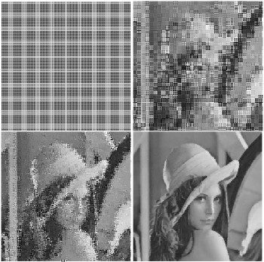

Decompression process of a fractal image

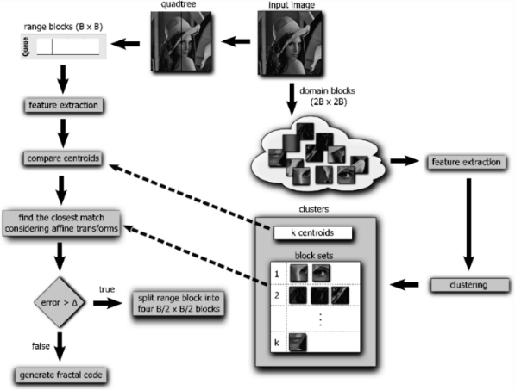 **3.2.3 Discrete cosine transform**The discrete cosine transform (DTC) algorithm is the key tool of JPEG compression. It is the most common function that provides spatial compression, capable of detecting the variation of information between an area and contiguous to a digital image.   
  
DCT is an orthogonal transformation method that decomposes an image to its spatial frequency spectrum. It is used a lot in compression tasks. It is a type of Fourier-related Transform, similar to discrete Fourier transforms (DFTs), but only using real numbers.

## The image must be divided into blocks of 8x8 pixels to better apply the redundancy of information. The encoding process is performed with the main transform formula. As the image is a two-dimensional signal, the equation must be adapted as a two-dimensional equation.

## The DCT coding is based on the following scheme:

First, the image to be compressed is divided into blocks or subimages of reduced size on which the DTC is applied. The result of the transformation of each block is quantized and then efficient codes are applied to transmit or store this information.  
  
Subsequently, the image has to be recomposed from the blocks into which it was originally divided.  
  
Complexity:  
The whole 3-D DCT calculation needs stages, and each stage involves butterflies. The whole 3-D DCT requires butterflies to be computed. Each butterfly requires seven real multiplications (including trivial multiplications) and 24 real additions (including trivial additions). Therefore, the total number of real multiplications needed for the is stage is, and the total number of real additions i.e. including the post-additions (recursive additions) which can be calculated directly after the butterfly stage or after the bit-reverse stage are given by:

## Representation of the base images of the cosine transform 2D 8x8

**3.2.4 Seam carving:**

Seam carving is an algorithm for content-aware image resizing. It functions by establishing a number of seams (paths of least importance) in an image and automatically removes seams to reduce image size or inserts seams to extend it.

Most of the original image cropping algorithms will distort the image, and this algorithm proposes an energy-based principle to accommodate cropping. Simply put, each pixel value is assigned an energy value, and then based on this pixel value, 8 connected domains are used for dynamic programming to get the minimum value, and then, applying this row algorithm per row or column per column you will get one power line, which is actually the phase. The line of the pixel with the smallest pixel value of two adjacent rows (columns) is removed from the original image. How many of those lines can be removed depends on the scale to be trimmed.The energy mentioned above is actually the same as the pixel gradient. The very important information in the image, its edge outline texture, etc. it will change enormously, and the gradient will also be obvious. So you may think that such important content has a lot of energy.

The basic steps of the algorithm:

1. Assign an energy value to each pixel

2. Find the eight connected paths of the pixel with the lowest energy value.

3. Remove all pixels in the path

4. Repeat steps 1-3 above until the number of deleted rows / columns reaches the ideal state.

## **3.3 Lossless Image-compression alternatives**

**3.3.1 LZ77**

This algorithm uses a wave heuristic to scan the image and suffix trie, to represent the dictionary, which is a window in previously encoded pixels.

The complexity of this algorithm is given by N. And the way the LZ77 works is by the dictionary- based scheme, which is designed to take advantage of the correlation between pixels in grayscale images. This wants to represent a block of uncompressed pixels by a pointer to the best approximate occurrence of that block in the compressed part of the image [1].

In this algorithm occurs a process of matching where there are multiple tasks to evaluate the pixels, according to measures. And after this process, and considering every possible match tooted in the region evaluated, the largest match is considered the best match

[*https://en.wikipedia.org/wiki/LZ77_and_LZ78*](https://en.wikipedia.org/wiki/LZ77_and_LZ78)

**Figure 1**

Example of LZ77

**3.3.2 Huffman coding**

Huffman is algorithm for data compressing, this algorithm uses a table with certain codes, in which it makes reference to a symbol. The choice of the representation of this symbols isn’t random, due to each of this representation creates a prefix code

This algorithm work in $O(n log n)$   and n represents the number of symbols, however if its in linear time I, its O $(n)$

This algorithm works by the construction of a tree and the symbols are in nodes, it is organized by weight and frequency, it continues that process until there is only one node. In the construction of this tree each symbol is assign values of 1 and 0. In case there is only one symbol, 1 is always first and 0 second.

This algorithm is use I other method compression, as multimedia codec deflation such as JPEG and MP3.

[*https://en.wikipedia.org/wiki/Huffman_coding*](https://en.wikipedia.org/wiki/Huffman_coding)

**Figure 2.**

Example of Huffman coding Wikipedia

**3.3.3 Burrows-Wheeler transform**

Also known as block-sorting compression, in this compression algorithm the value of the characters in the string are kept, due to the transformation of the char string that permutes the order of the characters.

In this compression, all the possible characters entrance rotations are organized column by column, until we got an easy codification. Also, this method is reversible, and we don’t need to store any additional data except the position of the first original character.

The complexity in this algorithm is of $O(n)$

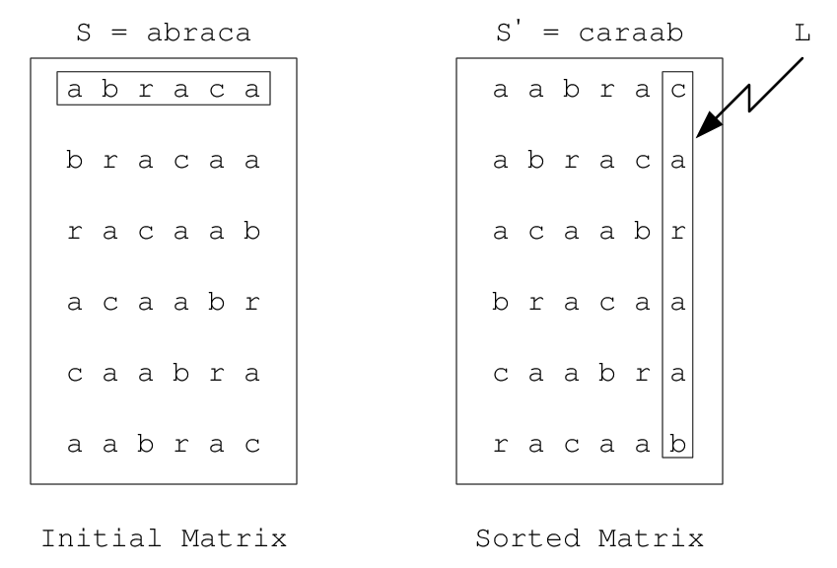

*https://www.researchgate.net/figure/An-example-of-a-Burrows-Wheeler-transformation_fig3_3225483*

**Figure 3**

Example Burrows-Wheeler transform

[*https://en.wikipedia.org/wiki/Burrows%E2%80%93Wheeler_transform*](https://en.wikipedia.org/wiki/Burrows%E2%80%93Wheeler_transform)

**3.3.4 ARITHMETIC CODIFICATION**

In arithmetic codification the algorithm is given an image with the value of its pixels in a matrix, this algorithm codifies the information of the image with a string of values between 1 and 0 in the line of real numbers, in this way, the image data obtain the lowest size. Even though this technique is easy, is not that efficient at the moment of compressing image data.

This method allows a lossless compression and as in Huffman codification, it creates a string of values between 1 and 0. However to use this method, first you need to define a pattern prediction model, that could be easily found in the message to encode, This models allows that the codification produce an optime codification.

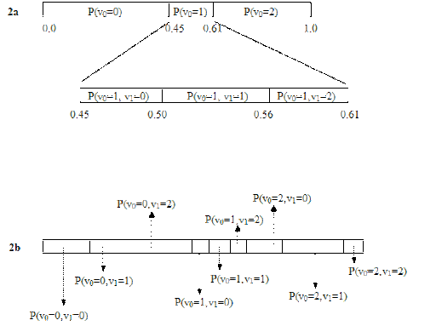

[*https://en.wikipedia.org/wiki/Arithmetic_coding*](https://en.wikipedia.org/wiki/Arithmetic_coding)

**Figure 4**

Example of Arithmetic coding

# **REFERENCES**

[1] *Wikipedia. 2017. WikipediA: the Free Encyclopedia. Retrieved from https://www.wikipedia.org/.*

[2]. Vázquez-Diosdado, J. et al., 2015. *Classification of behaviour in housed dairy cows using an accelerometer-based activity monitoring system*, Animal Biotelemetry.

[3].Vázquez-Diosdado, J., Paul, V., Ellis, K., Coates, D., Loomba, R. and Kaler, J., 2019. *A Combined Offline and Online Algorithm for Real-Time and Long-Term Classification of Sheep Behaviour: Novel Approach for Precision Livestock Farming*, Sutton Bonington: MDPI.

## [4]. Reference: Benjamin, M. and Yik, S., 2019. *Precision Livestock Farming in Swine Welfare: A Review for Swine Practitioners, East Lansing: MDPI.*

*[5]. Herinaina Andriamandroso, A. et al., 2017. Development of an open-source algorithm based on inertial measurement units (IMU) of a smartphone to detect cattle grass intake and ruminating behaviors, ScienceDirect.*

*[6]. Vincent Tabora. 2019 JPEG Image Scaling Algorithms(September 2019). Retrieved august 8, 2021 from*

[*https://users.cs.northwestern.edu/~agupta/_projects/image_processing/web/FractalImageCompression/*](https://users.cs.northwestern.edu/~agupta/_projects/image_processing/web/FractalImageCompression/)

*[7]Yaciro Cabezas, Jairo Guevara, Algoritmo de compresión y reconstrucción de imagen aplicando la teoría de wavelets (2005) Retrieved august 8, 2021 from* [*http://repositorio.unicauca.edu.co:8080/bitstream/handle/123456789/2136/ALGORITMO%20DE%20COMPRESIÓN%20Y%20RECONSTRUCCIÓN%20DE%20IMÁGENES%20FIJAS.pdf?sequence=1&isAllowed=y*](http://repositorio.unicauca.edu.co:8080/bitstream/handle/123456789/2136/ALGORITMO%20DE%20COMPRESIÓN%20Y%20RECONSTRUCCIÓN%20DE%20IMÁGENES%20FIJAS.pdf?sequence=1&isAllowed=y)

*[8]Jonathan Blow Arithmetic Coding, Part 2 (September 2003) Retrieved august 8, 2021 from http://number-one.com/product/Arithmetic%20Coding,%20Part%202/index.html*

[*https://zephyrnet.com/es/algoritmo-de-tallado-de-costuras-una-forma-aparentemente-imposible-de-cambiar-el-tamaño-de-una-imagen/*](https://zephyrnet.com/es/algoritmo-de-tallado-de-costuras-una-forma-aparentemente-imposible-de-cambiar-el-tamaño-de-una-imagen/)

*https://programmerclick.com/article/4510360417/*