Table of Contents

Requirements engineering (RE) 3

System identification 4

Purpose 4

Scope 4

Boundary 4

Context 4

Types of RE 4

Greenfield Engineering 4

Re-engineering 4

Interface Engineering 4

Types of requirements 5

Functional requirements 5

Non-functional requirements 5

Constraints (pseudo-requirements) 5

Process oriented view 6

Feasibility study 6

Requirements elicitation and analysis 6

Requirements specification 8

Validation techniques 8

Project management 10

Challenges 10

Management activities 10

Software Project Management Plan 10

Road Map for Project Management 11

Project scheduling 12

Activity network diagram 12

Activity timeline: Gantt chart 13

Tasks 14

Activities 14

Functions 14

Risk management 15

The process 15

Risk identification 16

Risk analysis 16

Risk planning 16

Risk monitoring 16

Team organization & Teamwork 17

Advantages of working in a team 17

Disadvantages of adding more people to a team 17

Team size 17

Team organization 18

Team dynamics 18

Meredith Belbin's Roles 18

Legal, Social, Ethical and Professional Issues 19

Professional issues 19

Profession 19

Basic technical knowledge 19

Professional bodies 20

Why is it important to be a Professional 20

Legal issues 21

• 1990 – Computer Misuse Act: 21

2. 1984-1988 – Data Protection Act: 21

• 2000 – Freedom of Information Act (FOIA): 21

3. 2000 – Regulations of Investigatory Powers Act (RIPA): 21

4. 2003 – Privacy and Electronic Communications Regulations: 22

5. 2006 – Police and Justice Act: 22

Ethical issues 22

What is Ethics? 22

Ethical Decision Making 22

BCS Code of Conduct 23

Guidelines for resolving ethical dilemmas 24

# Requirements engineering (RE)

Requirements engineering is the process of:

* Understanding and defining what services are required from the desired system

(*i.e.* **what the customer wants**)

* Identifying the **system constraints**

(*e.g.* deadlines, hardware specifications, budget, standards)

At the end of the requirements engineering process, a **requirements specification document** is produced.

RE addresses:

* The development and validation processes for **gathering, representing, and analysing** system requirements
* The methods for **transforming** these requirements **into specifications** for design and implementation

The process of RE is in software development is an **iterative process**. Often, it’s not possible to draw an exact line between the definition of requirements and the actual implementation.

## System identification

In order to uncover the system requirements, it’s necessary to ask some questions...

## Purpose

* **What is the purpose of the system?**

They will likely lead to functions and sub-functions that the system will need to carry out.

## Scope

* **What is included in the system?**

Since the system being analysed may be part of a larger environment, it’s important to understand what parts of the system we need to provide or not. This is fundamental to avoid missing required components or adding to non-requested ones.

It refers more to what could be implemented in the system, also in the future.

## Boundary

* **What is inside, what is outside?**

We need to identify which of the existing components will be part of the system and which won’t.

## Context

* **What is the environment of the system?**
* **What external entities may affect the system and its operation?**

We also need to think about the environment in which the system will have to run and what could influence it. E.g. hardware, network, etc.

## Types of RE

### Greenfield Engineering

* Development starts from scratch; no prior system exists.
* The requirements are extracted from the client/users.
* **Triggered by user needs**

### Re-engineering

* Re-design and/or re-implement an existing system using newer technology
* **Triggered by new technology**

### Interface Engineering

* Provide more/new services for an existing system
* **Triggered by new technology or new market needs**

## Types of requirements

### Functional requirements

* Describe the **interactions** between the system and its environment and/or its users.
* Are **independent from the implementation**.

E.g.

* The time displayed must be based on the user location.

### Non-functional requirements

* Describe the parts of the system non-related to the functional aspects:

E.g.

* Hardware specifications
* Bandwidth consumption
* Etc.

### Constraints (pseudo-requirements)

* **Limitations** on what we are allowed to do.
* Might be imposed by the client or the environment in which the system will operate.

E.g.

* The software must be implemented in PHP.

Some of the things that usually **are not** part of the requirements:

* Implementation technology
* Implementation language
* Development methodology
* Reusability
* Etc.

These *should* *not* be decided by the client.

## Process oriented view

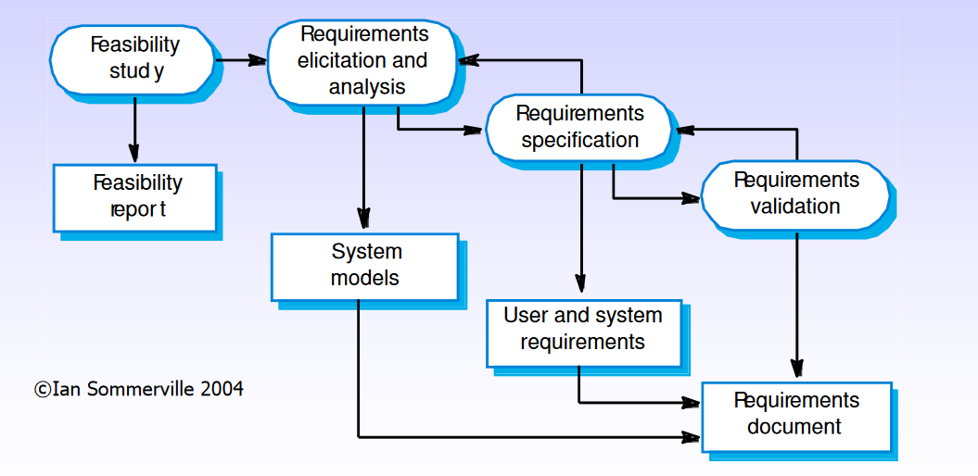

For each one of these stages, a document is produced.

### Feasibility study

*“Do we need this? Can we do it?”*

This part of the process is aimed at understanding if the user can be satisfied using **current software and technologies**, and whether the development will be **cost effective** and **within the budget**.

This should be a quick process.

The report allows the client to decide whether they want to proceed with a more detailed and costly analysis.

### Requirements elicitation and analysis

During this part of the process, requirements are extracted from the stakeholders.

Two complementary approaches used to elicit requirements are:

#### Viewpoints

They are a way of identifying *stakeholders* and other sources from which requirements can be extracted.

Perspectives from which the system can be look at, i.e. different people.

#### Scenarios

Real-life examples of how the system will be used (use cases in UML).

The user is asked to explain in detail how they would perform a task.

Once we have all the requirements, we need to **analyse** them in order to discover problems or inconsistencies. The requirements are then given back to the stakeholders. Finally, requirements may be rewritten.

A checklist might be used to verify each requirement.

##### Heuristics for finding scenarios

Some of the questions that may be asked are:

* What are the primary tasks that the system needs to perform?
* What data will the actor create, store, change, remove, or add in the system?
* What changes or events will the actor of the system need to be informed about?

If the system already exists (re-engineering or interface engineering), ask to speak with the end user. Some resistance might be expected if not working directly for the final user (contractors).

#### Analysis & Validation

Once all the requirements have been elicited from the stakeholders, they need to be validated to avoid additional costs later. The question to be answered at this stage is “**Have we got the right requirements?**”

***+++++ A final draft of the requirements is agreed upon. +++++***

* Analysis works with raw requirements as elicited from the stakeholders
* Validation works with a final draft of the requirements document

### Requirements specification

Viewpoints and scenarios are used to understand the current requirements, but also to communicate with the stakeholders and elicit additional information. They must be represented in a precise and well-structured way, but they should be easy enough so that also stakeholders can understand them.

#### Informal & semi-formal representation

Different representations can be used to represent the same scenarios, such as graphics or stylised natural language (**pseudo-code**), but semi-formal representations like **UML diagrams** are probably better because it’s easier to translate them into the actual code.

#### Formal representations

More formal representations should be used when working on critical projects where ambiguities might cause harm to people, e.g. avionics, finance, medical applications, etc.

They may be used for expressing:

* Properties of objects
* Objects in involved in (inter)actions
* Relationships between inputs and outputs

This formalization might be useful to:

* Disambiguate requirements and scenarios
* Perform mathematical analysis/checking of the design
* Assist in automated testing of the system

### Validation techniques

Some validation techniques that can be used to ascertain the correctness of the elicited requirements are:

#### Requirements reviews

* Systematic manual checking of the of the requirements
* If possible, stakeholders should be involved in review the process.

#### Prototyping

* An executable model of the system is used to check the requirements
* Allows clients/stakeholders to test dummy scenarios

#### Test-case generation

* Development of tests for each requirement

Each requirement must be **SMART**:

* Specific
* Measurable
* Achievable
* Realistic
* Time-bound

#### Requirement based testing

**Inventing requirements** tests could be an effective validation technique to **discover missing or ambiguous information** in the requirements.

#### Hard to test requirements

Some requirements that might not be easily testable are those relative to the **system as a whole**, requirements for **error handling** or system failures, or **non-functional requirements** that require large sets. Formal representations may be useful in these cases.

For further information, read Ian Sommerville’s book on Requirements Engineering (chapter 4).

# Project management

Project management is concerned with software:

* Being **delivered on time**
* **Meeting the requirements**

It is needed because software development is subject to

* **budget**
* **schedules**

set by the organization or the client that commissioned the software.

## Challenges

Since software is not tangible and requirements tend to be rather flexible because of the changes that happen every day (politics, technologies, market, etc.), therefore it is necessary to carefully manage all the steps of the project. An additional challenge is the lack of a standardised process due to the uniqueness of software projects. Different perspective of the people participating in the project need to be considered. **Try to satisfy as many stakeholders as possible.**

## Management activities

The activities involved in managing a software are:

* **Proposal** writing
* **Project** **planning** and scheduling
* **Project** **costing**
* **Personnel selection** and evaluation
* **Project monitoring** and reviews
* **Report writing** and presentations

## Software Project Management Plan

* The **controlling document** for a software project.
* Specifies the technical and managerial approaches to develop the software product.
* The project plan sets out the **resources available**, the **work breakdown**, and the **schedule**.
* Companion document to requirements specification: Changes in either may imply changes in the other document.
* SPMP may be part of the project agreement.

Project agreement (written document that defines the following for a client):

* The scope, duration, cost and deliverables for the project
* The exact items, quantities, delivery dates, delivery location.
* It can be a statement of work, a business plan, or a project charter – the basis for a contract

The project plan may address aspects of the project work, such as:

* **Quality plan**: quality procedures and standards to be used for system validation
* **Validation plan**: approach, resources, and schedules for system validation
* **Configuration management plan**: configuration managements procedures and structures used
* **Maintenance plan**: predicts maintenance requirements, costs, and effort required
* **Staff development plan**: describes how the skills and experience of the project team members are to be developed

And/or, aspects of the development process:

* **Introduction**: briefly, the objectives of project and sets constraints (e.g., budget, time, etc.) which affect project management
* **Project organisation**: way in which development team are organised, the people involved and their roles in the team
* **Risk analysis**: possible project risks, their likelihood of occurrence, and risk reduction strategies proposed
* **Hardware/software**: support required for the development; if hardware to be bought, estimates of price and delivery schedule
* **Work breakdown**: breakdown of project into activities and tasks, and identifies milestones and deliverables associated with each task
* **Project schedule**: dependencies between activities, estimated time required to reach each milestone, and allocation of people to activities
* **Monitoring and reporting mechanisms**: management reports which should be produced, when, and the monitoring mechanism.

## Road Map for Project Management

1. Understand the **project content, scope & time frame**

2. Identify **development process**: methods, tools, languages, documentation and support

3. Determine **organizational structure**: organizational elements involved

4. Identify **managerial process**: responsibilities of the participants

5. Develop **schedule**: times at which the work portions are to be performed

6. Develop **staffing plan**

7. Begin **risk management**

8. Identify **documents** to be produced

9. **Begin** the process

On-going monitoring, reviewing...

## Project scheduling

In order to finish a project in time it’s necessary to **divide** it **into a set of tasks** and create a schedule **allocating** the correct amount of **time and resources** for each of them.

Tasks should be organised to make an optimal use of the available workforce, while minimizing the dependencies between them.

### Activity network diagram

“An **Activity Network Diagram** is a diagram of project activities that shows the sequential relationships of activities using arrows and nodes. An [activity network diagram](http://www.sixsigmadaily.com/activity-network-diagram/) tool is used extensively in project management and is necessary for the identification of a project’s critical path (which is used to determine the expected completion time of the project).” -*sixsigmadaily*

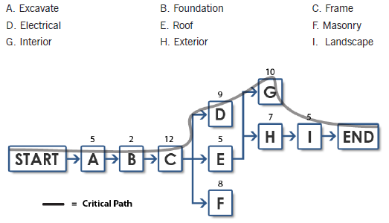

### Activity timeline: Gantt chart

“A **Gantt chart** is a type of [bar chart](https://en.wikipedia.org/wiki/Bar_chart) that illustrates a [project schedule](https://en.wikipedia.org/wiki/Schedule_(project_management)). Gantt charts illustrate the start and finish dates of the terminal elements and summary elements of a [project](https://en.wikipedia.org/wiki/Project). Terminal elements and summary elements comprise the [work breakdown structure](https://en.wikipedia.org/wiki/Work_breakdown_structure) of the project. Modern Gantt charts also show the [dependency](https://en.wikipedia.org/wiki/Dependency_(project_management)) (i.e., precedence network) relationships between activities. Gantt charts can be used to show current schedule status using percent-complete shadings and a vertical "TODAY" line as shown here.” -*Wikipedia*

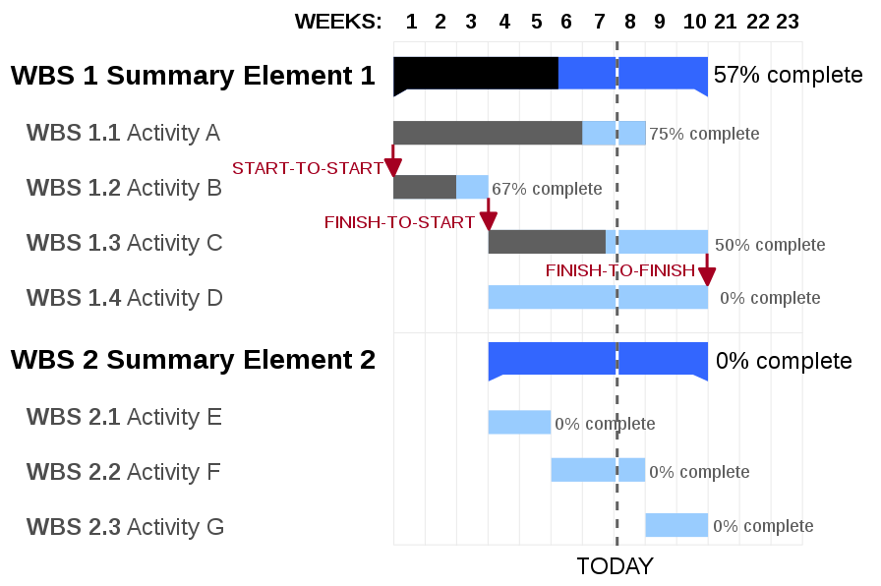

### Tasks

Tasks are activities that have been assigned to a resource the smallest units that should be used for planning and tracking, yet they should be large enough to avoid micromanagement. They have a finite duration, limited resources, and produce tangible results when complete.

Tasks need to be specified by using the following:

* **Name** (description of work that needs to be done)
* **Preconditions** for starting, **duration**, required **resources**
* **Outcomes** and **acceptance criteria**
* **Risk involved**

*Example of tasks:*

* Write unit test for class “Example”
* Write user manual
* Schedule code review

Finding the right size for a task is problematic because the team may not know how to decompose the problem into more tasks, but they should be decomposed into sizes that allow monitoring.

### Activities

Activities are major units of work that are assigned exact dates and that consist of a number of smaller activities or **tasks**. They culminate in project **milestones** which are internal **checkpoints used to measure progress**.

Activities might be grouped into larger activities in order to establish a hierarchical structure for the project and to allow separation of concerns.

### Functions

A function is an activity, or a set of activities, that span the duration of the project.

*Examples of functions are:*

* Project management
* Configuration management
* Documentation
* Quality control
* Training

# Risk management

One of the most important project management tasks is risk management. It is concerned with **identifying the risks** and drawing up plans for minimising their effect on a project. A risk is the probability that some adverse circumstance will occur. Risks can affect **schedules or resources, quality or performance** of the software being developed, while **business risks affect the organization** developing or procuring the software.

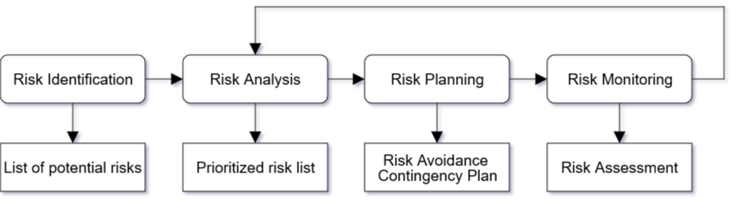

*Image from Vittorio Iocoland*

## The process

* **Risk identification**

Identify project, product and business risks

* **Risk analysis**

Assess the likelihood and consequences of these risks

* **Risk planning**

Draw up plans to avoid or minimise the effects of the risk

* **Risk monitoring**

Monitor the risks throughout the project

## Risk identification

The team leader may be asked to identify the risks, or the group could identify all the risks they can think of. Additionally, a checklist that may be used to identify common risk in projects is the following:

* **Technology risks**

A database is not fast enough for the amount of transactions the system will handle

* **People risks**

It is not possible to recruit people with the necessary experience

* **Organisational risks**

The manager is replaced in the middle of the project

* **Requirements risks**

Changes to requirements require to rework major parts of the design

* **Estimation risks**

The time required to develop the software is underestimated

## Risk analysis

The probability and seriousness of each risk has to be assessed. Depending on the probability of it happening, a risk may be categorised as very low, low, moderate, high, or very high. Its consequences may be insignificant, tolerable, serious, catastrophic.

## Risk planning

Each risk has to be considered so that different strategies can be developed:

* **Avoidance strategies**

The probability that the risk will arise is reduced using opportune strategies

* **Minimisation strategies**

The impact of the risk on the project or product will be reduced

* **Contingency plans**

If the risk arises, contingency plans are in place to deal with that risk

## Risk monitoring

* **Assess** each identified risk **regularly** to decide whether it is becoming less or more probable.
* Also **assess** whether the **effects** of the risk **have changed**.
* Each key risk should be **discussed** at management progress meetings.

# Team organization & Teamwork

## Advantages of working in a team

There are many reasons people to work in a team. In organizations, teams allow to:

* **Accomplish projects** that a single person could not do
* **Brainstorm** more solutions
* **Detect flaws** in solutions
* Build a **workplace community**

Exposure to teamwork is considered valuable in the educational process:

* Exposure to **different points of view**
* Increases **communication skills**
* **Critical thinking and evaluation skills**
* **Conflict resolution** **skills**

The BCS, The Chartered Institute for IT promotes teamwork as a professional development aspect for computing degrees.

## Disadvantages of adding more people to a team

* More **communication lines**
* Training **cost/time**
* Lower **productivity**
* **Brook's Law**: adding more people to a late project makes it later

## Team size

*“When effective decision-making is required,* ***three selected teams of four*** *are better than one group of twelve. [...]* ***small teams*** *deliberating separately* ***can quickly reach significant decisions****." – Meredith Belbin*

Although working in a team is mostly effective, a large team should be avoided because:

* Lines of communication are added for each member

n x (n - 1) ÷ 2 where n is the team size

* Large teams have too much overhead and are hardly effective
* The approximate optimal range seems to be from 3 to 7 members, even though big company CEOs think that the optimal range is from 5 to 7.

## Team organization

There are different ways of organizing a team. The most common are:

* **Hierarchical** organization: pyramid with the decision makers at the top.
* **Egoless programming peer**: each member of the team is on the same level.
* **Egoless groups with leaders**: many small groups that communicate with each other by electing a leader.
* **Project-based** organization: many small groups organized with hierarchies are themselves part of a bigger hierarchy.

## Team dynamics

**Tuckerman and Jensen**’s model is commonly accepted to describe how teams form and become productive. The model is divided in 4 stages:

* **Forming**: the members try to determine the purpose of the group and the role they will play
* **Storming**: the members try to resolve their differences of opinion
* **Norming**: a common understanding of the goals and the functioning of the team is reached
* **Performing**: the team members have a clear understanding of how they will contribute and interact

## Meredith Belbin's Roles

Meredith Belbin identified nine **team roles**. These roles are:

* **Plant**: Generates ideas and solves difficult problems.
* **Coordinator**: Clarify goals and delegates tasks effectively.
* **Monitor**/**Evaluator**: Sees all options and judges accurately.
* **Implementer:** Turns idea into actions and organises work that needs to be done.
* **Completer**/**Finisher**: Searches out errors. Polishes and perfects.
* **Resource Investigator**: Explores opportunities and develops contacts.
* **Shaper**: Has the drive and courage to overcome obstacles.
* **Team worker**: Listens and averts friction.
* **Specialist**: They provide specialist knowledge and skills.

# Legal, Social, Ethical and Professional Issues

## Professional issues

In order to become a *professional,* one or more requirements might be necessary:

* Intensive **course of study**
* **Professional practice**
* **Professional development** (further study after beginning professional practice)
* **Accreditation and certification** to demonstrate an adequate level of competence

### Profession

Professions need to ensure that knowledge and skills are put to **socially responsible** uses. This is usually achieved by ensuring that all the members of a profession follow the same **code of ethics** and/or a **code of conduct** (or practice). This implies that a profession has an identity, usually manifested as **professional society**.

A profession operates on two different levels:

* **Practitioner level**: the individual being part of a profession.
* **Infrastructure level**: structures and people that work to maintain the profession by providing education, accreditation, certification schemes, etc.

### Basic technical knowledge

A professional computer scientist must have:

* A **firm foundation** in the critical areas of the field
* An **in-depth knowledge of one or more areas of the field**, depending upon the person’s area of practice

A well-educated computing scientist should be able to apply fundamental concepts and techniques of:

* **Computation**
* **Algorithms**
* **Computer design**

Being a professional also means **engaging in Continuous Professional Development** (CPD).

### Professional bodies

Being a professional means being a member of a professional body.

In the UK this means being a member of either:

* Institution of Engineering Technology (**IET**)
* **BCS**, The Chartered Institute for IT

In the USA:

* Association for Computing Machinery (**ACM**)
* Institution of Electrical and Electronic Engineer (**IEEE**)

The computing profession *in the UK* is mainly treated as **engineering**.

### Why is it important to be a Professional

* Recognition by
  + Peers
  + Clients
  + External Bodies
  + The Public
* Continuing professional development
  + Preservation of qualification standards
* Lobbying
* Networking
* Access to learned society activities
* Financial and other services
* Professional register

## Legal issues

The most important laws that a computer scientist should remember are:

### 1990 – Computer Misuse Act:

* + **Unauthorised Access** ─ accessing (or attempting to) private computer material.
  + **Unauthorised Access for further offence** ─ situations for example where the material obtained was used to access a person's bank account.
  + **Unauthorised Modification** ─ modifying private computer material. This covers issues such as planting viruses, malicious deletion of files or altering bank account details.

### 1984-1988 – Data Protection Act:

Data Protection Act states that personal data must be:

* + Processed fairly and lawfully
  + Obtained only for one or more specified and lawful purposes.
  + Adequate, relevant and not excessive in relation to the purpose or purposes for which they are processed.
  + Accurate and, where necessary, kept up to date.
  + Not be kept for longer than is necessary for their purpose.
  + Processed in accordance with the rights of data subjects (individuals).
  + Protected with appropriate technical and organisational measures, against unauthorised or unlawful processing and against accidental loss or destruction, or damage.
  + Not transferred to a country or territory outside the European Economic Area (EEA) unless that country or territory ensures an adequate level of protection for the rights and freedoms of data subjects in relation to the processing of personal data.

It was deemed to be *ineffective against (D)DoS attacks*, that’s why this aspect had to be “fixed” by the Police and Justice Act.

### 2000 – Freedom of Information Act (FOIA):

* + Grants **the public** access to information held by **public authorities**. In **conflict** with the **Data Protection Act**.

### 2000 ­– Regulations of Investigatory Powers Act (RIPA):

Empowers the government to:

* + Demand that an ISP provides access to a customer's communications (data) in secret.
  + Demand your decryption keys so that they can access any encrypted data on your computer.
  + Further activities.

### 2003 – Privacy and Electronic Communications Regulations:

It came into force on 11 Dec 2003 and concerns electronic marketing and the

confidentiality of electronic data traffic.

### 2006 – Police and Justice Act:

It introduced new offences concerned with “impairing the operation of a computer” (**(D)DoS** attacks) including making and distributing hacking tools. This caused legal problem for those who created tools for **penetration testing** since they could be used for malicious activities.

## Ethical issues

### What is Ethics?

Ethics is the Systematic study of morals. It deals with the uncertainties and conflicts of opinion over matters of what is right and wrong conduct ethical conduct, i.e. doing the right thing.

Reasons for following an ethical conduct could include:

* **Trust** ─ an individual known to work within a consistent ethical framework is one who can be relied upon.
* **Duty** ─ because it's the right thing to do.
* **Security** ─ being aware of the consequences of your actions can guard against unexpected outcomes.
* **Comfort** ─ peace of mind.
* **Fear** ─ there may be sanctions imposed on those who act unethically.

### Ethical Decision Making

Ethical decision making is not straightforward, since there are many upsides and downside for every decision, often leading to the point that there is no right decision, due the very nature of ethics being subjective.

On the other hand, actors such as companies, need to act in their own interest, otherwise they would cease to exist. Companies could have policies in place to address ethical dilemmas.

Additionally, there might be conflict between short-term and long-term interest.

There are a few approaches to ethics, such us the rule of **harm minimisation** ─ chose the action that will lead to the least harm.

Often, the decision taken is to **maximise benefits and minimize harm**.

**An action that is unethical, although not necessarily illegal.**

### BCS Code of Conduct

#### Public Interest

1. You shall have due regard for public health, privacy, security and well being of others and the environment.
2. You shall have due regard for the legitimate rights of Third Parties.
3. You shall conduct your professional activities without discrimination on the grounds of sex, sexual orientation, marital status, nationality, colour, race, ethnic origin, religion, age or disability, or of any other condition or requirement.
4. You shall promote equal access to the benefits of IT and seek to promote the inclusion of all sectors in society wherever opportunities arise.

#### Professional Competence and Integrity

1. You shall only undertake to do work or provide a service that is within your professional competence.
2. You shall NOT claim any level of competence that you do not possess.
3. You shall develop your professional knowledge, skills and competence on a continuing basis, maintaining awareness of technological developments, procedures, and standards that are relevant to your field.
4. You shall ensure that you have the knowledge and understanding of Legislation and that you comply with such Legislation, in carrying out your professional responsibilities.
5. You shall respect and value alternative viewpoints and, seek, accept and offer honest criticisms of work.
6. You shall avoid injuring others, their property, reputation, or employment by false or malicious or negligent action or inaction.
7. You shall reject and will not make any offer of bribery or unethical inducement.

#### Duty to Relevant Authority

1. You shall carry out your professional responsibilities with due care and diligence in accordance with the Relevant Authority’s requirements whilst exercising your professional judgement at all times.
2. You shall seek to avoid any situation that may give rise to a conflict of interest between you and your Relevant Authority.
3. You shall accept professional responsibility for your work and for the work of colleagues who are defined in a given context as working under your supervision.
4. You shall NOT disclose or authorise to be disclosed, or use for personal gain or to benefit a third party, confidential information except with the permission of your Relevant Authority, or as required by Legislation
5. You shall NOT misrepresent or withhold information on the performance of products, systems or services (unless lawfully bound by a duty of confidentiality not to disclose such information), or take advantage of the lack of relevant knowledge or inexperience of others.

#### Duty to the Profession

1. You shall accept your personal duty to uphold the reputation of the profession and not take any action which could bring the profession into disrepute.
2. You shall seek to improve professional standards through participation in their development, use and enforcement.
3. Uphold the reputation and good standing of BCS, the Chartered Institute for IT.
4. You shall act with integrity and respect in your professional relationships with all members of BCS and with members of other professions with whom you work in a professional capacity.
5. You shall notify BCS if convicted of a criminal offence or upon becoming bankrupt or disqualified as a Company Director and in each case give details of the relevant jurisdiction.
6. You shall encourage and support fellow members in their professional development.

### Guidelines for resolving ethical dilemmas

Addressing to professional body code of conduct, or to the company policy might be a way of solving ethical dilemmas, and back up your choices.

Usually the following should be taken in consideration:

1. **Legal position**
2. **Company policy**
3. **Professional body code of conduct**
4. **Personal ethics**