Table of Contents

Introduction to databases 2

Terminology 2

Properties of relations 2

Keys 2

Super-key 3

Candidate key 3

Primary key 3

Foreign key 3

Relational integrity 3

Entity integrity 3

Referential integrity 3

ER Modelling 4

Weak entities 4

Unary relationships 4

Relationships 4

# Introduction to databases

Electronic databases have been created to:

* Decentralize information management
* Improve performance (inserting and reading)
* Reduce data loss, duplication, and incompatibility issues

## Terminology

* **Relation** ─ A two-dimensional table. AKA File.
* **Row** ─ An individual row of the table. AKA Record, Tuple.
* **Attribute** ─ A named column of a relation. AKA Field.
* **Cardinality** ─ Number of rows.
* **Degree** ─ Number of columns.
* **Domain** ─ A set of allowed values of a specific attribute.

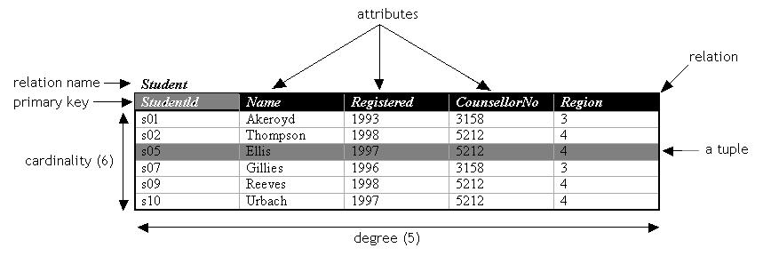

## Properties of relations

* The name of the relation is unique.
* The names of an attribute in unique only within its relation.
* The values of an attribute are all from the same domain.
* The order of attributes within a relation has no significance.
* The order of rows within a relation has no significance.
* The records within a relation should all be distinct.
* Each cell of a relation should contain at most *one value*.

## Keys

*Relational keys* consist of one or a set of attributes used to uniquely identify a row in a relation.

### Super-key

A **super-key** is any attribute (or set of attributes) that uniquely identifies a row. They may contain attributes that are not strictly required for unique identification.

### Candidate key

A candidate key is a super-key where all columns are needed to uniquely identify a row. A candidate key for a relationship has the following properties:

* **Uniqueness**: no two rows of the table can have the same value of the candidate key.
* **Irreducibility**: no subset of the candidate key has the uniqueness property.

To correctly identify a candidate key, we need to be aware of the meanings of the attributes in the real world, and think about whether duplicates could arise for a given choice of key.

### Primary key

A **primary key** is a candidate key that has been chosen to be the default way of identifying a row. If there is no natural attribute suitable as primary key, an **artificial key** can be created instead.

### Foreign key

A foreign key is an attribute, or set of attributes, that uniquely identifies a record of another relation, thus representing a relationship between them.

## Relational integrity

### Entity integrity

In a relation, no attribute of a primary key can be **null**.

### Referential integrity

In a relation, the value of a foreign key must **either exist** as a value of another attribute in a different, or the same, relation **or be null**.

# ER Modelling

## Weak entities

Entities that cannot exist without a parent entity. E.g. movie ---*burned onto*--> **DVD**

## Unary relationships

Entities that have a relationship with entities of the same relation.

## Relationships

…

# SQL

SQL (Structured Query Language) is a declarative language (the logic is described without any control flow) for manipulating a relational database. Commands can be issued to perform the following tasks:

* Creating and managing tables
* Inserting data into tables
* Searching and retrieving data from tables
* Deleting data and tables

MySQL is a dialect of SQL.

## Database engines

MySQL supports different database engines, each designed for different needs.

## Table constraints

Table can have constraints such as **foreign keys** or **default** values.

## MySQL statements

There are a few good practices and rules that should be used with MySQL, and SQL in general, to avoid confusion, or errors, in SQL statements:

* **Keywords** should be written in uppercase to distinguish them from table names, attributes, etc.
* **Strings** must be enclosed in single or double quotes.
* **Database elements** such as tables and fields should be enclosed between grave accents (`).
* **Statements** should be separated by semi-colons.

*Example:*

SELECT `ingredients` FROM `recipes` WHERE `name` = “arancino”;

Grave accents are not always necessary though:

SELECT ingredients FROM recipes WHERE name = “cipollina”;

## Data types

Choosing the data type for a column is something that should be done carefully because of the different sizes they have, the range of their values, and the operations that can be performed on the data they contain.

The following are the data types supported by MySQL 5.7.8. Modifiers can be used to create other datatypes. For instance, specifying the CHAR SET *binary*, CHAR becomes BINARY, VARCHAR becomes VARBINARY, and TEXT becomes BLOB.

### Numeric Type

| **Type** | **Storage** | **Minimum Value** | **Maximum Value** |
| --- | --- | --- | --- |
|  | **(Bytes)** | **(Signed/Unsigned)** | **(Signed/Unsigned)** |
| TINYINT | 1 | -128 | 127 |
|  |  | 0 | 255 |
| SMALLINT | 2 | -32768 | 32767 |
|  |  | 0 | 65535 |
| MEDIUMINT | 3 | -8388608 | 8388607 |
|  |  | 0 | 16777215 |
| INT, INTEGER | 4 | -2147483648 | 2147483647 |
|  |  | 0 | 4294967295 |
| BIGINT | 8 | -9223372036854775808 | 9223372036854775807 |
|  |  | 0 | 18446744073709551615 |

| **Data Type** | **Storage Required** |
| --- | --- |
| FLOAT(*p*) | 4 bytes if 0 <= *p* <= 24, 8 bytes if 25 <= *p* <= 53 |
| [FLOAT](https://dev.mysql.com/doc/refman/5.7/en/floating-point-types.html) | 4 bytes |
| DOUBLE [PRECISION], [REAL](https://dev.mysql.com/doc/refman/5.7/en/floating-point-types.html) | 8 bytes |
| DECIMAL(*M*,*D*), NUMERIC(*M*,*D*) | Varies; see following discussion |
| BIT(*M*) | approximately (*M*+7)/8 bytes |

### Date and Time Type

| **Data Type** | **Storage Required as of MySQL 5.6.4** |
| --- | --- |
| [YEAR](https://dev.mysql.com/doc/refman/5.7/en/year.html) | 1 byte |
| [DATE](https://dev.mysql.com/doc/refman/5.7/en/datetime.html) | 3 bytes |
| [TIME](https://dev.mysql.com/doc/refman/5.7/en/time.html) | 3 bytes + fractional seconds storage |
| [DATETIME](https://dev.mysql.com/doc/refman/5.7/en/datetime.html) | 5 bytes + fractional seconds storage |
| [TIMESTAMP](https://dev.mysql.com/doc/refman/5.7/en/datetime.html) | 4 bytes + fractional seconds storage |

### String Type

In the following table, **M** represents the declared column length in characters for nonbinary string types and bytes for binary string types. **L** represents the actual length in bytes of a given string value.

| **Data Type** | **Storage Required** |
| --- | --- |
| CHAR(*M*) | *M* × *w* bytes, 0 <= *M* <= 255, where *w* is the number of bytes required for the maximum-length character in the character set. See [Section 14.8.1.2, “The Physical Row Structure of an InnoDB Table”](https://dev.mysql.com/doc/refman/5.7/en/innodb-physical-record.html) for information about CHAR data type storage requirements for InnoDB tables. |
| BINARY(*M*) | *M* bytes, 0 <= *M* <= 255 |
| VARCHAR(*M*), VARBINARY(*M*) | *L* + 1 bytes if column values require 0 − 255 bytes, *L* + 2 bytes if values may require more than 255 bytes |
| [TINYBLOB](https://dev.mysql.com/doc/refman/5.7/en/blob.html), [TINYTEXT](https://dev.mysql.com/doc/refman/5.7/en/blob.html) | *L* + 1 bytes, where *L* < 28 |
| [BLOB](https://dev.mysql.com/doc/refman/5.7/en/blob.html), [TEXT](https://dev.mysql.com/doc/refman/5.7/en/blob.html) | *L* + 2 bytes, where *L* < 216 |
| [MEDIUMBLOB](https://dev.mysql.com/doc/refman/5.7/en/blob.html), [MEDIUMTEXT](https://dev.mysql.com/doc/refman/5.7/en/blob.html) | *L* + 3 bytes, where *L* < 224 |
| [LONGBLOB](https://dev.mysql.com/doc/refman/5.7/en/blob.html), [LONGTEXT](https://dev.mysql.com/doc/refman/5.7/en/blob.html) | *L* + 4 bytes, where *L* < 232 |
| ENUM('*value1*','*value2*',...) | 1 or 2 bytes, depending on the number of enumeration values (65,535 values maximum) |
| SET('*value1*','*value2*',...) | 1, 2, 3, 4, or 8 bytes, depending on the number of set members (64 members maximum) |

# Relational algebra

Relational algebra is the theoretical basis for programming languages like SQL. It contains operators that define operations on one or more relations, and allow to create new relations from the given ones.

The main five operators in Relational Algebra are:

* **Selection**
* **Projection**
* **Union** (or addition)
* **Difference**
* **Product**

Other derived operators are the combination of the fundamental operators:

* **Join**
* Intersection
* Division

## Projection

R1 := πL (R2)

* L is a list of attributes from the schema of R2.

R1 is constructed by looking at each tuple of R2, extracting the attributes on list L, in the order specified, and creating from those components a tuple for R1.

* Eliminate duplicate tuples, if any.

SQL clause: **SELECT DISTINCT**.

## Selection

R1 := σC (R2)

* C is a condition (as in “if” statements) that refers to attributes of R2.
* R1 is all those tuples of R2 that satisfy C.

SQL clause: **WHERE**.

## Product

R3 := R1 x R2

* Pair each tuple t1 of R1 with each tuple t2 of R2.
* Concatenation t1t2 is a tuple of R3.
* Schema of R3 is the attributes of R1 and then R2, in order.
* But beware of attributes with same names: use the relation name as a prefix for the attributes.

## Joins

Joins are a sequence of operations combined to produce a sensible result. There are different types of joins, such as natural join, equi-join, outer join, etc.

### Theta-join

R3 := R1 ⋈c R2

1. Take the **product** R1 x R2.
2. Apply **σC**to the result.

The condition can be any boolean-valued condition.

### Natural join

R3 := R1 ⋈ R2

The natural join operator is a combination of product, selection, and project where the result is the set of all combinations of tuples in R1 and R2 that are equal on their common attributes.

1. Take the **product** of R1 x R2.
2. Apply **σC**to the result so that only the equal values on the common attributes are taken.
3. Finally, apply **πL**so that each common attribute appears only once in the final result.

## Union, intersection, and difference

When using union, intersection, or difference operators, both operands must have the same relation schema, meaning that both relations must have the same degree and attributes must have the same name.

Compatibility problems may be solved by projecting the necessary attributes first.

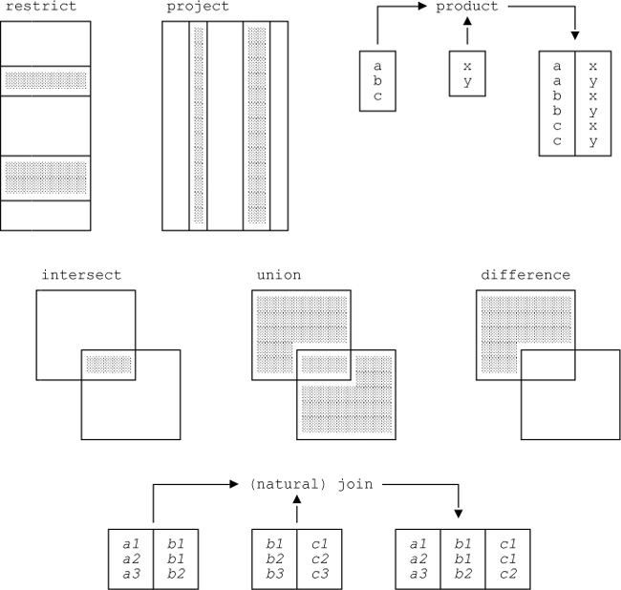

*Image by Vittorio Iocoland*

# Normalisation

# Backup and concurrency

A DBMS must ensure that the underlying database is **reliable** and remains in a **consistent** state. Both properties must be maintained also in case of hardware or software failures.

Since DBMS often allow users to perform simultaneous operations on the data, **concurrency** must be handled appropriately. Furthermore, **recovery control** is required to protect it from inconsistencies and data loss.

## Transactions

A transaction is an action, or a series of actions, carried out by a single user or an application which accesses or changes the content(s) of a database. If a transaction is completed, it is **committed** and the database reaches a new consistent state. If the transaction does not execute successfully, it is **aborted** and the database must be brought back to a consistent state through a **roll-back**.

## Properties of transactions

All transaction should possess four basic so-called **ACID** properties:

* **Atomicity**

A transaction is an indivisible number of operations performed entirely or not performed at all.

* **Consistency**

A transaction transforms the database from a consistency state into another.

* **Isolation**

Transactions execute independently of one another. Partial effects of an incomplete transaction should not be visible to other transactions, but they should be seen as executed one after another.

* **Durability**

Once has transaction has been committed, its effects should not be lost in the event of any error.

## Keywords

A DBMS has no way of knowing which updates are grouped together to form a single, logical transaction. Therefore, the user must be provided with a way to indicate the boundaries of each transaction. For example, there may be keywords such as **BEGIN_TRANSACTION**, **COMMIT**, and **ROLLBACK** to delimit a transaction. If such delimiters are not used, the whole program is usually treated as a single transaction with the DBMS automatically performing a COMMIT upon successful termination, or ROLLBACK if not.

## Database architecture

The **transaction manager** coordinates transactions on behalf of application programs. It communicates with the scheduler, which implements a particular strategy for concurrency control. The **scheduler** tries to maximise concurrency without allowing transactions to interfere with one another.

If failure occurs during a transaction, the **recovery manager** ensures that the database is restored to the state it was in before the start of the transaction. The **buffer manager** is responsible for the transfer of data between disk storage and main memory.

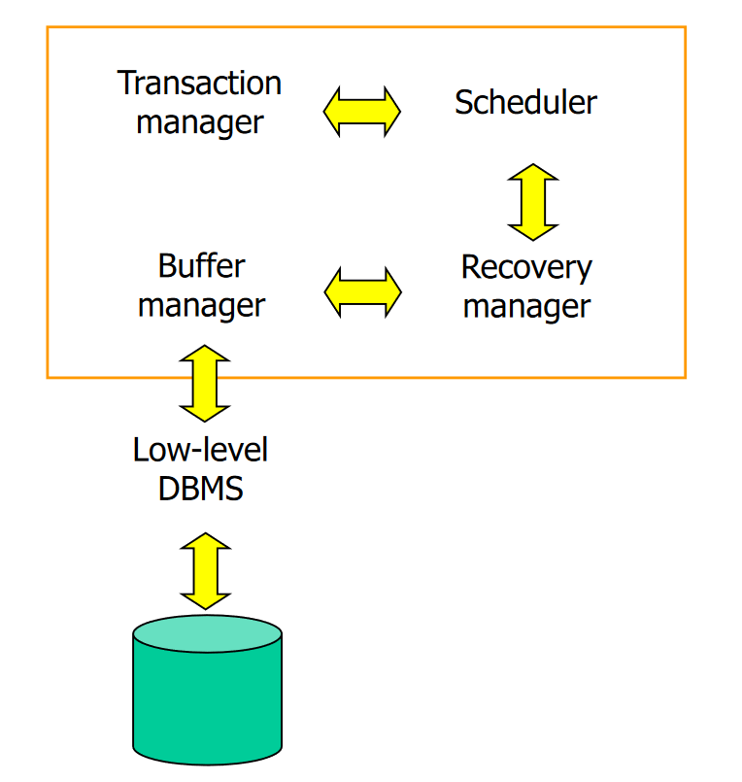

## Concurrency control

**Concurrency control** is the process of managing simultaneous operations on the database without having them interfere with each other. When one or more users are updating some data, the database must handle the transactions so that each one works on a consistent state of the database. This is insured by using either a **read or a write lock**.

* **Read Lock** ─ *Shared* lock that prevents other transaction to write.
* **Write Lock** ─ *Exclusive* lock that prevents other transaction to read and write.

Using locks in the wrong way can lead to **dead locks**, which are situations where two or more transactions wait for one another without being able to release the locks, thus interfering with the database functioning. To solve this problem, locks should be requested when the transaction is started (**growing phase**) and removed when the transaction is concluded (**shrinking phase**).

**Two-phase locking** protocol is used to prevent deadlocks using two simple rules:

* A transaction must acquire a lock on an item before operating on it.
* Once the transaction release the lock, it cannot acquire new locks.

However, this protocol introduces new problems such as **cascading rollbacks:**

* 2PL allows locks to be released before the final commit or rollback of a transaction.
* During this time, another transaction may acquire the locks released by the first transaction, and operate on the results of the first transaction.
* If the first transaction subsequently aborts, the second transaction must abort since it has used data now being rolled back by the first transaction.

This problem can be avoided by preventing the release of locks until the final commit or abort action.

## Recovery

**Recovery Control** is the process of restoring the database to a consistent state in case of failure. During this process, the DBMS must ensure that all the ACID properties are still valid.

There are two main effects of a database fault:

* The loss of main memory, including database buffers.
* The loss of disk copy of the database.

DBMS usually provides the following tools to perform an emergency recovery:

* **Backup mechanism**: make periodic backups of the database.
* **Logging facilities**: keep track of the current state of transaction.
* **Checkpoint facilities**: enable in-progress updates to be made permanent.
* **Recovery manager**: restores the system to a consistent state after a failure.4

Logs primarily contain **transaction records** which contain:

* The transaction identifier
* The record type (transaction start, insert, update, delete, abort, commit)
* The identity of the affected data (for insert, update, and delete)
* **Before-image** (the value before it’s been updated)
* **After-image** (the value after it’s been updated)
* Log information

**Checkpoints** are points of synchronization between the database on disk and the transactions log file. At the time of a checkpoint, all buffers are force-written onto the disk.

When a crash occurs, the recovery manager examines the log file for the last checkpoint recorded:

* All **transactions** that have **committed** since the last checkpoint (after) are **redone**.
* Any **active transaction** at the time of the crash is **undone**.

**Deferred updates**, in contrast to *immediate updates*, only makes a transaction persistent after it has been committed, thus – if a transaction (deferred) fails before committing – it will not have modified the database.

Log:

When **immediate updates** transactions are performed, in the event of a crash, it may be necessary to undo any changes if the transaction will have reached a checkpoint without committing.

Log: transacting that have both started and committed, are **redone** using the **after-image**, while transacting that have been started, but not committed, are **undone** using the **before-image**.

Changes have to be undone when using immediate mode using the after-image. In any case, they have to be redone with the after-image when the commit is done after the checkpoint.