# 1 Methods

## 1.1 Study area and data collection

The data was collected in three different ecosystems in southern Brazil (Fig. 1.1): south-western Cerrado (savannah, control environment), Pantanal (wetland, agricultural environment), and western Mata Atlântica (forest, degraded environment).

*Add details on climate and land use?*

Animals were tracked using VHF tracking (all three regions) and GPS tracking (Pantanal and Cerrado). *Add details on capturing and tracking devices*

A total of 74 tapirs were tracked starting in July of 1997 until October of 2019, with the majority of the data being in the Pantanal (46), while 17 and 11 were from the Cerrado and Mata Atlântica regions, respectively.

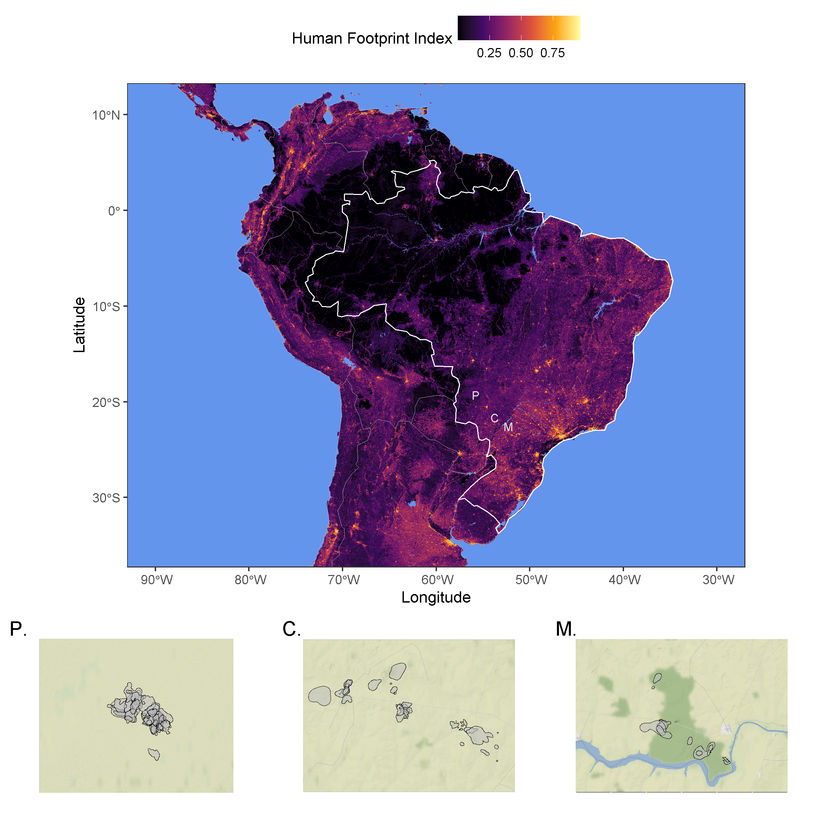

Figure 1.1: Location of the tree study sites (Pantanal, Cerrado, Mata Atlântica) over a raster of Human Footprint Index, which is a measure of anthropogenic alteration of an ecosystem.

## 1.2 Data analysis

All statistical analysis and plotting were performed using R (version 4.0.5, R Core Team 2021) using packages ctmm (version 0.6.1, “Ctmm: Continuous-Time Movement Modeling,” n.d.), mgcv (version 1.8-36, Wood 2017), ggplot2 (version , Wickham 2016) ggmap (version , Kahle and Wickham 2013). The furrr package (version 0.2.2, Vaughan and Dancho 2021) was used for parallel computation on Windows machines. All R code can be found in the GitHub repository at <https://github.com/StefanoMezzini/tapirs>.

Before analysis, outliers were removed if they appeared to be unreliable due to large measurement errors after accounting for measurement uncertainty and following the methods detailed in the ctmm package (“Ctmm: Continuous-Time Movement Modeling,” n.d.). Location estimates from GPS tracking were calibrated using a unitless Horizontal Dilution of Precision (HDOP), which estimated the accuracy of each positional fix. We then estimated an equivalent range error with the HDOP values from 883 and 174 measurements from tags in fixed locations in the Pantanal and Cerrado, respectively (C. H. Fleming et al. 2020). Data points were then considered as outliers (and removed) if they had a large (error-informed) distance from the median location and the minimum speed required to explain the displacement was unusually high (m/s). The Mata Atlântica dataset contained a total of 4 082 observations, 8 of which were removed as outliers; and the Pantanal dataset contained 139 138 observations, 914 of which were removed; while the Cerrado dataset contained 90 402 observations, 193 of which were removed. *(no speed outliers found when I (Stefano) was cleaning the datasets, but 1105 outliers had already been removed)*

The best Continuous-Time Movement Model (CTMM) for each animal was then chosen using the ctmm.select function from the ctmm package, which fits a series of CTMMs using perturbative Hybrid Residual Maximum Likelihood (pHREML, Christen H. Fleming et al. (2019)) and chooses the best model using small-sample-sized corrected Akaike’s Information Criterion (AICc).

Using each of the best models, we then estimated each animal’s home range (HR) area, range crossing time, directional persistence, and average daily speed. The models used here are insensitive to sampling frequency (Noonan et al. (2019)) and they account for spatio-temporal autocorrelation in the data (when possible), so they are robust to irregular or frequent sampling frequency, HR underestimation, and significance inflation.

The HR of each tapir was estimated as the area within the 95% isopleth of the Utilization Distribution using Autocorrelated Kernel Density Estimation (AKDE) obtained from the CTMM (C. H. Fleming et al. (2015)).

To test whether environmental modification significantly altered the animals’ behavior, the HR sizes and average daily speeds were regressed against their HR’s average human footprint index using Generalized Linear Models (GLMs) with a Gamma distribution and a log link for the response. The Gamma distribution allows for more accurate significance testing, while the log link scale allows HFI to have a multiplicative effect on the response. The GLMs were fit using the mgcv package (Wood 2017), and Restricted Maximum Likelihood (REML).

# 2 Results

*change values to more appropriate estimates; currently using mean +/- 1.96 sd/sqrt(n)*

The mean home range size across all monitored tapirs was 5.82 km (95% CI: 4.71 - 7.12 km), ranging between 1 km and 29.7 km (Fig. 2.1a). Tapirs had HR crossing times of 0.72 days on average (95% CI: 0.35 - 1.10), ranging from 0.05 to 12.8 days (Fig. 2.1b), and a mean velocity autocorrelation timescale of 0.44 hours (95% CI: 0.39 - 0.49), ranging from 0.17 to 1.88 hours (Fig. 2.1c). We estimated that tapirs had mean movement speeds of 11.2 km/day (95% CI: 10.2 - 12.1), ranging from 1.51 to 25.96 km/day (Fig. 2.1d).

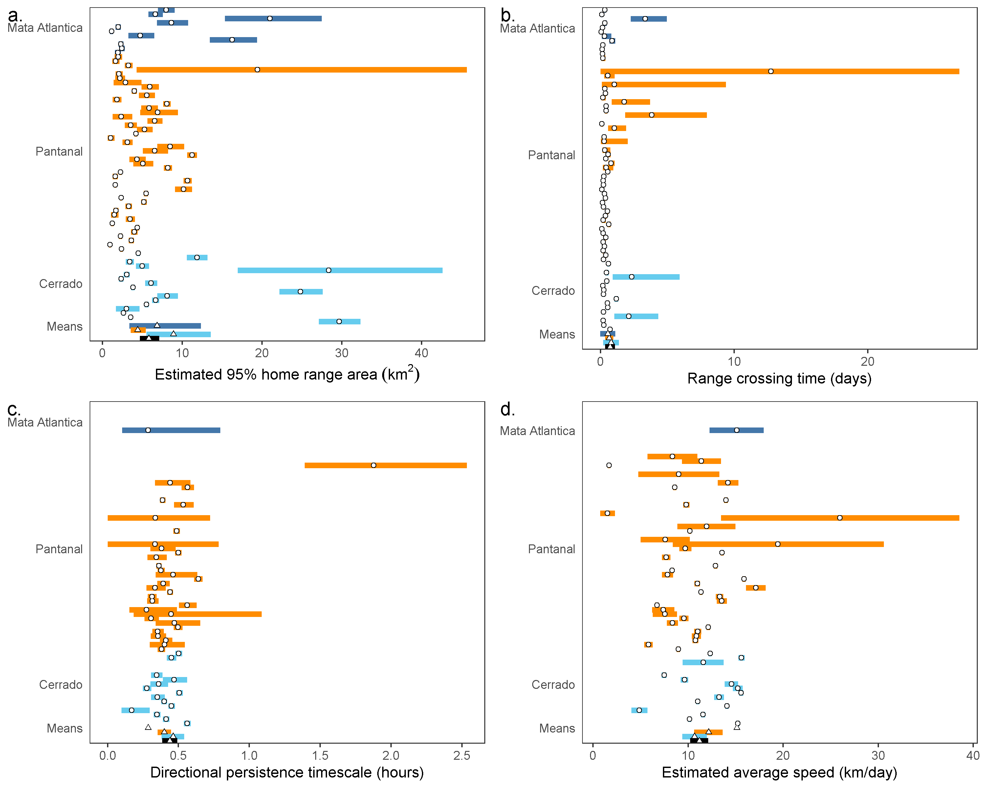

Figure 2.1: Parameter estimates from each tapir’s movement model (circles) and group means (triangles), with 95% confidence intervals. Individuals with a movement model that does not allow for inferences in movement speed are left blank.

HFI had a negative effect on both HR size and average daily speed, but the effect was not significant for HR (p-value = 0.90), nor daily speed (p-value = 0.53). A tapir living in a pristine environment (HFI = 0.004) was estimated to have a home range of 7.79 km and an average speed of 13.19 km/day, while a tapir from the most altered habitat (HFI = 0.31) had an estimated home range area of 6.93 km and an average speed of 10.43 km/day.

# References

“Ctmm: Continuous-Time Movement Modeling.” n.d. <https://github.com/ctmm-initiative/ctmm, https://groups.google.com/g/ctmm-user>.

Fleming, C. H., J. Drescher-Lehman, M. J. Noonan, T. S. B. Akre, D. J. Brown, M. M. Cochrane, N. Dejid, et al. 2020. “A Comprehensive Framework for Handling Location Error in Animal Tracking Data*.” Preprint. Ecology. <https://doi.org/10.1101/2020.06.12.130195>.

Fleming, C. H., W. F. Fagan, T. Mueller, K. A. Olson, P. Leimgruber, and J. M. Calabrese. 2015. “Rigorous Home Range Estimation with Movement Data: A New Autocorrelated Kernel Density Estimator.” *Ecology* 96 (5): 1182–88. <https://doi.org/10.1890/14-2010.1>.

Fleming, Christen H., Michael J. Noonan, Emilia Patricia Medici, and Justin M. Calabrese. 2019. “Overcoming the Challenge of Small Effective Sample Sizes in Home‐range Estimation.” Edited by Jason Matthiopoulos. *Methods in Ecology and Evolution* 10 (10): 1679–89. <https://doi.org/10.1111/2041-210X.13270>.

Kahle, David, and Hadley Wickham. 2013. “Ggmap: Spatial Visualization with Ggplot2.” *The R Journal* 5 (1): 144. <https://doi.org/10.32614/RJ-2013-014>.

Noonan, Michael J., Christen H. Fleming, Thomas S. Akre, Jonathan Drescher-Lehman, Eliezer Gurarie, Autumn-Lynn Harrison, Roland Kays, and Justin M. Calabrese. 2019. “Scale-Insensitive Estimation of Speed and Distance Traveled from Animal Tracking Data.” *Movement Ecology* 7 (1): 35. <https://doi.org/10.1186/s40462-019-0177-1>.

R Core Team. 2021. *R: A Language and Environment for Statistical Computing*. Vienna, Austria: R Foundation for Statistical Computing. <https://www.R-project.org/>.

Vaughan, Davis, and Matt Dancho. 2021. “Furrr: Apply Mapping Functions in Parallel Using Futures.” <https://CRAN.R-project.org/package=furrr>.

Wickham, Hadley. 2016. *Ggplot2: Elegant Graphics for Data Analysis*. Springer-Verlag New York. <https://ggplot2.tidyverse.org>.

Wood, S. N. 2017. *Generalized Additive Models: An Introduction with R*. 2nd ed. Chapman; Hall/CRC.