Results

Considering Europe as a whole by averaging across all countries, we found trends in the form of increases in polarization for almost all metrics and variables. Especially visible for the timeframe around 2015, We found increase in average deviation from neutrality, increase in dispersion, increase in the explained variance of the first principal component, increase in moderate divergence and thus a corresponding decrease in moderate group consensus, a strongly decreasing moderate size parity, and a very clear upward trend in non-neutrality. Paired with those findings, we found a tendency for an increase of the mean opinions towards a more slightly approving sentiment (Fig 3.xx).

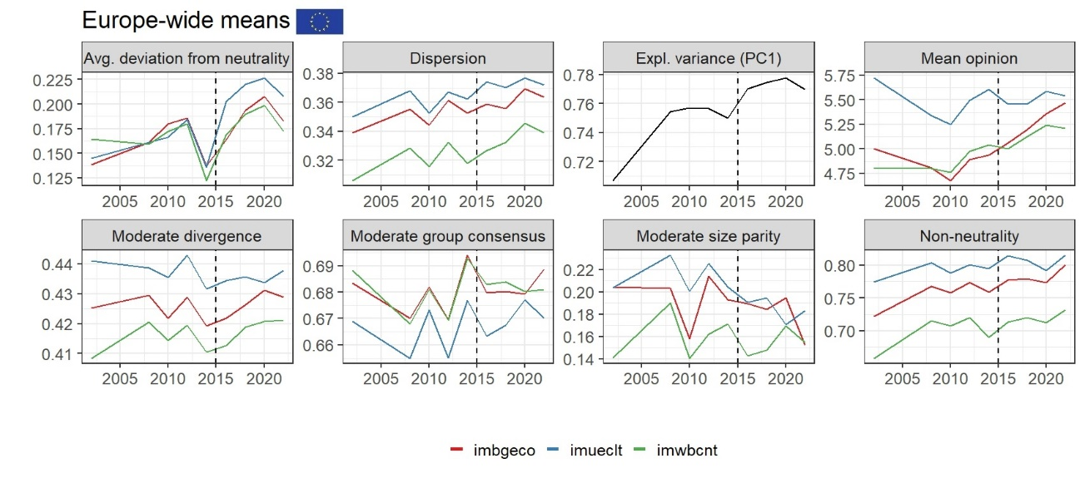

**Fig 3.xxx** The seven aspects of polarization and the mean opinion over time on the European continental level averaged across all available countries between 2002 and 2022. Avg. deviation from neutrality: Shows the average extent to which opinions deviate from a neutral stance, i.e., an increase of acceptance **or** rejection. Higher values suggest stronger opinions, indicating increasing polarization. The trends for the three variables seem to show a general increase in deviation from neutrality, suggesting that opinions on immigration have become less neutral and more shifted towards the extremes, particularly after 2015. **Dispersion:** Measures the deviation from the average opinion. Higher dispersion indicates a shift towards a more extreme opinion (in both directions), and can thus be a sign of polarization. The trends here show an upward tendency, again implying that the range of opinions on immigration has shifted towards the extreme ends. This is again especially visible after 2015. **Expl. variance (PC1):** Refers to the explained variance of the first principal component of the PCA based on the three migration variables. A higher value suggests that a single underlying dimension (the general sentiment towards immigration) explains a larger proportion of the variance in opinions. The upward trend in this graph suggests that opinions on immigration have become increasingly structured, indicating an increase in polarization in the form of issue alignment. Mean opinion: Shows the average opinion for each variable on the original Likert-scale. Small values indicate resentment, five indicates a neutral stance, and large values indicate approval. All three variables a tendency to increase in mean opinion towards the later part of the observed period. The period around 2010 seems to be a turning point for all three variables, with opinions generally starting improve towards a mildly positive stance after that year. M**oderate divergence:** Captures the extent to which the average views of the moderately accepting and moderately opposing individuals diverge. The trends are somewhat fluctuating, but there appears to be an overall increase in moderate divergence, indicating an increase in polarization between the two moderate groups, again more visibly after 2015. **Moderate group consensus:** Assesses the level of agreement within the two moderate groups. Over the years, the values have been fluctuating, but again, results show see a decrease in consensus right after 2015, indicating an increase in opinion polarization. Moderate size parity: Captures the ratio of the smaller to the larger group holding moderate opinions. Here, results are fluctuating, but a decrease in group size parity is visible for "imbgeco" and "imueclt" after 2015, again indicating an increase in polarization around that time. **Non-neutrality: M**easures the prevalence of non-neutral opinions. Higher values indicate a larger proportion of the population holding either positive or negative views on immigration. All three variables show a clear upward trend, especially after 2015, strongly suggesting a significant increase in the proportion of Europeans holding non-neutral opinions on immigration.

While the aggregated European data provided a valuable overview assessment, significant intra-European variation necessitated a more focused analysis. This section addressed this by examining immigration opinions in Hungary and Germany - two countries that may represent contrasting positions along the spectrum of public sentiment. This focused comparison allowed for the exploration of distinct socio-political contexts that potentially contribute to more polarized or differentiated viewpoints, revealing critical insights obscured by broader averages.

Germany

Similar to the Europe-wide results, the polarization metrics focussed on Germany show the year 2015 to have been a crucial turning point in regards to immigration opinions. The average deviation from neutrality increased for economic considerations, and decreased for overall and cultural variables. Dispersion increased, indicating a greater diversity of views. The explained variance of the first principal component increased, indicating that opinions on different variables of immigration became more aligned in a process otherwise known as issue alignment. The mean opinion decreased for cultural and general views, but again increased for economic considerations. Moderate divergence increased, and thus moderate group consensus decreased, indicating greater polarization even among those not holding extreme views. Moderate size parity increased, suggesting polarization for all three variables. Lastly, non-neutrality clearly increased (Fig. 3.xx).

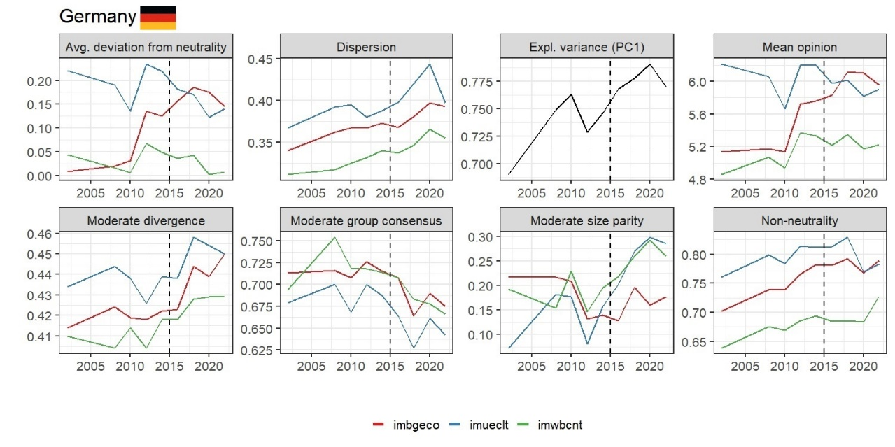

**Fig 3.xx** The seven aspects of polarization and the average opinion over time for Germany. Avg. deviation from neutrality: Shows how far, on average, opinions deviate from the neutral point. For “imueclt”, and “imwbcnt”, the average deviation from neutrality kept on decreasing after 2015, whereas “imbgeco” increased, suggesting that economic considerations became more important and a polarizing factor following at that point. Dispersion: Measures the deviation from the average opinion. Higher dispersion indicates a shift towards a more extreme opinion (in both directions), and can thus be a sign of polarization. For all three variables, the dispersion generally increases after 2015, indicating a greater diversity of opinions about immigration around that time. Expl. variance (PC1): Represents the amount of variance in the combined data of the three immigration variables that is explained by the first principal component of a PCA. A higher explained variance suggests that the opinions on these three variables tend to move together. The plot shows a general increase in explained variance of PC1 after 2015. This suggests that during that period, opinions on whether immigration is good for the economy, enriches culture, or makes the country a better place became more aligned, which is a process known as issue alignment. Mean opinion: Shows the average opinion on the original Likert scale. For “imueclt” and “imwbcnt”, the mean opinions decreased after 2015, indicating a shift towards more negative views on the cultural and overall impact of immigration at that point, whereas “imbgeco” increased, indicating an increasing believe that immigrants might boost the economy. Moderate divergence: Measures the difference in average opinion between those moderately accepting and those moderately opposing immigration. An increase indicates greater polarization between these moderate groups. The plot shows a clear increase in moderate divergence for all three variables after 2015, signifying that the gap between moderately accepting and moderately opposing individuals widened considerably following that year. Moderate group consensus: Measures the agreement within the moderately accepting and moderately opposing groups. For all three variables, there's a general decrease in moderate group consensus after 2015. This suggests that within both the moderately accepting and moderately opposing groups, opinions became more varied somewhere around that time. Moderate size parity: The ratio of the smaller to the larger moderate group. The plot shows that the parity increased after 2015 for all three variables. This suggests that the size of the two moderate groups became more equal in size, indicating an increase in polarization among the members of the moderate groups during that period. Non-neutrality: This shows the proportion of individuals holding non-neutral views. For all three variables, there is a weak increase in non-neutrality after 2015, suggesting a shift towards both more extreme ends of the opinion spectrum at that point.

Hungary

Considering Hungary, results strongly suggest that the period around 2015 was a critical turning point for public opinion on immigration. Before this time, average opinions tended to be slightly positive to neutral. The timeframe around 2015 appears to have triggered a significant shift: Average opinions turned sharply negative across all three dimensions (economic, cultural, and general impact). Opinions became more polarized, with individuals holding stronger views, both positive and negative, leading to higher average deviation from neutrality and increased dispersion. Views on the different variables of immigration became more aligned, as indicated by the increasing explained variance of the first principal component. Additionally, we found a growing divergence between moderate groups: The gap between those with moderately accepting and moderately opposing views widened. Also, the relative size of the moderately opposing group appears to have increased. Opinions became more extreme, with a larger proportion of the population holding non-neutral views, indicating polarization. In summary, the refugee crisis seems to have acted as a polarizing event in Hungary, leading to more negative, less neutral, and more divergent opinions on the various facets of immigration (Fig. 3.xxx).

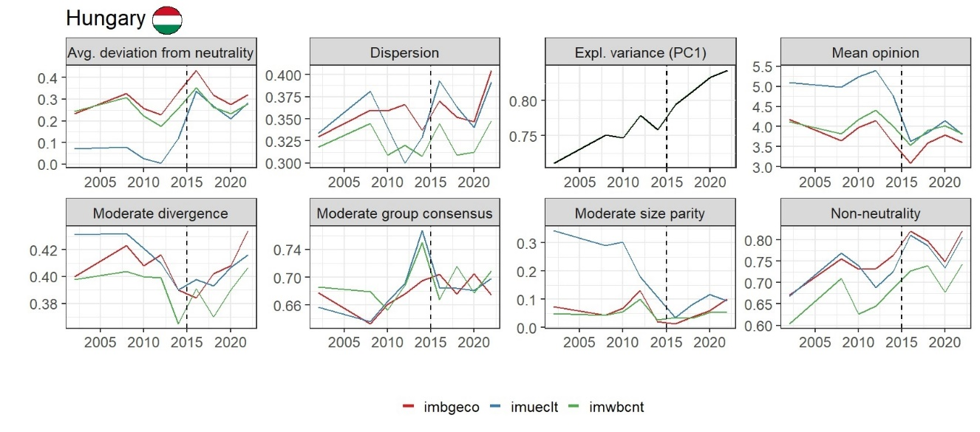

**Fig 3.xxx** The seven aspects of polarization and the average opinion over time for Hungary. Avg. deviation from neutrality: Shows how far, on average, opinions are from the neutral midpoint. Results indicate a general trend of increasing deviation from neutrality across all three variables after 2015. This suggests that opinions became less neutral and more strongly held in either the positive or negative direction around that time. Dispersion: Measures the deviation from the average opinion. The plot shows a spike of increasing dispersion levels after 2015 for all three variables, suggesting an average shift towards more extreme opinions in both directions during that period. Expl. variance (PC1): The explained variance of the first principal component from a PCA combining the three immigration variables shows a clear upward trend, especially after 2015. This suggests that a single underlying dimension - the general attitude towards immigration - became increasingly dominant in explaining the variation in opinions across the three measured variables. Opinions on the economic, cultural, and societal impacts of immigration became more aligned during that timeframe. Mean opinion: This displays the average opinion. For all three variables, the mean opinion generally decreases after 2015, indicating a shift towards more negative average perceptions of immigration. Moderate divergence: This measures the gap between the average opinions of moderately accepting and moderately opposing groups. Results show an increase in moderate divergence after 2015 for all three variables after ten years of decrease, suggesting that the views of those with somewhat positive and somewhat negative initial stances on immigration drifted further apart at that time. Moderate group consensus: This shows the internal agreement within the moderately accepting and moderately opposing groups. The plot shows varying trends, but there isn't a clear consistent pattern of increasing or decreasing consensus within these moderate groups across all three variables after 2015. Moderate size parity: This is the ratio of the smaller to the larger moderate group. The plot shows an increase in moderate size parity around and after 2015. This suggests that the size of the two moderate groups became more equal in size, indicating an increase in polarization among the members of the moderate groups during that period. Non-neutrality: This represents the proportion of individuals holding non-neutral views. There's a clear increase in non-neutrality across all three variables after 2015, indicating that more people moved away from a neutral stance and adopted a more definite positive or negative opinion on immigration at that time.

Europe vs. Hungary vs. Germany

For both the European averages and the Germany and Hungary individually, we found 2015 to be a turning point in immigration opinion dynamics. Treating the European averages as an overall central point of reference makes it easier to spot differences and deviations on the country-levels of Germany and Hungary. Comparing the Europe-wide results, starting at 2015, we found several similarities, but also striking differences.

Across Europe, we see an increase in average deviation from neutrality for all three variables, which is the same for Hungary. However, for Germany, we only see an increase in “imbgeco”, whereas the other two variables show a decreasing trend. This indicates that among German citizens, economic considerations are more divisive than cultural or general life-quality related ones. Considering dispersion, we see increasing trends in dispersion both across Europe as a whole and individually in Germany and Hungary. This indicates that patterns of increasing individual deviation from the average attitude probably don’t come from a few individual countries, but can be found all across Europe.

Similar to the dispersion metric, we see an increase in the proportion of explained variance of the first principal component across Europe as a whole, but also on the country-level in Germany and Hungary. This suggests that we see issue alignment not only on the continental level, but also in individual countries.

Looking at the moderate groups (individuals who either voted with 1 to 4, making them “moderate acceptors” or with 6 – 9, making them “moderate opponents” in the ESS surveys), we see an increase in moderate divergence both in the European averages, but also individually in Germany and Hungary. This reveals how the gap between the average views of moderately accepting and moderately opposing individuals is continuously widening, leading to more polarized positions. Considering the moderate group consensus, we find for the European averages that “imbgeco” and “imwbcnt” did not significantly change in the years after 2015 (the previously identified turning point), whereas “imueclt” visibly increased. This means that overall, in Europe, the distribution of opinions regarding economic and overall life-quality did not substantially change, whereas the in-group consensus about the cultural impact of immigrants has been increasing among the moderate groups. In contrast to this, we see that in Germany, the moderate consensus dropped for all three variables. This demonstrates how in Germany specifically, there seems to be an ongoing heterogenization of opinions among the moderate groups with regards to economic, cultural, and overall life-quality impacts of immigration. Compared to the European average and Germany, we see strongly fluctuating patterns of moderate consensus for “imbgeco” and “imwbcnt” in Hungary, indicating a certain instability of short-lived phases of consent and dissent after 2015.

Regarding the moderate size parity, for the European averages, we see a decrease from 0.20 to 0.16 for “imbgeco” and “imueclt”, whereas “imwbcnt” did not change substantially. This indicates a trend of decreasing moderate size parity, signalling a growing imbalance in the number of people holding moderately accepting versus moderately opposing views on immigration. This actually means a decrease in polarization among moderate voters, as with moderate size parity, maximum polarization occurs when both groups are equal in size.

Focussed on Germany, we find increases of moderate size parity for all three variables. “imueclt” and “imwbcnt” went up from 0.20 to 0.30 from 2015 to 2020, while “imbgeco” went up from 0.15 to 0.18. This indicates strong increases in polarization in regards to cultural and overall life-quality impacts and a weaker, yet substantial, increase in polarization with regards to economical impacts of immigration among moderate voters in Germany.

In Hungary, we find weaker increases for “imbgeco” and “imueclt” from 0.05 to 0.1, indicating a slight increase in polarization among moderate voters with regards to economic and cultural considerations of immigration. However, it should be noted that the initial moderate size parity values in 2015 were much smaller in Hungary (0.05) in comparison to Germany (0.20) and Europe overall (0.20). This means that in Hungary, the moderate size groups were much more imbalanced in 2015 as compared to Germany and Europe overall.

Looking at non-neutrality, perhaps the simplest metric, we see increases in the European averages, Germany, and Hungary. This indicates an overall trend of deviation from the neutral “5” on throughout Europe. It should be noted though, that the non-neutrality values for Europe overall, but also for Germany and Hungary, were quite high to begin with, ranging from 0.70 to 0.80 in 2015.

Finally, comparing the average opinion value, we see increases in all three variables across Europe, indicating a trend of a general pro-immigrant attitude.

Focussed on Germany, we see a positive trend for “imbgeco”, a decreasing trend for “imueclt”, and no visible trend for “imwbcnt”. This indicates that in Germany, there is a growing body of people who think that immigrants might be good for the economy, yet, at the same time, there is a body of people who believe that immigrants might negatively impact the cultural life.

In quite the contrast to the generally pro-immigrant picture of Europe as a whole and the multi-faceted picture of Germany, we see a stark decrease in opinions regarding all three opinion variables in Hungary. This indicates a trend of an overall resentment towards immigration in Hungary.

[HEATMAP?]