

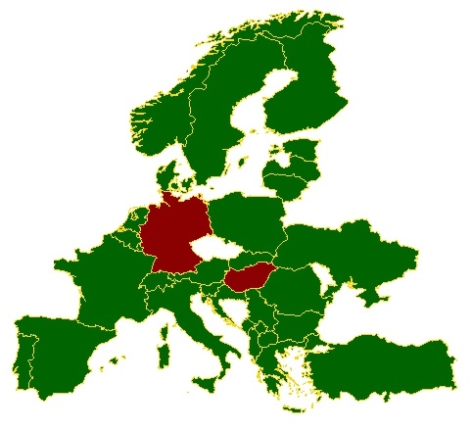Measuring the Divide: A Multi-Metric Comparison of Opinion Polarization in Europe, Germany, and Hungary.

Msc in Data Science for Society and Business

School of Business, Social & Decision Sciences

Stefano Giuliano Pinto

Matr.-No: 30007575

20th of May 2025

1st Supervisor: Prof. Dr. Jan Lorenz

2nd Supervisor: Dr. Mandi Larsen

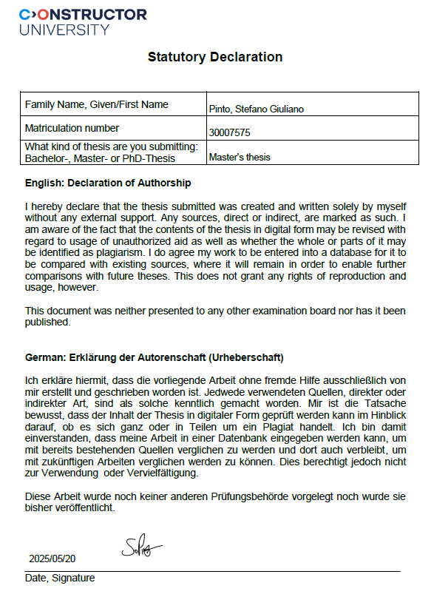

**Acknowledgements**

I would like to express my sincere gratitude to Prof. Dr. Jan Lorenz and Dr. Mandi Larsen for their invaluable contributions to my academic journey over the past two years. Their exceptional teaching, insightful advice, and dedicated service as reviewers for this thesis, including their coordination efforts, have been instrumental in my development and in the successful completion of this work.

**Contents**

**Abstract** 1

**1** **Introduction** 2

**2** **Methods** 5

2.1 ESS data 5

2.2 Software and packages 6

2.3 Polarization metrics 7

2.3.1 Non-neutrality 7

2.3.2 Average deviation from neutrality 8

2.3.3 Dispersion 8

2.3.4 Moderate divergence 9

2.3.5 Moderate group consensus 10

2.3.6 Moderate size parity 11

2.3.7 Explained variance of the first principal component 11

2.3.8 Average opinion 13

2.4 Web app for data exploration 14

**3** **Results** 17

3.1 Europe 17

3.2 Germany 19

3.3 Hungary 21

3.4 Europe vs. Hungary vs. Germany 23

**4** **Discussion** 26

4.1 Interpretation of results 26

4.2 Limitations 32

4.3 Future prospects 33

**5** **References** 34

**6** **Appendix** 44

# **Abstract**

This thesis investigates opinion polarization concerning immigration in Europe. It addresses the question of increasing polarization across the continent using longitudinal data from the European Social Survey (ESS) and an exploratory web application. Seven polarization metrics are employed, including a novel measure derived from Principal Component Analysis that incorporates Likert-scale values. A comparative analysis contrasts European averages with Germany and Hungary. The 2015 refugee crisis is identified as a key factor influencing polarization trends, with findings indicating increased polarization across nearly all metrics post-2015. Novel insights from this study reveal the role of economic factors in shaping immigration opinion polarization in Germany and highlight significant fluctuations in polarization levels within Hungary, challenging previously established knowledge.

**Keywords**: Computational Social Science, Immigration Opinion Polarization, European Social Survey (ESS), Germany, Hungary, Refugee Crisis, R, Shiny

# **Introduction**

The global number of international migrants has grown significantly, from 75 million in 1965 to around 272 million in 2019 (World Migration Report, 2020). Europe has emerged as one of the primary global destinations (Haas et al., 2019). Economic inequality, demographic pressures, and environmental crises are just some of the drivers of migration (Richmond, 2002). In Europe, opinions about immigration are heterogeneous. In Western Europe, short-term increases in immigration can lead to more negative attitudes, particularly when immigrants are from non-EU countries. However, regions with a higher share of foreign-born populations tend to be less anti-immigrant (Dražanová & Gonnot, 2023). Differences between countries often reflect economic conditions, for example the severity of a current recession (Hatton, 2016).

In the context of opinion dynamics, polarization refers to the divergence of attitudes within a society, often leading to the formation of distinct and opposing groups (Williams, 2018). In the context of immigration, polarization can manifest as stark differences or subtle distinctions in attitudes towards migrants, ranging from acceptance and support to scepticism and opposition. In the academic literature, several definitions of political or attitudinal polarization exist. For example, social psychology provides the concept of group polarization, which is a phenomenon where “members of a deliberating group move toward a more extreme point in whatever direction is indicated by the members’ predeliberation tendency” (Sunstein, 2003). In politics, polarization describes a phenomenon of accentuated differences in larger groups or societies. Political scientists distinguish between elite and mass polarization. Whereas elite polarization looks at the polarization of parties or elected officials (Druckman et al., 2013), mass polarization refers to polarization of the general public (although the pertinent literature disagrees on the exact definition of the concept, Silva, 2018). Another distinction is made between affective polarization and opinion polarization (sometimes called attitude polarization). Affective polarization refers to “a tendency among party supporters (partisans) to view other party/parties as a disliked outgroup(s) while holding positive ingroup feelings for one’s own party” (Reiljan, 2020). Opinion polarization looks at the “distributional properties of public opinion” (DiMaggio et al, 1996) regarding certain socio-political topics. This thesis investigated opinion polarization on three migration-related issues. Researchers investigating opinion dynamics have been employing a diverse array of quantitative methodologies. This methodological pluralism encompasses various survey designs, scaling techniques, and statistical modelling approaches, each with its own strengths and limitations. Examples include approaches using nonlinear modelling (Amelkin, Bullo & Singh, 2017), correlational studies (Nordio et al., 2019), Boltzmann equations originating from kinetic theory (Düring & Wolfram, 2015), stochastic modelling (Acemoglu et al., 2010), and more. While this variety allows for the exploration of the topic from different analytical angles, it also presents challenges in comparability across studies. Polarization is one type of opinion dynamic, and thus, researchers are not united as to the way they define and assess polarization either. Depending on their approach, researchers draw different conclusions (see e.g., Iyengar et al., 2012). Despite the richness of quantitative approaches, there seems to be a need for a more streamlined set of metrics to effectively capture different facets of opinion polarization regarding immigration in Europe. This current landscape, while offering detailed insights, can hinder comparative analysis and the identification of overarching trends. Using a few simpler, yet robust, metrics grounded in established theoretical frameworks and previous empirical research could offer a more accessible and consistent way to assess key dimensions of polarization. Such a focused set of indicators would facilitate clearer communication of research findings, enable more meaningful cross-national comparisons, and ultimately contribute to a more unified understanding of the evolving patterns of polarization surrounding immigration in Europe.

One additional aspect of polarization is issue alignment. Issue alignment refers to the process by which people's attitudes, beliefs, or preferences on one set of issues become correlated or aligned with their attitudes on other issues, often due to shared ideological, partisan, or social factors. This concept is commonly studied in political science, sociology, and psychology to understand how individuals or groups develop cohesive worldviews or political identities. Issue alignment is associated with increased negative political affect, particularly towards out-groups. This alignment of issue attitudes can exacerbate political hostility, as individuals perceive others with differing issue alignments as more ideologically distant (Bougher, 2017). Investigating issue alignment regarding immigration opinions in Europe is an important topic because it sheds light on how attitudes toward immigration are connected to broader political, social, and cultural dynamics, with significant implications for understanding public opinion, policy-making, and social cohesion.

Prior research in this domain frequently adopts a singular methodological lens to quantify polarization, sometimes using just a very simple metric such as the standard deviation (e.g., Musco et al, 2021; Koudenburg, Kiers & Kashima, 2021). In contrast, this thesis advances the field by integrating multiple established metrics, each capturing distinct facets of polarization, to provide a more comprehensive and nuanced understanding of immigration-related opinion dynamics across Europe. Furthermore, we introduce an innovative approach to quantifying issue alignment. Departing from conventional single-variable measures, our methodology incorporates three attitudinal variables simultaneously, offering a richer and potentially more accurate assessment of how opinions on different aspects of immigration cohere within individuals.

To our knowledge, there is no existing systematic, Europe-wide study that comprehensively analyses opinion polarization by simultaneously considering overall and country-specific trends over time using multiple polarization metrics alongside a multi-variable approach to issue alignment. While studies have examined aspects of polarization across Europe and utilized ESS data, they often focus on a limited number of metrics or employ single-variable measures for issue alignment. Therefore, an analysis that integrates several polarization metrics, distinguishes between overall and country-level dynamics across the extensive timeframe covered by the ESS (2002-2022), and incorporates a novel multi-variable approach to issue alignment would represent a significant and novel contribution to the field of computational social science. This comprehensive approach would offer a more nuanced and in-depth understanding of the complex landscape of opinion dynamics related to immigration in Europe.

This leads to the leading research question of this thesis: Has there been an ongoing trend of several aspects of polarization, including issue alignment in Europe regarding opinions about immigration? Drawing upon data from the European Social Survey (ESS), this investigation delved into the multifaceted nature of opinion polarization across Europe. To achieve this, we computed six distinct metrics, informed by existing literature, to quantify various trends and aspects of polarization, examining both overall patterns and country-specific variations. Furthermore, we introduced a novel multi-variable approach to assess issue alignment, employing principal component analysis (PCA) to capture underlying structures in attitudinal data. Our analysis utilized the weighted survey data provided by ESS, spanning the period from its inception in 2002 up to the most recent available wave in 2022. Including these weights ensured that our findings are representative of the national populations surveyed across this twenty-year timeframe. By analysing these measures over successive ESS waves, we were able to identify and characterize significant temporal patterns in opinion dynamics, shedding light on the evolution of public sentiment on opinions regarding immigration.

# **Methods**

The data were acquired from the ESS. Then, the relevant variables were selected and cleaned, including removal of missing values and transformation of round to corresponding year. The working data set consisted of 403,837 respondents from 39 countries across ten survey waves. After the data cleaning, the polarization metrics were calculated, and a separate PCA was performed for each round and country. The loadings and explained variance metrics derived from the first principal component were then considered for further interpretation.

## ESS data

The data were obtained from the website of the European Social Survey Data Portal (ESS Data Portal, 2024) using the inbuilt datafile builder wizard tool which allows to specific selection of the variables, rounds, and countries of interest and extracts the resulting data set as a CSV file. The data for our analysis comprised the following 39 European countries Albania, Austria, Belgium, Bulgaria, Croatia, Cyprus, Czechia, Denmark, Estonia, Finland, France, Germany, Greece, Hungary, Iceland, Ireland, Israel, Italy, Kosovo, Latvia, Lithuania, Luxembourg, Montenegro, Netherlands, North Macedonia, Norway, Poland, Portugal, Romania, Russia, Serbia, Slovakia, Slovenia, Spain, Sweden, Switzerland, Turkey, Ukraine and The United Kingdom. The data surveyed by the ESS are on a typical Likert scale. This type of scale measures attitudes, opinions, or perceptions and provides a range of options for respondents to choose from. It often ranges from strongly disagree (0) to neutral (5) to strongly agree (10), with shades in between (e.g., Jamieson, 2004). The Likert scale is often used in social science in order to quantify subjective data such as attitudes and satisfaction levels (Journal of Social Sciences, 2022). The focus on was on three variables related to opinions about migration, which ranged from 0 to 10. Thus, 0 would indicate strong resentment, 5 a neutral sentiment, and 10 a strong approval of immigration. Other values encoding questionnaire answers such as 77 = ‘Refusal’, 88 = ‘Don’t know’ and 99 = ‘No answer’ were present in the data as well. Those values were re-labeled as missing data points and subsequently removed them from the data set. The three relevant variables were ‘imwbcnt‘(‘Immigrants make country worse (0) or better (10) place to live’), ‘imueclt’ (‘Country's cultural life is undermined (0) or enriched (10) by immigrants’), and ‘imgbeco’(‘Immigration is bad (0) or good (10) for country's economy’).

Weights are crucial in survey data as they help to ensure that the survey results accurately reflect the population being studied. Surveys aim to gather information from a sample of the population, but it's often difficult to get a perfectly representative sample. Some groups within the population may be over-represented or under-represented in the sample due to factors like sampling design and responsiveness (some people chosen for the survey don't participate). Weights adjust the data to compensate for these imbalances, giving more influence to the responses of under-represented groups and less influence to the responses of over-represented groups (Pfeffermann, 1996; Ciol et al., 2006). The ESS provides several survey weight variables. The analysis weight (variable name *anweight*)corrects for differential selection probabilities within each country as specified by sample design, for nonresponse, for noncoverage, and for sampling error related to the four post-stratification variables, and takes into account differences in population size across countries. It is constructed by first deriving the design weight, then applying a post-stratification adjustment, and then a population size adjustment. Starting from Round 9, *anweight* is provided in the integrated data file (ESS weighting variables, 2024). For data from earlier ESS rounds, *anweight* was derived by multiplying *pspwght* with *pweight* in accordance with instructions provided by the ESS (Guide to Using Weights and Sample Design Indicators with ESS Data, 2024).

## Software and packages

The data were analysed using the R programming language in version 4.3.2 (R Core Team, 2023). PCA was done using the inbuilt stats (R Core Team, 2023) package. Data manipulation was done using the dplyr (Wickham et al., 2023) and the glue (Hester & Bryan, 2024) packages. The 2-letter country codes were transformed to the full country names and vice versa using the countrycode (Arel-Bundock, Enevoldsen & Yetman, 2018) package. Missing data were handled using the naniar package (Tierney & Cook, 2023). Visualizations were created using the ggplot2 (Wickham, 2016) and the ggrepel (Slowikowsi, 2024) packages and composed using the Patchwork (Pedersen, 2024) package. A complementary web application was created in order to create a visual interface for data exploration using the shiny (Chang et al., 2023), shinyWidgets (Perrier et al., 2025) and shinydashboard (Chang & Borges Ribeiro, 2021) packages. The complete implementation and related materials for this thesis are publicly available. The GitHub repository containing the source code can be accessed at https://github.com/StefanoPinto/MA_repo, whereas the exploratory web application can be found at https://stefanopinto.shinyapps.io/shiny_app/. Lastly, the Consensus web application was used for literature research, and Google Gemini 2.0 Flash was used for spellchecking and rephrasing.

## Polarization metrics

As in the work of DiMaggio et al. (1996), of Evans et al. (2001), and of Bramson et al. (2016), we assess opinion polarization using representative survey data as provided by the ESS. Work by Bauer (2019) attempts to give an overview of like-minded existing approaches, classifying them according to several criteria: response scale type, dimensionality, and investigated distributional characteristics. Regarding Bauer’s (2019) concept of scale types, the questions we use have eleven response options.

“imbgeco”, “imueclt” and “imwbcnt” all range from 0 (extremely negative) to 10 (extremely positive), with 5 being a neutral stance. However, for many of the following metrics, the fractions denoted as had to be calculated first as the relative proportions of valid answers for the options zero to ten regarding the survey variable in question. A proportion compares a part to the whole. It indicates what fraction of the total a particular part represents and thus ranges from 0 to 1. The weighted proportions of each level of “imbgeco”, “imueclt” and “imwbcnt” were calculated, taking into account the aforementioned weighting variable “anweight”.

According to Bauer’s (2019) concept of dimensionality our approach was unidimensional with the exception of the last metric: We measured polarization for one topic at a time as a function of the distribution of valid answers for one country and round, not including missing data, “Don’t know”, “Refusal”, and “No answer” responses. Basis for the assessment of polarization are the various principles (DiMaggio et al., 1996) and axioms (Esteban and Ray, 1994; Duclos et al., 2004) for polarization measures that previous research identified. Bramson et al. (2016) offer an overview as well as formal measures. Inspired by these publications, we used the following six distinct and unidimensional aspects of polarization with the addition of one multidimensional metric we developed ourselves.

### Non-neutrality

(1)

Non-neutrality (not choosing ‘5’ on a 0-10 scale) indicates polarization by measuring the proportion of individuals with non-impartial views. Increased non-neutrality on immigration implies fewer neutral opinions, with more people leaning towards acceptance or objection. A completely polarized society would lack any neutral stances, aligning with Esteban and Ray's (1994) axiom that polarization increases when population mass moves away from the center. Ademmer and Stöhr (2018) also used a low fraction of central responses as a polarization measure (cf. Abramowitz and Saunders, 2008; Fiorina and Abrams, 2008 in the US). Our reversed measure reflects Draca and Schwarz's (2021) "disappearing centre" effect.

### Average deviation from neutrality

(2)

where

Average deviation from neutrality, similar to psychological group polarization (how far the average attitude is from the midpoint), is calculated as the absolute difference between the mean opinion and the neutral point (5). While distinct, high average deviation can paradoxically indicate consensus at an extreme, contrasting with the typical view of polarization as the opposite of consensus. The measure is normalized by for a maximum value of one. Regarding public opinion on immigration, a rising average deviation from neutrality indicates increasingly accepting or rejecting individual views. Maximum polarization in this sense occurs when everyone holds an extreme opinion ('0' or '10'). This aligns with Esteban and Ray's (1994) third axiom regarding "shifting population mass from the central mass" and relates to social psychology's group polarization concept, capturing opinion shifts "toward a more extreme point" (cf. Sunstein, 2003). However, maximal polarization here implies extremity-based consensus, contrasting with the subsequent polarization notion.

### Dispersion

(3)

**Dispersion,** measured by the mean absolute deviation of an opinion distribution, serves as a basic polarization measure for bounded scales (like 0-10 Likert-scale values of the ESS). Maximum dispersion occurs with equal halves at both extremes, while minimum dispersion reflects complete consensus. This measure aligns precisely with **Bramson et al. (2016).** The measure's maximal value is again normalized to 1 by a factor of . Regarding public opinion on immigration, increased dispersion signifies greater individual deviation from the average attitude. Note that average deviation from neutrality thus measures the deviation of the mean from a fixed value (5), whereas dispersion measures the average spread of individual data points around the mean. Maximum polarization with dispersion thus occurs in a society split equally between total acceptance and total objection. The dispersion principle of polarization was introduced by DiMaggio et al. (1996): "Other things being equal, the more dispersed opinion becomes, the more difficult it will be for the political system to establish and maintain centrist political consensus". Prior studies using dispersion as a polarization measure include Adams et al (2011), Bramson et al. (2016), Duffy et al. (2019), and Rapp (2016).

### Moderate divergence

(4)

with

and

and

and

As Bramson et al. (2016) note, the preceding three aspects don't fully encompass polarization. They propose measures considering group divergence, internal consensus, and size parity, assuming group existence. While US research often uses self-identified partisans as exogenous groups (suitable for the two-party system), this doesn't readily apply to Europe. Bramson et al. (2016) suggest endogenous group formation based on distribution. Lorenz (2017) identified five endogenous groups in ESS opinion distributions: extreme left, moderate left, neutrals, moderate right, and extreme right. We operationalize analogous groups per item: 0 (full acceptors), 1-4 (moderate acceptors), 5 (neutrals), 6-9 (moderate opponents), and 10 (full opponents). Separating scale mid- and endpoints acknowledges their distinct treatment by respondents, with midpoints as neutral and endpoints representing "the most extreme instances" (Tourangeau, 2018). To define the group-based polarization aspects described by Bramson et al. (2016) we use two endogenous groups: The moderate accepting group and the moderate opposing group , as well as the corresponding mean attitudes and

Moderate divergence is then assessed by the absolute difference of group means of the moderate accepting group and the moderate opposing group, as described in Bramson et al. (2016). The factor normalizes the measure. Regarding public opinion on immigration, increased moderate divergence signifies a greater gap between the average views of moderately accepting and moderately opposing individuals. Maximum polarization in this sense occurs when these positions are furthest apart. Prior studies using this measure include DiMaggio et al. (1996) and Fiorina and Abrams (2008). It reflects DiMaggio et al.'s (1996) bimodality principle: "the greater the extent to which opinions move toward separate modes (and the more separate those modes become), the more likely it is that social conflict will ensue".

### Moderate group consensus

(5)

where

and

**Moderate group consensus** is measured by the mean absolute deviation (MAD) within the two moderate groups. Unlike with the dispersion metric, higher group consensus corresponds to lower MAD within these groups. For public opinion on immigration, increasing moderate group consensus means greater agreement among members of each moderate group. Maximum polarization in this sense occurs when each group perfectly agrees on a single opinion. This aspect was introduced by **Bramson et al. (2016)** and relates to the identification aspect in **Duclos et al.'s (2004)** identification-alienation framework, indicating the coherence of moderate stances.

### Moderate size parity

(6)

}

**Moderate size parity** is the ratio of the smaller to the larger moderate group's size. A parity of 1 signifies equally sized groups, indicating maximum polarization in terms of parity. This is a simplified version of **Bramson et al.'s (2016)** measure. For public opinion on immigration, increasing moderate size parity means the number of moderately accepting and opposing individuals becomes more balanced. Maximum polarization occurs when both groups are equal in size. This aspect, introduced by **Bramson et al. (2016)**, conceptually relates to **DiMaggio et al.'s (1996)** bimodality principle and the alienation effect in **Duclos et al.'s (2004)** identification-alienation framework, where equal group size enhances alienation.

### Explained variance of the first principal component

While the previous six metrics are unidimensional in Bauer’s (2019) classification, this seventh metrics follows a multi-dimensional approach by considering “imbgeco”, “imueclt” and “imwbcnt “simultaneously using PCA.PCA transforms a dataset with potentially correlated variables into a new set of uncorrelated variables: The so-called principal components. These principal components are ordered so that the first few retain most of the variation present in all of the original variables, allowing to simplify complex datasets while preserving crucial information. As the first step of performing PCA, the covariance matrix is calculated to understand the relationships between the considered variables “imbgeco”, “imueclt” and “imwbcnt”. That is, by which amount and direction the variables vary by themselves and together. Then, the correlation matrix is derived from the covariance matrix by standardization. The weights were incorporated by creating the correlation matrix using the analysis weight variable (anweight), resulting in the weighted correlation matrix based on which the following steps of the PCA were done. Next, the eigenvectors and eigenvalues of the covariance matrix are computed using methods from linear algebra. The eigenvectors become the directions of the principal components, and the eigenvalues indicate the amount of variance explained by each component. By selecting only the top few principal components - those with the highest explained variance -, it is possible to reduce the dimensionality of the original data (e.g., Abdi & Williams, 2010; Gewers et al., 2018). In essence, PCA is a way to find the most important patterns in a complex dataset by finding the directions of greatest variance, and then using those directions to represent the data in a simpler way. To use an analogy, one could think of a shadow shining a light on a cloud of dots representing data points. The shadow on the wall is a simplified version of the cloud. PCA is like finding the best angle to shine the light, so the shadow captures as much of the original shape as possible. Now, imagine stretching the cloud along its longest stretch and squeezing it along its shortest stretch. PCA is like finding the right stretches and squeezes to simplify the cloud.

As mentioned before, each principal component (PC) has a certain amount of explained variance. Based on the insights of a previous project done in the course of the “capstone project” module, we found that the first principal component (PC1) is sufficient to capture and reflect a general migration attitude, which we could confirm by looking at its variable loadings (Fig. 2.1).

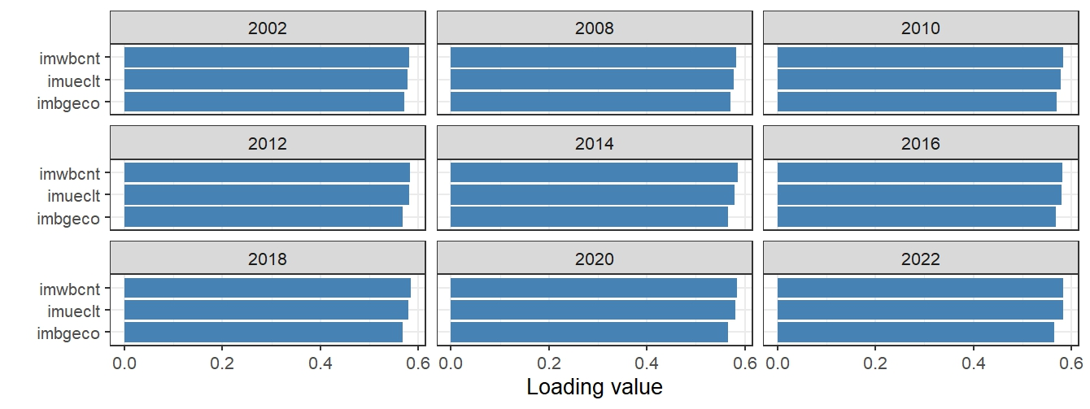

**Fig 2.1** Mean PCA loadings across all countries and years. The data were centered and scaled. PC1 seemed to be a general migration attitude with larger values indicating a pro-immigration attitude and smaller values indicating an anti-immigration attitude. Important about this figure is the fact, that all bars point towards left, i.e., all values are positive. In the previous capstone project, a “flipping” of the values, alternating between positive and negative values between the years, was observed. However, that was not the case for this project, which can probably attributed to the fact that we used the princomp() function instead of the usually used prcomp() function R, since the former made it easier to use the weighted correlation matrix.

Additionally, we had to make sure that the variable loading values of PC1 would remain consistent over time, at least when averaged across Europe, in order to make sure it would consistently capture the general attitude towards immigration. This was indeed the case (Fig. 2.2).

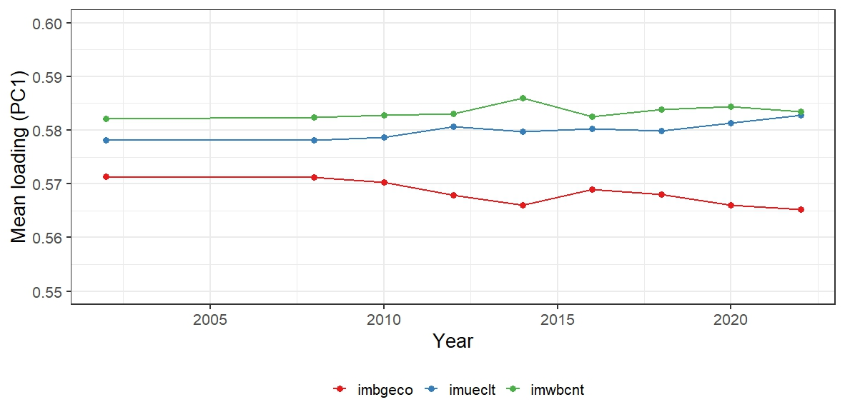

**Fig 2.2** Mean PC1 Loadings of imbgeco, imueclt & imwbcnt across all countries over time. The corresponding loading values of the three variables have been consistently between 0.55 and 0.60 over all rounds.

On the country level, the loadings of PC1 for the three considered migration variables ranged similarly stable between 0.54 and 0.60, with some smaller and larger differences between the countries (see appendix). The consistency of the loading values of PC1 ensured that there was no between-year variation of the meaning of PC1. The seventh metric was thus the explained variance of the first PC for a given year and country. We were now able to visually identify trends by assessing the explained variance of PC1 over time.

### Average opinion

(6)

Finally, while not a polarization metric per se, we calculated the weighted mean opinion values based off the raw Likert-values for each variable, year, and country. Reason being that we needed not only a way to quantify the different aspects and trends of polarization, but also needed a way to track in which direction (up or down the Likert-scale) a countries sentiment would generally be moving at the same time in order to get the full picture.

## Web app for data exploration

Investigating polarization dynamics across seven distinct metrics observed over ten time points spanning two decades (2002-2022) for three key variables presented a substantial analytical challenge, particularly when conducted at both continental and individual country levels. Consequently, a dedicated tool with the ability to facilitate effective data exploration, filtering, and visualization was built prior to the substantive analysis. With the data obtained from the ESS, this web application allowed to assess the temporal development of each metric and variable on both the continental and country levels. Additionally, it made it possible to rank the data using any of the metrics and variables for a given year. Lastly, it allowed to focus on a given country-year-variable combination, yielding insights into all metrics in comparison to the European average along with a view into the distribution of opinions (0 to 10 on the Likert scale) for the same time frame (Figs. 2.3 to 2.6).

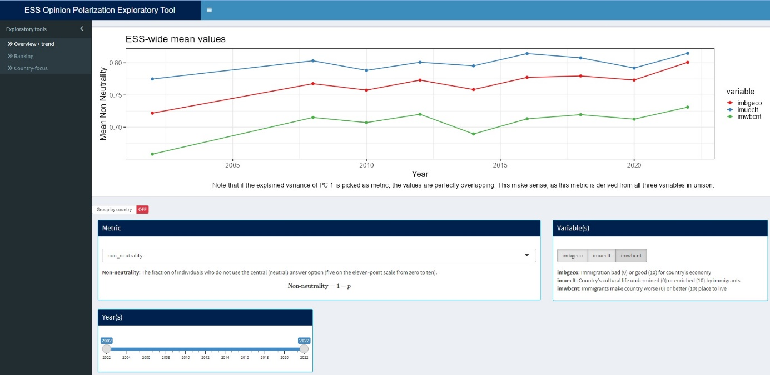

**Fig 2.3** The “Overview + trend” page of the exploratory web app, showing the development of the non-neutrality metric for the three opinion variables between 2002 and 2022 using the Europe-wide average.

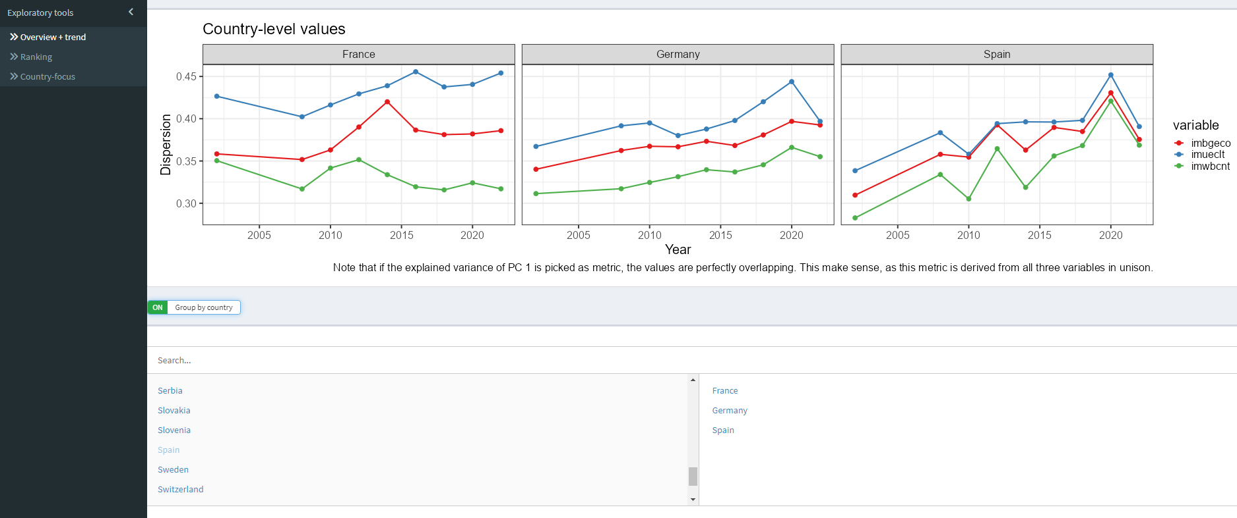

**Fig 2.4** The “Overview + trend” page of the exploratory web app, showing the development of the dispersion metric for the three opinion variables between 2002 and 2022 separately for France, Germany and Spain.

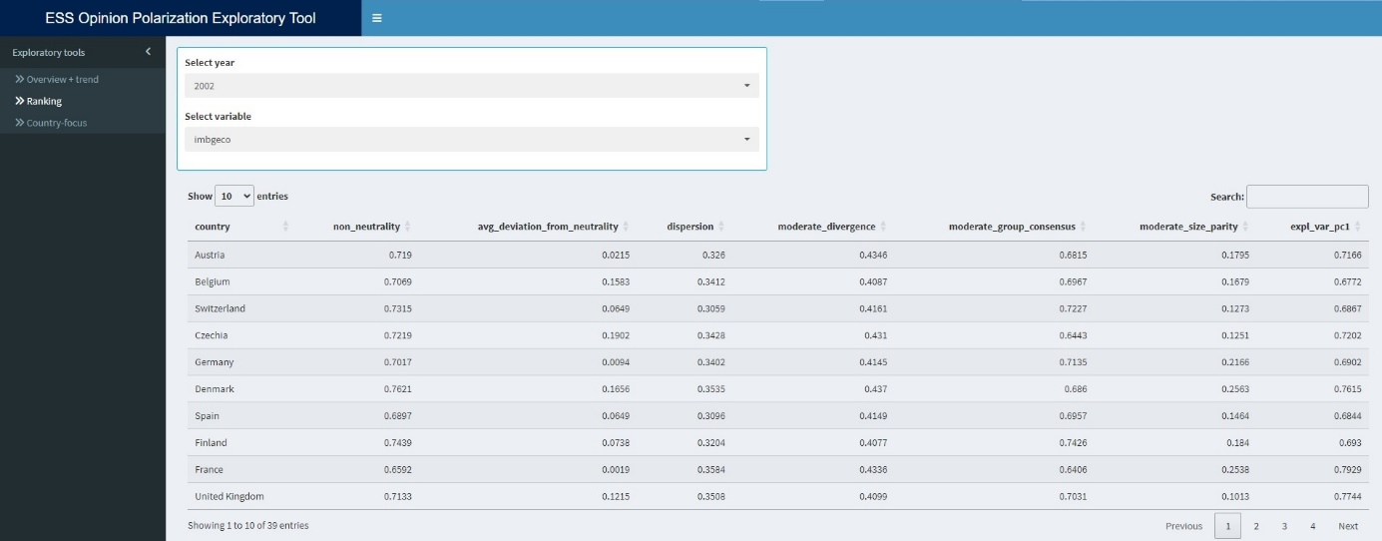**Fig 2.5** The “Ranking” page of the exploratory web app, showing all metrics for imbgeco in 2022. This table could now be sorted based on any of the metric, resulting in a corresponding country-ranking.

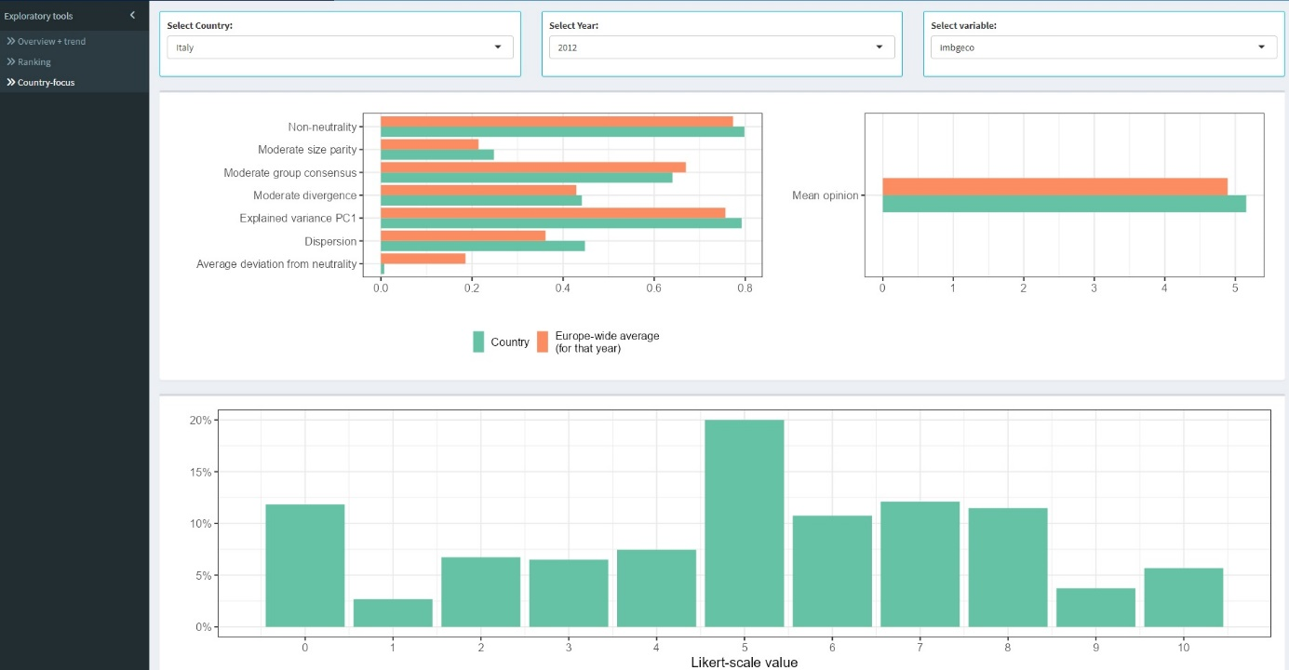

**Fig 2.6** The “Country-focus” page of the exploratory web app, showing the development of all metrics for imbgeco in 2012 for Italy in comparison with the Europe-wide averages. The bottom plot shows the distribution of the Likert-Scale values for the same time frame.

# **Results**

Based on the insights obtained by utilizing the previously built web application, we compared the European averages of our metrics with those of Germany and Hungary - two countries that may represent contrasting positions along the spectrum of public sentiment, while the aggregated European data provided a valuable overview assessment and served as reference point.

## Europe

Considering Europe as a whole by averaging across all countries, we found trends in the form of increases in polarization for almost all metrics and variables. Especially visible for the timeframe around 2015, We found increase in average deviation from neutrality, increase in dispersion, increase in the explained variance of the first principal component, increase in moderate divergence and thus a corresponding decrease in moderate group consensus, a strongly decreasing moderate size parity, and a very clear upward trend in non-neutrality. Paired with those findings, we found a tendency for an increase of the mean opinions towards a more slightly approving sentiment (Fig 3.1).

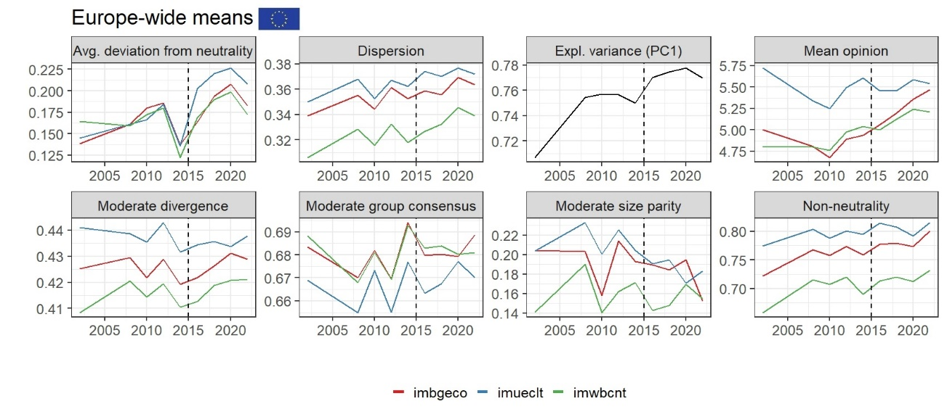

**Fig 3.1** The seven aspects of polarization and the mean opinion over time on the European continental level averaged across all available countries between 2002 and 2022. Avg. deviation from neutrality: Shows the average extent to which opinions deviate from a neutral stance, i.e., an increase of acceptance **or** rejection. Higher values suggest stronger opinions, indicating increasing polarization. The trends for the three variables seem to show a general increase in deviation from neutrality, suggesting that opinions on immigration have become less neutral and more shifted towards the extremes, particularly after 2015. **Dispersion:** Measures the deviation from the average opinion. Higher dispersion indicates a shift towards a more extreme opinion (in both directions), and can thus be a sign of polarization. The trends here show an upward tendency, again implying that the range of opinions on immigration has shifted towards the extreme ends. This is again especially visible after 2015. **Expl. variance (PC1):** Refers to the explained variance of the first principal component of the PCA based on the three migration variables. A higher value suggests that a single underlying dimension (the general sentiment towards immigration) explains a larger proportion of the variance in opinions. The upward trend in this graph suggests that opinions on immigration have become increasingly structured, indicating an increase in polarization in the form of issue alignment, with a notable spike after 2015. Mean opinion: Shows the average opinion for each variable on the original Likert-scale. Small values indicate resentment, five indicates a neutral stance, and large values indicate approval. All three variables a tendency to increase in mean opinion towards the later part of the observed period. The period around 2010 seems to be a turning point for all three variables, with opinions generally starting improve towards a mildly positive stance after that year. M**oderate divergence:** Captures the extent to which the average views of the moderately accepting and moderately opposing individuals diverge. The trends are somewhat fluctuating, but there appears to be an overall increase in moderate divergence, indicating an increase in polarization between the two moderate groups, again more visibly after 2015. **Moderate group consensus:** Assesses the level of agreement within the two moderate groups. Over the years, the values have been fluctuating, but again, results show see a decrease in consensus right after 2015, indicating an increase in opinion polarization. Moderate size parity: Captures the ratio of the smaller to the larger group holding moderate opinions. Here, results are fluctuating, but a decrease in group size parity is visible for "imbgeco" and "imueclt" after 2015, again indicating an increase in polarization around that time. **Non-neutrality: M**easures the prevalence of non-neutral opinions. Higher values indicate a larger proportion of the population holding either positive or negative views on immigration. All three variables show a clear upward trend, especially after 2015, strongly suggesting a significant increase in the proportion of Europeans holding non-neutral opinions on immigration.

## Germany

Similar to the Europe-wide results, the polarization metrics focussed on Germany show the year 2015 to have been a crucial turning point in regards to immigration opinions. The average deviation from neutrality increased for economic considerations, and decreased for overall and cultural variables. Dispersion increased, indicating a greater diversity of views. The explained variance of the first principal component increased, indicating that opinions on different variables of immigration became more aligned in a process otherwise known as issue alignment. The mean opinion decreased for cultural and general views, but again increased for economic considerations. Moderate divergence increased, and thus moderate group consensus decreased, indicating greater polarization even among those not holding extreme views. Moderate size parity increased, suggesting polarization for all three variables. Lastly, non-neutrality clearly increased (Fig. 3.2).

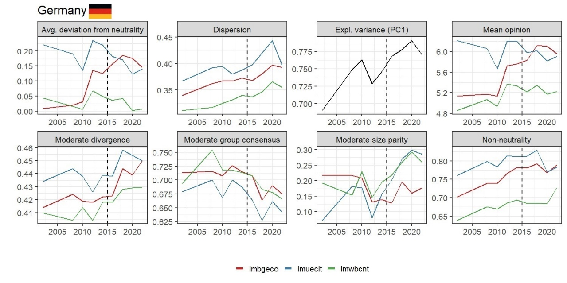

**Fig 3.2** The seven aspects of polarization and the average opinion over time for Germany. Avg. deviation from neutrality: Shows how far, on average, opinions deviate from the neutral point. For “imueclt”, and “imwbcnt”, the average deviation from neutrality kept on decreasing after 2015, whereas “imbgeco” increased, suggesting that economic considerations became more important and a polarizing factor following at that point. Dispersion: Measures the deviation from the average opinion. Higher dispersion indicates a shift towards a more extreme opinion (in both directions), and can thus be a sign of polarization. For all three variables, the dispersion generally increases after 2015, indicating a greater diversity of opinions about immigration around that time. Expl. variance (PC1): Represents the amount of variance in the combined data of the three immigration variables that is explained by the first principal component of a PCA. A higher explained variance suggests that the opinions on these three variables tend to move together. The plot shows a general increase in explained variance of PC1 after 2015. This suggests that during that period, opinions on whether immigration is good for the economy, enriches culture, or makes the country a better place became more aligned, which is a process known as issue alignment. Mean opinion: Shows the average opinion on the original Likert scale. For “imueclt” and “imwbcnt”, the mean opinions decreased after 2015, indicating a shift towards more negative views on the cultural and overall impact of immigration at that point, whereas “imbgeco” increased, indicating an increasing believe that immigrants might boost the economy. Moderate divergence: Measures the difference in average opinion between those moderately accepting and those moderately opposing immigration. An increase indicates greater polarization between these moderate groups. The plot shows a clear increase in moderate divergence for all three variables after 2015, signifying that the gap between moderately accepting and moderately opposing individuals widened considerably following that year. Moderate group consensus: Measures the agreement within the moderately accepting and moderately opposing groups. For all three variables, there's a general decrease in moderate group consensus after 2015. This suggests that within both the moderately accepting and moderately opposing groups, opinions became more varied somewhere around that time. Moderate size parity: The ratio of the smaller to the larger moderate group. The plot shows that the parity increased after 2015 for all three variables. This suggests that the size of the two moderate groups became more equal in size, indicating an increase in polarization among the members of the moderate groups during that period. Non-neutrality: This shows the proportion of individuals holding non-neutral views. For all three variables, there is a weak increase in non-neutrality after 2015, suggesting only a mild shift towards both more extreme ends of the opinion spectrum at that point.

## Hungary

Considering Hungary, results strongly suggest yet again that the period around 2015 was a critical turning point for public opinion on immigration. Before this time, average opinions tended to be slightly positive to neutral. The timeframe around 2015 appears to have triggered a significant shift: Average opinions turned sharply negative across all three dimensions (economic, cultural, and general impact). Opinions became more polarized, with individuals holding stronger views, both positive and negative, leading to higher average deviation from neutrality and increased dispersion. Views on the different variables of immigration became more aligned, as indicated by the increasing explained variance of the first principal component. Additionally, we found a growing divergence between moderate groups: The gap between those with moderately accepting and moderately opposing views widened. Also, the relative size of the moderately opposing group appears to have increased. Opinions became more extreme, with a larger proportion of the population holding non-neutral views, indicating polarization. In summary, the refugee crisis seems to have acted as a polarizing event in Hungary, leading to more negative, less neutral, and more divergent opinions on the various facets of immigration (Fig. 3.3).

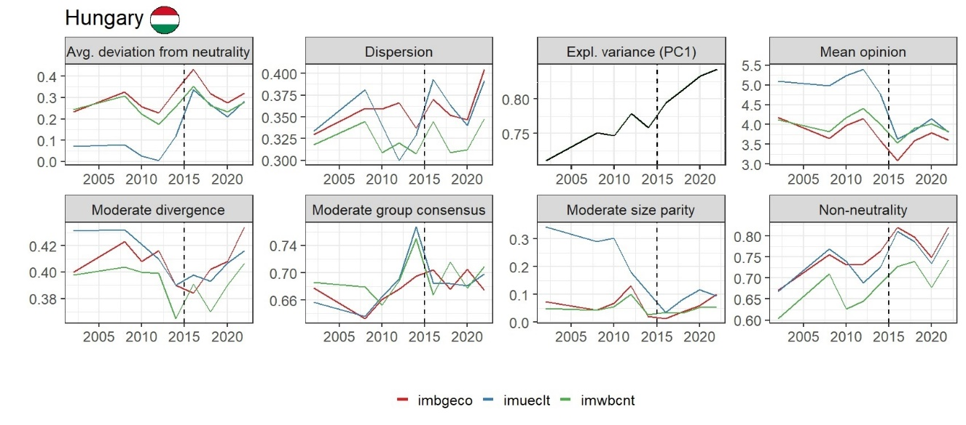

**Fig 3.3** The seven aspects of polarization and the average opinion over time for Hungary. Avg. deviation from neutrality: Shows how far, on average, opinions are from the neutral midpoint. Results indicate a general trend of increasing deviation from neutrality across all three variables after directly 2015, with a quickly following decrease. This suggests that opinions became less neutral and more strongly held in either the positive or negative direction around that time, but also indicate a certain volatility of opinions. Dispersion: Measures the deviation from the average opinion. The plot shows a spike of increasing dispersion levels after 2015 for all three variables, suggesting an average shift towards more extreme opinions in both directions during that period. But again, rather quickly followed by a decrease, again indicating fluctuating opinions. Expl. variance (PC1): The explained variance of the first principal component from a PCA combining the three immigration variables shows a clear upward trend, especially after 2015. This suggests that a single underlying dimension - the general attitude towards immigration - became increasingly dominant in explaining the variation in opinions across the three measured variables. Opinions on the economic, cultural, and societal impacts of immigration became more aligned during that timeframe, indicating issue alignment. Mean opinion: This displays the average opinion. For all three variables, the mean opinion generally decreases after 2015, indicating a shift towards more negative average perceptions of immigration. Followed by a slight increase thereafter, but still way below the neutral value of 5. Moderate divergence: This measures the gap between the average opinions of moderately accepting and moderately opposing groups. Results show an increase in moderate divergence after 2015 for all three variables after ten years of decrease, suggesting that the views of those with somewhat positive and somewhat negative initial stances on immigration drifted further apart at that time, albeit with quite the fluctuations. Moderate group consensus: This shows the internal agreement within the moderately accepting and moderately opposing groups. The plot shows varying trends, but there isn't a clear consistent pattern of increasing or decreasing consensus within these moderate groups across all three variables after 2015 due to strong fluctuations. Moderate size parity: This is the ratio of the smaller to the larger moderate group. The plot shows an increase in moderate size parity around and after 2015. This suggests that the size of the two moderate groups became more equal in size, indicating an increase in polarization among the members of the moderate groups during that period. Non-neutrality: This represents the proportion of individuals holding non-neutral views. There is an increase in non-neutrality across all three variables after 2015, indicating that more people moved away from a neutral stance and adopted a more definite positive or negative opinion on immigration at that time. However, shortly after the increases, we see a decrease in non-neutrality until 2020, after which it increases again, again pointing at the presence of fluctuating opinions.

## Europe vs. Hungary vs. Germany

For both the European averages and the Germany and Hungary individually, we found 2015 to be a turning point in immigration opinion dynamics. Treating the European averages as an overall central point of reference made it easier to spot differences and deviations on the country-levels of Germany and Hungary. Comparing the Europe-wide results, starting at 2015, we found several similarities, but also striking differences.

Across Europe, we see an increase in average deviation from neutrality for all three variables, which is the same for Hungary, but with more fluctuations. However, for Germany, we only see an increase in “imbgeco”, whereas the other two variables show a decreasing trend. This indicates that among German citizens, economic considerations are more divisive than cultural or general life-quality related ones. Considering dispersion, we see increasing trends in dispersion both across Europe as a whole and individually in Germany and Hungary. But again, for Hungary, the dispersion values are fluctuating stronger. This indicates that patterns of increasing individual deviation from the average attitude probably don’t come from a few individual countries, but can be found all across Europe. Similar to the dispersion metric, we see an increase in the proportion of explained variance of the first principal component across Europe as a whole, but also on the country-level in Germany and Hungary. This suggests that we see issue alignment not only on the continental level, but also in individual countries. Looking at the moderate groups (individuals who either voted with 1 to 4, making them “moderate acceptors” or with 6 – 9, making them “moderate opponents” in the ESS surveys), we see an increase in moderate divergence both in the European averages, but also individually in Germany and Hungary. This reveals how the gap between the average views of moderately accepting and moderately opposing individuals is continuously widening, leading to more polarized positions. But yet again, Hungary displayed stronger fluctuations. Considering the moderate group consensus, we find for the European averages that “imbgeco” and “imwbcnt” did not significantly change in the years after 2015 (the previously identified turning point), whereas “imueclt” visibly increased. This means that overall, in Europe, the distribution of opinions regarding economic and overall life-quality did not substantially change, whereas the in-group consensus about the cultural impact of immigrants has been increasing among the moderate groups. In contrast to this, we see that in Germany, the moderate consensus dropped for all three variables. This demonstrates how in Germany specifically, there seems to be an ongoing heterogenization of opinions among the moderate groups with regards to economic, cultural, and overall life-quality impacts of immigration. Compared to the European average and Germany, we see strongly fluctuating patterns of moderate consensus for “imbgeco” and “imwbcnt” in Hungary, indicating a certain instability of short-lived phases of consent and dissent after 2015. Regarding the moderate size parity, for the European averages, we see a decrease from 0.20 to 0.16 for “imbgeco” and “imueclt”, whereas “imwbcnt” did not change substantially. This indicates a trend of decreasing moderate size parity, signalling a growing imbalance in the number of people holding moderately accepting versus moderately opposing views on immigration. This actually means a decrease in polarization among moderate voters, as with moderate size parity, maximum polarization occurs when both groups are equal in size. Focussed on Germany, we find increases of moderate size parity for all three variables. “imueclt” and “imwbcnt” went up from 0.20 to 0.30 from 2015 to 2020, while “imbgeco” went up from 0.15 to 0.18. This indicates strong increases in polarization in regards to cultural and overall life-quality impacts and a weaker, yet substantial, increase in polarization with regards to economic impacts of immigration among moderate voters in Germany. In Hungary, we find weaker increases for “imbgeco” and “imueclt” from 0.05 to 0.1, indicating a slight increase in polarization among moderate voters with regards to economic and cultural considerations of immigration. However, it should be noted that the initial moderate size parity values in 2015 were much smaller in Hungary (0.05) in comparison to Germany (0.20) and Europe overall (0.20). This means that in Hungary, the moderate size groups were much more imbalanced in 2015 as compared to Germany and Europe overall. Looking at non-neutrality, perhaps the simplest metric, we see increases in the European averages, Germany, and Hungary. This indicates an overall trend of deviation from the neutral “5” on throughout Europe. It should be noted though, that the non-neutrality values for Europe overall, but also for Germany and Hungary, were quite high to begin with, ranging from 0.70 to 0.80 in 2015. However, we again found a more fluctuating pattern for Hungary. Finally, comparing the average opinion value, we see increases in all three variables across Europe, indicating a trend of a general pro-immigrant attitude. Focussed on Germany, we see a positive trend for “imbgeco”, a decreasing trend for “imueclt”, and no visible trend for “imwbcnt”. This indicates that in Germany, there is a growing body of people who think that immigrants might be good for the economy, yet, at the same time, there is a body of people who believe that immigrants might negatively impact the cultural life. In quite the contrast to the generally pro-immigrant picture of Europe as a whole and the multi-faceted picture of Germany, we see a stark decrease in opinions regarding all three opinion variables in Hungary. This indicates a trend of an overall resentment towards immigration in Hungary.

In summary, our results showed that 2015 was a pivotal year in terms of immigration opinions in Europe. After that year, we found deviations from a neutral stance both on the continental and country-level for Germany and Hungary, with economic factors being the most divisive factor in Germany. At the same time, we found an ongoing increase of the first principal component explaining more and more of the variance. Additionally, we found evidence for the moderate group becoming more polarized and uneven in size. However, at the same time, an increasing in the Likert-opinion values in the European averages was found. We found evidence for a growing body of people who think that immigrants might be good for the economy, yet, at the same time, there is a body of people who believe that immigrants might negatively impact the cultural life in Germany. The trend of an overall resentment towards immigration in Hungary is not very surprising. More surprising, however, are the stronger fluctuations for five out of eight metrics we found for Hungary, indicating that the opinions there are more volatile than in Germany or compared with the European average.

# **Discussion**

Several results pointed at 2015 being a pivotal year for immigration dynamics across Europe and the national levels of Germany and Hungary, causing increases in several aspects of polarization regarding opinions about immigration. This can be explained by the fact that that year was the height of the European refugee crisis. During that year, over one million people arrived in Europe by sea, mainly fleeing conflicts in the Middle East, Africa, and South Asia, and especially Syria (Almustafa, 2021; Piguet, 2024). Previous research shows that the 2015 refugee crisis placed strain on European institutions and politics, leading to increased party competition and polarization. Political elites and parties shifted their positions, with right-wing and populist movements gaining traction by emphasizing national sovereignty and stricter immigration controls. The crisis acted as a catalyst for movements and parties that challenged the existing political order, often using xenophobic rhetoric (e.g., Izak, 2021; Hutter & Kriesi, 2021; Yaseen et al., 2025). However, there were regional differences as the crisis sparked different reactions in Eastern and Western Europe, with trust in domestic and EU institutions playing a key role in shaping attitudes (Peshkopia, Bllaca & Lika, 2018).

## Interpretation of results

We found clear evidence increases in polarization in the form of the non-neutrality increasing both averaged across Europe and focused on Hungary after 2015, albeit only very weakly for Germany. Meaning there is an ongoing trend of a shifting away from a neutral stance across Europe, but perhaps to varying degrees. Indeed, after 2015, many European countries experienced a shift away from neutral stances, with public opinion becoming more divided and, in some cases, more negative toward immigration, especially in countries where the debate was framed around security concerns (e.g., Cichocki & Jabkowski, 2019; Torres, 2019). Considering Germany, we found only very weak evidence for increasing non-neutrality following the 2015 refugee crisis. Indeed, prior research suggests that some specific events such as the 2015-16 New Year’s Eve sexual assaults in Germany or 2016 Berlin terror attack might have led to temporary negative (i.e., non-neutral) shifts in attitudes toward refugees, but these changes would often be short-lived and usually wouldn’t translate into a long-term trend (Vollmer & Karakayali, 2018, Schmidt-Cantra & Czymara, 2020). For Hungary, we found a clearer increase in non-neutrality after 2015. Reason being the aforementioned governmental anti-immigration campaigns. However, shortly after that increase, we found a period of decreasing non-neutrality, meaning more people moved again towards a neutral stance between 2016 and 2020. After 2020, we again saw a stark increase in non-neutrality. This volatility was found for other metrics as well, indicating that many Hungarians tend to change their minds about immigration rather quickly. This is contradicting other research that states that Hungarian opinions on immigration during this period were stable and strongly anti-immigration, rather than volatile or quickly changing (e.g., Bajomi-Lázár, 2019; Bíró-Nagy, 2021). In addition to the increases in non-neutrality, we found evidence for an ongoing shift away from a neutral opinion stance about immigration across Europe on average as of 2015 in the form of increases in the average deviation from neutrality. The framing of immigration by political actors and the media can contribute to the differentiation and sometimes polarization of public opinion (Lahav, 2004; Kehrberg, 2007). Interestingly, it seems to be the distinguishment between the words “immigrant” and “refugee” which can already lead to more nuanced, but also polarized, attitudes. People generally hold more positive views toward refugees than immigrants, and attitudes vary further based on ethnicity, country of origin, and economic background of newcomers (Kehrberg, 2007). However, while some countries experienced more restrictive opinions in response to increased immigration flows and political framing, overall shifts in public opinion across Europe have been relatively mild, with significant variation between countries (Hatton, 2016). For example, in Germany, we only found an increasing polarization with regards to economic considerations as per an increasing average deviation from neutrality value with the “imbgeco” variable. In fact, the sentiment of Germans about immigration can be shaped by both economic self-interest such as concerns about personal finances and job security (Van Hauwaert & Vegetti, 2025). Germans with neoliberal economic views are more likely to see immigrants as a drain on the welfare state, while those with left-leaning economic views are more likely to see immigrants as beneficial (Grdešić, 2019). While we found economic factors to be the divisive force of immigration opinion shaping with the metric, others report more of a mix of factors. According to Fetzer (2000), cultural marginality and ethnocentrism are often stronger predictors of anti-immigration sentiment than economic self-interest, especially in Western Germany.

Unlike non-neutrality and average deviation from the neutrality, dispersion measures the average spread of individual data points around the mean of a distribution, and not a fixed value such as the neutral “5”. Thus, dispersion measures the individual’s deviation from the average opinion. Higher dispersion means a larger pool of opinions. For Europe overall, we found, as of 2015, only weak increases for “imbgeco” and “imueclt”, with “imwbcnt” increasing a bit stronger, which is a pattern that has started back in 2002. This is consistent with current research, reporting only mild shifts in public opinion on immigration between 2002 and 2012, citing the severity of economic recessions as one major driver (Kehrberg, 2007). The pattern is similar for Germany. However, Hungary again showed much stronger fluctuations following an increase directly after 2015, indicating a larger volatility of opinions even on the individual level at that point.

We identified two moderate groups based on Lorenz’s (2017) research: The moderate acceptors and the moderate opponents. Our results suggest an increase in moderate divergence across Europe, but also distinctively in Germany and Hungary. In Germany, the presence of both pro- and anti-immigration stances within moderate parties, such as the Christian Democratic Union (CDU), has led to internal divisions and conflicting messages on immigration policy, reflecting broader divergences among moderate voters (Schmidtke, 2024). Indeed, studies show a clear antagonism between supporters and opponents of immigration within the German electorate, including among those who identify as moderate or centrist. This divide is especially visible on the issue of immigration (Hebenstreit, 2022). In Hungary, on the other hand, the government’s intensive anti-immigration campaigns, especially during and after the 2015 migration wave, significantly influenced public opinion. These campaigns made anti-immigration sentiment widespread across the political spectrum - including among moderates (Bocskor, 2018). Before the crisis, differences in anti-immigrant attitudes between political groups, including moderates, were minor. However, after the crisis and the government’s campaign, these differences became more pronounced, with party preference playing a larger role in shaping attitude (Barna & Koltai, 2019).

When moderate divergence increases, moderate consensus should logically decrease – which is what we found for Germany and Hungary after 2015. Interestingly, in comparison to Germany, the moderate group consensus for Hungary fluctuated much stronger. This again indicates that the opinions about immigration of moderate voters in the Hungary are much more volatile in comparison with Germany or the European average. Our finding here is directly contradictory to other research which states that immigration preferences among the public tend to remain stable over time. However, it could be changes in the frequency of the salience of immigration as a political issue, which can drive temporary increases in support for far-right parties when immigration is highly visible in public debate, which might be a hidden driver here (Magistro & Wittstock, 2021; Cools, Finseraas & Røgeberg, 2021)

Averaged across Europe, we found evidence for a decreasing moderate size parity for “imbgeco” and “imueclt”, indicating a decrease in polarization among the moderate voters when it comes to economic and cultural factors. This is contradictory to other research which reports stability of attitudes across Europe as a whole, finding only little evidence for significant divergence or convergence between pro and anti-immigration groups, including the moderate voters (Hatton, 2016). However, Di Lillo (2018) reports significant spatial clustering of anti-immigrant attitudes. Nonetheless, this clustering would not necessarily reflect a Europe-wide shift in the balance between moderate pro- and anti-immigrant groups. And indeed, we found substantial evidence for Hungary being one of these anti-immigration hotspots, as indicated by decreasing Likert-scale opinion values (see below).

For Germany, we found increases in moderate size parity for all three variables after 2015, meaning the group sizes of the moderate acceptors and moderate opponents are becoming more equal. In this context, this means an increase in polarization among the moderately opinionated individuals. Current research does not provide clear evidence of a sustained trend toward parity between these groups after 2015, meaning our finding here provides a novel insight. Though not as pronounced as in Germany, we found similar increases in moderate size parity for all three variables in Hungary after 2015, following years of decreasing size parity (meaning years of decreasing polarization among the moderate groups). This evidence shows how even members of the moderate groups can be influenced by state-driven anti-immigrant propaganda in either direction. Strikingly, for all the variables, the moderate size parity ended up at a value smaller than 0.1, indicating that the group sizes were extremely imbalanced at this point. There seems to be no clear prior research that suggests that the group sizes of moderate pro- and moderate anti-immigrant opinionated citizens in Hungary were extremely unequal. Indeed, available research and survey data do not indicate a dramatic imbalance between these groups prior to the 2015 migration crisis (e.g., Schneider, 2007). This means that our findings here might provide another novel insight.

Looking at the raw Likert-opinion values, we actually found positives trends for the average opinion across Europe, moving slightly above the neutral “5”, at least since 2010. This is especially visible for “imbgeco” and “imwbcnt”, while “imueclt” did not change substantially after 2015. Meaning that despite all media coverage and government-run campaigns fueling fear against immigrants run by certain countries, the average European does still have a slightly positive view on immigration, and especially when it comes to economic potential and overall quality of life considerations. Other research points out that there has been a gradual shift toward more positive attitudes about immigrants in Western EU countries since the 2000s, mainly due to younger generations being more open. However, this positive trend appears to be slowing, as the newest cohorts are not significantly more positive than previous ones (Schmidt, 2021). Yet, our results show only “imueclt” stalling, while “imbgeco” and “imwbcnt” are going strong. Considering the raw Likert-scale opinion values, we found that in Germany, there seems to be a growing body of people who think that immigrants might be good for the economy, yet, at the same time, there is a body of people who believe that immigrants might negatively impact the cultural life after 2015. In fact, In Germany, immigration is widely recognized as having positive economic effects, particularly by addressing labor shortages and supporting economic growth. Historically, immigration has helped Germany tackle demographic challenges, such as an aging population and labor shortages, by providing both high- and low-skilled workers. This has boosted productivity, innovation, and overall economic growth (Higgins & Klitgaard, 2019; Grajdeanu, 2023). While a common concern, most studies find little to no negative impact of immigration on native employment or wages (Prantl & Spitz-Oener, 2020). Yet at the same time, while immigrants clearly can contribute to cultural diversity (Giovanis, Akede & Ozdamar, 2021), there are ongoing debates and concerns among some groups about the potential for cultural change or loss of traditional values. Some native-born Germans become less supportive of welfare programs as the proportion of immigrants increases, especially during periods of high unemployment. This reflects concerns about social cohesion and resource allocation, particularly in the early phases of immigration wave (Schmidt-Catran & Spies, 2016). In contrast to the mixed trends in Germany, there is an overall trend of increasing resentment towards immigration in Hungary. The Hungarian government, especially under Viktor Orbán, has run intensive anti-immigration campaigns since 2015, framing immigration as both an economic and security threat. These campaigns conflated migrants with terrorists and criminals, and presented the government as the defender of Hungarian and Christian values (Bocskor, 2018; Bajomi-Lázár, 2019). The media environment in Hungary is highly politicized, with limited pluralism and critical voices. This has amplified government messaging and reduced the visibility of alternative or critical perspectives on immigration (Farkas, 2021). Thus, this trend is largely the result of deliberate political strategies that portray immigration as a danger to Hungarian values and identity, especially since 2015. However, note that several of our polarization metrics show strong fluctuations for Hungary.

To the polarization metrics described in literature, we added a new one in the form of the explained variance of the first principal component (PC1) of the PCA using the three immigration variables. We interpreted an increase of the proportion of explained variance of PC1 as an increase in issue alignment – the synchronization of opinions towards a specific topic. For example, if a person would agree that immigrants are good for the cultural life of a country, with increasing issue alignment, it would be increasingly likely that that person would also consider immigrants to be good for the economy. This is exactly what we found - averaged across Europe before and after 2015, but also on the country-level for both Germany and Hungary. Indeed, individuals who view immigrants positively in one domain, such as cultural life, are often more likely to hold positive views in other domains such as economic contributions (Van Hauwaert, S., & Vegetti, F., 2025). According to our findings, the ongoing trends of issue alignment have been roughly equally fast for both Germany and Hungary after 2015. Germany generally has a more positive opinion about immigration than Hungary (see below. Also, Bocskor, 2018; Heath & Richards, 2019; Bíró-Nagy, 2021). However, other research suggests that the alignment of positive opinions is more likely among those with higher political tolerance, stronger European identity, and better information about immigration (Lahav, 2004; De Coninck, 2020; Van Hauwaert & Vegetti, 2025). Meaning we would have expected a faster rate in Germany than in Hungary.

While the fact that 2015 immigrant crisis was a major turning point in terms of opinions about immigration is perhaps established knowledge, it is striking how much it is reflected in our results regarding polarization. We found several leads that suggest that opinion polarization has been happening both on the European continental scale, and on the national scale, at least for Germany and Hungary, for both the moderate and more extreme groups, since 2015. More surprising, indeed, are the strong fluctuations we found for five out of eight metrics regarding Hungary for that year. This suggests that the opinions there are much more changing and volatile than previously thought, even on the individual level. Considering that the country is under an autocratic, anti-immigrant leadership (or perhaps exactly because the country is under an autocratic anti-immigrant leadership), this finding is quite surprising.

Our results suggest that opinion polarization is quite nuanced and faceted. In Germany, it seems to be mainly economic considerations that have been causing a polarized stance, while cultural concerns seem to be secondary. Whereas in Hungary strongly fluctuating metrics make it hard to discern, whether it is economic, cultural, general quality-of-life or rather a mix of the three factors that have been driving opinion polarization as of 2015. Yet at the same time, there seems to be an ongoing trend of an “overall immigration opinion” that takes over across Europe, but also in Germany as well as in Hungary. Our analysis also sheds light on the more seldom considered moderate group of opinion holders, showing that even among this group, polarization has been happening as well on both the continental and national levels.

This research offers a novel understanding of immigration opinion dynamics across Europe through a robust, large-scale empirical approach. Leveraging polarization metrics established from literature and a completely new one, namely the explained variance of the first principal component (which also serves as a metric for issue alignment). This study reveals both continental and national intricacies of economic, cultural, and quality-of-life considerations of opinion dynamics about immigration. Partly challenging previous assumptions based on established research, this thesis adds a valuable piece to the puzzle. Furthermore, the development of an extensible exploratory web application provides a practical tool for future research and analysis in this field.

## Limitations

While this study offers novel insights, certain limitations warrant consideration. The analysis focused on two specific countries in addition to European averages. While these selections provided valuable contrasting cases, the inclusion of additional countries, perhaps a Scandinavian country, known for its progressive policies, could have offered further nuanced and contrasted perspectives. However, due to time restrictions, we had to focus on just Germany and Hungary along with the European average. Furthermore, the temporal analysis of the time series data relied primarily on visual assessment rather than employing specific trend identification methods. While visual assessment allowed for the identification of salient patterns, future research could benefit from the application of formal time series methodologies to quantify trends with greater statistical rigor. Lastly, we based some of the interpretations on trends beginning shortly after 2015, whereas data up until 2022 were available. However, many of these trends did indeed reach into 2022 and perhaps even beyond.

While our study often confirms previous research, it also unveiled several novel insights. For Germany, we found a trend of increasing size parity as of 2015, which, to our knowledge, has not yet been reported, along with the stronger importance of economic factors over cultural ones. Another previously unreported insight is the extremely unequal moderate Group sizes in Hungary, also as of 2015. Whereas previous research suggests that issue alignment should be proceeding faster in Germany than in Hungary, we found that the two countries seem to “issue align” at the same pace, which might mean that either Germany and Hungary are ideologically closer to each other, at least with regards to immigration, than previously thought. Or that the effects of higher political tolerance, stronger European identity, and better information about immigration are not as important, and it is other factors that drive the speed of issue alignment. Also, previous research established that opinions about immigration in Hungary have been quite consistent over the years. However, our results suggest that opinions about immigration are here much more volatile than previously thought, indicating that substantial parts of the Hungarian population are not as indoctrinated by the government-driven anti-immigration propaganda as one might think. Lastly, our research shows that the moderate group size equalness has been decreasing across Europe since 2015 for “imbgeco” and “imueclt”, indicating the opposite of polarization here, while previous research is reporting more of a stable process.

## Future prospects

The continuously increasing proportion of the explained variance of PC1 across Europe as a whole indicates a more binary view of “the immigrant”, merging concerns about economy, culture and overall quality of life into one big concern, potentially removing and nuance we have found so far, meaning the potential for even more polarization.

Our research showed that nuanced views are necessary in order to identify the underlying factors and locations of immigration opinion polarization hotspots, and that the Hungarian population might not be the “bulwark” of anti-immigrant sentiment it sometimes seems to be considered as. However, our results also suggest that these nuances might disappear in the verge of an overall “the immigrant” opinion, at least when it comes economics, cultural, and overall quality-of-life considerations regarding immigration. This process might only accelerate with (far-)right parties being on the rise across Europe. As of Mai 2025, Germany once again has a conservative leader in form of Friedrich Merz (CDU) with the AFD being on the rise. Viktor Orbán is also not going anywhere. However, one silver lining is that, despite everything, the average opinion about immigration is still getting better, at least averaged across Europe, and a new pope is in place who might use his voice to spread his pro-immigration world views.

# **References**

Abdi, H., & Williams, L., 2010. Principal component analysis. *Wiley Interdisciplinary Reviews: Computational Statistics*, 2. https://doi.org/10.1002/wics.101.

Abramowitz, A.I., and K.L. Saunders. 2008. Is polarization a myth? The Journal of Politics 70 (2): 542-555. https://doi.org/10.1017/S0022381608080493

Acemoglu, D., Como, G., Fagnani, F., & Ozdaglar, A., 2010. Opinion Fluctuations and Disagreement in Social Networks. Economics of Networks eJournal. https://doi.org/10.1287/moor.1120.0570.

Adams, J., C.E. de Vries, and D. Leiter. 2011. Subconstituency reactions to elite depolarization in the Netherlands: An analysis of the Dutch public’s policy beliefs and partisan loyalties 1986 – 98. British Journal of Political Science 42 (1): 81–105. https://doi.org/10.1017/S0007123411000214Ademmer, E., and T. Stöhr. 2018. Europeans are more accepting of immigrants today than 15 years ago. Evidence from eight waves of the European Social Survey. MEDAM Policy Brief, October, https://www.stiftung-mercator.de/de/publikationen/europeans-are-more-accepting-of-immigrants-today-than-15-years-ago/. Accessed 06 April 2025.

Almustafa, M., 2021. Reframing refugee crisis: A “European crisis of migration” or a “crisis of protection”?. Environment and Planning C: Politics and Space, 40, pp. 1064 - 1082. https://doi.org/10.1177/2399654421989705.

Amelkin, V., Bullo, F., & Singh, A., 2017. Polar Opinion Dynamics in Social Networks. IEEE Transactions on Automatic Control, 62, pp. 5650-5665. https://doi.org/10.1109/TAC.2017.2694341.

Arel-Bundock, V., Enevoldsen, N., & Yetman, C. (2018). countrycode: An R package to convert country names and country codes. Journal of Open Source Software, 3(28), 848. https://doi.org/10.21105/joss.00848

Bajomi-Lázár, P., 2019. An anti-migration campaign and its impact on public opinion: The Hungarian case. European Journal of Communication, 34, pp. 619 - 628. https://doi.org/10.1177/0267323119886152.

Barna, I., & Koltai, J., 2019. Attitude Changes towards Immigrants in the Turbulent Years of the 'Migrant Crisis' and Anti-Immigrant Campaign in Hungary. Intersections. https://doi.org/10.17356/IEEJSP.V5I1.501.

Bauer, P.C. 2019. Conceptualizing and measuring polarization: A review. SocArxiv working paper, 12 September, https://doi.org/10.31235/osf.io/e5vp8. Accessed 6 April 2025.

Bíró-Nagy, A., 2021. Orbán’s political jackpot: migration and the Hungarian electorate. Journal of Ethnic and Migration Studies, 48, pp. 405 - 424. <https://doi.org/10.1080/1369183X.2020.1853905>.

Bocskor, Á., 2018. Anti-Immigration Discourses in Hungary during the ‘Crisis’ Year: The Orbán Government’s ‘National Consultation’ Campaign of 2015. Sociology, 52, pp. 551 - 568. https://doi.org/10.1177/0038038518762081.

Bougher, L. (2017). The Correlates of Discord: Identity, Issue Alignment, and Political Hostility in Polarized America. Political Behavior, 39, 731-762. https://doi.org/10.1007/S11109-016-9377-1.

Böcskei, B., & Molnár, C., 2019. The radical right in government? – Jobbik’s pledges in Hungary’s legislation (2010–2014). East European Politics, 35, pp. 1 - 20. https://doi.org/10.1080/21599165.2019.1582414.

Bramson, A., P. Grim, D.J. Singer, S. Fisher, W. Berger, G. Sack, and C. Flocken. 2016. Disambiguation of social polarization concepts and measures. Journal of Mathematical Sociology 40 (2): 80–111. https://doi.org/10.1080/0022250X.2016.1147443

Cichocki, P., & Jabkowski, P., 2019. Immigration attitudes in the wake of the 2015 migration crisis in the Visegrád Group countries. Intersections. https://doi.org/10.17356/IEEJSP.V5I1.480.

Ciol, M., Hoffman, J., Dudgeon, B., Shumway-Cook, A., Yorkston, K., & Chan, L., 2006. Understanding the use of weights in the analysis of data from multistage surveys. Archives of physical medicine and rehabilitation, 87 2, pp. 299-303. https://doi.org/10.1016/J.APMR.2005.09.021.

Chang, W., Cheng, J., Allaire, J., Sievert, C., Schloerke, B., Xie, Y., Allen, J., McPherson, J., Dipert, A. & Borges, B. (2023). shiny: Web Application Framework for R. R package version 1.8.0. Retrieved from https://CRAN.R-project.org/package=shiny.

Chang, W. & Borges Ribeiro, B. (2021). shinydashboard: Create Dashboards with 'Shiny'. R package version 0.7.2. Retrieved from https://CRAN.R-project.org/package=shinydashboard.

Cools, S., Finseraas, H., & Røgeberg, O., 2021. Local Immigration and Support for Anti‐Immigration Parties: A Meta‐Analysis. American Journal of Political Science. https://doi.org/10.1111/AJPS.12613.

De Coninck, D., 2020. Migrant categorizations and European public opinion: diverging attitudes towards immigrants and refugees. Journal of Ethnic and Migration Studies, 46, pp. 1667 - 1686. https://doi.org/10.1080/1369183X.2019.1694406.

Di Lillo, M., 2018. The geography of anti-immigrant attitudes across Europe, 2002–2014. Journal of Ethnic and Migration Studies, 138, pp. 1-19. https://doi.org/10.1080/1369183X.2018.1427564.

DiMaggio, P., J.H. Evans, and B. Bryson. 1996. Have American’s social attitudes become more polarized? The American Journal of Sociology 102 (3): 690–755. https://www.jstor.org/stable/2782461

Dochow-Sondershaus, S., & Teney, C., 2024. Opinion polarization of immigration and EU attitudes between social classes – the limiting role of working class dissensus. European Societies, 26, pp. 1363-1394. https://doi.org/10.1080/14616696.2024.2312948.

Duclos, J., J. Esteban, and D. Ray. 2004. Polarization: Concepts, measurement, estimation. Econometrica 72 (6): 1737-1772. https://www.jstore.org/stable/3598766

Duffy, B., K. Hewlett, J. McCrae, and J. Hall. 2019. Divided Britain? Polarization and fragmentation trends in the UK. King’s College London research report, September, https://www.kcl.ac.uk/policy-institute/assets/divided-britain.pdf. Accessed 07 February 2022.Düring, B., & Wolfram, M., 2015. Opinion dynamics: inhomogeneous Boltzmann-type equations modelling opinion leadership and political segregation. Proceedings of the Royal Society A: Mathematical, Physical and Engineering Sciences, 471. https://doi.org/10.1098/rspa.2015.0345.

Draca, M., and C. Schwarz. 2021. How polarized are citizens? Measuring ideology from the ground-up. SSRN research paper, 11 May, https://doi.org/10.2139/ssrn.3154431. Accessed 06 April 2025.

Dražanová, L., & Gonnot, J. (2023). Attitudes toward immigration in Europe: Cross-regional differences. Open Research Europe, 3. https://doi.org/10.12688/openreseurope.15691.1.

Druckman, J.N., E. Peterson, and R. Slothuus. 2013. How elite partisan polarization affects public opinion formation. American Political Science Review 107 (1): 57–79. https://doi.org/10.1017/S0003055412000500

European Social Survey (2024). ESS Data Portal. Retrieved from https://ess.sikt.no/en/?Table=overview

ESS weighting variables (2024). Retrieved from https://www.europeansocialsurvey.org/methodology/ess-methodology/data-processing-and-archiving/weighting

Esteban, J., and D. Ray. 1994. On the measurement of polarization, Econometrica 62 (4): 819-852. https://www.jstor.org/stable/2951734

Evans, J.H., B. Bryson, and P. DiMaggio. 2001. Opinion polarization: Important contributions, necessary limitations. American Journal of Sociology 10 (4): 944–959. https://doi.org/10.1086/320297

Farkas, E., 2021. Discussing immigration in an illiberal media environment: Hungarian political scientists about the migration crisis in online public discourses. European Political Science, 21, pp. 95 - 114. https://doi.org/10.1057/s41304-021-00340-y.

Fetzer, J., 2000. Economic self-interest or cultural marginality? Anti-immigration sentiment and nativist political movements in France, Germany and the USA. Journal of Ethnic and Migration Studies, 26, pp. 23 - 5. https://doi.org/10.1080/136918300115615.

Fiorina, M.P., and S.J. Abrams. 2008. Political polarization in the American public. Annual Review of Political Science 11: 563–588. https://doi.org/10.1146/annurev.polisci.11.053106.153836

Funk, N., 2016. A spectre in Germany: refugees, a ‘welcome culture’ and an ‘integration politics’. Journal of Global Ethics, 12, pp. 289 - 299. https://doi.org/10.1080/17449626.2016.1252785.

FWU Journal of Social Sciences. Likert Scale in Social Sciences Research: Problems and Difficulties (2022). https://doi.org/10.51709/19951272/winter2022/7.

Gewers, F., Ferreira, G., Arruda, H., Silva, F., Comin, C., Amancio, D., & Costa, L., 2018. Principal Component Analysis. ACM Computing Surveys (CSUR), 54, pp. 1 - 34. https://doi.org/10.1145/3447755.

Giovanis, E., Akdede, S., & Ozdamar, O., 2021. Impact of the EU Blue Card programme on cultural participation and subjective well-being of migrants in Germany. PLoS ONE, 16. https://doi.org/10.1371/journal.pone.0253952.

Grajdeanu, A., 2023. The demo-economic effects of Germany's migration. Culegere de lucrari stiintifice: Simpozion stiintific al tinerilor cercetatori, vol 1. https://doi.org/10.53486/9789975359023.09.

Grdešić, M., 2019. Neoliberalism and Welfare Chauvinism in Germany. German Politics and Society. https://doi.org/10.3167/gps.2019.370201.

Guide to Using Weights and Sample Design Indicators with ESS Data (2024). Retrieved from https://www.europeansocialsurvey.org/sites/default/files/2023-06/ESS_weighting_data_1_1.pdf

Haas, H., Czaika, M., Flahaux, M., Mahendra, E., Natter, K., Vezzoli, S., & Villares-Varela, M. (2019). International Migration: Trends, Determinants, and Policy Effects. Population and Development Review. https://doi.org/10.1111/PADR.12291.

Hatton, T., 2016. Immigration, public opinion and the recession in Europe. Economic Policy, 31, pp. 205-246. https://doi.org/10.1093/EPOLIC/EIW004.

Heath, A., & Richards, L., 2019. How do Europeans differ in their attitudes to immigration?: Findings from the European Social Survey 2002/03 – 2016/17.

Hebenstreit, J., 2022. Voter Polarisation in Germany: Unpolarised Western but Polarised Eastern Germany? German Politics, 32, pp. 63 - 84. https://doi.org/10.1080/09644008.2022.2056595.

Hegedüs, D., 2019. Rethinking the incumbency effect. Radicalization of governing populist parties in East-Central-Europe. A case study of Hungary. European Politics and Society, 20, pp. 406 - 430. https://doi.org/10.1080/23745118.2019.1569338.

Helbling, M., Jäger, F., Maxwell, R., & Traunmüller, R., 2023. Broad and Detailed Agreement: Public Preferences for German Immigration Policy. International Migration Review. https://doi.org/10.1177/01979183231216076.

Hester, J. and Bryan, J. (2024) glue: Interpreted String Literals. R package version 1.7.0. Available at: https://CRAN.R-project.org/package=glue.

Higgins, M., & Klitgaard, T., 2019. How Has Germany's Economy Been Affected by the Recent Surge in Immigration?

Hoogduin, and C. Hemelrijk, 255–266. Cham: Springer International Publishing. Migration and migrants: A global overview. World Migration Report, 2020. https://doi.org/10.1002/wom3.12.

Hutter, S., & Kriesi, H., 2021. Politicising immigration in times of crisis. Journal of Ethnic and Migration Studies, 48, pp. 341 - 365. https://doi.org/10.1080/1369183X.2020.1853902.

Iyengar, S., G. Sood, and Y. Lelkes. 2012. Affect, not ideology: A social identity perspective on polarization, Public Opinion Quarterly 76 (3): 405-431. https://doi.org/10.1093/poq/nfs038

Izak, K. (2021). Changes in the perception of immigration, integration, multiculturalism and threats of Islamic radicalism in certain EU member states. 13, 375-403. https://doi.org/10.4467/20801335PBW.21.017.13574.

Kehrberg, J., 2007. Public Opinion on Immigration in Western Europe: Economics, Tolerance, and Exposure. Comparative European Politics, 5, pp. 264-281. https://doi.org/10.1057/PALGRAVE.CEP.6110099.

Koudenburg, N., Kiers, H., & Kashima, Y., 2021. A New Opinion Polarization Index Developed by Integrating Expert Judgments. Frontiers in Psychology, 12. https://doi.org/10.3389/fpsyg.2021.738258.

Kumari, K., & Yadav, S., 2018. Linear regression analysis study. Journal of the Practice of Cardiovascular Sciences, 4, pp. 33 - 36. https://doi.org/10.4103/JPCS.JPCS_8_18.

Jamieson, S. (2004). Likert scales: how to (ab)use them. Medical Education, 38. https://doi.org/10.1111/J.1365-2929.2004.02012.X.

pedersen patchwork

Lahav, G., 2004. Public Opinion Toward Immigration in the European Union. Comparative Political Studies, 37, pp. 1151 - 1183. https://doi.org/10.1177/0010414004269826.

Lorenz, J. 2017. Modeling the evolution of ideological landscapes through opinion dynamics. In Advances in social simulation 2015, ed. W. Jager, R. Verbrugge, A. Flache, G. de Roo, L.

Lugosi, N., 2018. Radical right framing of social policy in Hungary: between nationalism and populism. Journal of International and Comparative Social Policy, 34, pp. 210 - 233. https://doi.org/10.1080/21699763.2018.1483256.

Magistro, B., & Wittstock, N., 2021. Changing Preferences versus Issue Salience: The Political Success of Anti-immigration Parties in Italy. South European Society and Politics, 26, pp. 383 - 411. https://doi.org/10.1080/13608746.2021.2009107.

Musco, C., Ramesh, I., Ugander, J., & Witter, R., 2021. How to Quantify Polarization in Models of Opinion Dynamics. ArXiv, abs/2110.11981.Neis, H., Meier, B., & Furukawazono, T., 2018. Welcome City: Refugees in Three German Cities. Urban Planning. https://doi.org/10.17645/UP.V3I4.1668.

Nordio, A., Tarable, A., Chiasserini, C., & Leonardi, E., 2019. Opinion Dynamics on Correlated Subjects in Social Networks. IEEE Transactions on Network Science and Engineering, 7, pp. 1901-1912. https://doi.org/10.1109/TNSE.2019.2956861.

Perrier, V., Meyer, F. & Granjon, D. (2025). shinyWidgets: Custom Inputs Widgets for Shiny. R package version 0.9.0. Retrieved from https://CRAN.R-project.org/package=shinyWidgets.

Peshkopia, R., Bllaca, L., & Lika, J. (2018). Individual similarities and regional differences: the impact of 2015 refugee crisis on Europeans’ attitudes toward immigration. European Politics and Society, 23, 660 - 678. https://doi.org/10.1080/23745118.2021.1927375.

Pfeffermann, D., 1996. The use of sampling weights for survey data analysis. Statistical Methods in Medical Research, 5, pp. 239 - 261. https://doi.org/10.1177/096228029600500303.

Piguet, E. (2024). THE ASYLUM MIGRATION CRISIS IN THE BALKANS AND ON THE ROAD TO EUROPE: UNFOLDING THE DRIVERS COMPLEX. The 5th Congress of Slavic Geographers and Ethnographers. https://doi.org/10.46793/csge5.32ep.

Prantl, S., & Spitz-Oener, A., 2020. The Impact of Immigration on Competing Natives' Wages: Evidence from German Reunification. Review of Economics and Statistics, 102, pp. 79-97. https://doi.org/10.1162/rest_a_00853.

Rapp, C. 2016. Moral opinion polarization and the erosion of trust. Social Science Research 58: 34–45. https://doi.org/10.1016/j.ssresearch.2016.02.008

Reiljan, A. 2020. ‘Fear and loathing across party lines’ (also) in Europe: Affective polarisation in European party systems. European Journal of Political Research 59 (2): 376–396. https://doi.org/10.1111/1475-6765.12351.

Richmond, A. (2002). Globalization: implications for immigrants and refugees. Ethnic and Racial Studies, 25, 707 - 727. https://doi.org/10.1080/0141987022000000231.

Schmidt, K., 2021. The dynamics of attitudes toward immigrants: Cohort analyses for Western EU member states. International Journal of Comparative Sociology, 62, pp. 281 - 310. https://doi.org/10.1177/00207152211052582.

Schmidtke, O., 2024. Migration as a building bloc of middle-class nation-building? The growing rift between Germany’s centre-right and right-wing parties. Journal of Ethnic and Migration Studies, 50, pp. 1677 - 1695. https://doi.org/10.1080/1369183X.2024.2315350.

Schmidt-Catran, A., & Czymara, C., 2020. “Did you read about Berlin?” Terrorist attacks, online media reporting and support for refugees in Germany. Soziale Welt. https://doi.org/10.5771/0038-6073-2020-1-2-201.

Schmidt-Catran, A., & Czymara, C., 2022. Political elite discourses polarize attitudes toward immigration along ideological lines. A comparative longitudinal analysis of Europe in the twenty-first century. Journal of Ethnic and Migration Studies, 49, pp. 85 - 109. https://doi.org/10.1080/1369183X.2022.2132222.

Schneider, S., 2007. Anti-Immigrant Attitudes in Europe: Outgroup Size and Perceived Ethnic Threat. European Sociological Review, 24, pp. 53-67. https://doi.org/10.1093/ESR/JCM034.

Silva, B.C. 2018. Populist radical right parties and mass polarization in the Netherlands. European Political Science Review 10 (2): 219–244. https://doi.org/10.1017/S1755773917000066Su, X., Yan, X., & Tsai, C., 2012. Linear regression. Wiley Interdisciplinary Reviews: Computational Statistics, 4. https://doi.org/10.1002/wics.1198.

Sunstein, C. 2003. The law of group polarization. In Debating Deliberative Democracy, ed. J.S. Fishkin, and P. Laslett, 80-101. Blackwell Publishing

Slowikowski ggrepel

Teney, C., & Rupieper, L., 2023. A New Social Conflict on Globalisation-Related Issues in Germany? A Longitudinal Perspective. Kolner Zeitschrift Fur Soziologie Und Sozialpsychologie, pp. 1 - 30. https://doi.org/10.1007/s11577-023-00884-5.

Tierney NANIAR

Torres, M., 2019. Public Opinion toward Immigration, Refugees, and Identity in Europe: A Closer Look at What Europeans Think and How Immigration Debates Have Become So Relevant. pp. 70-76.

Tourangeau, R. 2018. The survey response process from a cognitive viewpoint. Quality Assurance in Education. 26 (2): 169-181. https://doi.org/10.1108/QAE-06-2017-0034

Vadhanavisala, O., 2020. Radical Right-Wing Politics and Migrants and Refugees in Hungary. European Journal of Social Sciences. https://doi.org/10.26417/ejss-2020.v3i1-89.

Van Der Brug, W., & Harteveld, E., 2021. The conditional effects of the refugee crisis on immigration attitudes and nationalism. European Union Politics, 22, pp. 227 - 247. https://doi.org/10.1177/1465116520988905.

Van Hauwaert, S., & Vegetti, F., 2025. Public responsiveness and the macro-origins of immigration opinions across Western Europe. European Political Science Review. https://doi.org/10.1017/s1755773925000037.

Vollmer, B., & Karakayali, S., 2018. The Volatility of the Discourse on Refugees in Germany. Journal of Immigrant & Refugee Studies, 16, pp. 118 - 139. https://doi.org/10.1080/15562948.2017.1288284.

Wickham, H., François, R., Henry, L., Müller, K. and Vaughan, D. (2023) dplyr: A Grammar of Data Manipulation. R package version 1.1.4. Available at: https://CRAN.R-project.org/package=dplyr.

Wickham, H. (2016) ggplot2: Elegant Graphics for Data Analysis. Springer-Verlag New York.

Williams, L (2018). Polarization in Contemporary Societies: Causes and Consequences. Routledge

Yaseen, M., Ghayoor, S., Hassan, M., Jabeen, F., Hassan, M., & , S. (2025). The Political Dynamics of Refugee Migration in Europe: Analyzing the Impact of Nationalism, EU Solidarity, and the Dublin Regulation Post-2015 Migrant Crisis. The Critical Review of Social Sciences Studies. https://doi.org/10.59075/ma4tcx41.

Zimmerer, F., 2016. German media on the refugee crisis: how the refugees-welcome campaign has backfired.

# **Appendix**

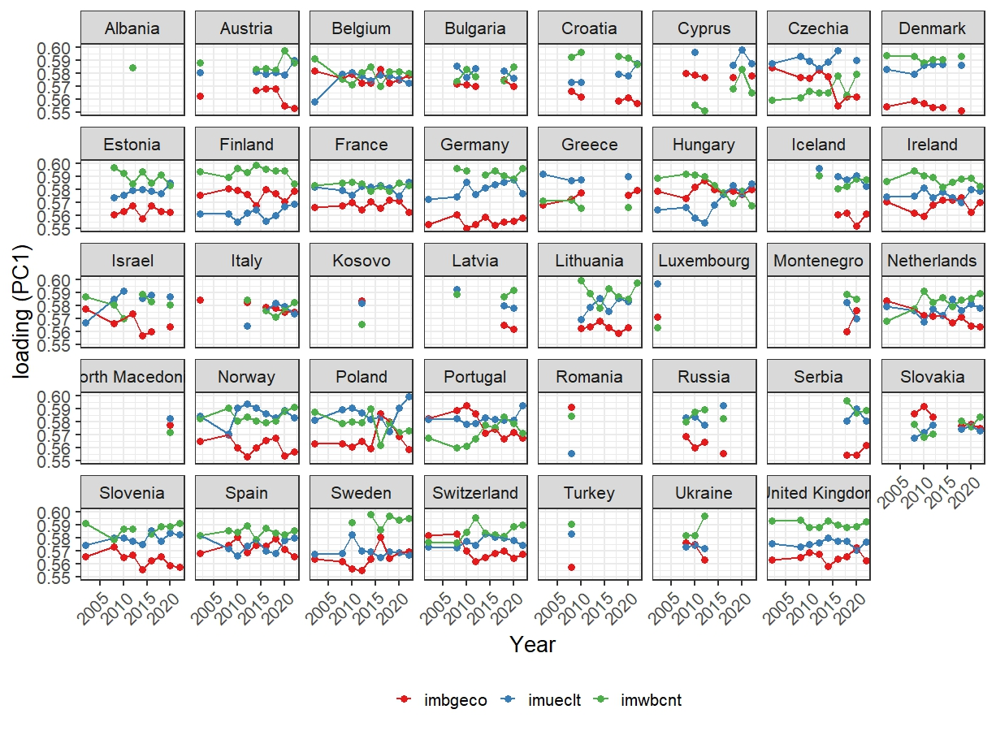

**Fig 6.1** The loadings of PC1 for all countries and years. The plot shows how for several countries, not all rounds were available. Some countries, for example Albania, Kosovo and Romania, only participated once, meaning for those countries, no trend analysis would have been possible. However, even those countries could be included when calculating the European averages. More importantly is, that Germany and Hungary participated in enough rounds to conduct meaningful trend analyses.