**TBPS NOTES ON ANGULR OBSERVABLES**

**The full Decay Rate**

Neglecting Lepton masses, the differential decay rate of , as a function of the angular observables, is the sum of coefficients containing information of decay amplitudes [1][2][5]:

for a total of **12** parameters. Luckily it can be simplified in the limit of negligible (massless leptons):

* vanishes
* and .
* Dilepton mass distribution normalisation .

bringing us to a total of 8 parameters. Still many.

**The full Decay Rate**

We shall move to its CP-averaged version [3]. In fact, define the CP-averaged coefficients [2]:

As with , in the limit of massless leptons:

This allows us to define the the longitudinal polarisation coefficient of , which is [1]

Then, we have the 8 parameters beast:

Frequent in literature are the forward-backwards asymmetry and the transverse polarisation asymmetry [1] [5]:

**PS Conversion**

From [1] [3] also

and from [4]

**The “easy ones” from Integration**



Stefano’s note: I think is .

Hence allow us to find . From [5] also

**The Folding Approach**

From [1], with transformations confirmed in [4]:

For :

For :

For :

For :

For :

**The Counting Approach (from [6])**

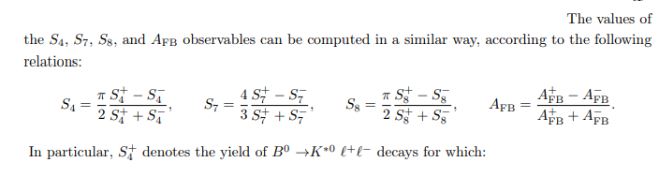

**Literature Values**

From [7]:

**References**

[1] De Cian M. Track Reconstruction Efficiency and Analysis of at the LHCb Experiment. 2013, Sep. Available at <https://cds.cern.ch/record/1605179>.

[2] Altmannshofer W, et al. Symmetries and Asymmetries of B → K∗µ +µ − Decays in the Standard Model and Beyond, JHEP 0901 (2009) 019. Available at <https://arxiv.org/pdf/0811.1214.pdf>.

[3] (Belle collaboration) S. Wehle et al. Lepton-flavor-dependent angular analysis of B → K∗ ` +` −, Phys. Rev. Lett. 118 (2017) 111801, arXiv:1612.05014. Available at <https://journals.aps.org/prl/abstract/10.1103/PhysRevLett.118.111801>.

[4] ATLAS Collaboration Angular analysis of B 0 d → K ∗µ +µ − decays in p p collisions at √ s = 8 TeV with the ATLAS detector. Available at <https://arxiv.org/pdf/1805.04000.pdf>.

[5] (LHCb collaboration) Aaij R, et al. Differential branching fraction and angular analysis of the decay B0→ K∗0µ+µ−. Available at <https://arxiv.org/abs/1304.6325>.

[6] Lionetto F. Measurements of Angular Oservables of and Decays and the Upgrade of LHCb. 2018, Feb. Available at <https://cds.cern.ch/record/2624938>. (Pages 94-96)

[7] LHCb collaboration. Angular analysis of the B0→ K∗0µ+µ− decay using 3 fb−1 of integrated luminosity. Available at <https://arxiv.org/pdf/1512.04442.pdf>.

**RESULTS**

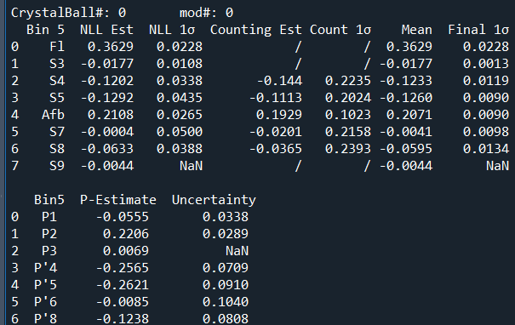

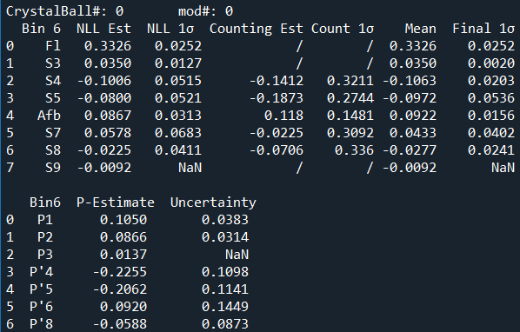

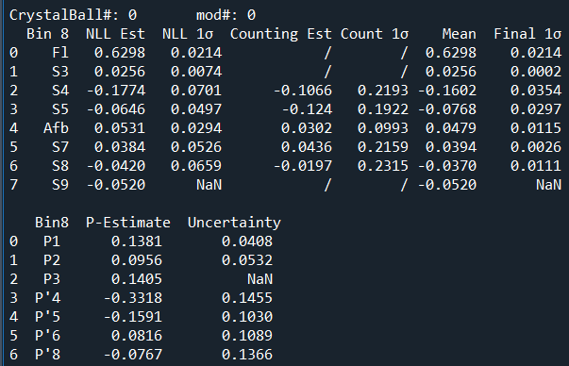

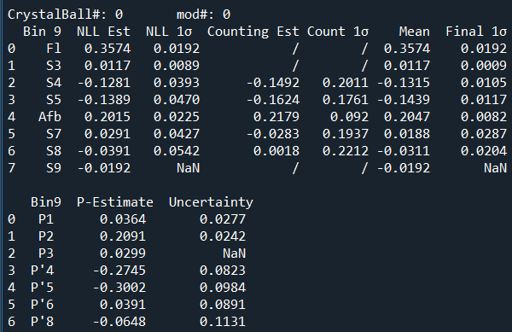

|  |  |
| --- | --- |
| **Backrground & Misclassification** | |
|  |  |
|  |  |
|  |  |
|  |  |
|  |  |
|  |  |

