WorkX Time and Attendence

Stefanos Sophocleous

CST-451 Capstone Project Final Architecture & Design

Grand Canyon University

Instructor: Professor Mark Reha

Revision: 2

Date: 04/14/2022

**ABSTRACT**

At Workx our team strives to achieve one simple goal, provide the best product while ensuring the highest quality service. For companies that are looking to stay up to date with the latest technologies or have simply outgrown their current HR infrastructure, Workx is here to help. Managing the employee experience is something our team values and believe if there is a centralized place for them to punch into work and view their schedules less time will be wasted.

Through this software, executives will have administrative accounts with access to a dashboard to conduct their tasks in an aesthetically pleasing platform. The dashboard will be used to perform a range of operations to make sure the employees are organized and have a successful experience. Avoiding unforced errors made by outdated or overly complex technology, is something we aim to push our partners away from.

|  |
| --- |
| History and Signoff Sheet |

**Change Record**

|  |  |  |
| --- | --- | --- |
| **Date** | **Author** | **Revision Notes** |
| March 3rd 2022 | Stefanos Sophocleous | The project has now shifted back to Angular and it was approved by the professor. The project was leveraging thymeleaf for the front end before. |
| April 14th 2022 | Stefanos Sophocleous | Updated – UML front end to Angular JS. (Reflects Components) Updated – Logical Flow Diagrams. Updated – Backend UML Diagram. Updated ADMIN SIDE sitemap. Updated ER Diagram. |
| April 10th 2022 | Stefanos Sophocleous | Communicated to professor that Calendar Functionality does not save to a Database. The documentation changes will reflect that change and other changes from the front end! Updated API Documentation Design for the entire project leveraging Postmans documentation services. Additionally, Updated the UI Sitemaps to be more accurate. |

|  |
| --- |
| **Overall Instructor Feedback/Comments** |

|  |
| --- |
| **Overall Instructor Feedback/Comments** |

**Integrated Instructor Feedback into Project Documentation**

Yes  No

**TABLE OF CONTENTS**

Design Overview 4

Detailed High-Level Solution Design 5

Detailed Technical Design 6

Appendix A – Technical Issue and Risk Log 7

Appendix B – References 8

Appendix C – External Resources 9

Design Introduction

|  |  |  |  |  |  |
| --- | --- | --- | --- | --- | --- |
| Deliverable Acceptance Log | | | | | |
| ID | Deliverable Description | Comments | Evaluator (internal or external as applicable) | Status | Date of Decision |
| 1 | High Level Solution | N/A | Internal | Done | 11/21/2021 |
| 2 | Physical Solution | N/A | Internal | Done | 11/21/2021 |
| 3 | Logical Solution | N/A | Internal | Done | 11/21/2021 |
| 4 | ER Diagram | N/A | Internal | Done | 11/21/2021 |
| 5 | DDL Scripts | N/A | Internal | Done | 11/21/2021 |
| 6 | Process Flow Admin/Employee | N/A | Internal | Done | 11/21/2021 |
| 7 | UML Class Digrams Backend/FrontEnd | N/A | Internal | Done | 11/21/2021 |
| 8 | UserInterface Admin/Employee | N/A | Internal | Done | 11/21/2021 |
| 9 | Service API Design | N/A | Internal | Done | 11/21/2021 |
| 10 | NFR | N/A | Internal | Done | 11/21/2021 |
| 11 | Operational Support Design | N/A | Internal | Done | 11/21/2021 |
|  |  |  |  |  |  |

Detailed High-Level Solution Design

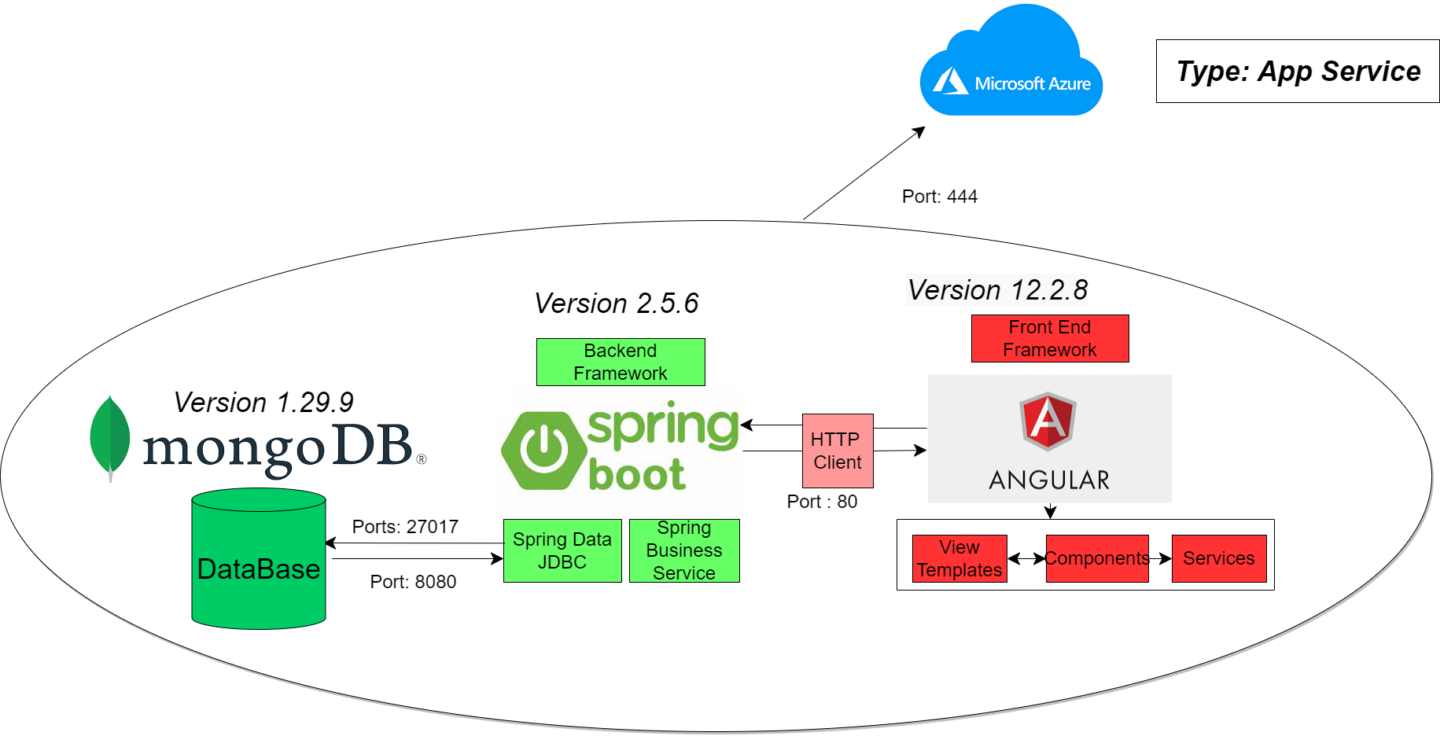

|  |  |  |
| --- | --- | --- |
| Proof of Concepts | |  |
| **Description** | **Rationale** | **Results** |
| 1.Login Register Application | Test Mongo DB working with Spring Boot | Was able to successfully implement these technologies |
| 2 – Youtube Clone Application | Test Mongo DB, working with Spring Boot, and Angular JS with Azure | Was able to successfully implement all working technologies in a live environment |
| 3 – Blog Application | Test Spring Boot with Angular JS | Was able to successfully implement all working technologies in a live environment. |
| 4 - |  |  |
| 5 - |  |  |

|  |
| --- |
| Hardware and Software Technologies |
| 1 -Mongo DB |
| 2 – Spring Boot |
| 3 – Angular JS |
| 4 – Azure Web Apps |
| 5 -Intellije IDE |

**Logical Solution Design:**

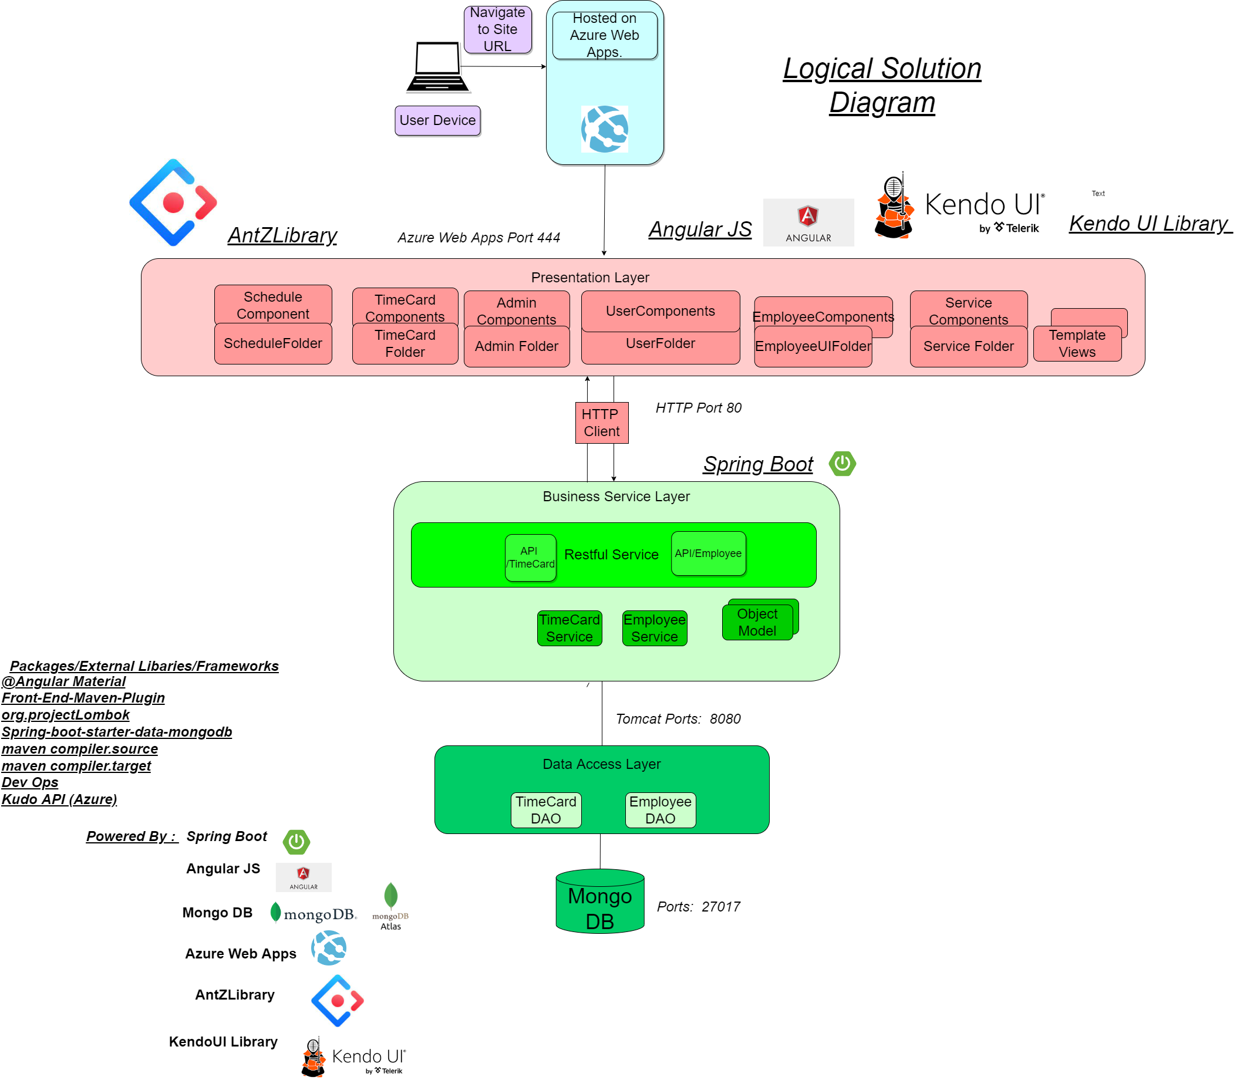

**Physical Solution Design:**

**General Technical Approach:**

The general technical approach to all designs were originated off a detailed sitemap of the website. I started by designing what I wanted my web application to look like and worked backwards from there. I removed functionality along the way and was able to understand at a high-level what datatypes would be needed. I met with my mentor Professor Mark Reha multiple times throughout this process to make sure my designs were practical. In one of our brainstorming sessions, we talked about how data was going to be passed and the requirements that would be needed to be met. We also talked about specific libraries that would need to be used for this project and he assisted me on my understanding of using APIs in a full stack environment.

**Key Technical Design Decisions:**

A Key technical design decision was to build prototypes and to simulate similar package / maven requirements that I would need to download. In a full stack application, the biggest technical challenges will be the dependences and additional technologies that will need to be included. The technical decisions for using MongoDB was because our team wanted to explore the high level capabilities of a non-relational database. Spring Boot was implemented for the backend, because of its highly effective libraries and the ability to avoid writing boiler plate code. Angular JS was implemented to take the design specifications to the next level and to implement a better way of passing data from the business service. In my proof of concepts, a majority of the work was implementing project setup and the foundation of how WorkX Time and Attendance would be built on.

**Database ER Diagram:**

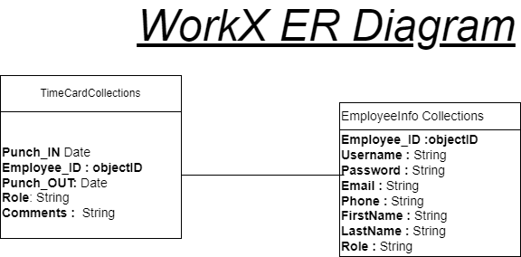

**Database DDL Scripts:**

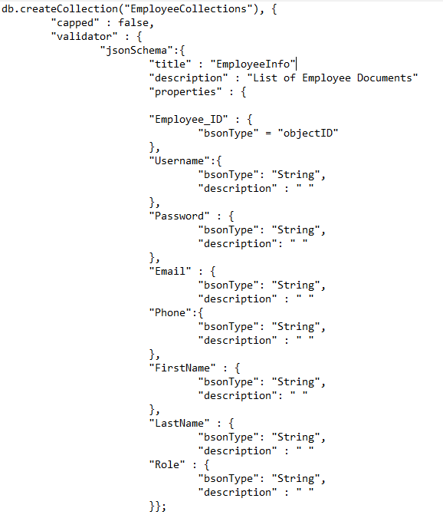

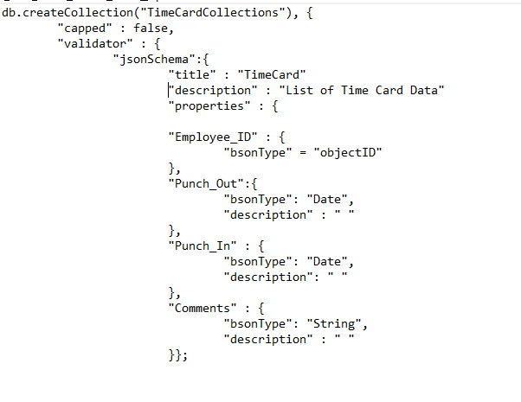

**Flow Charts/Process Flows:**

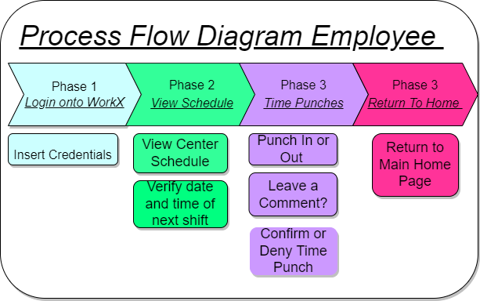

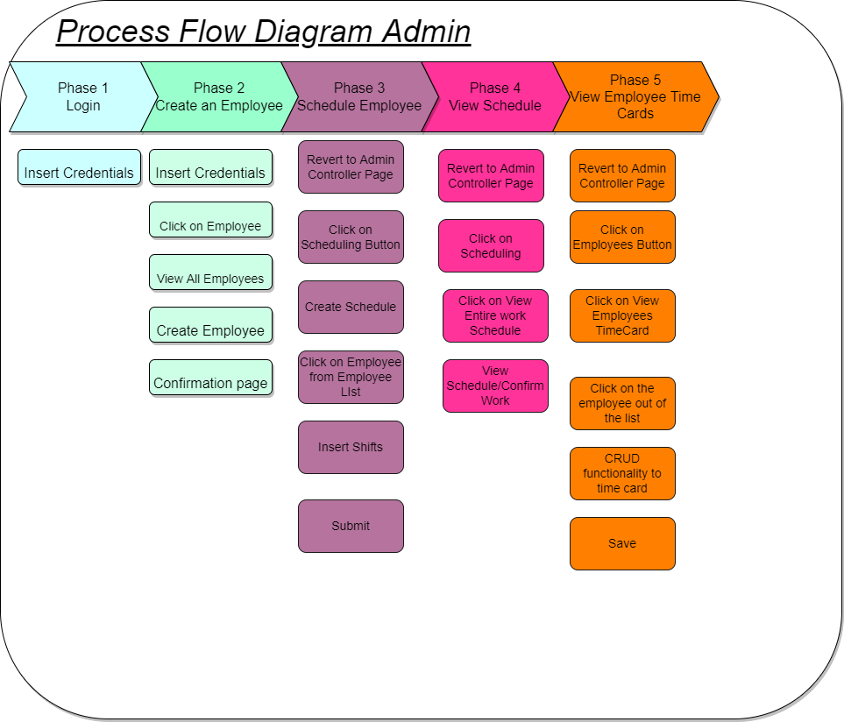

**Sitemap Diagram:**

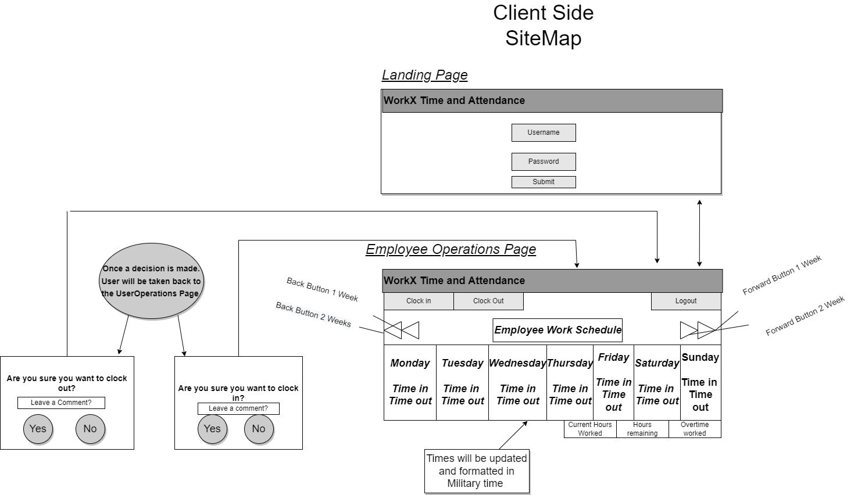

* Was Unable to effectively increase visibility for Administrator Side Sitemap. To view please zoom in on the document. I apologize for the inconvenience.

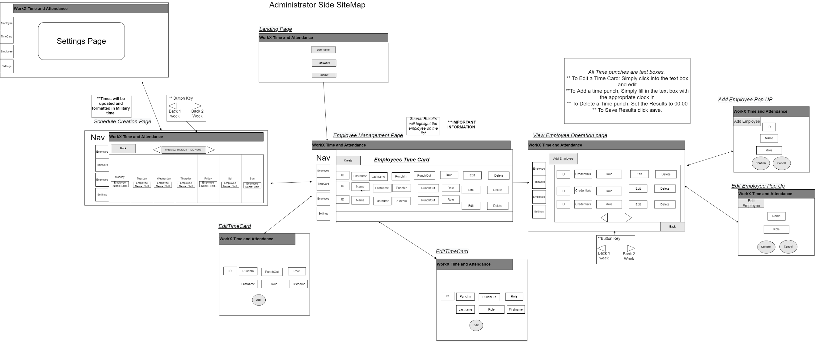

**User Interface Diagrams:**

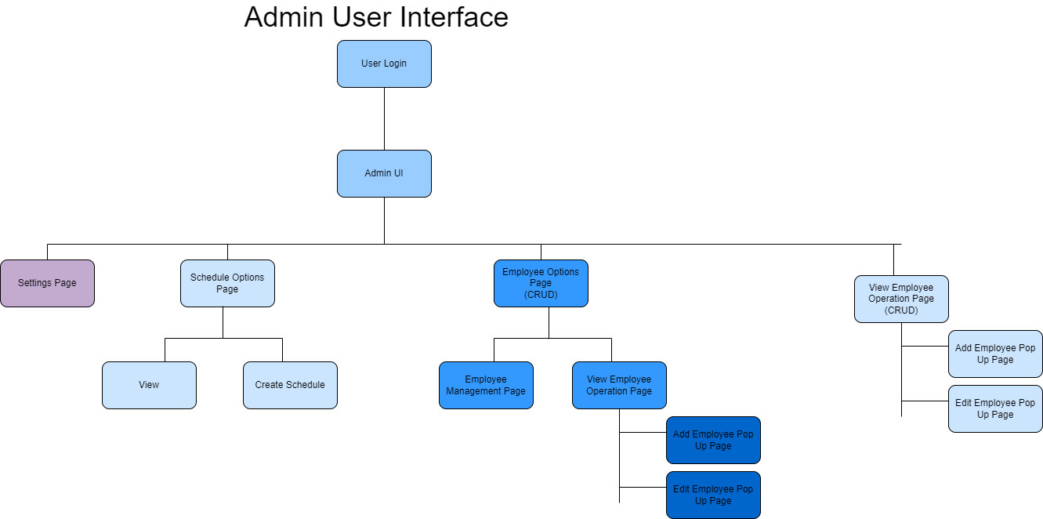

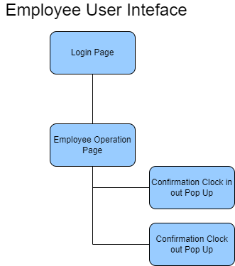

**UML Diagrams:**

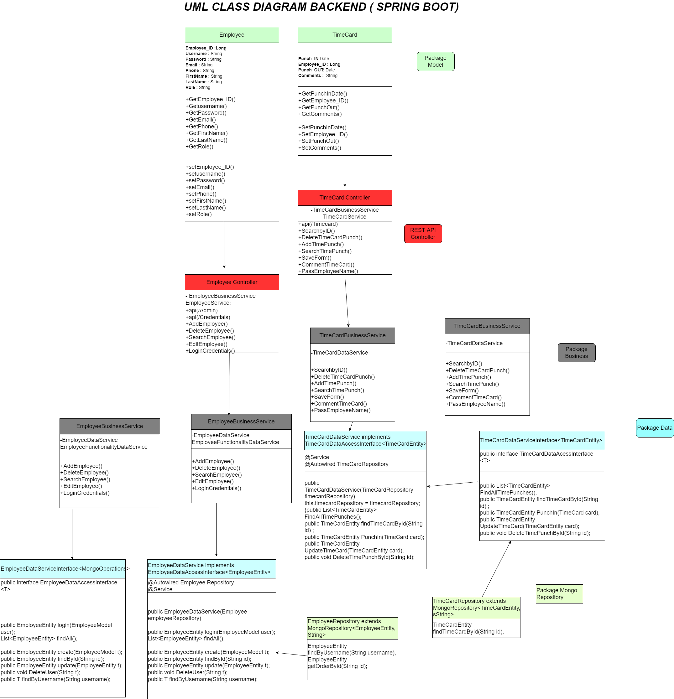

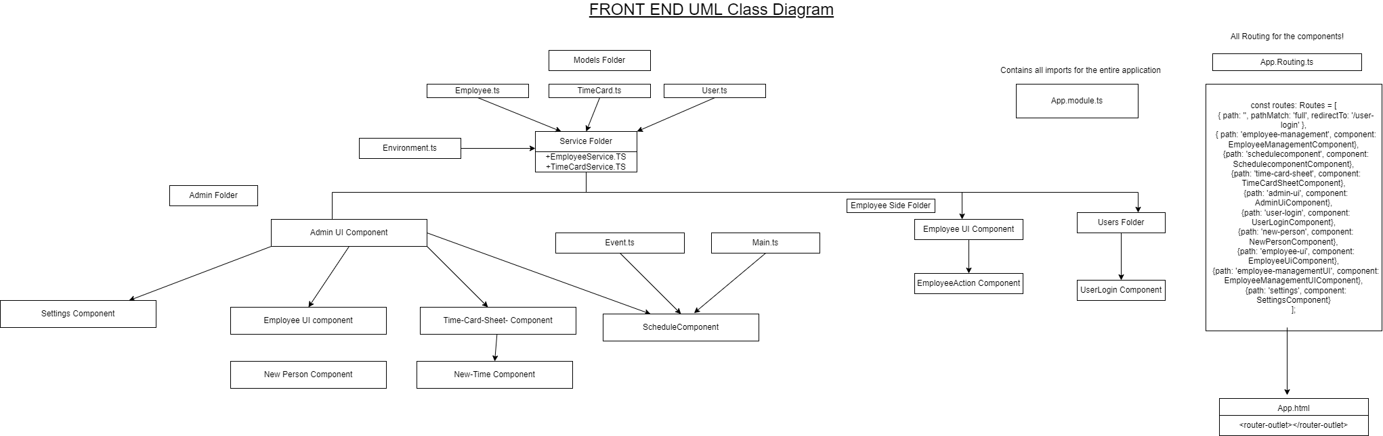

**Service API Design Documents**

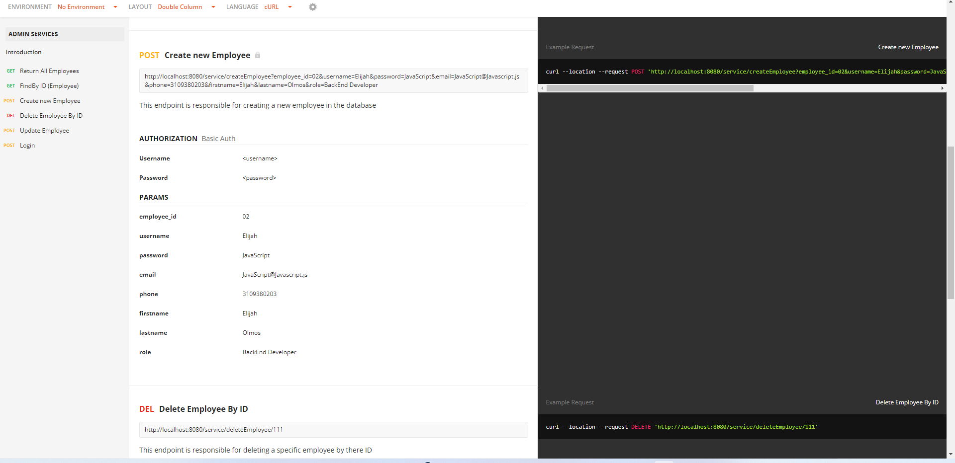

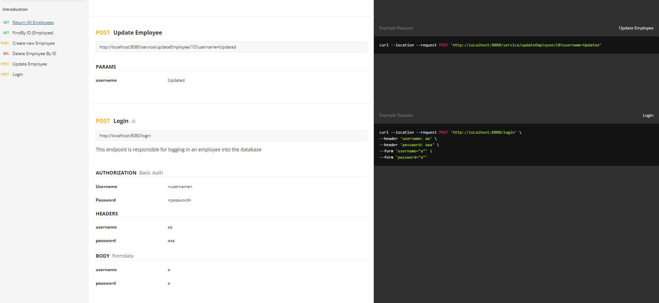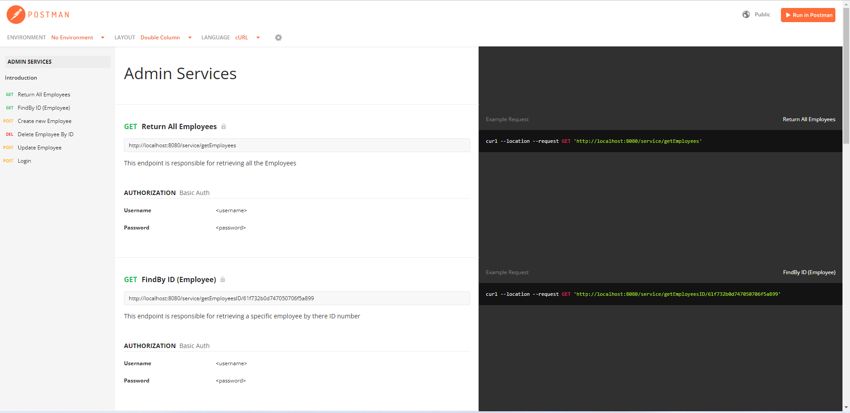

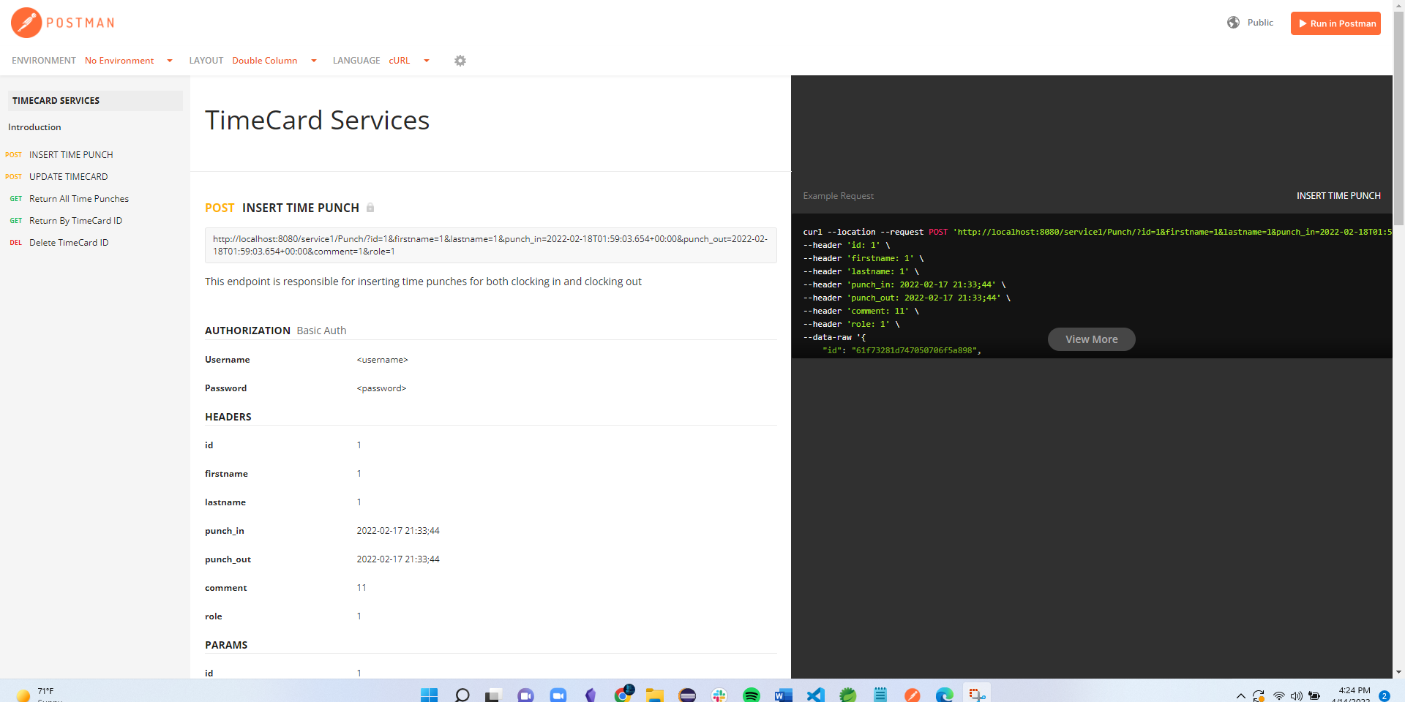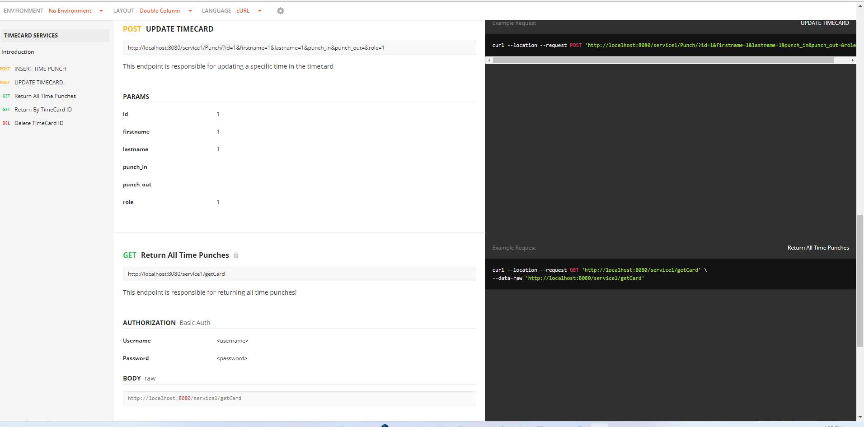

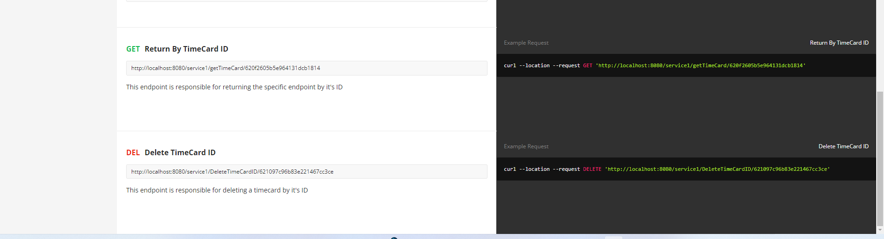

**NFR’s (Security Design, etc.):**

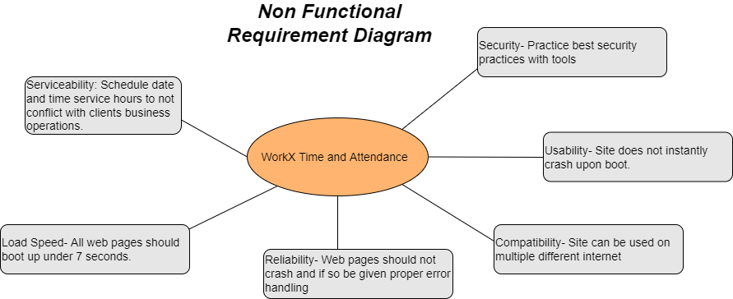

**Operational Support Design:**

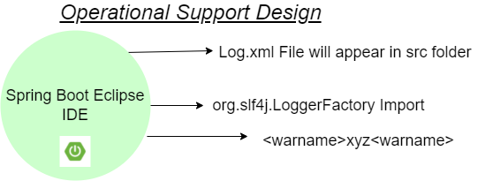

**Other Documentation:**

N/A

Appendix A – Technical Issue and Risk Log

1. Use the template to identify and monitor project issues and risks.

|  |  |  |  |  |  |  |  |  |
| --- | --- | --- | --- | --- | --- | --- | --- | --- |
| Issues and Risk Log | | | | | | | | |
| **Issue or Risk** | **Description** | **Project Impact** | **Action Plan/Resolution** | **Owner** | **Importance** | **Date Entered** | **Date to Review** | **Date Resolved** |
| I/R | What is the issue or risk? | How will this impact scope, schedule, and cost? | How do you intend to deal with this issue? | Who manages this issue? |  |  |  |  |
| Issue | Eclipse Spring Boot IDE is giving the development team to many technical issues | Project will be needed to be developed in Intellije Instead | Communicate with Mentor and request permission to use Intellije as the main IDE | Project Manager | High | 11/20/2021 | 11/21/21 | Conversation with mentor has to take place. On 11/22/2021. Development with Intellije has been proven to be successful |
|  |  |  |  |  |  |  |  |  |

Appendix B – References

“Web App Service: Microsoft Azure.” *Web App Service | Microsoft Azure*, https://azure.microsoft.com/en-us/services/app-service/web/.

*Https://Angular.io/Docs*.

[*Https://SpringBoot.io/Docs*](Https://SpringBoot.io/Docs)

*https://www.udemy.com/course/the-complete-angular-master-class/learn/lecture/7348992?start=165#overview*

*Mark Reha 451 Course Padlet*

Appendix C – External Resources

|  |  |
| --- | --- |
| **GIT URL:** | *Backend Github Link:* *https://github.com/StefanosINC/HerokuCapstone*  *Front End Github Link: https://github.com/StefanosINC/frontend-ui* |
| **Hosting URL:** | *The Hosting URL (if applicable).* |