***Paper prototypes***

**INITIAL PROTOTYPES**

**Calories Tab**: Select workout type through pull-down menu, duration and calculation of calories after pressing ‘Calculate’ button.

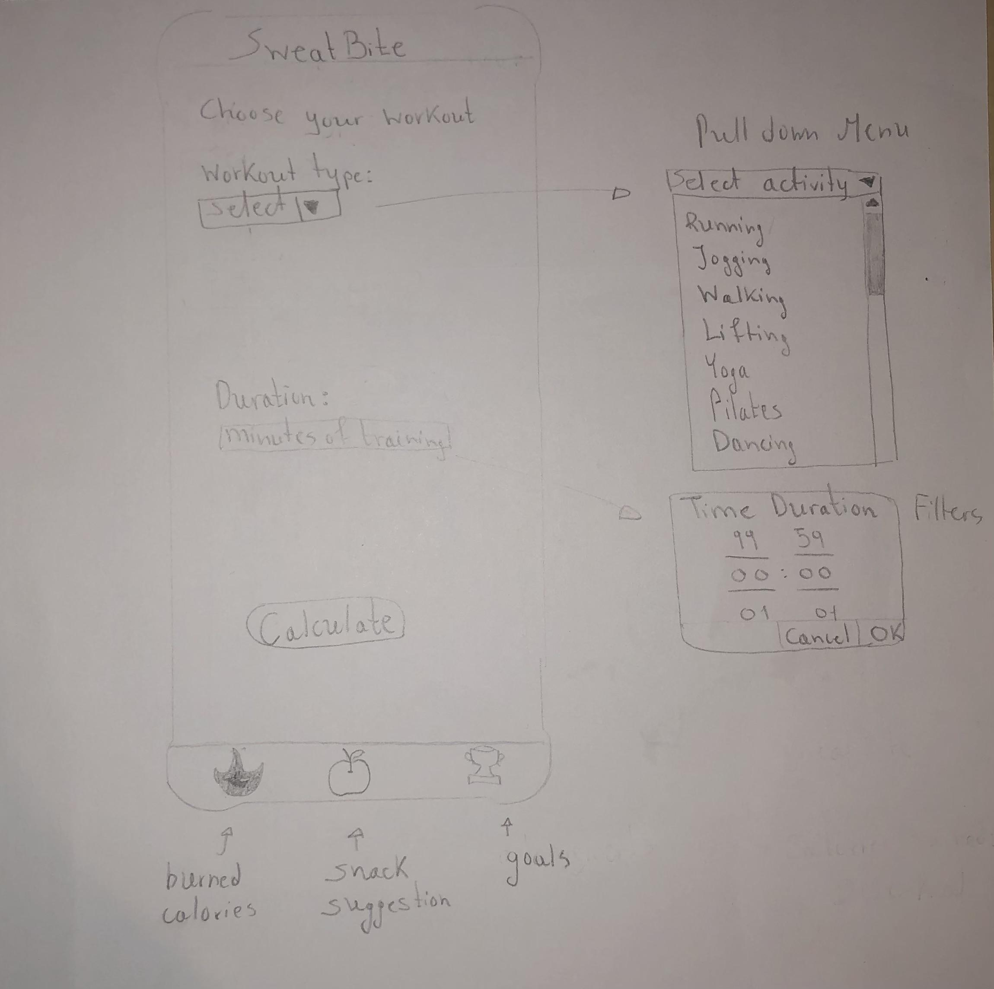

**Snacks Tab:**

* Choose between two radio button options and view snacks suggestions as cards with some basic description, from which the user can choose.

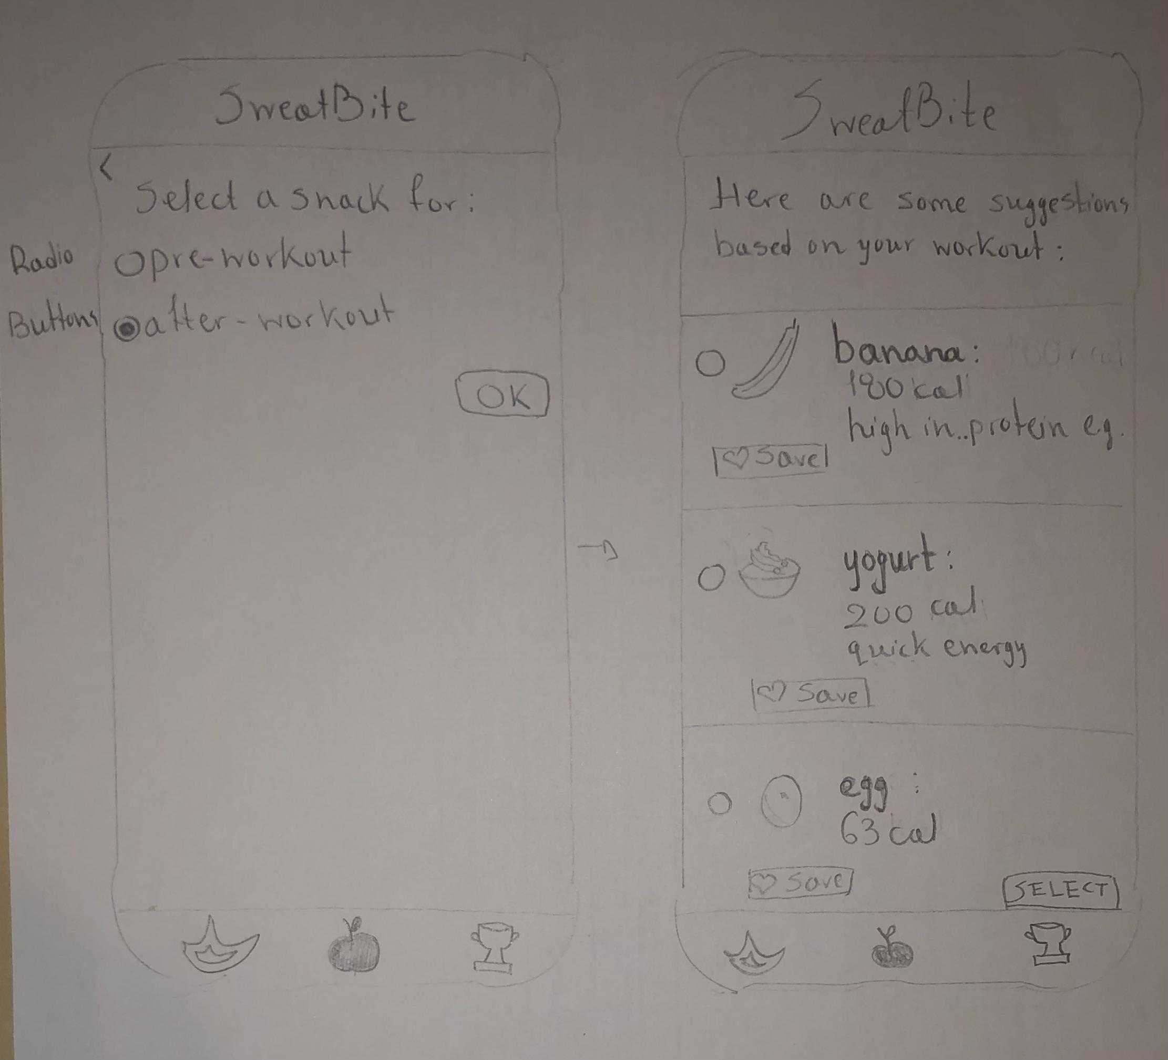

**Goals Tab:**

* Tap button ‘+’ to set a new goal. Initially the goal was only one - calculate burned calories, with different options depending on the duration of the goal.

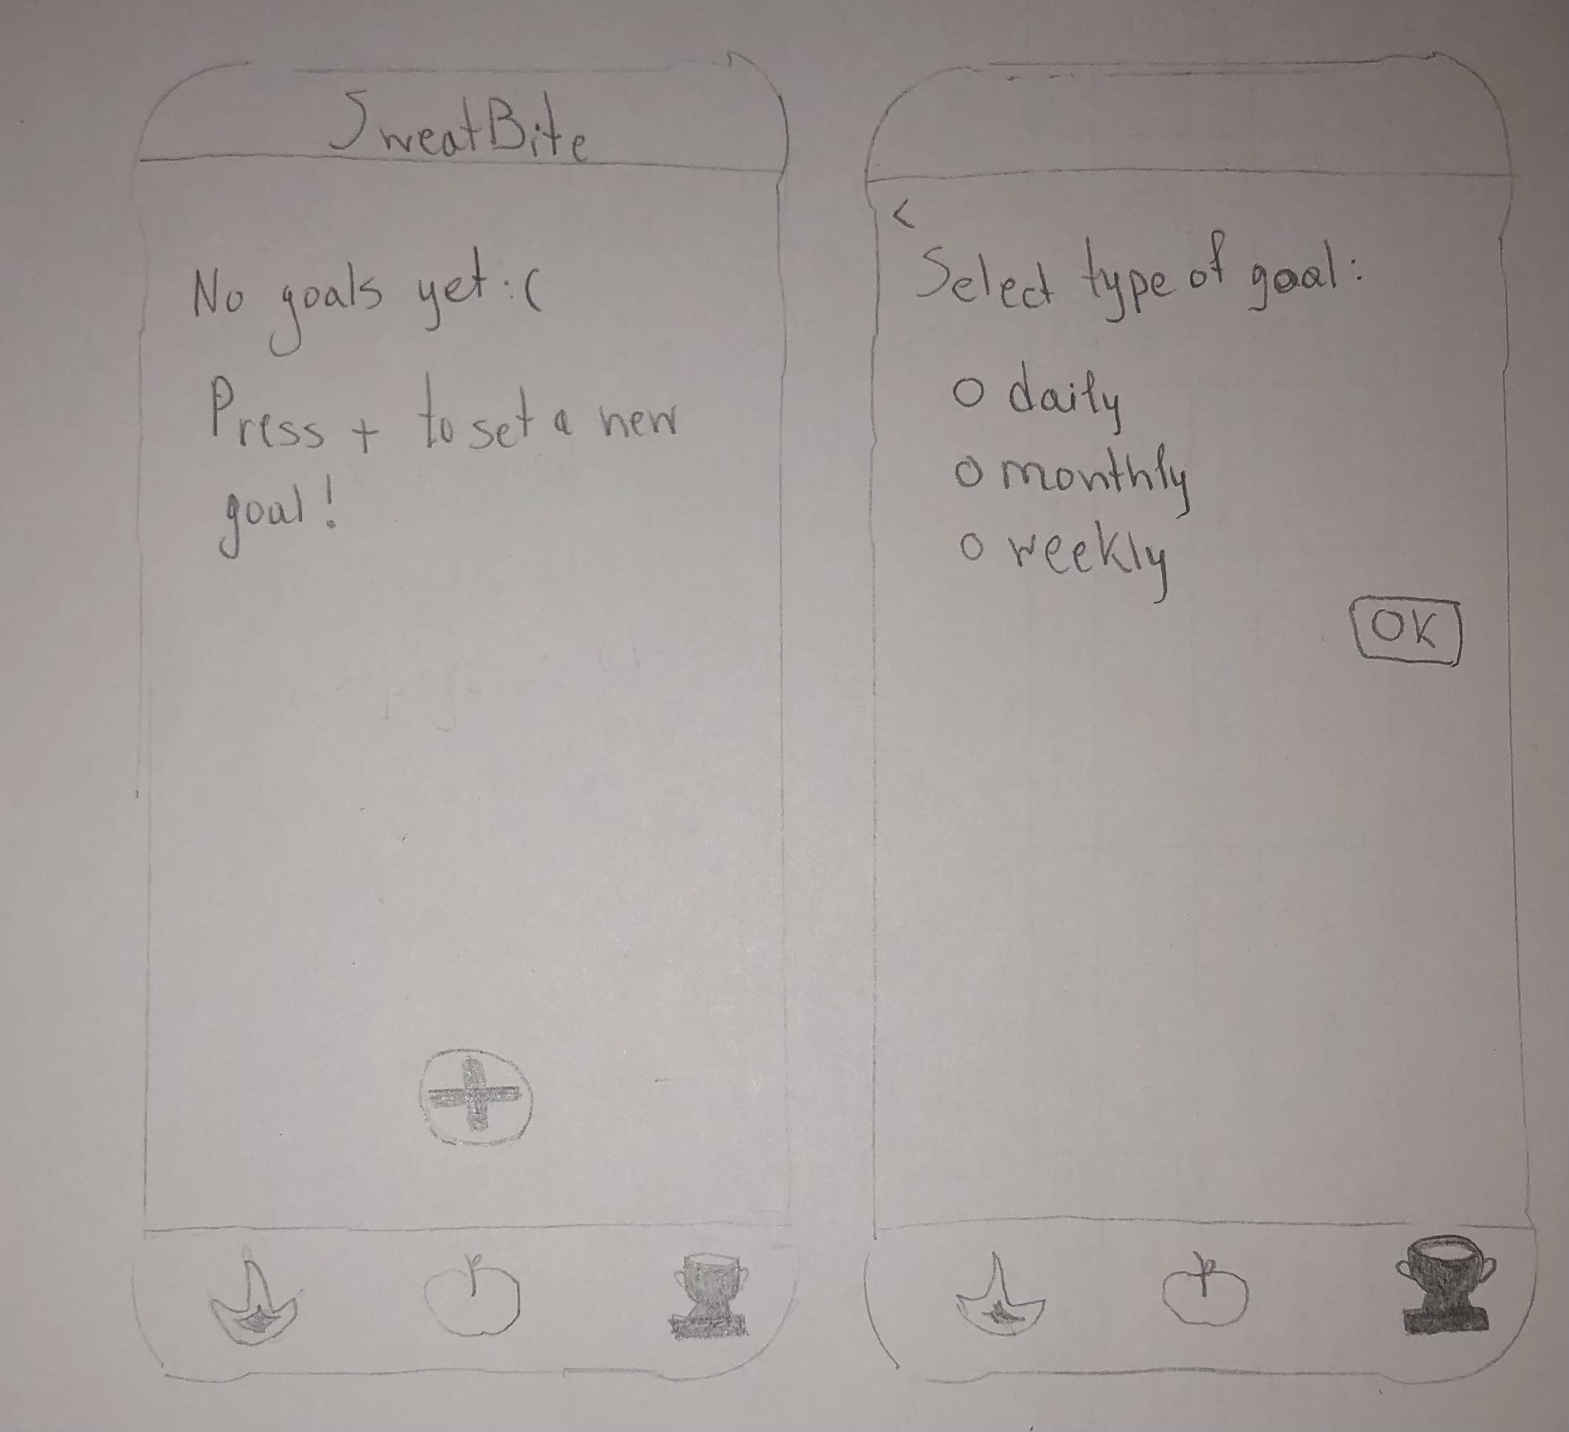

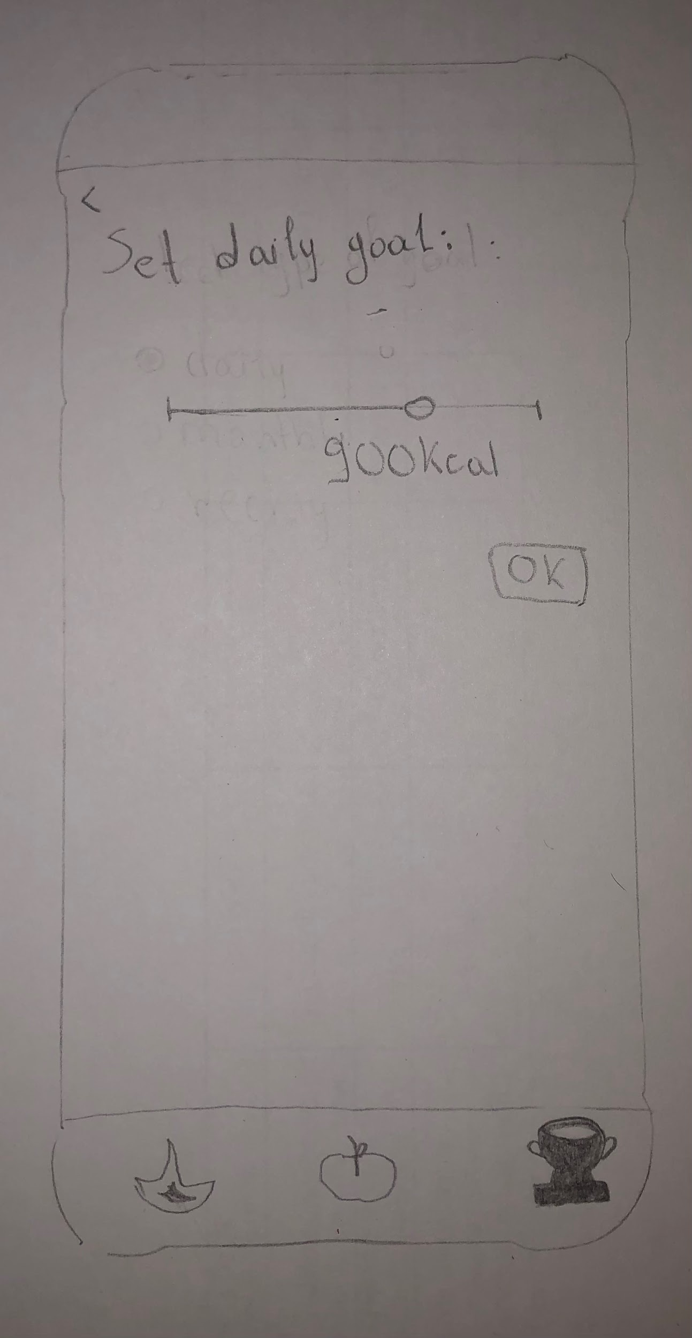

**IMPROVED PROTOTYPES**

Calories Tab:

* real-time calculation of calories instead of manual calculation
* No ‘calculate’ button
* Workout type is a modal and not a small pull-down menu
* Duration can be chosen through a slider
* It does not navigate the user automatically to the Snacks tab, instead there is a label encouraging him to go to the Snacks tab to get suggestions.

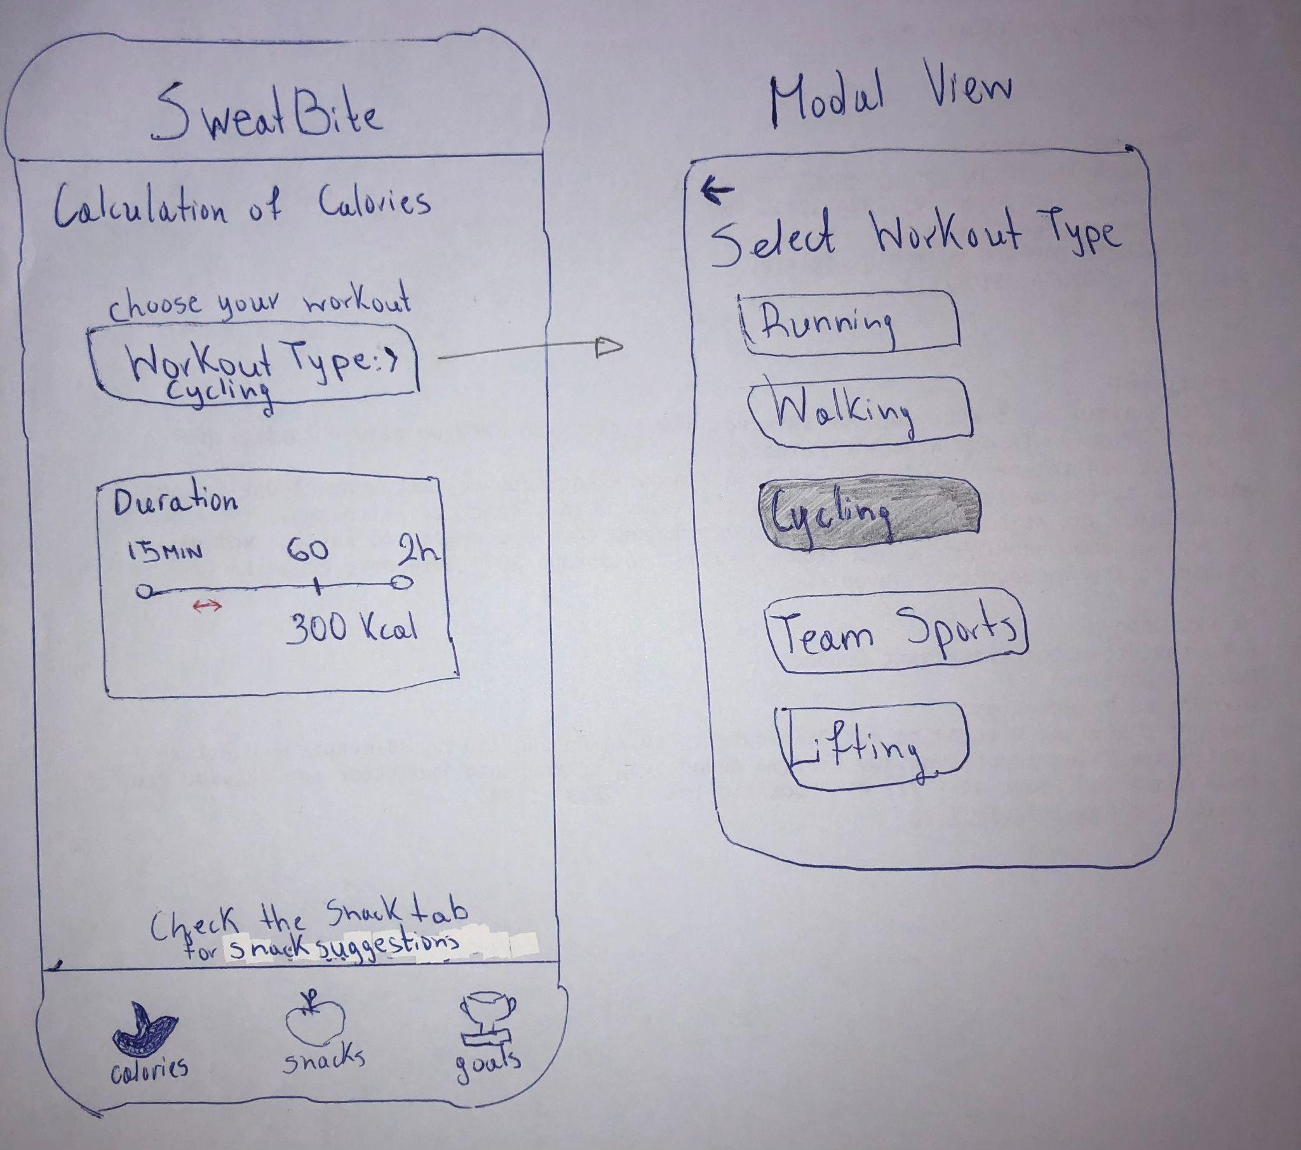

**Snacks Tab**

* Pre-workout snack based on intensity of workout the user wants to perform (modal view)
* Snack suggestions as cards in a list and not options to choose from, since the selection of the snack does not benefit anything and it confuses the users.

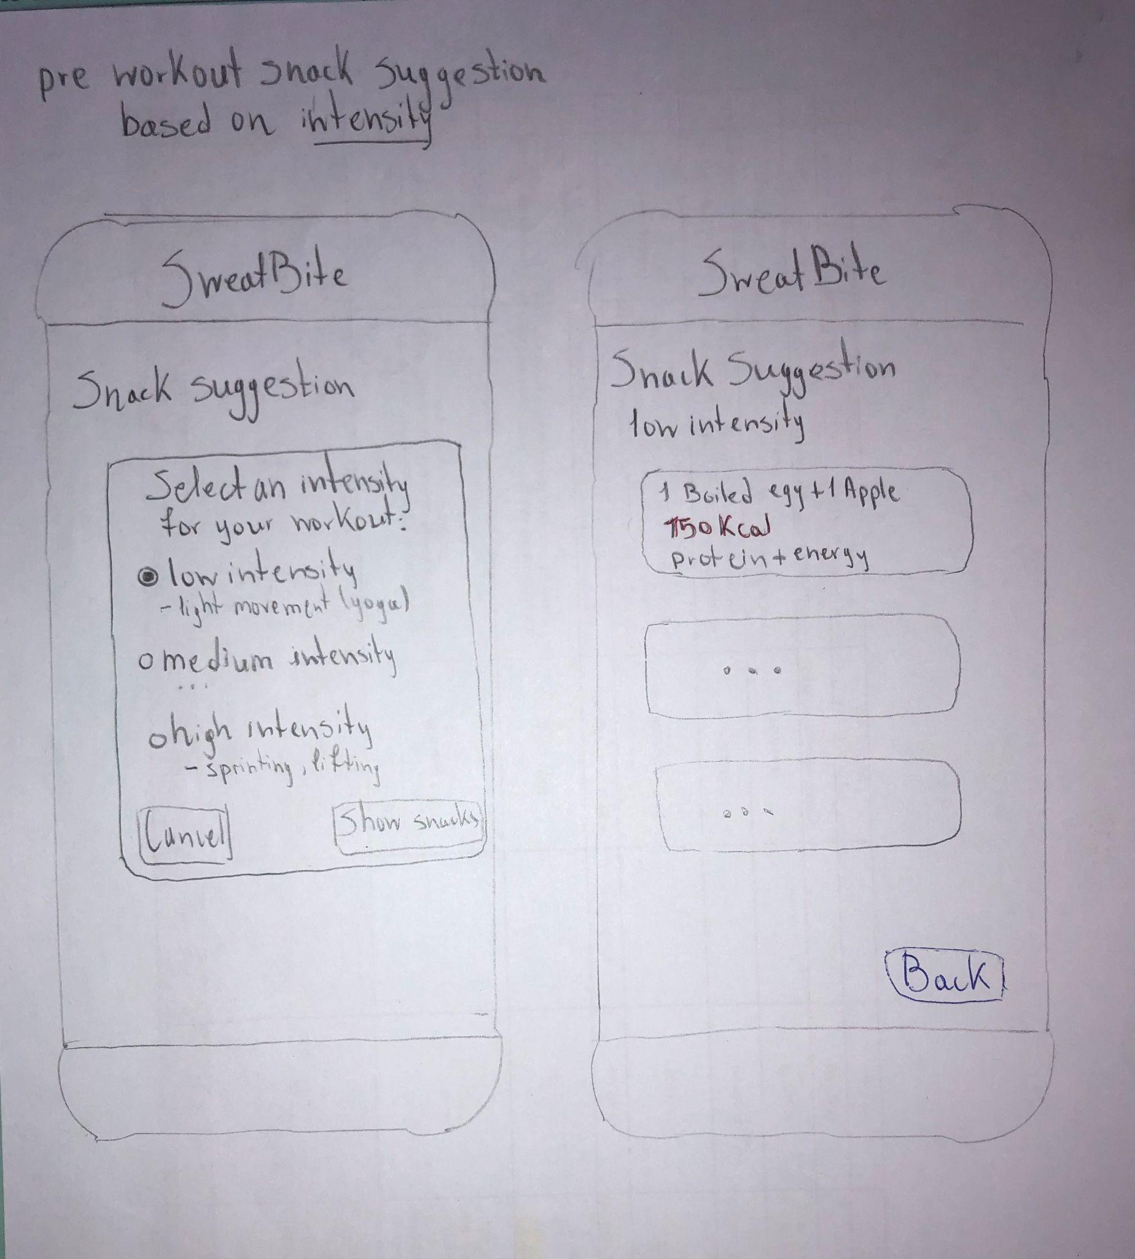

* After-workout snack based on recent workouts: the user can choose one of his latest workout to get a snack suggestion on(modal view)
* Snack suggestions are shown in a list of cards, on top there is a basic summary of the workout

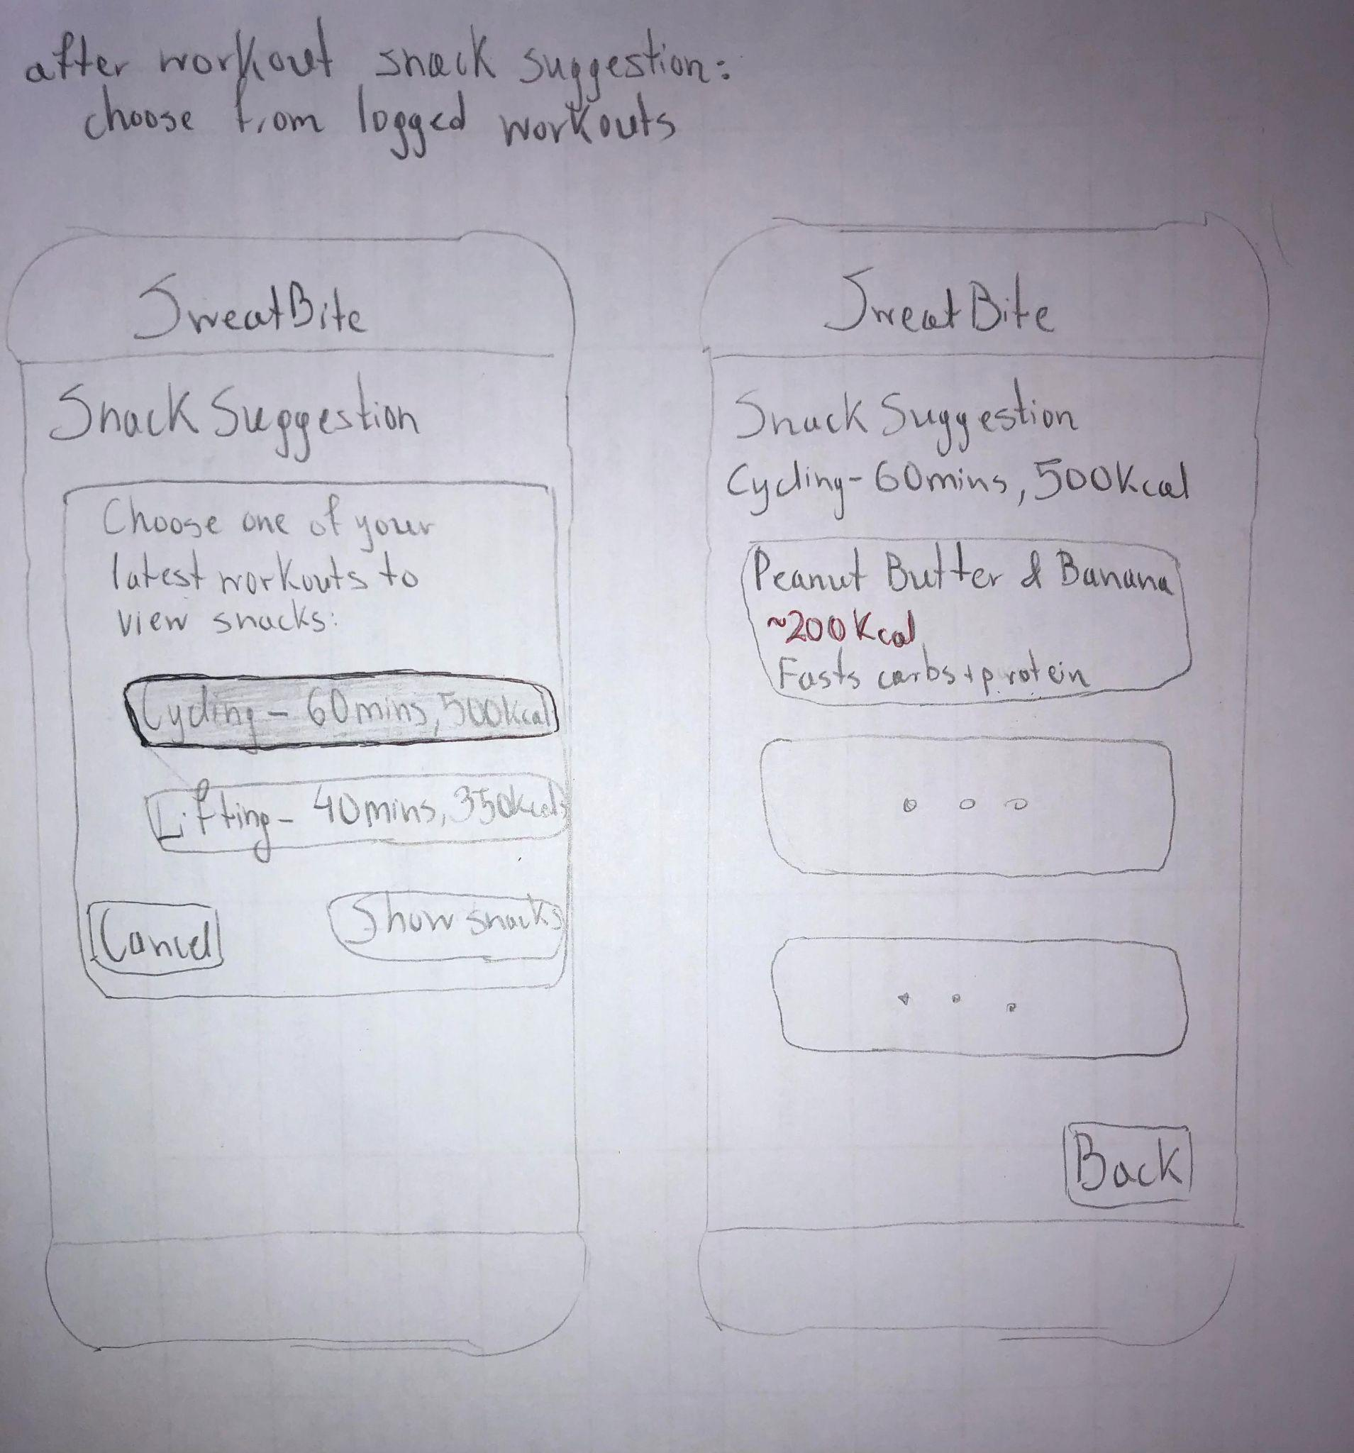

**Goals Tab**

* The user can set between two goals(shown in a modal view as a radio button with description).

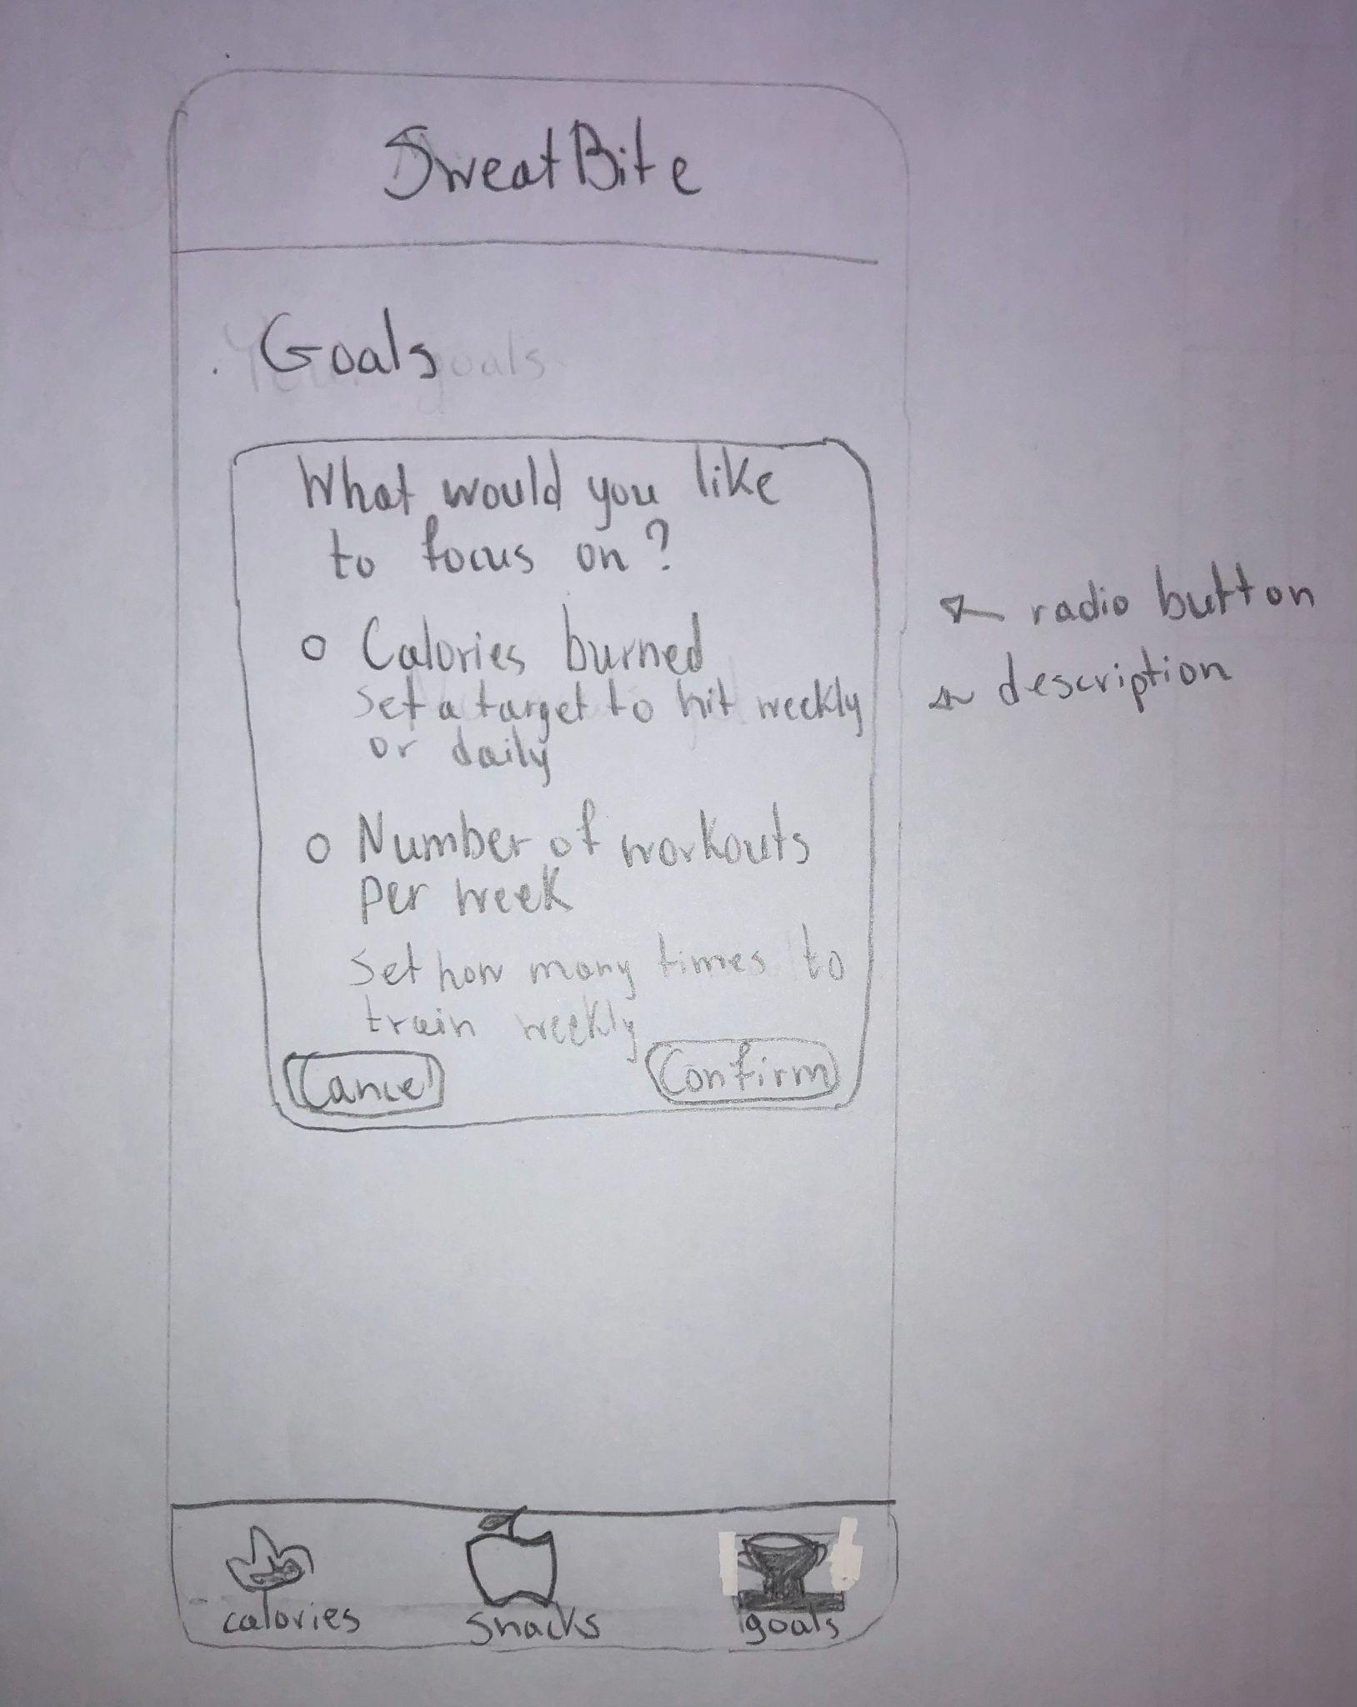

* The user can view all of his goals, completed or not, as well as their progress in the Goals Tab and delete the ones he does not longer need.

