FringeIsland
How we work
The FringeIsland development system — four axes, five diagrams, seventeen flagged gaps.

Authored 2026-04-19
Living document — updated when canonical sources change

Overview
This document describes how FringeIsland is actually developed — end-to-end, from ecosystem purpose down to the shipped code. It has two purposes: a self-orientation aid for the sole developer, and onboarding material for future contributors.
The development system has four axes. Each axis is described in its own chapter with a diagram and prose. You can read them in any order, but the order below is the one that builds understanding fastest.
Chapters
- Chapter 1 — Decomposition cascade. How work descends from ecosystem vision down to individual tasks. The vertical axis.
- Chapter 2 — Cadence and waves. How time is structured. Cycles, cooldowns, retros, the six waves. The horizontal axis.
- Chapter 3 — Execution: backlog and kanban. How items move through refinement into an active cycle board.
- Chapter 4 — Execution: the build loop. What happens when a task is being worked on. Research, plan, annotate, implement. BDD and TDD.
- Chapter 5 — Agent routing. How an agent or human enters the system and builds context. The routing axis that wraps everything else.
- Consolidated gaps register. Seventeen flagged gaps across the four axes, grouped and prioritised.
On gaps
The system has known documentation and design gaps. They are flagged inline in each chapter and consolidated at the end of the document. The gaps are surfaced honestly because the primary audience for this document is using it to spot what is missing. Future contributors should treat the gap list as a to-do, not a stable description of the system.
As of this writing, there are seventeen flagged gaps across the four axes. None of them is blocking current solo-operator work. All of them compound as the system scales toward the fifty-plus-contributor target.

1 — The decomposition cascade
The vertical axis. How work descends from ecosystem purpose down to the tasks that ship code. Five levels, five verticals threading through every level, three unresolved gaps.
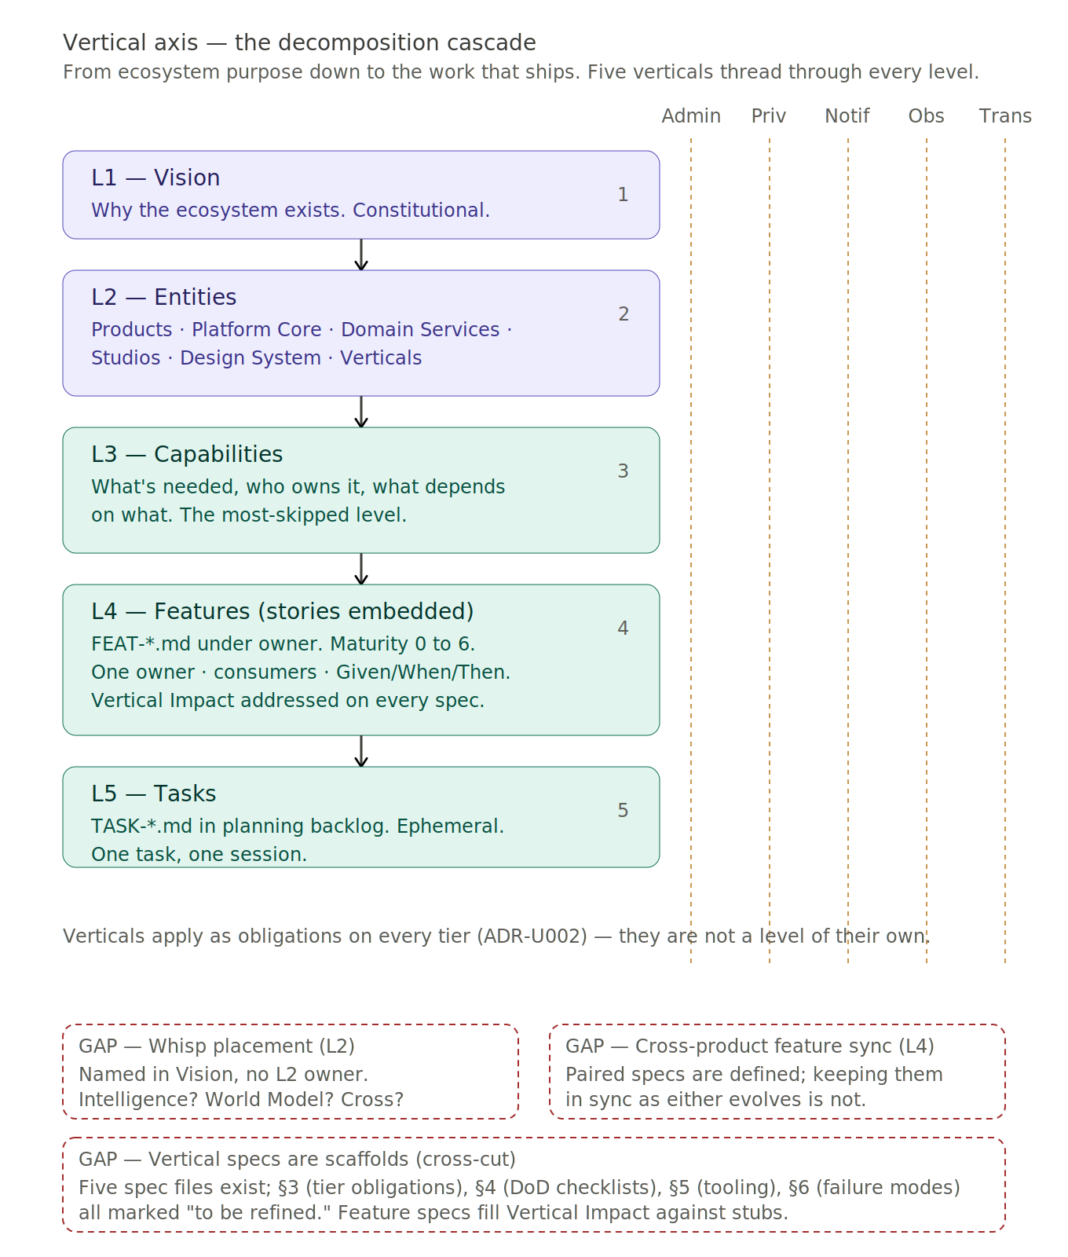

What this shows
Work in FringeIsland lives in a five-level hierarchy. The same idea moves down the levels as it matures — vision-level questions become entities, entities become capabilities, capabilities become features, features become tasks. Each level answers a different question at a different frequency.
- L1 — Vision. Why does this ecosystem exist? docs/ecosystem/VISION.md.
- L2 — Entities. What are we building and for whom? Products, platform, studios, design system, verticals.
- L3 — Capabilities. What capabilities are needed, who owns them, what depends on what? The most-skipped level.
- L4 — Features. How is each capability specified? Stories with Given/When/Then live inside feature specs.
- L5 — Tasks. What implementation work is needed? Ephemeral — deleted after the cycle retrospective.
A single feature spec file carries the feature from maturity 0-raw all the way to 6-done. The state is tracked in YAML frontmatter, not by which folder the file lives in.

The five verticals thread through every level
Running vertically through the diagram are five amber dashed columns — Administration, Privacy/GDPR, Notifications, Observability, Transactions. These are not a sixth level; they are obligations that cut through every level.
The verticals exist because vision-level principles demand them. "Privacy over commercial opportunity" is a founding principle — Privacy as a vertical is how that principle becomes operational at every tier below. The same pattern applies to the other four. They are locked at five by ADR-U002.
Every feature spec template mandates a Vertical Impact section addressing all five verticals. No blanks. If a feature does not touch a given vertical, the spec says "None" with rationale — the vertical still gets addressed, just negatively.

Why this axis matters
The decomposition cascade is the architecture of the development process, not just of the code. Documentation hierarchy, folder structure, README cascades, and YAML frontmatter function as the API for the entire development process. Getting this axis right is the difference between a solo developer’s convenience tree and an ecosystem that fifty contributors can navigate without getting lost.
Every ambiguity at this level propagates downward. A fuzzy L2 ownership produces ambiguous L4 spec homes. A skipped L3 capability map produces L4 specs without dependencies named. An unpopulated vertical spec at the cross-cut produces L4 specs with quiet assumptions.

Gaps on this axis
- G-01 — Whisp architectural placement (L2). Vision names Whisp as a core structural concept. At L2 none of the current entities owns it. Candidates: Intelligence (DS-7), World Model (DS-1), or a cross-service abstraction.
- G-02 — Cross-product feature sync (L4). Paired specs (Hub UI + Platform data model) are linked at creation; no mechanism keeps them synchronized as either evolves.
- G-03 — Vertical specs are scaffolds (cross-cut). Highest-priority gap in the document. The five vertical spec files exist but §3 through §6 are marked "to be refined." Feature specs are forced to fill Vertical Impact against stubs; implicit definitions diverge across specs; when the specs are eventually populated, a subset of shipped features will be out of compliance.

2 — Cadence and waves
The horizontal axis. How time is structured at FringeIsland. Six waves as overlapping thematic focus buckets, cycles and cooldowns as the operational rhythm, four nested retrospective scales.
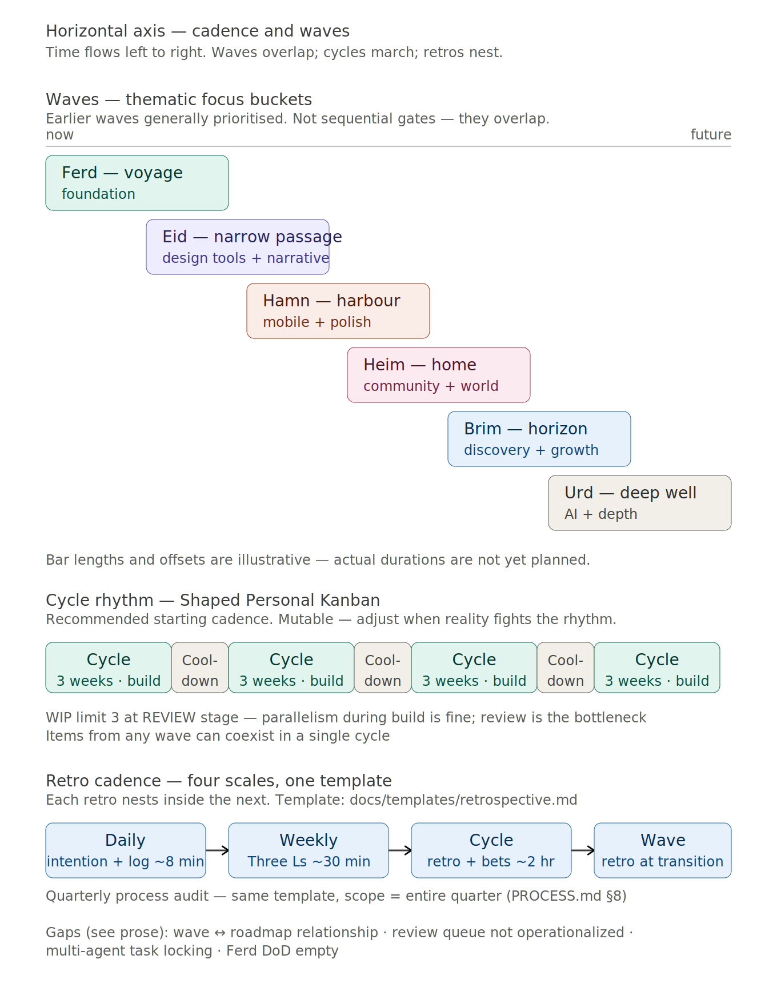

What this shows
Three bands, each operating at a different frequency.
- Waves band (top). Strategic focus over time — what the ecosystem prioritises in a given period. Six named waves — Ferd (voyage, foundation), Eid (narrow passage, design tools + narrative), Hamn (harbour, mobile + polish), Heim (home, community + world), Brim (horizon, discovery + growth), Urd (deep well, AI + depth).
- Cycle band (middle). The operational rhythm — 3-week build cycles with 1-week cooldowns between them. The actual temporal structure of solo-operator work.
- Retro band (bottom). The reflective cadence that threads through everything — daily intention and log, weekly Three Ls retrospective, cycle boundary retrospective and betting table, wave transition retrospective.

Waves are thematic focus, not sequential gates
This is the single most counter-intuitive point about the wave model. Waves are not phases that complete before the next begins. Waves are thematic focus buckets that overlap in time. The bars in the diagram overlap deliberately — Eid work ramps up while Ferd is still winding down; Hamn work can begin before Eid is "done."
Wave tags on feature specs are used for filtering, prioritisation, and strategic overview. They are not permission gates. A feature tagged wave:hamn can be worked on during Ferd if the capacity exists and no higher-priority Ferd item is blocked on it.

The cycle rhythm — Shaped Personal Kanban
The cadence is a hybrid: Personal Kanban’s continuous flow for daily execution, plus Shape Up’s strategic shaping at cycle boundaries. 3-week build cycles with 1-week cooldowns between them. Cooldown is not downtime — it is where bug fixing, tech debt, process refinement, and shaping of next cycle’s bets happen.
WIP limit of 3 at the REVIEW stage — not at the doing stage. Parallelism during build is fine; review is the real bottleneck.
The cadence is explicitly mutable. The shape (cycles + cooldown + WIP limit + daily/weekly/cycle reflection) matters more than the specific durations.

Retros nest like Russian dolls
The same retrospective template is used at four scales: daily (~8 min), weekly (~30 min, Three Ls), cycle (~2 hr, boundary retro + betting table), wave (at wave transition). A quarterly process audit uses the same template with quarter-scope.
Nesting means daily learning feeds weekly reflection feeds cycle shaping feeds wave strategy. A retro that does not produce a concrete, actionable improvement for the next scale is just journaling.

Gaps on this axis
- G-04 — Wave ↔ roadmap relationship. PROCESS.md references roadmaps alongside waves. The relationship is unresolved — do waves replace, duplicate, or complement roadmaps?
- G-05 — Review queue not operationalized. High priority. Tasks have status:review but no reviewer assignment, queue, or handoff protocol is documented. The bottleneck has no enforcement mechanism.
- G-06 — Multi-agent task locking. High priority. At 50+ parallel contributors, two agents can independently pick up the same TASK. No atomicity rule or collision detection is specified.
- G-07 — Ferd DoD empty. The wave-spec template has the DoD shape. Ferd’s specific criteria have not been populated. "Are we done with Ferd?" cannot be answered concretely.

3 — Execution: backlog refinement and the kanban board
Part 1 of the execution axis. How items flow from raw ideas through progressive refinement into an active cycle board. Before you can build something, it has to be ready to build.
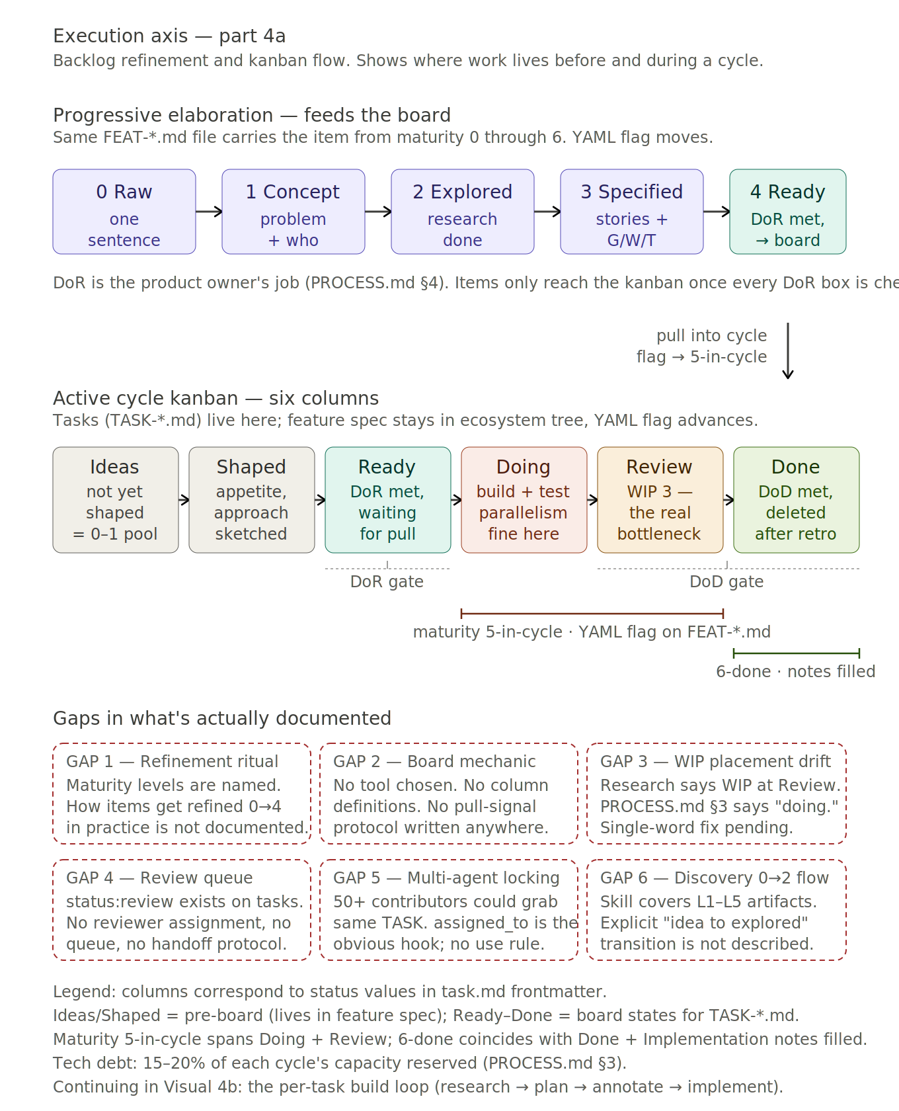

What this shows
Two stages of the execution axis, stacked vertically.
- Progressive elaboration (top), maturity 0 to 4. The refinement pipeline — same FEAT-*.md file, carrying the item from raw idea to ready-to-pull-into-a-cycle. The file’s YAML maturity frontmatter changes; the file path does not.
- Active cycle kanban (bottom), maturity 5 to 6. Six columns — Ideas, Shaped, Ready, Doing, Review, Done. When an item at 4-ready is pulled into a cycle, the YAML flag advances to 5-in-cycle and TASK files are generated. The spec reaches 6-done when every task has passed DoD and Implementation notes are filled in.

The full pipeline: 0 through 6 on one file
An item enters at maturity 0 and progresses through the levels as genuine work is done. The discipline is never skip a level. Under Model A, the same FEAT-*.md file carries the item from raw idea to shipped — no separate PRDs, no separate user-story files.

Refinement (0 to 4) — product owner’s lane
The diagram’s top row. Levels 0 through 4 are owned by the product owner. The artifact at each level is the feature spec itself, progressively filled in.
- 0 Raw. One sentence — "wouldn’t it be cool if..."
- 1 Concept. Problem identified, who benefits, rough shape.
- 2 Explored. Research done, approach sketched, risks named.
- 3 Specified. Stories written with Given/When/Then acceptance criteria.
- 4 Ready. All questions answered, DoR met, estimable.

On-board (5 to 6) — developer’s lane
The diagram’s bottom row. Levels 5 and 6 are owned by the developer (the AI agent, when delegated).
- 5 In cycle. The YAML flag on FEAT-*.md flips from 4-ready to 5-in-cycle when a cycle pulls the item. TASK-*.md files are generated. Maturity 5 spans both the Doing and Review kanban columns — a task can be in Review while its parent feature is still at 5-in-cycle.
- 6 Done. When the last task on the feature passes DoD and is approved through review, the developer flips the YAML to 6-done and populates the Implementation notes section: what was actually built, where it lives, key files, migrations, RPCs, components, decisions made during implementation. Forward-looking sections on the spec (Solution sketch, Appetite, Rabbit holes) become obsolete. The spec has reshaped itself from proposal into record. The task files are deleted after the cycle retrospective is committed.

Maturity and kanban columns are orthogonal
These are two different tracking mechanisms operating on two different objects. Maturity is a YAML flag on the feature spec — one feature, one flag. Kanban column is the status field on a task file — one feature can have multiple tasks, each in a different column.
A feature reaches maturity 5-in-cycle the moment any of its tasks enters Doing. It only reaches 6-done when all of its tasks reach the Done column and the Implementation notes are written. If a feature has three tasks and two are Done while one is still in Review, the feature is at 5-in-cycle, not 6-done.

Why the pipeline matters
The pipeline exists because of a lesson learned: Ferd’s early roadmap was built before proper research, leading to architectural assumptions that were not validated. The pipeline enforces "research before specification" — an item cannot reach maturity 3 without having passed through maturity 2. Skipping ahead is how bad assumptions get baked in.

The Definition of Ready is the gate into the board
An item does not get pulled onto the kanban just because someone wants to build it. It must first pass DoR — defined in PROCESS.md §4. Every box must check. DoR is the product owner’s job, not the developer’s. Its purpose is to protect the developer (and the AI agent) from vague work.

Kanban column semantics
The six columns correspond to values of the task status field (except Ideas and Shaped, which are pre-board states living in feature specs at maturity 0–1 and 2 respectively).
- Ideas — pre-board. Features at maturity 0-raw or 1-concept. No task file yet.
- Shaped — pre-board. Features at maturity 2-explored. Appetite set and rough approach; still not ready to build.
- Ready — on the board. Features at maturity 3 and 4. Tasks generated. Passed DoR. Waiting to be pulled into the active cycle.
- Doing — on the board. Tasks in motion. Parent feature is at maturity 5-in-cycle. Parallelism here is fine — WIP is enforced downstream.
- Review — on the board. Tasks awaiting review. Parent feature still at maturity 5-in-cycle. This is where WIP limit 3 applies — review capacity is the real bottleneck.
- Done — on the board. Tasks that have passed DoD. When all of a feature’s tasks are Done and Implementation notes are filled in, the parent feature flips to 6-done. The task files survive the cooldown and are deleted after the cycle retrospective is committed.

Definition of Done is the gate out
DoD is universal across all work. Every applicable box must check: acceptance criteria implemented and verified; ESLint + TypeScript strict pass; key logic unit-tested; mobile responsive for any UI change; Supabase RLS policies applied for every new table and access pattern; builds clean locally and in CI; deployed to preview and verified; README/CHANGELOG updated if user-visible behavior changed; Platform Specification updated if a shared API surface changed; complex decisions documented as ADR.
DoD is applied per task. The feature-level transition to 6-done happens when all of a feature’s tasks have individually cleared DoD AND the Implementation notes section on the spec has been populated.

Tech debt allocation
15-20% of each cycle’s capacity is reserved for tech debt. This is a target that prevents feature work from consistently crowding out quality work. Tech debt items live in the same backlog as features, tagged type:tech-debt.

Gaps on this axis
- G-09 — Refinement ritual undocumented. Maturity levels are named; how items actually get refined 0→4 in practice is not.
- G-10 — Board mechanic unchosen. The six-column board has no documented tool. GitHub Projects? Linear? Markdown table + grep?
- G-14 — Discovery 0→2 flow orphaned. The ecosystem-decomposition skill covers levels 1-5 as artifacts. The explicit "raw idea to explored" transition has no home.
- G-18 — Research pathway under-specified. Three research mechanisms exist but are not unified: maturity-2 as a research stage on a feature spec, type:spike as a work-item type, and docs/research/ for long-form reports. When does a question warrant a spike vs a research report? How do findings flow back into affected specs? The connective tissue is missing.

4 — Execution: the per-task build loop
Part 2 of the execution axis. What happens once a task moves from Ready into Doing. The build loop, the BDD-to-test translation, the testing trophy shape.
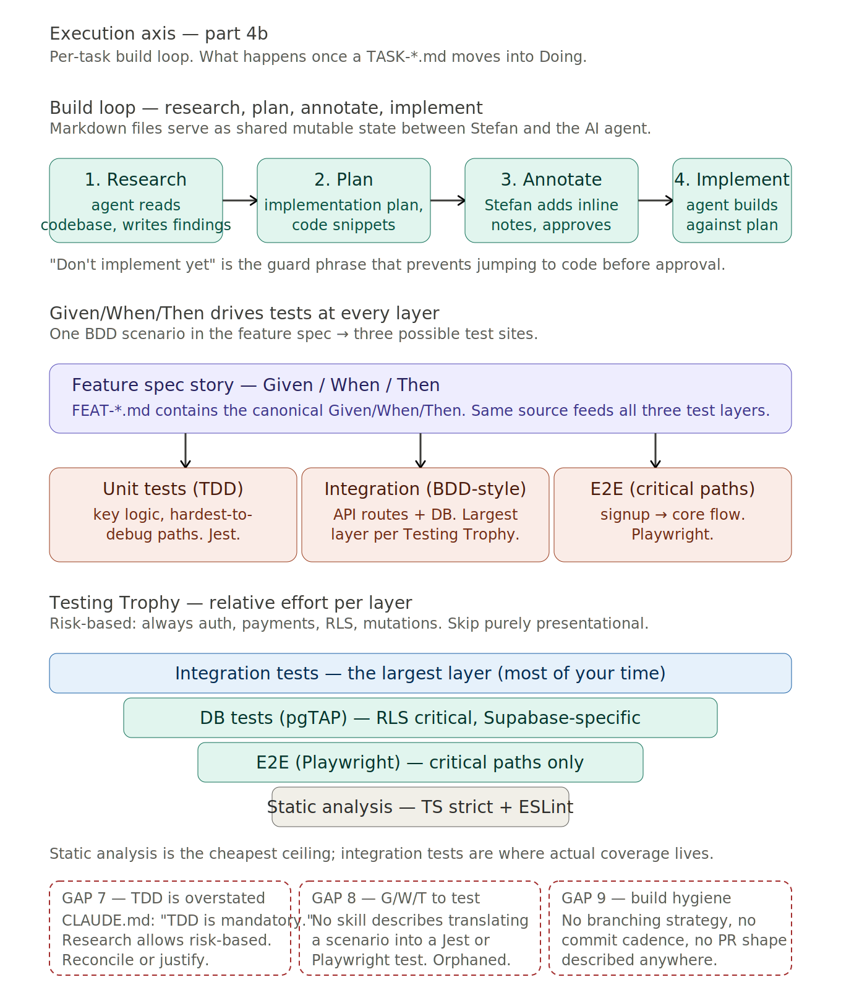

What this shows
Three stacked sections.
- The build loop (top). Research → Plan → Annotate → Implement. The canonical pattern for working with an AI coding agent. Markdown files serve as shared mutable state between the developer and the agent.
- Given/When/Then feeds three test layers (middle). The same BDD scenario from the feature spec becomes the input to unit tests (TDD-style), integration tests (BDD-style), and E2E tests (critical paths). One source, three layers.
- The Testing Trophy (bottom). Relative effort per layer. Integration is the biggest band. Static analysis is the free foundation. E2E and database tests are smaller but critical — database tests especially matter in a Supabase-RLS-heavy stack.

The build loop: Research → Plan → Annotate → Implement
This is the core working pattern with an AI coding agent. The markdown file is the interface. It is read and written by both the developer and the agent. It carries the state of the work across turns.
- 1. Research. The agent reads relevant code and writes findings to a research document.
- 2. Plan. The agent produces a detailed implementation plan with code snippets in a plan document.
- 3. Annotate. The developer reviews the plan, adds inline notes, then instructs the agent: "I added notes, address them and update the plan. Don’t implement yet." The guard phrase is critical.
- 4. Implement. Once the plan is solid, the developer instructs: "Implement it all. Mark tasks as completed in the plan document."
This is the concrete mechanism that makes "documentation IS the primary artifact, code is the byproduct" operational at the task level — not an aspirational slogan.

Given/When/Then is one source, three test sites
The feature spec template requires each story to have Given/When/Then acceptance criteria inline. Those same scenarios are then the canonical source for test writing at three layers.
- Unit tests (TDD-style, Jest). Test the hardest-to-debug internal logic.
- Integration tests (BDD-style, Jest + Supabase). API routes with their real database, components with their real dependencies. The largest layer per the Testing Trophy.
- E2E tests (Playwright). Critical user paths only — signup → onboarding → core feature flow.
The value of keeping the source canonical in the feature spec is that the same scenario can be referenced from any of the three test files — and when the scenario changes, all three test layers know where to look.

The Testing Trophy shape
Kent C. Dodds’s Testing Trophy replaces the classic testing pyramid. Static analysis is free and catches the largest class of bugs with zero test-writing effort. Integration tests are the largest layer — most of the testing time goes there. Database tests (pgTAP) are Supabase-specific and RLS-critical. E2E tests are the smallest slice but catch what integration cannot.
The shape is "risk-based testing": always test auth, payments, RLS policies, and data mutations. Integration-test API routes and critical flows. E2E-test the signup-to-core-feature path. Skip testing purely presentational components and prototype features.

Strong bookends, weak middle
Looking at chapters 3 and 4 together, the FringeIsland development system has a strong top (vision, entities, capabilities, feature specs are thoroughly described), a strong bottom (DoD is explicit and well-structured), and a weak middle (how items move through maturity is named but not described; the build loop is not in any skill; the Given/When/Then to test translation has no home).
The highest-leverage improvement available is probably expanding the feature-development skill to cover the build loop explicitly, the Given/When/Then to test translation, and the branching/commit hygiene. Not a new skill — the existing one, made fit for purpose.

Gaps on this axis
- G-11 — TDD overstated vs risk-based. Root CLAUDE.md mandates TDD. The research report permits risk-based testing as an alternative. Reconcile or justify.
- G-12 — Given/When/Then to test translation. High priority. The single highest-leverage practice from the research — one artifact serving as spec, tests, and AI prompt — has no documented translation mechanic.
- G-13 — Build hygiene unspecified. No branching strategy, no commit cadence, no PR shape documented. For 50+ contributors the absence is load-bearing.

5 — Agent routing
The routing axis. How an agent (or a human) enters the FringeIsland repo and builds context progressively from project orientation down to the specific task at hand. The entry path for every contributor, every session.
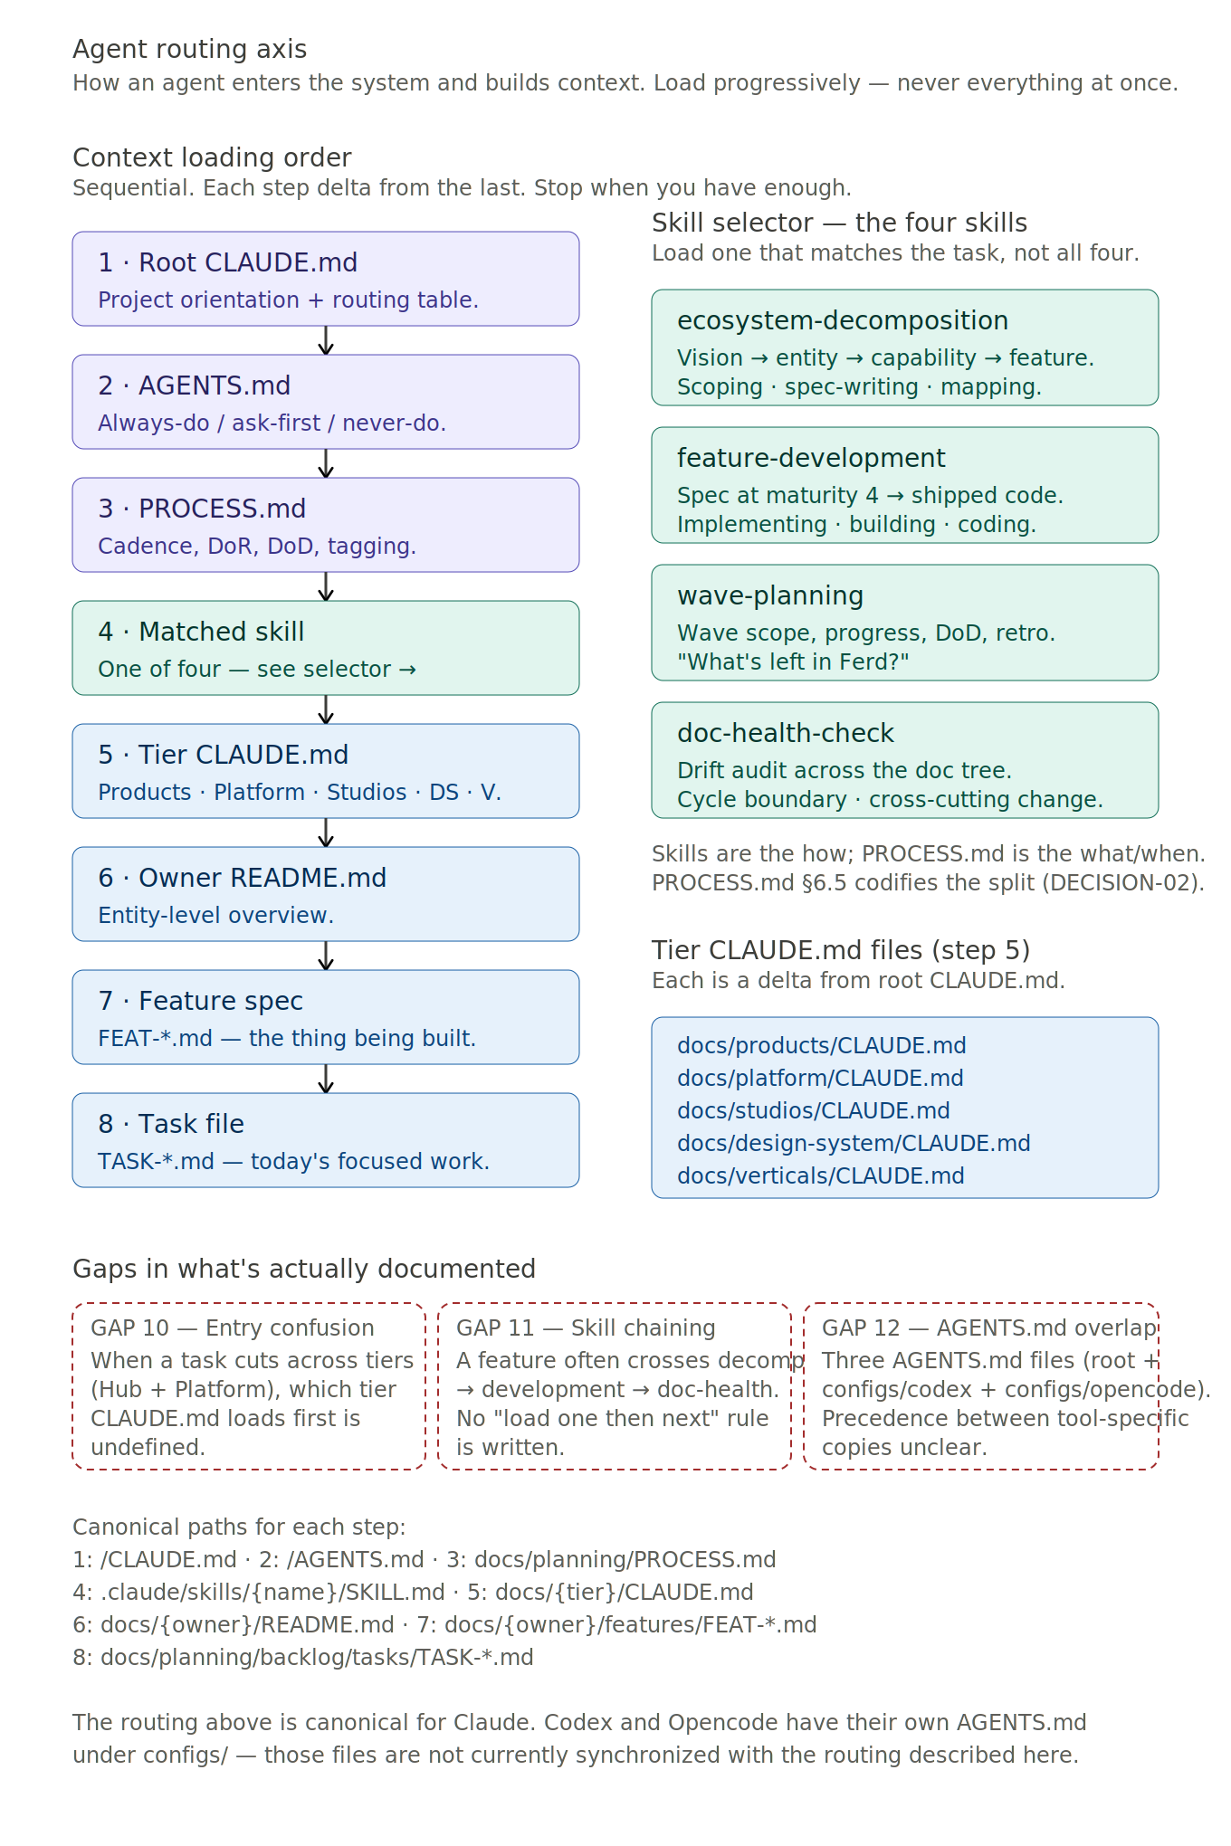

What this shows
Two columns. The left shows the eight-step context loading order. The right shows the skill selector — at step 4, the agent chooses which of the four skills matches the task.

Load progressively, never all at once
The canonical rule: "Load progressively. Never load all features at once — pull only what the task actually needs." An agent that loads everything available at the start of a session spends its context budget on orientation rather than work. The eight-step order is tuned to pay for exactly as much context as the task needs, then stop.

The eight steps
- 1. Root CLAUDE.md. Project orientation and routing table. Where to look, which skill to load. The entry document.
- 2. AGENTS.md. Always-do / ask-first / never-do boundaries. What you may and may not do.
- 3. PROCESS.md. Way of working. Cadence, DoR, DoD, tagging. WHAT and WHEN.
- 4. Matched skill. One of four under .claude/skills/. HOW. The execution layer.
- 5. Tier CLAUDE.md. The tier where the work lives. Products, Platform, Studios, Design System, or Verticals. Each is a delta from root.
- 6. Owner README.md. The entity (Hub, Platform Core, Journey Studio, specific vertical). Entity-level overview, list of specs, status.
- 7. Feature spec. The canonical source of acceptance criteria for the thing being built.
- 8. Task file. Today’s focused unit of work. The build loop from chapter 4 begins here.

The skill selector
PROCESS.md says what and when. The four skills say how. They live under .claude/skills/ and are loaded at step 4 based on the task type.
- ecosystem-decomposition. Load when scoping, spec-writing, or mapping. Decomposing vision → product → feature → story → task.
- feature-development. Load when implementing, building, coding. Features at maturity 4 or higher. Generates tasks, writes code against acceptance criteria, runs lint and tests, updates maturity to 6-done.
- wave-planning. Load when asking about wave scope, progress, DoD, or retrospective. "What’s left in Ferd?"
- doc-health-check. Load at cycle boundaries or after cross-cutting changes. Runs checks across the documentation tree to catch drift.

Why this axis matters
Chapters 1-4 describe what exists and how work moves through it. Chapter 5 describes how a new participant finds their place in it. It is the onboarding path.
The quality of this axis is what lets FringeIsland scale from solo operator to fifty contributors without central coordination. If root CLAUDE.md is clear, the cascade from there is self-routing. If root is unclear, every contributor reinvents the routing from scratch.
A tell for whether the axis is healthy: new contributors should be able to start useful work within 30 minutes of opening the repo. The eight-step path, followed in order, should get them there.

Gaps on this axis
- G-15 — Cross-tier entry order. For cross-tier features (Hub UI + Platform data model), which tier CLAUDE.md loads first is undefined. Wrong order means less-relevant constraints get internalized first.
- G-16 — Skill chaining undocumented. Most real work crosses skills. The chains are currently tacit — no document says "after X, load Y."
- G-17 — AGENTS.md precedence across tools. Three AGENTS.md files exist (root + configs/codex + configs/opencode). No precedence rule is written.

Consolidated gaps register
Seventeen known documentation and design gaps across the FringeIsland development system as of 2026-04-19. When a gap is resolved, it is removed both here and from the relevant chapter. New gaps surfaced in later sessions are added with the next sequential ID.
Priority is a relative ranking. High-priority gaps compound silently, affect multiple future decisions, or block scale. Medium-priority gaps affect clarity and contributor onboarding but are not blocking today. Low-priority gaps are single-word fixes or edge cases.
ID | Gap | Priority
G-01 | Whisp architectural placement (L2) | Medium
G-02 | Cross-product feature sync (L4) | Medium
G-03 | Vertical specs are scaffolds (cross-cut) | High
G-04 | Wave ↔ roadmap relationship | Medium
G-05 | Review queue not operationalized | High
G-06 | Multi-agent task locking | High
G-07 | Ferd DoD empty | Medium
G-09 | Refinement ritual undocumented | Medium
G-10 | Board mechanic unchosen | Medium
G-11 | TDD overstated vs risk-based | Low
G-12 | Given/When/Then to test translation | High
G-13 | Build hygiene unspecified | Medium
G-14 | Discovery 0→2 flow orphaned | Medium
G-15 | Cross-tier entry order | Medium
G-16 | Skill chaining undocumented | Medium
G-17 | AGENTS.md precedence across tools | Low
G-18 | Research pathway under-specified | Medium

Priority summary

High priority
- G-03 Vertical specs are scaffolds
- G-05 Review queue not operationalized
- G-06 Multi-agent task locking
- G-12 Given/When/Then to test translation

Medium priority
- G-01 Whisp architectural placement
- G-02 Cross-product feature sync
- G-04 Wave ↔ roadmap relationship
- G-07 Ferd DoD empty
- G-09 Refinement ritual undocumented
- G-10 Board mechanic unchosen
- G-13 Build hygiene unspecified
- G-14 Discovery 0→2 flow orphaned
- G-15 Cross-tier entry order
- G-16 Skill chaining undocumented
- G-18 Research pathway under-specified

Low priority
- G-11 TDD overstated vs risk-based
- G-17 AGENTS.md precedence across tools

The pattern visible across the register
Strong bookends (vision at the top; DoD at the bottom), weak middle (how items move through maturity, how specs translate to tests, how the build loop is documented, how review actually handshakes). Seven of the seventeen gaps are middle-layer gaps. This is not accidental — it reflects an ecosystem that has invested heavily in strategic scaffolding and lightly in tactical scaffolding. Acceptable while tacit knowledge fills the gap. Blocking at the 50-contributor scale the architecture is designed for.
The highest-leverage single move is probably expanding the feature-development skill to cover the build loop, the Given/When/Then to test translation, and build hygiene. Three gaps closed by one skill expansion.

Canonical sources this document is built on
This document is a view onto the canonical sources. When they change, this document must be updated to match. When it disagrees with a canonical source, the canonical source wins.
- docs/ecosystem/VISION.md — the constitutional document
- docs/planning/PROCESS.md — way of working (strategic layer)
- .claude/skills/*/SKILL.md — the four skills (execution layer)
- /CLAUDE.md, /AGENTS.md — root orientation and boundaries
- docs/{tier}/CLAUDE.md — tier-specific guidance (five files)
- docs/templates/*.md — the reusable shapes
- docs/architecture/decisions/*.md — ADRs, especially U002 (verticals) and U023 (architecture)

